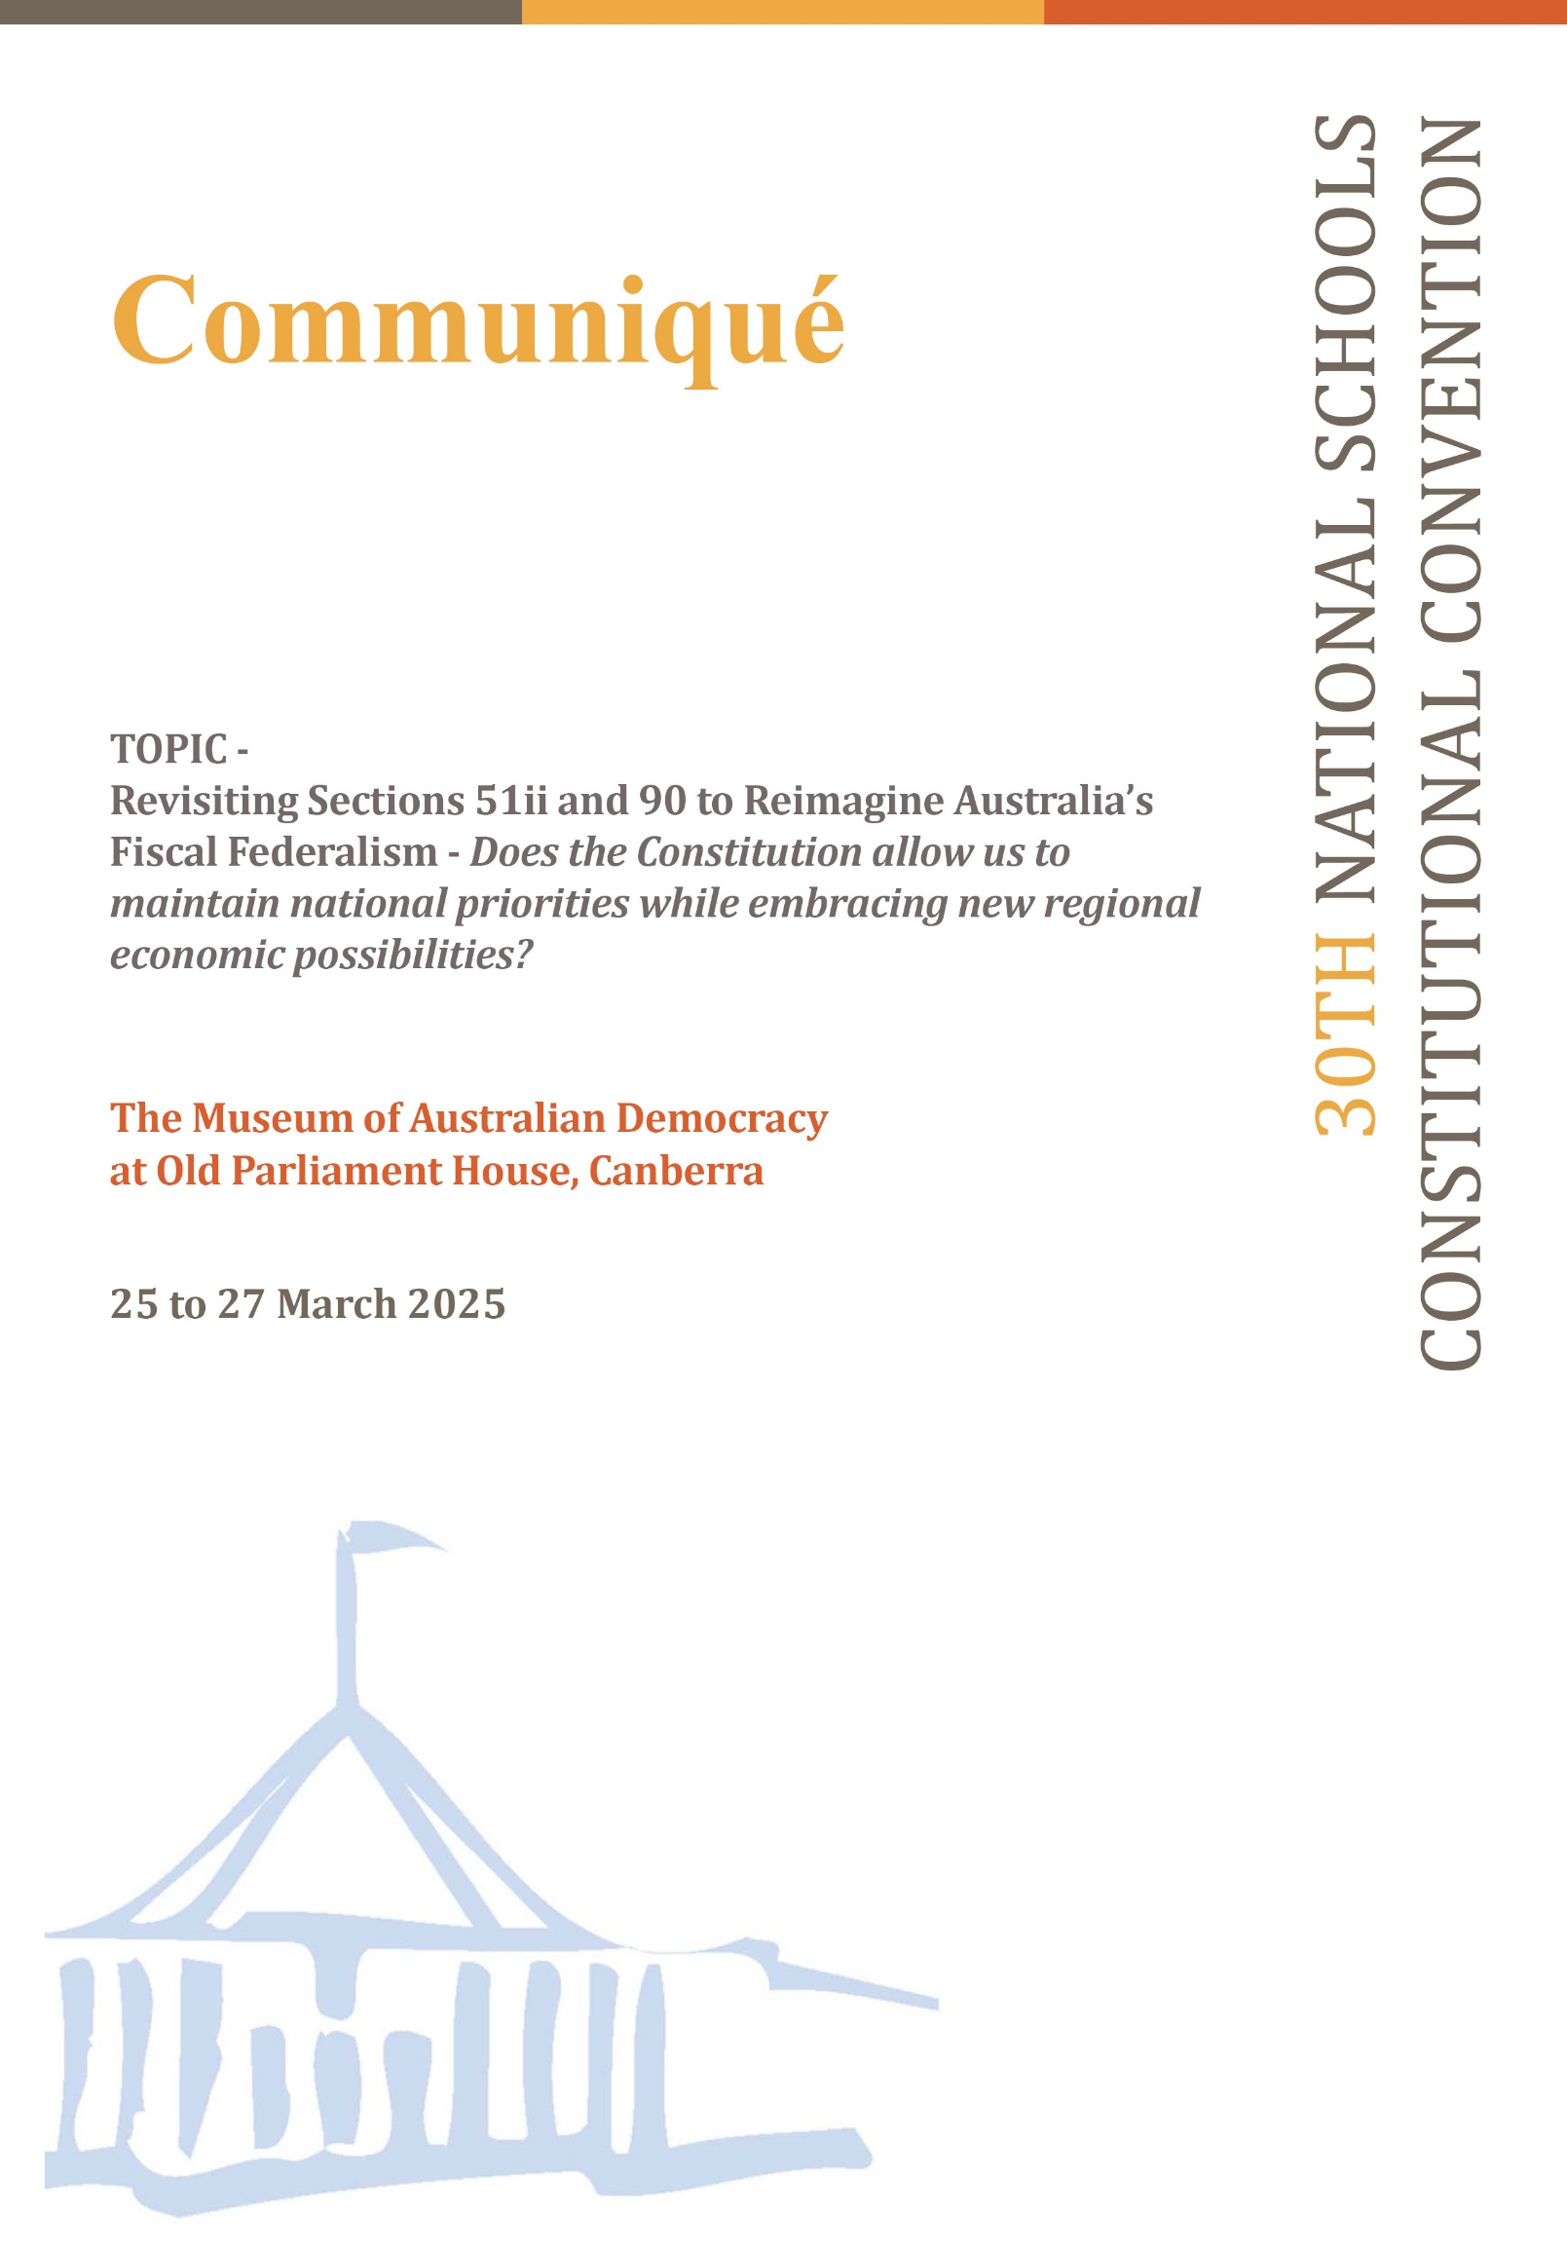

**Introduction**

The 30th National Schools Constitutional Convention (NSCC) was held at the Museum of Australian Democracy (MoAD) at Old Parliament House, Canberra, from 25 to 27 March 2025. A total of 119 students (delegates) from diverse schooling backgrounds across Australia attended. They discussed whether sections 51(ii) and 90 of the Constitution should be amended to allow the Australian Federation to maintain national priorities while embracing new regional economic possibilities.

**Introduction of facilitator**

Mr Geoffrey O’Neill, Executive Director of National Curriculum Services, welcomed delegates on behalf of the Department of Education and National Curriculum Services. He introduced the co-facilitators, Emeritus Professor Clement Macintyre and Professor Alan Fenna.

In his opening remarks, Professor Macintyre noted that while the Constitution is a small document, it has a significant impact on the lives of Australians. He emphasised the importance of the Constitution’s fiscal arrangements in ensuring the success of the Federation, and observed that, during the convention, delegates would examine these arrangements and consider whether the Constitution continues to meet the needs of contemporary Australia.

He explained that constitutional change is a key political process and that delegates would vote in a referendum during the convention to decide whether to support constitutional change. Professor Macintyre encouraged active, respectful participation and engagement of all delegates over the next two days.

**Welcome to Country**

Ngunnawal and Kamilaroi custodian and Cultural Director of the Traditional Owners Aboriginal Corporation, Richie Allan, conducted the Welcome to Country, reflecting on the significance of the House of Representatives chamber's inclusive horseshoe layout and the value of respectful dialogue when engaging with different perspectives on any issue.

**Welcome to MoAD**

Stephanie Smith, Manager of Learning at MoAD, welcomed delegates and reminded them of the heritage overlay of Old Parliament House. She emphasised the importance of preserving this historic site and its significant role in the development of Australia’s democracy.

**Convention official opening**

Professor Macintyre officially opened the convention, emphasising its status as a key component of the Civics and Citizenship program, supported by the Australian Government Department of Education and both sides of politics for 30 years. He noted that, during the drafting of the original Constitution, the people were involved through a series of conventions held across the colonies. This process allowed feedback to be provided to politicians and the government. Over the next two days, delegates would replicate this process, discussing various perspectives, listening to expert input, voting on two referendum questions, and ultimately preparing a communiqué for government. He acknowledged the role of National Curriculum Services in organising the event.

**Keynote 1: Why do we have a Federal Constitutional system? Understanding how the Constitution was developed and interpreted and how that impacts on State and Territory powers, including the raising of revenue.**

* **Professor Kim Rubenstein, University of Canberra**

Professor Rubenstein outlined the historical context of the Constitution’s drafting in the 1890s, noting that it reflected the perspectives of its drafters - primarily Anglo-British men. She invited students to consider whether the Constitution adequately reflects the diversity of contemporary Australia.

She asked delegates to reflect on the motivations of the Constitution’s drafters. Economic motivations included whether to adopt protectionist policies or promote free trade. Socially, although the Constitution was liberal in intent, it was shaped by the discriminatory norms of the time - for example, proposals to restrict immigration from non-European backgrounds. Ultimately, the overarching aim was to unify the colonies under a centralised legal and governmental framework while maintaining checks on power.

The Constitution, she explained, was democratically developed with public input and influenced by US and UK models. It incorporates principles of responsible government and separation of powers. Key sections discussed included:

* section 64 (executive members must sit in Parliament)
* section 109 (federal law overrides state law)
* sections 41 and 108 (voting rights and continuation of state laws)

Student delegate questions included:

* Should Australia adopt a Bill of Rights?
* Can High Court judges be removed?
* Should federalism continue?

**Keynote 2: The impact on the States of the changing meaning of excise.**

* **Professor Emerita Anne Twomey, The University of Sydney**

Professor Twomey highlighted the pivotal role of revenue in federalism. Central to the story of Federation is a political agreement that involved the voluntary transfer of certain powers from the states to the Commonwealth in the interest of national unity. Section 51(ii) was included to prevent discriminatory taxation by the Commonwealth.

Potential benefits of amending section 51(ii):

* Greater flexibility for regional taxation approaches
* Support for disaster recovery and regional development
* Trialling location-specific taxes, e.g. congestion levies

Potential drawbacks:

* Increased coercive power for the Commonwealth
* Risk of capital flight to low-tax states
* Politically motivated taxation used to influence state policy

She discussed section 90 and the definition of excise. The Vanderstock case challenged the scope of excise taxes. The High Court ruled that Victoria’s EV road-user tax was unconstitutional, as it constituted an excise that only the Commonwealth can impose.

She also addressed the implications of states raising their own taxes, including improved accountability, but warned of risks like double taxation and administrative burdens for businesses.

Student delegate questions included:

* Are conditional grants constitutional?
* Are there international examples of state-level taxation?
* Should grants be non-discriminatory?

**Feedback session 1**

Delegates discussed centralised taxation and generally supported greater state autonomy in revenue raising. Many expressed concerns about Commonwealth control over funding. Proposals included adopting a federal reserve-style fund for national contingencies and concerns about double taxation.

**Keynote 3: The role of the Grants Commission in Building a Federation.**

* **Dr Angela Jackson, Commonwealth Grants Commissioner**

Dr Jackson outlined the Commonwealth Grants Commission (CGC)’s role in supporting equity across states. The CGC was established in 1933 in response to the Great Depression, which caused widespread poverty and deprivation in parts of the Federation that lacked the financial capacity to respond effectively. Over time, the CGC has evolved from providing special grants to financially struggling states to distributing funding to all states based on relativities such as state revenue, demographic differences and natural resource endowment. Today, the CGC distributes around $95 billion annually, including GST revenue.

The CGC ensures horizontal equalisation, so all states can provide a consistent level of services regardless of their revenue capacity. Challenges ahead include:

* State revenue volatility
* Population and demographic change
* Evolving expectations for service delivery

Student delegate questions included:

* Can the CGC influence special grants?
* How can states ensure financial sustainability?
* What determines the size of the GST pool?

**Feedback session 2**

Most groups supported the CGC’s mission to promote equitable access to services across all states and territories. However, several concerns were raised about regional service gaps - particularly in areas where communities felt they received fewer services despite contributing comparable tax revenues.

Delegates also debated the role of the CGC as a non-elected body responsible for managing and distributing large sums of public funding. Some groups advocated expanding the CGC’s authority by giving it greater powers to allocate funds and monitor how states use them. Others were more critical, questioning whether such financial decisions should be made by a body that is not directly accountable to voters.

Several groups suggested that greater transparency around the CGC’s distribution formula and decision-making processes would improve public trust. In addition, some delegates proposed that mechanisms be established to compensate states that have, over extended periods, contributed more than they have received under the equalisation framework.

**Keynote 4: What might be done, has been done, should be done and could be done to improve Australian fiscal federalism?**

* **Professor Alan Fenna, Curtin University**

Professor Fenna described Australia’s federal structure as a purposeful choice allowing for both national cohesion and state autonomy. Both the geography of Australia and the social and economic diversity of our country has seen the benefits of Australia’s unique model of Federalism. However, fiscal power has become increasingly centralised. Examples include:

* Section 96 allows the Commonwealth authority to give money to the States on terms it seems fit
* Income Tax Act 1942 and the States Grants (Income Tax Reimbursement) Act 1942 gave the Commonwealth control over income and corporate taxes
* 1946 referendum expanded federal powers to include social services with Medicare seen an extension of this authority in the area of health.

Reforms to address vertical fiscal imbalance have included returning payroll tax to the states and the introduction of GST, with all revenue allocated to states. In 2018, the GST distribution formula was revised to favour less wealthy states.

Options proposed for future reform:

1. Return some taxation powers to states
2. Introduce revenue-sharing (e.g. German model where a certain percentage of tax revenue raised belongs to States)
3. Increase and broaden the GST
4. Amend section 90 to enable indirect taxation by states

Of the four, amending section 90 was considered most politically viable, as it reassigns tax powers from the Commonwealth to the States without introducing new taxes.

Student delegate questions included:

* Should Australia adopt a unitary system?
* Who decides on differentiated state tax rates?

**Feedback session 3**

Student delegates showed limited support for variable tax rates across states due to concerns about tax competition and inequality, including the creation of perceived tax havens amongst the States. Many preferred revenue sharing to enhance state accountability. Some supported state-based indirect taxes, with caution about double taxation impacts on both business and consumers.

**Introducing the referendum questions**

Wystan Fisher, from the Australian Electoral Commission, explained how referendums amend the Constitution. Under section 128, a change requires a double majority: national voter majority and majority of states. Parliament must first pass enabling legislation.

**The vote**

**Question 1**

To alter s.51(ii) of the Constitution to omit the words, “but so as not to discriminate between States or parts of States”

|  |  |  |  |
| --- | --- | --- | --- |
|  | **Formal Yes votes** | **Formal No votes** | **Is the majority in favour?** |
| New South Wales | 6 | 22 | **No** |
| Victoria | 2 | 23 | **No** |
| Queensland | 4 | 18 | **No** |
| Western Australia | 1 | 14 | **No** |
| South Australia | 3 | 9 | **No** |
| Tasmania | 1 | 4 | **No** |
| Australian Capital Territory | 2 | 3 |  |
| Northern Territory | 2 | 3 |  |
| **National total** | **21** | **96** |  |

**Question 2**

To alter the Constitution to allow States to impose a tax on goods after their production and manufacture but only in a way that does not discriminate against goods from other states.

|  |  |  |  |
| --- | --- | --- | --- |
|  | **Formal Yes votes** | **Formal No votes** | **Is the majority in favour?** |
| New South Wales | 10 | 18 | **No** |
| Victoria | 7 | 18 | **No** |
| Queensland | 7 | 15 | **No** |
| Western Australia | 4 | 11 | **No** |
| South Australia | 5 | 7 | **No** |
| Tasmania | 1 | 4 | **No** |
| Australian Capital Territory | 1 | 4 |  |
| Northern Territory | 2 | 3 |  |
| **National total** | **37** | **80** |  |

**Convention official closing**

The final communiqué, including outcomes from discussions and referenda, was presented to the President of the Senate, the Honourable Sue Lyons, for tabling in Parliament and incorporation into Hansard.