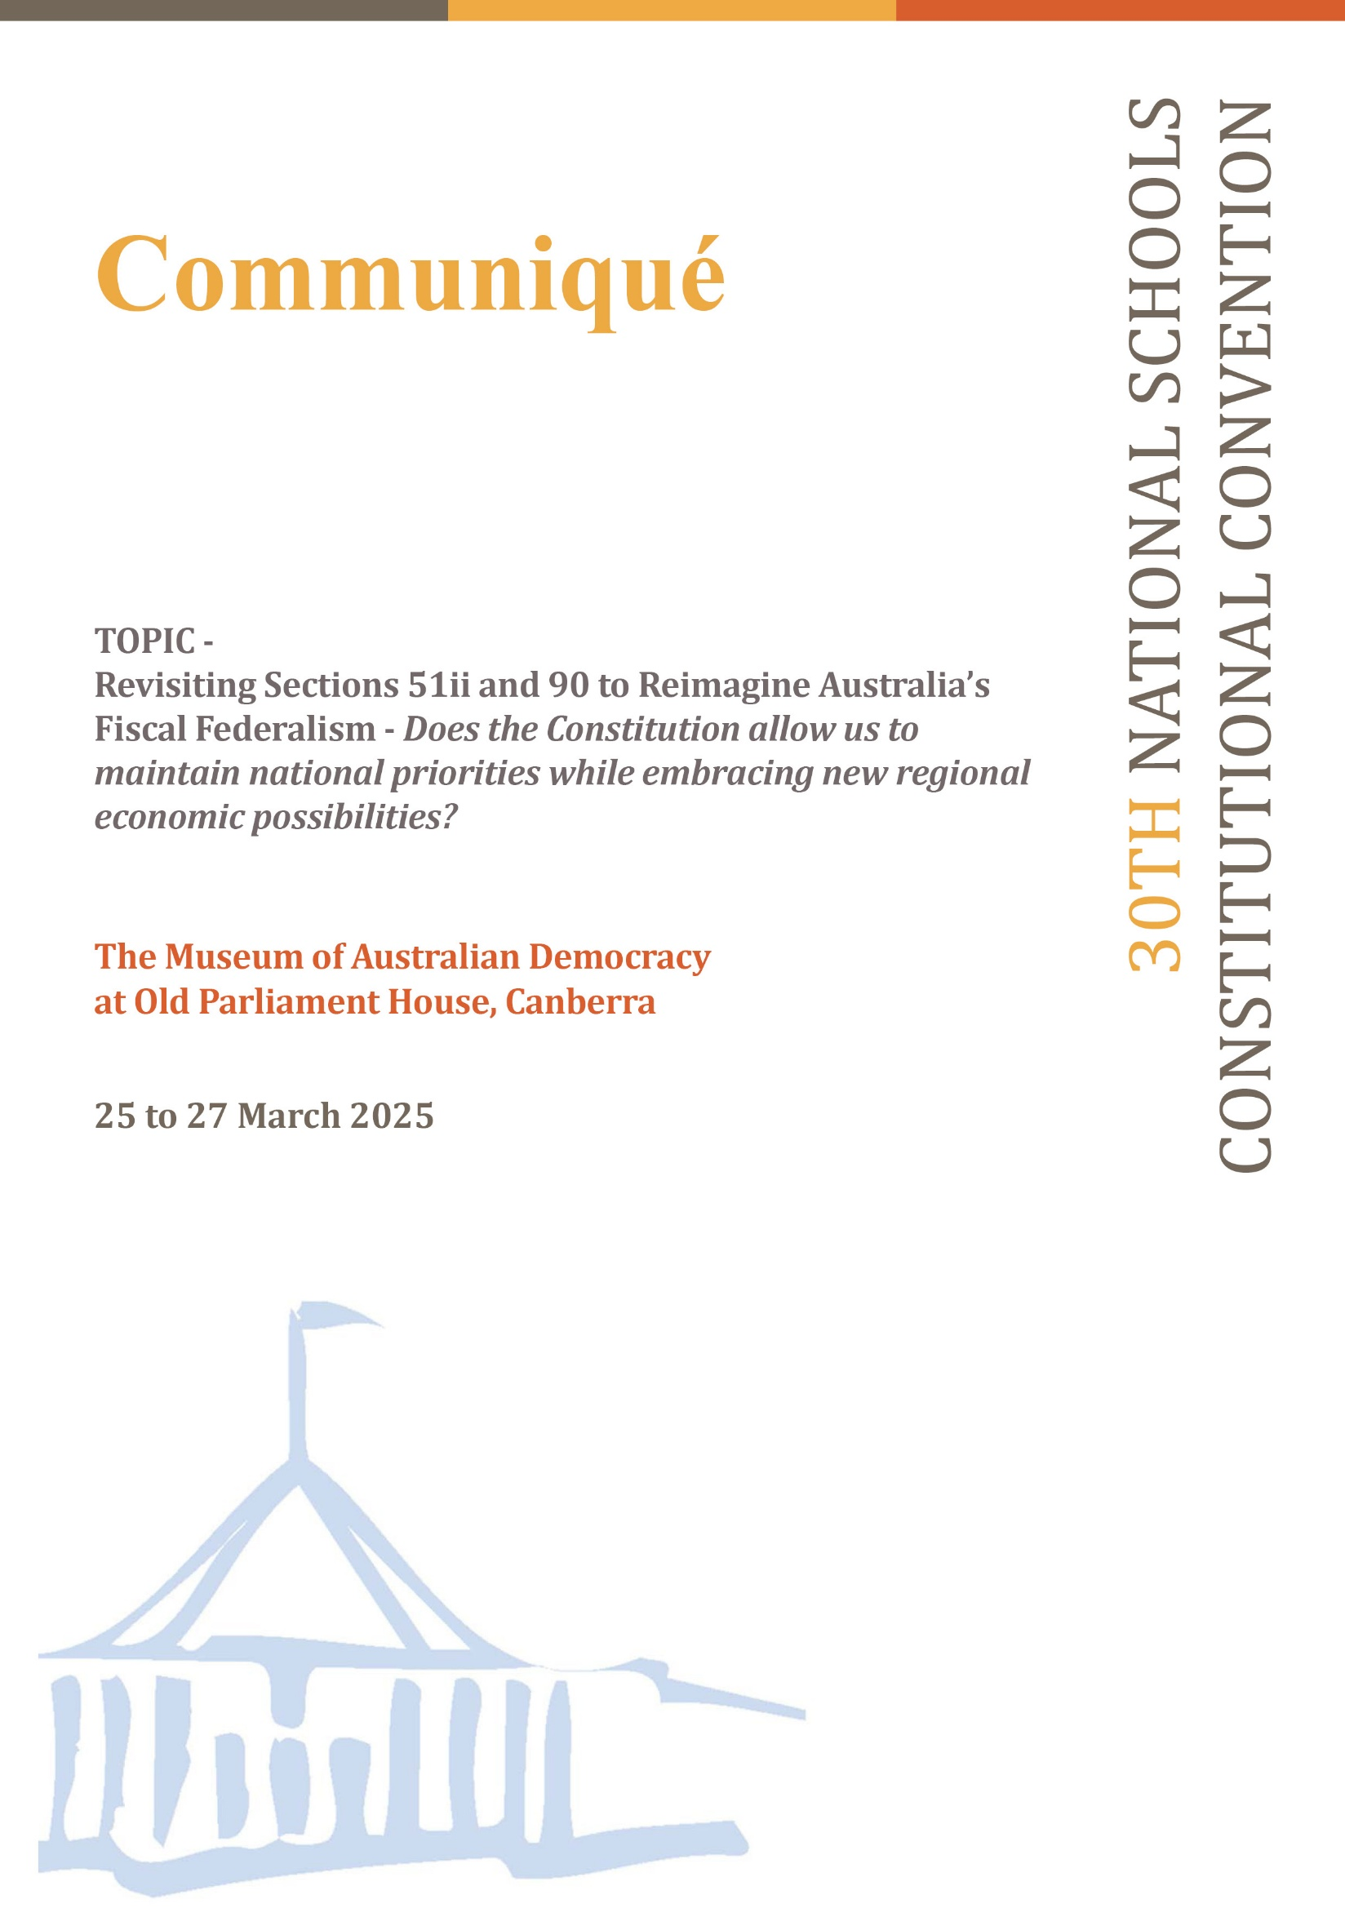**Introduction**

The 30th National Schools Constitutional Convention (NSCC) was held at the Museum of Australian Democracy (MoAD) at Old Parliament House, Canberra, from 25 to 27 March 2025. A total of 119 students from diverse schooling backgrounds across Australia attended. They discussed whether sections 51(ii) and 90 of the Constitution should be amended to allow the Australian Federation to maintain national priorities while embracing new regional economic possibilities.

**Convention process**

Under the guidance of Emeritus Professor Clement Macintyre and Professor Alan Fenna and following a Welcome to Country by Ngunnawal and Kamilaroi custodian and Cultural Director of the Traditional Owners Aboriginal Corporation, Richie Allan, delegates embarked on a comprehensive examination of sections 51(ii) and 90.

Professor Macintyre opened the convention by emphasising civic engagement and the importance of having a voice in our democracy. He noted that approximately 3,000 young Australians have participated in this program over the past 30 years. He acknowledged the ongoing support of the Australian Government Department of Education and the work of National Curriculum Services in organising the event.

Keynote speakers - including Professor Kim Rubenstein, Professor Emerita Anne Twomey, Dr Angela Jackson and Professor Alan Fenna – examined and explored the tensions in Australia’s fiscal federalism, including how taxation can be used not only to redistribute income but also to create economic incentives for states and regions.

**Delegate deliberations**

Through workshops, delegates explored the complexities of state and federal taxation powers, funding mechanisms and the implications of vertical and horizontal fiscal imbalances. They considered the role of taxation in raising revenue for essential services and its potential as a tool for public policy to achieve national goals.

Key discussion points included:

* concerns about the share of taxation revenue between the federal and state governments
* the risk of coercion by the Commonwealth due to vertical fiscal imbalance
* the need to safeguard state revenues and promote equal service delivery
* inequities faced by regional areas despite paying similar tax rates as metropolitan residents
* political motivations behind conditional grants and their impact on social justice and equity
* the importance of federal support for states impacted by natural disasters
* concerns that new state taxes could increase the cost of living for households and businesses
* awareness that constitutional change carries potential risks and unintended consequences

While there was general support for greater state autonomy in taxation, delegates also expressed concern that this could result in double taxation, negatively affecting both business and consumers.

Suggestions for reform included:

* reviewing current taxation systems to ensure more reliable funding for states to support essential services
* exploring alternative revenue-raising options, including a revenue-sharing model with a set proportion between the Commonwealth and states
* establishing an independent body to review grants and improve transparency
* improving funding certainty to enhance state accountability
* considering legislative reforms to rebalance powers between the Commonwealth and states as an alternative to constitutional change

**The Vote**

Facilitated by Wystan Fisher from the Australian Electoral Commission, delegates voted on two questions.

**Question 1**

To alter s.51(ii) of the Constitution to omit the words, “but so as not to discriminate between States or parts of States”

|  |  |  |  |
| --- | --- | --- | --- |
|  | **Formal Yes votes** | **Formal No votes** | **Is the majority in favour?** |
| New South Wales | 6 | 22 | **No** |
| Victoria | 2 | 23 | **No** |
| Queensland | 4 | 18 | **No** |
| Western Australia | 1 | 14 | **No** |
| South Australia | 3 | 9 | **No** |
| Tasmania | 1 | 4 | **No** |
| Australian Capital Territory | 2 | 3 |  |
| Northern Territory | 2 | 3 |  |
| **National total** | **21** | **96** |  |

**Question 2**

To alter the Constitution to allow States to impose a tax on goods after their production and manufacture but only in a way that does not discriminate against goods from other states.

|  |  |  |  |
| --- | --- | --- | --- |
|  | **Formal Yes votes** | **Formal No votes** | **Is the majority in favour?** |
| New South Wales | 10 | 18 | **No** |
| Victoria | 7 | 18 | **No** |
| Queensland | 7 | 15 | **No** |
| Western Australia | 4 | 11 | **No** |
| South Australia | 5 | 7 | **No** |
| Tasmania | 1 | 4 | **No** |
| Australian Capital Territory | 1 | 4 |  |
| Northern Territory | 2 | 3 |  |
| **National total** | **37** | **80** |  |

**Convention Outcome**

The communiqué summarising the convention’s discussions, deliberations and vote outcomes will be presented to Senator Sue Lines, President of the Senate, for tabling in Parliament and incorporation into Hansard. This document reflects the informed and thoughtful engagement of Australia’s youth in key constitutional and fiscal issues.

To access the full version of the 2025 NSCC communiqué, please follow this link:

<https://ncsonline.com.au/uploads/media/NSCC2025Communique_LongVersion_FINAL-1744688751.docx>