

**The Museum of Australian Democracy (MoAD)**

**Old Parliament House, Canberra, ACT**

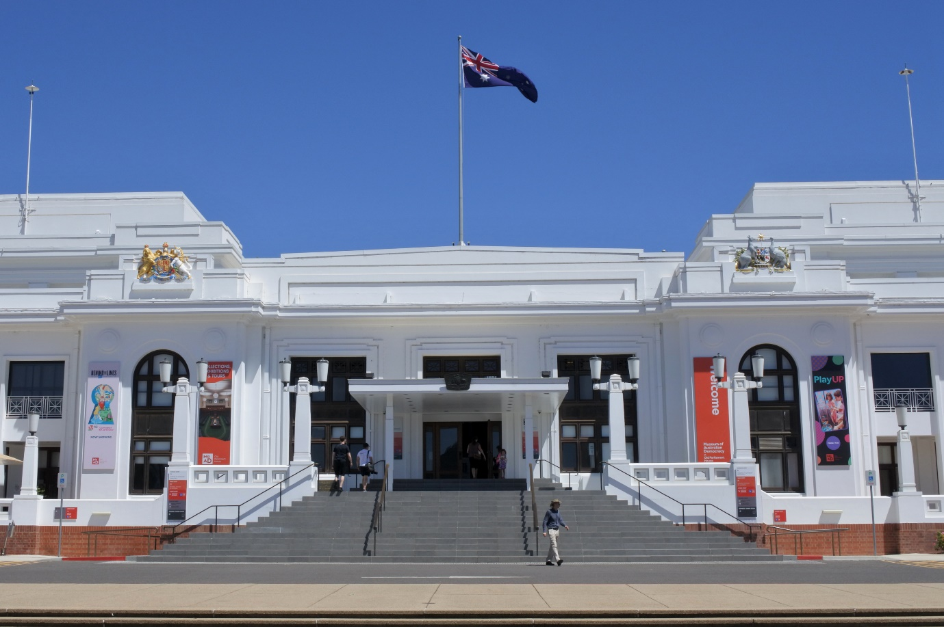

*This project is supported by funding from the Commonwealth Department of Education. National Curriculum Services Pty Ltd organises & manages the event on behalf of the Australian Government. The views expressed at the 2025 National Schools Constitutional Convention do not necessarily represent the view of the Commonwealth Department of Education.*

As of 17-Mar-2025

**30th National Schools Constitutional Convention**

**Topic: Revisiting Sections 51ii and 90 to Reimagine Australia’s Fiscal Federalism**

*Does the Constitution allow us to maintain national priorities while embracing new regional economic possibilities?*

**Program**

|  |  |
| --- | --- |
| **DAY 0 - Monday 24 March 2025** | |
| Afternoon | Arrival of NCS Staff |
| Evening | Arrival of WA and NT delegates |
| 8:00pm – 9:30pm (1hr) | DINNER at Pavilion on Northbourne Hotel (3rd Floor Conference Room) |
| From 9:30pm | Accommodation at Pavilion Northbourne Hotel |
| **DAY 1 - Tuesday 25 March 2025** | |
| From 6:30am | BREAKFAST at Pavilion on Northbourne Hotel (3rd Floor Conference Room) |
| 9:10am | *Bus departs for National Archives of Australia (WA, NT & SA Only)* |
| 9:30am – 11:00am (1.5hrs) | **Tour at National Archives of Australia (WA, NT & SA Only)** |
| From 10:00am | Delegates arrive Pavilion on Northbourne Hotel in batches |
| 11:05am | *Bus departs for Pavilion on Northbourne Hotel (WA, NT & SA Only)* |
| From 10:30am | LUNCH - *Collect & eat boxed lunched from Pavilion on Northbourne Hotel* (3rd Floor Conference Room or take on coach) |
| 11:50am | *Bus departs for Parliament House* |
| 12:15pm – 12:30pm (15 mins)  *Parliament House* | **Clear security** |
| 12:30pm – 1:30pm (1hr) | **Parliament House Tour** |
| 1:40pm – 3:10pm (1.5hrs) | **Attend House of Representatives Question Time (Level 1)** |
| 3:10pm – 3:30pm | Moving time to Theatrette |
| 3:30pm – 5:00pm (1.5hrs)  *Theatrette & Foyer, Parliament House* | **Prime Minister’s Welcome Reception & Meet Your Politician Session**  Guest of Honour: The Hon Dr Andrew Leigh MP, Assistant Minister for Competition, Charities and Treasury, Assistant Minister for Employment |
| 5:05pm – 6:00pm (55 mins)  *Theatrette,  Parliament House* | Briefing of Students and Supervisors| Introduction to Working Groups  Ice Breaking Activities |
| 6:00pm – 7:00pm (1hr) | DINNER served at APH Theatrette Foyer |
| 7:15pm – 8:00pm (45 mins) | **Attend Budget Speech at House of Representative (Level 2)** |
| 8:15pm | Departure from Parliament House |
| 8:30pm | Accommodation at Pavilion on Northbourne Hotel  *[Supervisors Check-In Session]* |

|  |  |
| --- | --- |
| **DAY 2 – Wednesday 26 March 2025** | |
| 6:15am – 7:30am (45 mins) | BREAKFAST at Pavilion on Northbourne Hotel (Conference Room) |
| 7:45am | *Bus departs for Old Parliament House* |
| 8:00am – 8:30am (30 mins) | Photography session at Front Steps of Old Parliament House |
| 8:30am – 8:45am (15 mins) | *Moving time* |
| 8:45am – 9:00am (15 mins) *House of Rep Chamber, MoAD* | **Facilitator Introduction** – Geoffrey O’Neill **NSCC Welcome** – Facilitators - Emeritus Professor Clement Macintyre, University of Adelaide **Welcome to Country** – Richie Allan, Ngunnawal and Kamilaroi Custodian and Cultural Director of Traditional Owners Aboriginal Corporation (TOAC) |
| 9:00am – 9:15am (15 mins) *House of Rep Chamber, MoAD* | **Heritage Message** by Stephanie Smith, Manager Learning, Museum of Australian Democracy |
| 9:15am – 9:30am (15 mins) *House of Rep Chamber, MoAD* | **Official opening  Presentation of Certificates** |
| 9:30am – 9:35am (5 mins) *House of Rep Chamber, MoAD* | **Setting the Scene – Topic introduction, referendum question, rules of engagement –** Emeritus Professor Clement Macintyre, University of Adelaide |
| 9:35am – 10:15am (40 mins) *House of Rep Chamber, MoAD* | **Keynote 1 - Why do we have a Federal constitutional system?  Understanding how the Constitution was developed and interpreted and how that impacts on State and Territory powers, including the raising of revenue.** Professor Kim Rubenstein, University of Canberra |
| 10:15am – 10:25am (10 mins) | *Move to Member’s Dining Room* |
| 10:25am – 11:00am (35 mins) | MORNING TEA |
| 11:00am – 11:40am (40 mins) *Members Dining Room MoAD* | **Keynote 2 - The impact on the States of the changing meaning of excise** Professor Emerita Anne Twomey, University of Sydney |
| 11:40am – 11:45am (5 mins) | *Move to break out rooms* |
| 11:45am – 12:25pm (40 mins) *Breakout rooms,* *MoAD* | **Working Groups Session 1** *[Supervisors Session with National Capital Educational Tourism Project (NCETP)]* |
| 12:25pm – 12:30pm (5 mins) | *Move back to Member’s Dining Room* |
| 12:30pm – 1:05pm (35 mins) *Members Dining Room, MoAD* | **Working Groups Session 1 - report back** Led by Facilitators - Emeritus Professor Clement Macintyre, University of Adelaide |
| 1:05pm – 1:45pm (40 mins) | LUNCH |
| 1:45pm – 2:25pm (40 mins) *Members Dining Room, MoAD* | **Keynote 3 - The Role of the Grants Commission in Building a Federation** Dr Angela Jackson, Commonwealth Grants Commissioner |
| 2:25pm – 2:30pm (5 mins) | *Move to break out rooms* |
| 2:30pm – 3:10pm (40 mins) *Breakout rooms,* *MoAD* | **Working Groups Session 2**  *[Supervisors Session with Parliamentary Education Office (PEO)]* |
| 3:10pm – 3:15pm (5 mins) | *Move back to Member’s Dining Room* |
| 3:15pm – 3:50pm (35 mins) *Members Dining Room, MoAD* | **Working Groups Session 2 - report back** Led by Facilitators - Emeritus Professor Clement Macintyre, University of Adelaide |
| 3:50pm – 4:20pm (30 mins) *Members Dining Room, MoAD* | **Soapbox Session 1** Led by Facilitators - Emeritus Professor Clement Macintyre, University of Adelaide |
| 4:20pm – 4:30pm (10 mins) *Members Dining Room, MoAD* | **Recap & Wrap-Up Day 1** |
| 4:35pm | *Bus departs for Government House* |
| 5:00pm – 6:15pm (1 hr 15 mins) | **Official Reception at Government House** Hosted by Her Excellency the Honourable Ms Sam Mostyn AC |
| 6:15pm | *Bus departs for National Press Club* |
| 6:30pm – 9:30pm (3 hrs) | **OFFICIAL DINNER – National Press Club of Australia** Guest Speaker(s):   * Caitlin Figueiredo, CEO and Founder of Jasiri Australia, Co-Chair of the Australian Youth Affairs Coalition * Emeritus Professor John Warhurst AO, Australian National University * Cameron Strauss, Policy Officer, Department of Employment and Workplace Relations - NSCC 2018 Alumnus * Jasper Lindell, Legislative Assembly Reporter, The Canberra Times, 2016 NSCC Alumnus |
| 9:30pm | *Bus departs for Pavilion on Northbourne Hotel* |
| 9:45pm | Accommodation at Pavilion on Northbourne Hotel |

|  |  |
| --- | --- |
| **DAY 3 – Thursday 27 March 2025** | |
| 6:15am – 7:30am (1 hr) | BREAKFAST at Pavilion on Northbourne Hotel (Conference Room) |
| 8:00am | *Bus departs for The Museum of Australian Democracy at Old Parliament House* |
| 8:30am - 8:40am (10 mins) *Members Dining Room, MoAD* | **Welcome back and recap -** Facilitators - Emeritus Professor Clement Macintyre, University of Adelaide |
| 8:40am – 9:20am (40 mins) *Members Dining Room, MoAD* | **Keynote 4 - What might be done, has been done, should be done, and could be done to improve Australian fiscal federalism** Professor Alan Fenna, Curtin University, Western Australia |
| 9:20am – 9:25am (5 mins) | *Move to break out rooms* |
| 9:25am – 10:05am (40 mins) *Breakout rooms,* *MoAD* | **Working Groups Session 3** |
| 10:05am – 10:10am (5 mins) | *Move back to Member’s Dining Room* |
| 10:10am – 10:40am (30 mins) | MORNING TEA |
| 10:40am – 11:15am (35 mins) *Members Dining Room, MoAD* | **Working Groups Session 3 - report back** Led by Facilitators - Emeritus Professor Clement Macintyre, University of Adelaide |
| 11:15am – 11:50am (35 mins) *Members Dining Room, MoAD* | **Soapbox session 2** Led by Facilitators - Emeritus Professor Clement Macintyre, University of Adelaide |
| 11:50am – 12:10pm (20 mins)  *Members Dining Room, MoAD* | **Introduction of the referendum and the referenda process**  Wystan Fisher, Australian Electoral Commission |
| 12:10pm – 12:20pm (10 mins) *Members Dining Room, MoAD* | **Vote -** Australian Electoral Commission |
| 12:20pm – 1:10pm (50 mins) | LUNCH |
| 1:10pm – 1:25pm (15 mins)  *Members Dining Room, MoAD* | **Results of Referendum**  Led by Facilitators - Emeritus Professor Clement Macintyre, University of Adelaide |
| 1:25pm – 1:45pm (20 mins)  *Members Dining Room, MoAD* | **Confirming of draft Communique with students incorporating referendum results & Student Convention Reflections** Led by Facilitators - Emeritus Professor Clement Macintyre, University of Adelaide |
| 1:45pm – 1:55pm (10 mins)  *Members Dining Room, MoAD* | *Short Break* |
| 1:55pm – 2:55pm (1hr) | **Tour of the Museum of Australian Democracy at Old Parliament House** |
| 3:00pm – 3:15pm (15 mins) *House of Rep Chamber, MoAD* | **Parliamentary arrangements for the House of Representatives -**  Emeritus Professor Clement Macintyre, University of Adelaide |
| 3:15pm – 3:45pm (30 mins) *House of Rep Chamber, MoAD* | **Acceptance of communiqué, Address delegates**  Senator The Hon Sue Lines, President of the Senate |
| 3:45pm – 3:50pm (5 mins)  *House of Rep Chamber, MoAD* | **Closing, thank you and farewell** - Emeritus Professor Clement Macintyre, University of Adelaide |
| 3:50pm – 4:00pm (10 mins)  *Members Dining Room, MoAD* | *Move back to Member’s Dining Room*  *Pack-up, Evaluations* |
| 4:00pm | *Convention Close & Departure* |