
The Museum of Australian Democracy (MoAD)
Old Parliament House, Canberra, ACT
Topic: Should Section 53 of the Constitution be amended to prevent the Senate from blocking supply (rejecting money bills)?

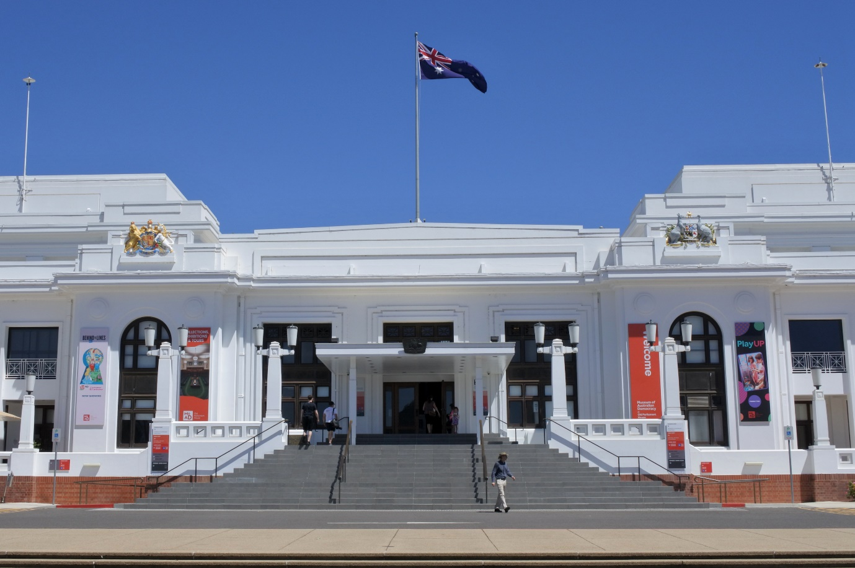

This project is supported by funding from the Commonwealth Department of Education. National Curriculum Services Pty Ltd organises & manages the event on behalf of the Australian Government. The views expressed at the 2026 National Schools Constitutional Convention do not necessarily represent the view of the Commonwealth Department of Education.

As of 5-Mar-26
31st National Schools Constitutional Convention
Program – SITTING WEEK
DAY 0 - Monday 23 March 2026
Afternoon | Arrival of NCS Staff
Evening | Arrival of QLD, WA and NT delegates
8:00pm – 9:30pm (1hr) | DINNER at Pavilion on Northbourne Hotel (3rd Floor Conference Room)
From 9:30pm | Accommodation at Pavilion Northbourne Hotel
DAY 1 - Tuesday 24 March 2026
From 6:30am | BREAKFAST at Pavilion on Northbourne Hotel (3rd Floor Conference Room)  QLD, WA and NT delegates
From 8:45am | Delegates arrive Pavilion on Northbourne Hotel in batches
9:30am | Bus departs for National Archives of Australia (NT, QLD, SA & WA)
9:45am – 11:15am (1.5hr) | Visit and Tour at National Archives of Australia
11:20am | Bus departs for Pavilion on Northbourne Hotel (NAA group)
From 10:30am | LUNCH - Collect & eat boxed lunched from Pavilion on Northbourne Hotel (3rd Floor Conference Room or take on coach)
11:35am | Bus departs for Parliament House
11:50am – 3:15pm (3hrs25mins) | Parliament House Visit & Tour  Attend Question Time
3:30pm –5:00pm (1 hr30mins)  Main Committee Room, Parliament House | Prime Minister’s Welcome Reception hosted by The Hon Jason Clare MP, Minister for Education  - Official opening of NSCC 2026 & Presentation of Certificates to student representatives  Meet Your Politician Session (include refreshments)
5:15pm – 5:30pm (15mins) | Photo time outside Parliament House
5:30pm – 6:00pm (30mins) | Bus departs for Pavilion on Northbourne Hotel via Consulate Route
6:00pm – 6:30pm (15mins) | Check-in, drop bags in rooms
6:30pm – 7:30pm (1hr) | DINNER served at Pavilion on Northbourne Hotel (3rd Floor Conference Room)
7:30pm – 8:00pm (30mins) | Ice Breaking Activities  Briefing of Students and Supervisors | Introduction to Working Groups
8:00pm | Accommodation at Pavilion on Northbourne Hotel  [Supervisors Briefing Session]

DAY 2 – Wednesday 25 March 2026
6:30am – 7:30am (1 hr) | BREAKFAST at Pavilion on Northbourne Hotel (Conference Room)
7:45am | Bus departs for Old Parliament House
8:00am – 8:30am (30 mins) | Photography session at Front Steps of Old Parliament House
8:30am – 8:45am (15 mins) | Moving time, bag drop
9:00am – 9:15am (15 mins)  House of Rep Chamber, MoAD | Facilitator Introduction – Geoffrey O’Neill  NSCC Welcome – Facilitator - Emeritus Professor Clement Macintyre, University of Adelaide  Welcome to Country – Richie Allan, Ngunnawal and Kamilaroi Custodian and Cultural Director of Traditional Owners Aboriginal Corporation (TOAC)
9:15am – 9:30am (15 mins)  House of Rep Chamber, MoAD | Heritage Message by Georgie Bryant, Museum of Australian Democracy
9:30am – 9:35am (5 mins)  House of Rep Chamber, MoAD | Address from Attorney-General of Australia (Video)  The Hon Michelle Rowland MP
9:35am – 9:40am (5 mins)  House of Rep Chamber, MoAD | Setting the Scene – Topic introduction, referendum question, rules of engagement – Emeritus Professor Clement Macintyre, University of Adelaide
9:40am – 10:25am (45 mins)  House of Rep Chamber, MoAD | Keynote 1 - Federation, Democracy and Tradition: The Fraught Compromise of Section 53 of the Constitution  Professor Gabrielle Appleby, University of New South Wales
10:25am – 10:35am (10 mins)  House of Rep Chamber, MoAD | Move to Member’s Dining Room
10:35am – 11:20am (45 mins) | MORNING TEA
11:20am – 12:05pm (45 mins)  Members Dining Room MoAD | Keynote 2 - Blocking Supply: The Whitlam Dismissal Revisited  Professor Emerita Anne Twomey, University of Sydney
12:05pm – 12:10pm (5 mins) | Move to break out rooms
12:10pm – 12:50pm (40 mins)  Breakout rooms, MoAD | Working Groups Session 1  [Supervisors Session with National Capital Educational Tourism Project (NCETP)]
12:50pm – 12:55pm (5 mins) | Move back to Member’s Dining Room
12:55pm – 1:30pm (35 mins)  Members Dining Room, MoAD | Working Groups Session 1 - Report Back  Led by Facilitator - Emeritus Professor Clement Macintyre, University of Adelaide
1:30pm – 2:30pm (60 mins) | LUNCH
2:30pm – 3:15pm (45 mins)  Members Dining Room, MoAD | Keynote 3 - Political Perspectives on the Use of Section 53  Former Senator Nick Minchin AO, Former Minister for Finance and Administration & Former Director of the Liberal Party of Australia (SA)  Former Senator John Faulkner, Former Minister for Defence & Former President of the Australian Labor Party
3:15pm – 3:20pm (5 mins)  Members Dining Room, MoAD | Short Break
3:20pm – 4:05pm (45 mins)  Members Dining Room, MoAD | Soapbox Session 1  Led by Facilitator - Emeritus Professor Clement Macintyre, University of Adelaide
4:05pm – 4:20pm (15 mins)  Members Dining Room, MoAD | Recap & Wrap-Up Day 1
4:20pm – 4:30pm (10 mins)  Members Dining Room, MoAD | Pack up & short break
4:30pm | Bus departs for Government House
5:00pm – 6:15pm (1 hr 15 mins) | Official Reception at Government House  Hosted by Her Excellency the Honourable Ms Sam Mostyn AC, Governor-General of Australia
6:15pm | Bus departs for National Press Club
6:30pm – 9:30pm (3 hrs) | OFFICIAL DINNER – National Press Club of Australia  Guest Speakers:  Amber Brock-Fabel, Founding Director of the South Australian Youth Forum  Tom McIlroy, Political Editor at Guardian Australia
9:30pm | Bus departs for Pavilion on Northbourne Hotel
9:45pm | Accommodation at Pavilion on Northbourne Hotel

DAY 3 – Thursday 26 March 2026
6:30am – 7:30am (1 hr) | BREAKFAST at Pavilion on Northbourne Hotel (Conference Room)
8:00am | Bus departs for The Museum of Australian Democracy at Old Parliament House
8:30am - 8:40am (10 mins)  Members Dining Room, MoAD | Welcome back and recap - Facilitator - Emeritus Professor Clement Macintyre, University of Adelaide
8:40am – 9:20am (40 mins)  Members Dining Room, MoAD | Keynote 4 - Arguments For and Against a Change: Drawing the Threads Together  Professor Alan Fenna, Curtin University, Western Australia
9:20am – 9:25am (5 mins) | Move to break out rooms
9:25am – 10:05am (40 mins)  Breakout rooms, MoAD | Working Groups Session 2  [Supervisors Session with Parliamentary Education Office (PEO)]
10:05am – 10:10am (5 mins) | Move back to Member’s Dining Room
10:10am – 10:40am (30 mins) | MORNING TEA
10:40am – 11:15am (35 mins)  Members Dining Room, MoAD | Working Groups Session 2 - Report Back  Led by Facilitator - Emeritus Professor Clement Macintyre, University of Adelaide
11:15am – 11:50am (35 mins)  Members Dining Room, MoAD | Soapbox session 2  Led by Facilitator - Emeritus Professor Clement Macintyre, University of Adelaide
11:50am – 12:10pm (20 mins)  Members Dining Room, MoAD | Introduction of the referendum and the referenda process  Lisa Wyllie, Australian Electoral Commission (AEC)
12:10pm – 12:20pm (10 mins)  Members Dining Room, MoAD | Vote - Australian Electoral Commission
12:20pm – 1:10pm (50 mins) | LUNCH
1:10pm – 1:25pm (15 mins)  Members Dining Room, MoAD | Results of Referendum  Led by Facilitator - Emeritus Professor Clement Macintyre, University of Adelaide
1:25pm – 1:40pm (15 mins)  Members Dining Room, MoAD | Confirming of draft Communique with students incorporating referendum results  Led by Facilitator - Emeritus Professor Clement Macintyre, University of Adelaide
1:40pm – 1:45pm (5 mins)  Members Dining Room, MoAD | Short Break
1:45pm – 2:30pm (45 mins) | Tour of the Museum of Australian Democracy at Old Parliament House
2:30pm – 2:50pm (20 mins)  Members Dining Room, MoAD | Student Reflections & NSCC Evaluations  Students Pack Up
2:50pm – 3:00pm (10 mins) | Move to House of Representatives Chamber
3:00pm – 3:15pm (15 mins)  House of Rep Chamber, MoAD | Parliamentary arrangements for the House of Representatives -  Emeritus Professor Clement Macintyre, University of Adelaide
3:15pm – 3:45pm (30 mins)  House of Rep Chamber, MoAD | Acceptance of communiqué, Address delegates  Representative of President of the Senate
3:45pm – 3:50pm (5 mins)  House of Rep Chamber, MoAD | Convention Close, Thank you and Farewell  Emeritus Professor Clement Macintyre, University of Adelaide
3:50pm – 4:00pm (10 mins)  Members Dining Room, MoAD | Move back to Member’s Dining Room  Pick up afternoon tea, Take bags, board buses
4:00pm | Convention Close & Departure

