Primary School convention: Should the State or Federal Government have control over school education?
Resources/articles/links relating to

What is State and Federal Government and their roles.

Should the State or Federal Government have control over school education?

These resources relate to the topics of this convention and may be used as pre-reading materials for students prior to attending the Conventions.

These resources can be borrowed from LMERC

See: Languages & Multicultural Education

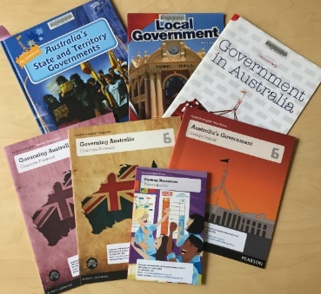
What is State and Federal Government and their roles

Books
  - These books are all available for loan from LMERC. Many of these titles are also available in ebook format in public library and some school library collections.
Pearson English 6 – Governing Australia series (2014)
Titles in the set:
Governing Australia: Teacher companion – by Charlotte Forwood
Australia’s Government – by George Ivanoff
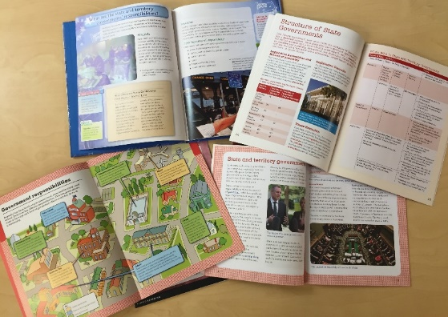
Governing Australia (magazine) – by Charlotte Forwood
Pooling resources – by Pamela Rushby (chapter book - fiction)
Grade 6 are fundraising for their trip to Canberra but also for a swimming pool for the school. When they find out their local member of parliament and a local councillor are coming to the school, they need to work out who might be able to help with the pool.
Government in Australia, Democracy series, Andrew Einspruch, Pearson Australia (2012) 32 pages
Chapters include What is democracy?, Australia’s government, Structure of governments – Federal, State and Local, Elections, Public service, Judiciary, Influencing the government. A timeline and glossary is also included.

Mac Australia Topics: Civics and Citizenship (Middle level), (Ages 8.5-10yrs)
Titles in the set
Teacher Resource Book (Upper Primary--Social Systems & Structure, Civics & Citizenship, and History)- by Tanya Gibb
Local government – by Katy Gerner (2011). Reader, 31 pages. Includes Chapters on What is local government, Local laws, How local government is run, Local services, Key questions and a glossary.

The kids’ guide to government – by Sharon Parsons, Nelson Cengage (2012) Big book with CD. Includes narrative, exposition and discussion text types. In three parts Get into government, How government works and Canberra – a city for government. Part 2 includes Services, taxes and laws,

Online
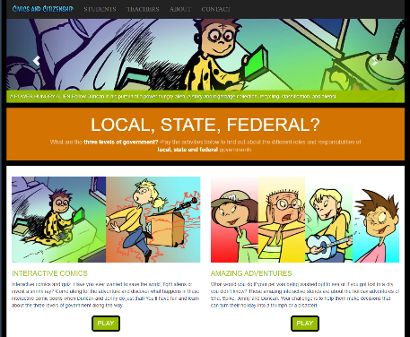
Parliament of Victoria – Local, State, FederaL? (Interactive comics)
What are the three levels of government? Play the activities below to find out about the different roles and responsibilities of local, state and federal governments.
See: Parliament of Victoria – Three levels

Parliament of Victoria (Interactive comics), Teacher guide
See: Parliament of Victoria – three levels – Teacher guide

The roles and responsibilities of the three levels of government – Parliamentary education office
This fact sheet introduces the three levels of government in Australia: the federal—Australian—Parliament, state and territory parliaments, and local councils. It includes the roles and responsibilities of each level.
The roles and responsibilities of the three levels of government - Parliamentary Education Office (peo.gov.au)

Levels of government – ABC Education (video clip – 3:38mins)
A humorous way to explore the different responsibilities at the three levels of government through superheroes and their powers.
See: ABC Education – Levels of government

Should the State or Federal Government have control over school education?

Online
Milestones in Australian democracy, Museum of Australian Democracy (MOAD)
The timeline includes mentions of two milestones related to funding and responsibility for schools.
- National Board of Education – 1848 ‘The first National Board of Education is established to regulate schools set up and managed under Lord Stanley’s system of education.’
- Federal funding for schools – 1964 ‘The Commonwealth States Grants (Science Laboratories and Technical Training) Act 1964 allows the Menzies government to directly fund state and private schools.’
See: Exploring Democracy · Milestones in Australian democracy · Museum of Australian Democracy at Old Parliament House (moadoph.gov.au)

Funding schools, Behind the News (BTN), ABC
Video 2:27mins. Broadcast: Tue 6 Jun 2017. Presented by Jack Evans
Transcript available.
See: Funding Schools - Classroom - BTN (abc.net.au)

If COVID-19 is a national emergency, can the federal government take control of schools? – by Matt Harvey, The Conversation (March 2020)
‘Legally and constitutionally the Commonwealth can’t force schools to open. The fact it has attempted to induce independent schools to reopen by bringing forward a payment highlights that the Commonwealth’s involvement in education, as in so many areas, is through the power of the purse.
The Commonwealth has an almost unlimited power of taxation under s51(ii), together with its power under s96 to make grants to states “on such terms and conditions as the Parliament thinks fit”.
This reached an extreme in the Howard era when the Commonwealth made a payment to state schools conditional on them having at least an hour of physical education per week, and a flagpole.’
See: https://theconversation.com/if-covid-19-is-a-national-emergency-can-the-federal-government-take-control-of-schools-137593

Federal government has no place in the classroom – by Jennifer Buckingham, ABC – The Drum website (July 2013)
‘Arguably, in a federation where education is the responsibility of states, policy at the national level should be minimalist when it comes to the operation of schools. The proper and sole role of the federal government, which does not operate any schools or employ any teachers (but nonetheless employs 1,000 people in its education department) is to create the conditions and incentives for schools to flourish, not to impede or engineer their activities.’
See: ABC – The Drum

Is education better off in state or federal hands? – by Kevin Gould The Conversation (June 2014)
Looks at the way schools are financed, potential ways to address equity. What sort of policies /responsibilities are best handled by federal or state governments?
See: Is education better off in state or federal hands? (theconversation.com)

Federal government should get out of school funding, says former top bureaucrat – by Jessica Irvine and Natassia Chrysanthos, Sydney Morning Herald (17 February 2020)
See: SMH – Federal Government should get out of school funding

Teacher resources

The Australian education system (2017) Department of Foreign Affairs and Trade
Chapter 3: Australian, State and Territory government responsibilities
Chapter 4: Early Childhood and compulsory school education
See: The Australian Education System - Foundation level (dfat.gov.au)

