May 2021

Secondary school convention:

Should the Australian Government fund a new National Anti-Racism Strategy as its main initiative for combating racial discrimination in Australia?

Resources relating to
- Federal Government policies relating to Anti-Racism strategies
- Anti-racism education
- Racism
These resources relate to the topics of this convention and may be used as pre-reading materials for students prior to attending the Conventions.
Resources can be borrowed from the Languages and Multicultural Education Resource Centre (LMERC) or are available online. The LMERC collection includes many picture books, novels and non-fiction resources relating to racism. LMERC is a state-wide resource centre for educators across all levels and sectors with a focus on English as an Additional Language (EAL), Languages, Cross Curriculum Priority Areas and Intercultural Capability.
  - See: Languages & Multicultural Education

Online
Schools standing up to racism – Centre for Multicultural Youth (2020)
Schools Standing Up to Racism is a free resource designed to support schools to address racism and discrimination in their school environment. The resource has been developed in collaboration between the Centre for Multicultural Youth (CMY) and the Victorian Department of Education and Training (DET). Schools Standing Up to Racism resource provides a range of strategies, ideas, and tools.
See: Schools Standing Up To Racism - Centre For Multicultural Youth (cmy.net.au)

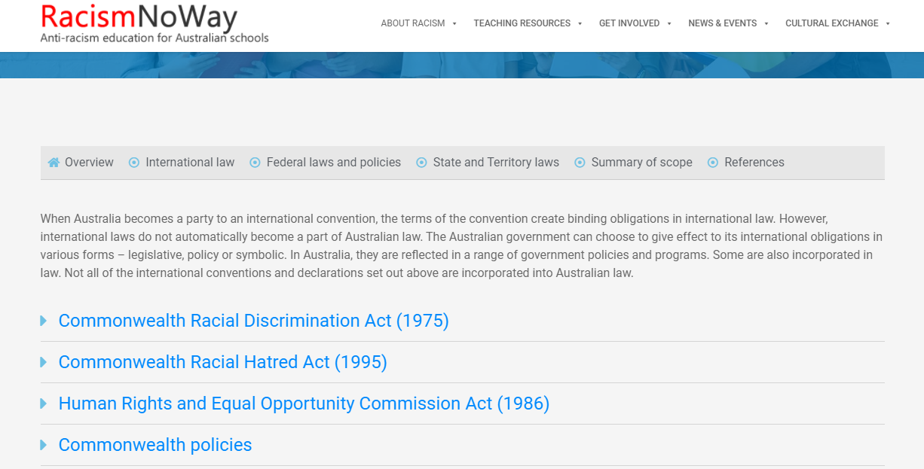
Racism no way: Commonwealth of Australia laws and policies – Australian Government, NSW Government
A list of laws and policies related to racism. ‘All Australian laws (Commonwealth and State) impose some responsibility on schools and individuals, be they teachers or students, to take steps to prevent and combat racism. The Australian laws are aimed at protecting individuals from racism at school and to protect those individuals who make complaints about racism.’ From the website.
See: Australian Racism and Human Rights Laws and Policies (racismnoway.com.au)

Racism: it stops with me – Australian Human Rights Commission
This website provides tools and resources to help people and organisations learn about racism and stand against it by acting for positive change.
See: Resources for teachers | Racism. It Stops With Me (humanrights.gov.au)
See: Racism. It Stops with Me

Tackling racism – by Dr Matteo Vergani
A collaborative initiative developed by researchers from Deakin University, University of Sydney, Michigan State University and City University of New York. It aims to build the capacities of community organisations, government agencies, law enforcement, researchers, and students to tackle hate and extremism.
See: Home - Tackling Hate

National Anti-Racism Strategy and Racism. It stops with me campaign – Australia Human Rights Commission, Australian Government
‘In 2011, the Australian Government committed to develop and implement the National Anti-Racism Strategy for Australia. The Strategy was launched in 2012. In 2015, it was extended for a further three years. It focuses on public awareness, education resources and youth engagement and is be underpinned by research, consultation and evaluation.
The aim of the National Anti-Racism Strategy is to promote a clear understanding in the Australian community of what racism is, and how it can be prevented and reduced.
See: National Anti-Racism Strategy and Racism. It Stops with Me Campaign | Australian Human Rights Commission

Videos
Is Australia Racist? - Measuring racism in Australia – SBS (2017)
‘Ray Martin investigates the question: Is Australia Racist? This one-hour documentary puts survey findings into action through a series of hidden camera social experiments, capturing the experience of racism through the eyes of those who have suffered it.’
See: Is Australia Racist? - | SBS On Demand

Racism: a history – The History channel (2010)
A series of documentaries taking a long view of racism all around the world including in Australasia.
See: Racism: A History - ClickView

The truth about racism – SBS (2017)
Host Yassmin Abdel-Magied and four volunteers from different ethnic backgrounds undergo scientific tests to detect racial bias in the brain. Interactive questions included.
See: The Truth about Racism - ClickView

Resources directly related to the theme of the convention
Developing a national anti-racism framework (2021)
‘Australia’s Race Discrimination Commissioner, Chin Tan has announced plans to develop a National Anti-Racism Framework and is calling on the Federal Government to support the framework, fully resource it and implement it. The Commission also aims to work in partnership with all sectors of Australian society because dismantling racism is a joint responsibility and will require a coordinated effort.’ From the Australian Human Rights Commission website.
Developing a National Anti-Racism Framework (2021) | Australian Human Rights Commission

A national anti-racism strategy is being launched in Australia amid a surge in attacks – by SBS News (March 2021)
‘Australia’s Race Discrimination Commissioner Chin Tan has established a plan for a new national anti-racism framework and is calling on the federal government to support and implement it.’
See: A national anti-racism strategy is being launched in Australia amid a surge in attacks

Attorney-General’s Department
‘The Attorney-General's Department has portfolio responsibility for driving the implementation of the government's human rights policy agenda. This includes supporting the Attorney-General as First Law Officer by providing policy advice on human rights matters to the government and administering Australia's federal anti-discrimination legislation. ‘ From the website
See: Human rights and anti-discrimination | Attorney-General's Department (ag.gov.au)
Recommendation 128
See: Recommendation 128 | Attorney-General's Department (ag.gov.au)

Resources at LMERC
I'm not racist but ... forty years of the Racial Discrimination Act – by Tim Soutphommasane (2015)
‘Tim Soutphommasane, Australia's Race Discrimination Commissioner, reflects on the national experience of racism and the progress that has been made since the introduction of the Racial Discrimination Act in 1975. As the first federal human rights and discrimination legislation, the Act was a landmark demonstration of Australia's commitment to eliminating racism.Published to coincide with the Act's fortieth anniversary, this book gives a timely and incisive account of the history of racism, the limits of free speech, the dimensions of bigotry and the role of legislation in our society's response to discrimination.’ Description from Australian Human Rights Commission website.

Race hate – Anne Rooney (2006)
Chapters addressing questions such as: ‘What is race?’, Why hate races? Is it ever just a laugh? What are race hate groups? Includes a timeline, glossary and links to related international websites. 48 pages.

Teacher resources
Navigation intercultural issues in the classroom – VCAA (2019)
‘This guide aims to provide teachers with background knowledge and practical ideas for navigating intercultural issues as part of the Victorian Curriculum: F–10 Intercultural Capability. It was developed in response to teacher requests for advice on teaching these issues sensitively and appropriately. While the Intercultural Capability curriculum, in itself, addresses many intercultural issues and attempts to foster cultural sensitivity through explicit teaching of its content, the guide aims to offer further support.’
See: Navigating intercultural issues in the classroom (vcaa.vic.edu.au)

Let's talk race: a guide on how to conduct a conversation about racism - Australian Human Rights Commission (2019)
1 e-book (28 pages)
See: Racism: it stops with me, conversation guide

Making Multicultural Australia
A website containing teaching resources on multiculturalism and strategies to promote cultural diversity
See: Making multicultural Australia | Teacher and student resources on multiculturalism, cultural diversity and tolerance

Help stop racism – Australian Government
This website aims to tackle racism in schools in Australia, through providing teachers, school students, parents and governors with games, research and lesson ideas that explore the causes and effects of racism for practical use in the classroom.
See: Racism. No Way: Anti-racism education for Australian schools

Contact us:
LMERC
Address: Level 1, 189 Faraday Street, (CO.AS.IT Building), Carlton 3053
Phone: (03) 9349 1418
Email: lmerc.library@edumail.vic.gov.au
Web: LMERC Homepage

© State of Victoria (Department of Education and Training) 2021. Except where otherwise noted, material in this document is provided under a Creative Commons Attribution 4.0 International Please check the full copyright notice

Published by: Statewide Services, School Operations and Statewide Services Division, Schools and Regional Services Group
Department of Education and Training
Carlton, 2021
© State of Victoria (Department of Education and Training) 2021
An educational institution situated in Australia, which is not conducted for profit, or a body responsible for administering such an institution, may copy and communicate the materials, other than third party materials, for the educational purposes of the institution.
The copyright in this document is owned by the State of Victoria (Department of Education and Training), or in the case of some materials, by third parties (third party materials). No part may be reproduced by any process except in accordance with the provisions of the Copyright Act 1968, the National Education Access Licence for Schools (NEALS) (see below) or with permission.

