

Victorian Schools Parliamentary Program (VSPP)
2026 ONLINE PRIMARY SCHOOL CONVENTION
Topic
Should the government ban businesses from being cashless?



STUDENT ACTIVITIES

Table of Contents
LEARNING INTENTION FOR THESE STUDENT ACTIVITIES: 3
SUCCESS CRITERIA FOR THESE STUDENT ACTIVITIES: 3
PRE-CONVENTION ACTIVITIES 4
Activity 1: Introductory Activities 4
Activity 1a: Getting Started: Exploring the Three Levels of Government Activity 4
Activity 1b: Introducing the Concept of a Cashless Society – Brainstorming Activity 6
Activity 1c: Cash or Card? What are the Current Rules? Scenario Sorting Activity 9
Activity 2: Cash or Cashless? Sorting The Reasons Activity 12
Activity 3: Should We Go Cashless? BTN Video Investigation Activity 14
Activity 4: Cash or Card? The Great Money Debate Activity 18
Activity 5: Exploring a Cashless World – Infographic Investigation 21
Activity 6: Cash vs Card – Which One Wins? - Be a Blog Detective Activity 24
POST CONVENTION ACTIVITIES 29
Activity 1: Looking Back, Looking Forward – Reflection Activity 29
Activity 2: Headline Challenge – Think- Pair-Share Activity 31
Activity 3: Escape Room: Save the Community Activity 33

LEARNING INTENTION FOR THESE STUDENT ACTIVITIES:
By the completion of these activities, students will be able to:
- Understand the arguments for and against requiring businesses to accept cash.
- Investigate how a cashless business can affect people, businesses, the community and the economy.
- Explore different viewpoints and consider how different groups in society may be affected by businesses not accepting cash.
- Develop research, teamwork and writing skills while preparing for the Convention.
- Work collaboratively to discuss ideas, share thinking and use evidence to support their opinions.
- Participate confidently in the Online Convention by presenting ideas, listening respectfully and responding to different viewpoints.

SUCCESS CRITERIA FOR THESE STUDENT ACTIVITIES:
Students will be able to:
- Explain why some people believe businesses should be required to accept cash while others prefer cashless payments.
- Describe how different groups in the community, including consumers, businesses, older Australians, people in regional areas, people experiencing financial disadvantage and the government, may be affected by cashless businesses.
- Gather and use facts and evidence from a range of resources to support their ideas.
- Work independently and collaboratively through a range of activities to develop and justify their opinion whether businesses should be allowed to operate without accepting cash.
- Listen respectfully to different viewpoints and respond thoughtfully during discussions.
- Work collaboratively to prepare for and participate confidently in the Online Convention.

PRE-CONVENTION ACTIVITIES

Activity 1: Introductory Activities

Activity 1a: Getting Started: Exploring the Three Levels of Government Activity
Learning Intention

We are learning to identify the responsibilities of the three levels of government in Australia and explain some of their responsibilities.

Success Criteria

I can name the three levels of government (federal, state and local) and match government responsibilities to the correct level of government. I can explain one responsibility of each level of government and provide examples of how they each affect our daily lives.

Task Instructions:
Students can complete one, some or all the following tasks independently or with a partner.
- Watch the PEO ‘Three Levels of Government’ video. As you watch, identify the three levels of government and listen for examples of responsibilities carried out by each level to complete the table.
- Complete the interactive sorting game by dragging each responsibility or service into the correct category: Federal, State or Local Government. (link to website provided below).
- Complete the Three Levels of Government online quiz. Use your knowledge to identify which level of government is responsible for different services and responsibilities. (link to website provided below).
- Individually complete the Exit Ticket Activity and share your answers with the class.

1. Watch and Learn Video Activity (5 minutes)
Link: Parliamentary Education Office – Three levels of government
Level of Government | Examples:

2. Government Sorting Game (5 minutes)
Link: Parliamentary Education Office – Federal, state and local

3. Check your Understanding Online Quiz
Link: Parliamentary Education Office – Three levels of government – click ‘start quiz’
Record your result here: _________________________________

4. Exit Ticket (5 minutes)
Answer the following questions to check your understanding.
- State what each level of government is responsible for:
The federal government: _______________________________________________________________________
The state government: _________________________________________________________________________
Local government: ____________________________________________________________________________

- Which level of government affects your daily life the most? Why?

Activity 1b: Introducing the Concept of a Cashless Society – Brainstorming Activity
Learning Intention

We are learning what a cashless society is and how people pay for goods and services in different ways.

Success Criteria

I can contribute ideas and keywords about the different ways people pay for goods and services. I can explain what a cashless society is using examples.

Task Instructions:
- Individually, think about the question: "What is a cashless society?"
- Consider how you, your family and your friends pay for goods and services. Think about whether they use cash, bank cards, mobile phones, smart watches, online payments or other payment methods.
- Write down as many words, phrases and ideas as you can in the space provided below.
- Share your ideas with the other members of your group (3–4 students).
- As a group, combine your ideas to create a Word Splash, Word Cloud, Word Art or Padlet that includes the key words and phrases you identified.
- Share your group's Word Splash, Word Cloud/Word Art or Padlet with the rest of the class and compare your ideas with those of other groups.
- As a class, discuss the following questions:
  - Which payment methods require physical cash?
  - Which payment methods are cashless?
  - Why do people choose different payment methods?
  - What could happen if all shops stopped accepting cash
- Using the ideas from the class discussion, work together to develop a shared definition of a cashless society.
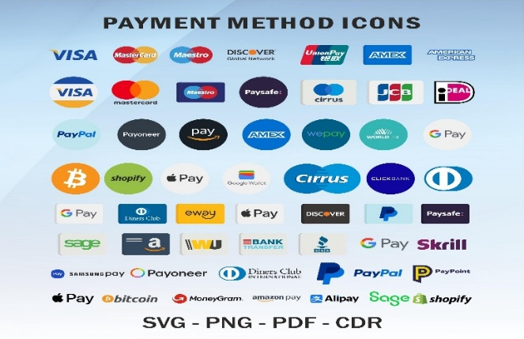
WHAT IS A:
WORD SPLASH: Brainstorming activity where students share words and ideas they associate or connect to the topic. The words are displayed for the whole class to see, helping build background knowledge, develop topic-specific vocabulary and prepare students for future discussions and learning activities.


WORD CLOUD: Visual image of words where the most frequently used words appear larger than the less common words.
Word Cloud Tool

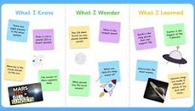
PADLET: Online collaborative or digital noticeboard where students can share ideas, pictures, links and comments in one place.
Padlet Tool

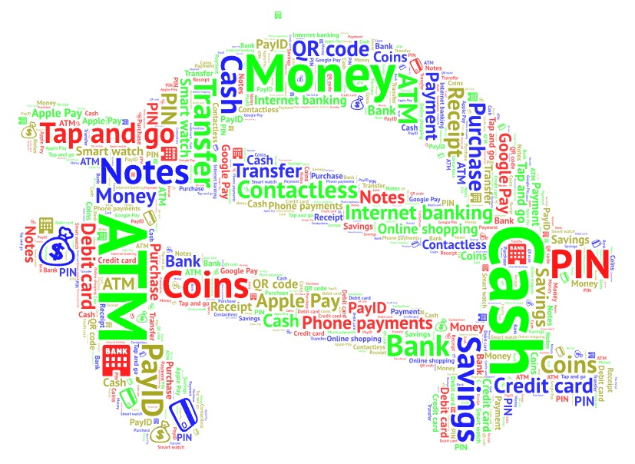
Instructions 3 and 4: Words students may already know:

Instruction 5: Sample made using the WordArt Tool

Use the ideas from your group’s Word Splash, Word Cloud or Padlet to participate in a class discussion. As a class, discuss the following questions:
- What payment methods require people to use physical cash or notes and coins?
- Which payment methods are cashless?
- Why do people choose different methods of payment?
- What would happen if all the shops stopped accepting cash?

As a class, write a definition of the term ‘cashless society’.

Activity 1c: Cash or Card? What are the Current Rules? Scenario Sorting Activity
Learning Intentions

We are learning about the current rules and practices relating to businesses accepting cash in Australia.

Success Criteria

I can identify when businesses are required to accept cash and explain one reason why some businesses choose to accept or refuse cash.

Task Instructions:
- Listen carefully as your teacher reads out some information about payment methods in Australia and the meaning of legal tender.
- Work with a partner to read each of the scenarios below. Decide whether each scenario belongs to one of the following three categories:
- Cash Accepted
- Cash not accepted
- Need more information
- Justify your decision by writing a brief reason next to each scenario.
- Think like a business owner. Choose two scenarios and, with your partner, answer the questions that follow:
- Why a business may choose to accept or refuse cash
- How this decision could affect different customers
- Is the decision fair? Why/Why not?
- Participate in a class discussion sharing your ideas about the questions being considered.

  - Information about payment methods in Australia (to be read out by the teacher)
In Australia, there are many ways to pay for goods and services, including cash, debit cards (using money in your bank account to pay for items), credit cards (money you borrow from a bank and repay with interest) and mobile payments using smartphones, smartwatches and other mobile devices. Most businesses can choose which payment methods they accept. However, they must tell customers before they make their purchases if they do not accept cash.

Australian notes and coins are legal tender, which means they are official forms of money. In some situations, cash can be used to pay a debt even if a business would prefer another payment method.

  - Scenario Challenge
Working in pairs, read each scenario and decide whether:
- Cash is accepted.
- Cash is not accepted.
- Need more information.

Justify your choice using evidence and reasons.
Scenario | Your decision | Justification/Why?
A café has a sign at the entrance saying, ‘Card Only’.

A customer finishes a meal at a restaurant and is told at the register that cash is not accepted.

An online clothing store only accepts online payments.

A school canteen accepts both cash and card.

A sporting event advertises that all food stalls are cashless.

A market stall has no EFTPOS because the internet is down.

  - Explain Your Thinking as a Business Owner.

Working with a partner, choose two of the six business scenarios from Question 2. For each business, discuss and answer the following questions:

Business 1: ______________________________________
- Why might this business prefer customers to pay with cash or card?
- How could this decision affect its customers?
- Do you think this payment method is fair? Why?
Business 2: ______________________________________
- Why might this business prefer customers to pay with cash or card?
- How could this decision affect its customers?
- Do you think this payment method is fair? Why?
  - Class Discussion Questions (Optional)
- Should businesses be allowed to refuse cash?
- Who might be disadvantaged if businesses become cashless?
- What are the advantages and disadvantages of cashless payments for business and customers?

Activity 2: Cash or Cashless? Sorting The Reasons Activity
Learning Intention

We are learning to identify and explain different viewpoints about cashless businesses.

Success Criteria

I can identify reasons that support cashless businesses and reasons that support allowing people to pay with cash for goods and services.

Task Instructions:
- Work with a partner.
- Read each statement carefully.
- Decide whether each statement is:
- a reason that supports cashless businesses.
- a reason that supports keeping cash as a payment option.
- Write each statement in the correct section of the mind map.
- Highlight three reasons you think are the strongest and be prepared to explain your choices.
- Share your answers and reasons with the class during the discussion.

Statements:
- Card payments are quicker.
- Businesses are less likely to be robbed.
- Some people do not own a bank card.
- Older people may prefer using cash to buy their goods and services.
- Less cash means less counterfeit (forged or fake) money.
- Technology can stop working.
- Faster service.
- Paying with a phone is very convenient.
- Tourists can tap and pay instead of carrying cash.
- It costs businesses money to process card payments.
- Children often use cash to buy what they want or need.
- Everyone can still pay.
- Easier record keeping for businesses.
- Gives people more payment choice.

CASHLESS BUSINESSES
Reasons that Support Reasons that Support
Cashless Businesses Keeping Cash Available
(Reasons Against a Ban) (Reasons to Ban Cashless Businesses)
• ________________________ • _________________________
• ________________________ • _________________________
• ________________________ • _________________________
• ________________________ • _________________________
• ________________________ • _________________________
• ________________________ • _________________________
• ________________________ • _________________________

Activity 3: Should We Go Cashless? BTN Video Investigation Activity
Learning Intention

We are learning to understand the benefits and problems of a cashless society.

Success Criteria

I can describe what a cashless society is, identify reasons for and against cashless payments and explain my opinion using evidence from the BTN video.

Task Instructions:
- Watch the BTN – High: Cashless Society video.
- Answer the comprehension questions as you watch.
- Complete the True or False activity.
- Complete the Cause-and-Effect table.
- Identify the advantages of cashless payments and the advantages of keeping cash.
- Complete the Who Said It? activity.
- Participate in the Opinion Line activity and justify your opinion using evidence from the video.

Behind the News (BTN) – Cashless Society
Answer the following questions as you watch the video:
  - Describe what a cashless society is.
_____________________________________________________________________________________________________________________________________________________________________________________________________________________________________________________________________________________________________________________
  - Explain why fewer Australians are using cash.
_____________________________________________________________________________________________________________________________________________________________________________________________________________________________________________________________________________________________________________________
  - Identify two ways people can make digital payments.
_____________________________________________________________________________________________________________________________________________________________________________________________________________________________________________________________________________________________________________________
  - Some businesses prefer cashless payments. Why?
_____________________________________________________________________________________________________________________________________________________________________________________________________________________________________________________________________________________________________________________

  - Explain what happened during the Optus power failure.
_____________________________________________________________________________________________________________________________________________________________________________________________________________________________________________________________________________________________________________________
  - List the groups of people who may still rely on cash.
_____________________________________________________________________________________________________________________________________________________________________________________________________________________________________________________________________________________________________________________
  - Why do some people believe cash should always be available?
_____________________________________________________________________________________________________________________________________________________________________________________________________________________________________________________________________________________________________________________
  - Identify one advantage of paying with cash.
_____________________________________________________________________________________________________________________________________________________________________________________________________________________________________________________________________________________________________________________
  - State one thing you learned from the video that you did not know before.
_____________________________________________________________________________________________________________________________________________________________________________________________________________________________________________________________________________________________________________________

Decide if the following statements are True or False
- Most Australians still pay with cash every day. T/F
- Businesses save time using digital payments. T/F
- Technology never fails. T/F
- Some people still rely on cash. T/F
- Power or internet outages or failures can affect digital payments. T/F
- Everyone agrees Australia should become cashless. T/F

Cause and Effect Table
Complete the table by thinking about what happens for each of the following scenarios:
Cause | Effect/Outcome
Many people use bank cards and phones.

Businesses stop accepting cash.

The Optus or Telstra network goes down.

Some people cannot use digital payments.

Cash is no longer accepted.

Advantages of both payment methods.
Three advantages of cashless payments are:
1._____________________________________________________________________________________________________
2. _____________________________________________________________________________________________________
3._____________________________________________________________________________________________________

Three advantages of keeping cash are:
1. ____________________________________________________________________________________________________
2. ____________________________________________________________________________________________________
3. _____________________________________________________________________________________________________

Who said it?
Decide whether each statement would most likely be said by:
- A business owner.
- A customer.
- Someone who supports cash.
- Someone who supports cashless payments.
Statements:
1. It’s much faster ___________________________________________________________________
2. I need cash when technology fails__________________________________________________
3. Handling cash takes too much time ________________________________________________
4. Everyone should have a choice ____________________________________________________
7. Opinion Line
After watching the video, stand on an opinion line in the position that best represents/shows your view on the statement:
‘Australia should become a completely cashless society’.
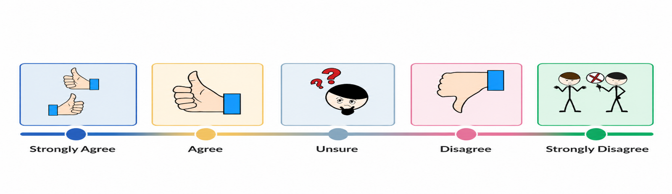

Activity 4: Cash or Card? The Great Money Debate Activity
Learning Intention

We are learning to compare the advantages and disadvantages of cash and cashless payment methods so we can explain our opinion about whether Australia should become a cashless society.

Success Criteria

I can describe the advantages and disadvantages of cash and card payments, listen to different opinions and explain my own opinion using reasons and evidence.

Task Instructions:
Step 1: Become an Expert
- Read the article your teacher has given you.
- Complete the Source Detective activity for your article, writing down the key ideas and important information relevant to this Convention topic.
- Form a group of three students. Each group member should have read a different article and completed the Source Detective activity before sharing their answers with the group.
Step 2: Teach your Team
- Take turns teaching the other members of your group about your article. Each expert has two minutes to explain the key information and the main ideas to the rest of the group.
- While each person is presenting, the other students record key advantages and disadvantages of cash and cashless payments in the table provided.
Step 3: Design Australia’s Payment System
- Imagine your team has been hired by the Australian Government to design Australia’s payment system for 2035.
- Using what you learned from the three articles, create an A3 poster explaining your payment system. Your poster can be completed by hand with each member contributing information or digitally using a computer program like Canva, Microsoft Word or Adobe Firefly.
- Use the guiding questions to help you make your decisions. You do not have to answer every question.
- Present your poster to the class and explain why your payment system is the best choice for Australia’s future.
Articles
Article 1: ABC News – Teaching your kids about personal finance in the age of digital money
Article 2: Kids News – Thousands of school canteens adopt cashless technology
Article 3: ABC News – Australia’s transition to a cashless society raises concerns about financial exclusion, privacy and safety
Article 4: News.com.au – Why a truly cashless society will doom Australia
Article 5: Stripe – What is a cashless society and what does it mean for businesses?
Article 6: BBC Story Works – Why cash is no longer king
Article 7: ABC News – Cashless kids: Is tap-and-go technology promoting financial illiteracy?
Article 8: Kids News – Invisible cash is making it harder for children to learn about money
Article 9: SBS News – Teaching kids money in a cashless society
Step 1: Source detective
Read your article and record the following information.
List three important facts:
1.____________________________________________________________________________________________________________________________________________________________________________________________________________
2.____________________________________________________________________________________________________________________________________________________________________________________________________________
3.____________________________________________________________________________________________________________________________________________________________________________________________________________
Explain who benefits most from this payment method?
______________________________________________________________________________________________________________________________________________________________________________________________________________
_______________________________________________________________________________________________________
Identify one concern or disadvantage?
______________________________________________________________________________________________________________________________________________________________________________________________________________
_______________________________________________________________________________________________________

Step 2: Teach Your Team
As each expert presents, record the key ideas in the table below:
Article | Benefits | Negatives
Article 1

Article 2

Article 3

Step 3: Design Australia’s Payment System for 2035

Create an A3 poster explaining your team’s payment system.

Your poster should include:
- A title for your payment system.
- A labelled diagram or drawing.
- A short explanation of how it works.
- Reasons why it is the best system for Australia.
- Evidence or proof from the articles to support your decisions.

Guiding questions:
- Should Australians still be able to use cash? Why/Why Not?
- How will children learn about money?
- What happens if the internet or electricity stops working?
- How will older Australians or people without smartphones pay?
- How will your system protect people from scams and fraud?
- How will your payment system be fair and accessible for everyone?
- List the main advantages of your payment system.

Activity 5: Exploring a Cashless World – Infographic Investigation
Learning Intention

We are learning to identify and organise the key information from the infographic about cashless societies.

Success Criteria
I can identify the main ideas in the infographic, organise them into categories, and explain the benefits and challenges of a cashless society.

Task Instructions:
- Get into groups of 3 to 4 students.
- Carefully read the ‘Cashless Society’ infographic (page 22).
- Use the information to complete the mind map that follows (page 23).
- Work together as a team to discuss your ideas and make sure everyone contributes.
- Share your completed mind map with the class and explain the most important thing your group learned about cashless societies from this activity.

Sources referred to in the Infographic on page 22:
- Reserve Bank of Australia.
- Bank of International Settlements (BIS).
- World Bank (Global Findex Database).
- European Central Bank.

On page 23, create a Mind Map.

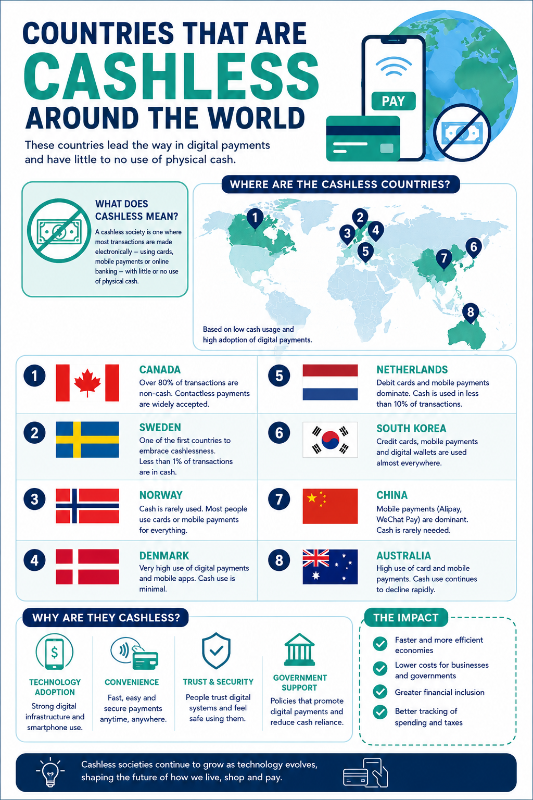

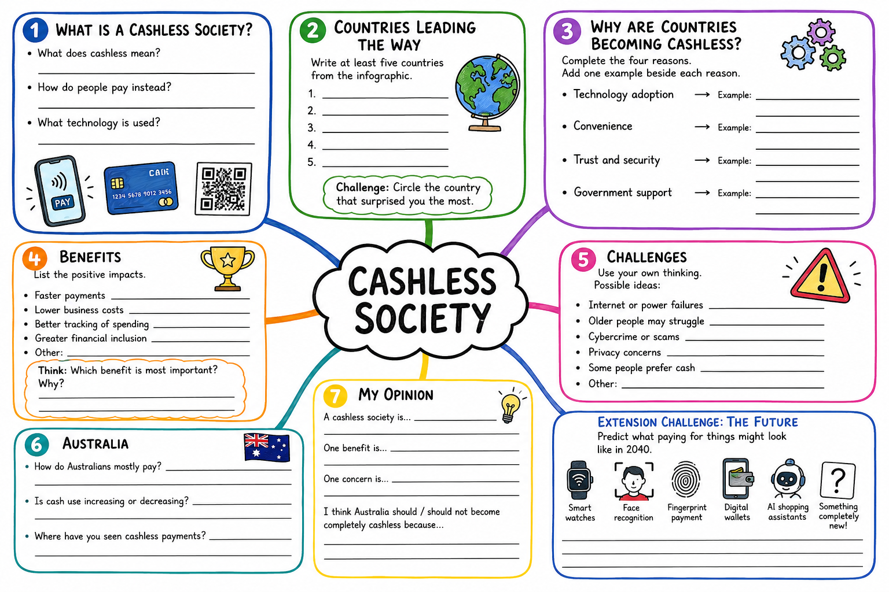

Activity 6: Cash vs Card – Which One Wins? - Be a Blog Detective Activity
Learning Intention

We are learning to identify the advantages and disadvantages of cash and cashless payments by finding evidence in a text.

Success Criteria

I can identify the advantages and disadvantages of cash and cashless payments, find evidence in a text to support my ideas and explain my opinion using reasons and evidence.

Task Instructions:
- Read the Kid Talk Blog: Would You Give Up Cash Forever?
- As you read, become a Blog Detective and look for clues about the advantages and disadvantages of becoming a cashless society.
- Highlight the evidence using three different colours:
🟢 Green = advantages or benefits of becoming a cashless society.
🔴 Red = disadvantages, challenges or concerns about becoming cashless.
🔴 Yellow = interesting points that surprised you or made you think.
- OPTIONAL STEP: Use the evidence you highlighted to complete the PMI (Plus, Minus, Interesting) Chart.
- Answer the two reflection questions and compare your ideas with another student.
- Share your findings with the class and explain which arguments you think are the strongest.

What is a blog?
A blog is an online article where a person shares their thoughts, opinions, ideas or experiences about a particular topic. Blogs are written in a friendly, conversational style as if the writer is talking to you.
In this activity:
The Kids Talk Blog has been set up by Priya, an 11-year-old who enjoys sharing her thoughts about different issues that affect her or her family. In this blog, Priya shares her thoughts about whether Australia should become a cashless society. She shares personal experiences, facts and different points of view to get readers thinking.

Kid Talk Blog Would you give up cash forever? Blogger: Priya, Aged 11

Hi Friends,

Last weekend I went to the football with my family. My dad bought the tickets online. Mum paid for our snacks by tapping her phone and my brother bought a drink using his smartwatch. Then I realised something strange. Nobody in my family had used cash all day!

It made me wonder if we still need cash anymore.

Lots of people love paying with cards or phones because it is so quick and easy. You don’t have to count coins or wait for change. If you forget your wallet, you might still be able to pay using your phone or smartwatch. Lots of people also like checking their banking app to see exactly how much money they have spent. It can make budgeting and keeping track of spending much easier.

Some people also think a cashless society can help reduce crime. It is harder for thieves to steal money that is stored safely in a bank account than cash sitting in someone’s pocket. Digital payments can also make it harder for businesses to hide income or avoided paying tax because every payment leaves a record.
Dad says another good thing about paying by card is that you don't need to carry lots of cash around. If someone steals your wallet, your bank may be able to cancel your card before any money is taken. But if you lose cash, it is gone forever.

But then not everyone agrees.

My grandma still likes using cash. She says it helps her stick to a budget because she can actually see how much money she has left. She finds using ATM s and banking apps confusing, so cash is easier for her to manage. My little cousin is learning about money at school too, and his teacher says using real notes and coins helps children understand how much things cost and how to count money.

Some people also worry that not everyone has a bank account, smartphone or reliable internet connection. Older people like our neighbour next door, people with disabilities and families living in remote areas might find it harder to pay if cash disappeared completely.

Then something interesting happened a few weeks ago. A big storm knocked out the power in our area. Some shops could not accept card payments because their EFTPOS machines were not working. Luckily, a few people still had cash and were able to buy the food and supplies they needed. It made me think that cash can be really useful in emergencies when technology fails.

I have also heard the adults talking about scams, hackers and people having their bank accounts hacked. That sounded pretty be scary to me. While banks have security systems to protect customers, online fraud can still happen. But friends, cash is not perfect either as it can be stolen or lost.

Another thing I just thought about is privacy. Every time your pay with your phone or card there is a digital record of what your bought. Some people don’t mind this but other prefer using cash because it keeps what they buy more private.

I have noticed more places becoming card only. When my family went to see Toy Story 5, the cinema only accepted card payments for tickets and snacks. It made me wonder if cash was slowly disappearing.
Some people think Australia should become completely cashless because it is faster, safer and more convenient. Others believe we should always keep cash because technology can fail and everyone should really have a choice of how they pay.

So, what do you think?
Should Australia become cashless or should we keep both cash and digital payments, so everyone has the chance to choose?
I would love to hear your opinion in the comments section.


Activity - Be a Blog Detective

As you read the blog, look for clues about the advantages and disadvantages of becoming a cashless society.
Complete the PMI (Plus, Minus, Interesting) Chart using evidence from the blog.
- ➕ Plus: Write/Record the advantages or benefits of becoming a cashless society.
- ➖ Minus: Write/Record the disadvantages or challenges or concerns about becoming a cashless society.
- 🤔 Interesting: Write/Record facts, ideas or questions from the blog that made you think. These do not have to be good or bad things about the topic, just interesting, surprising or important points to consider.
Remember: Use evidence and examples from the blog.

Teacher Note: Students may choose to highlight the text using three different colours (green, red, yellow) to identify the Pluses, Minuses and Interesting points, complete the PMI chart provided below or do both tasks.

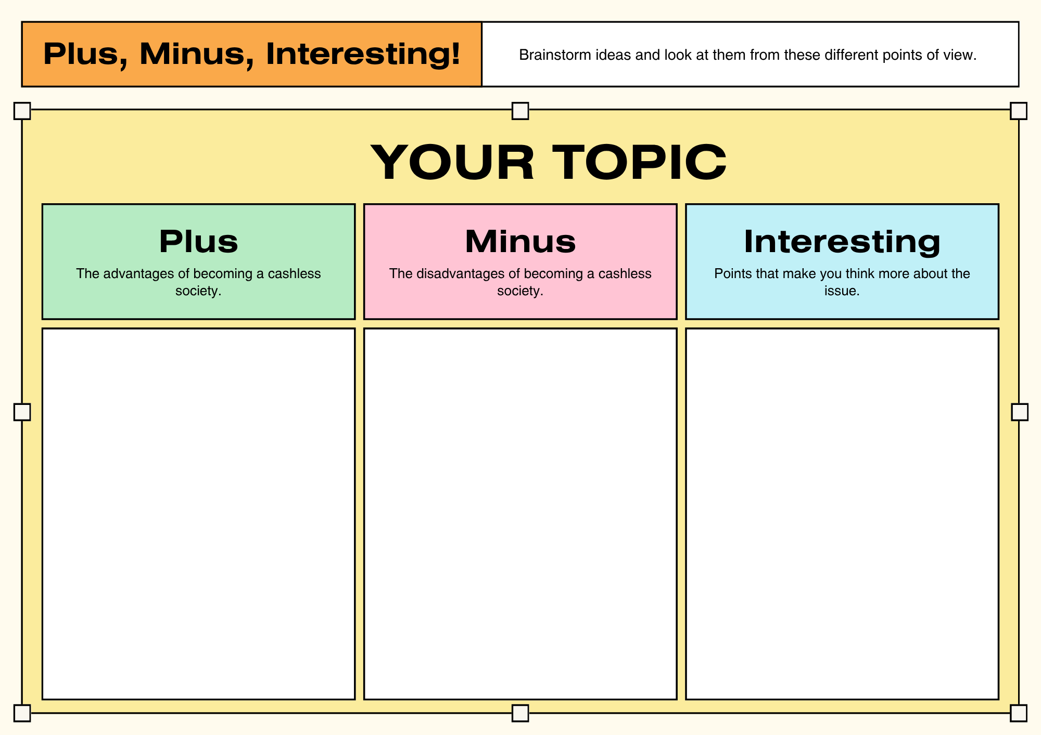

Reflection:
What opinion do you think Priya has about this issue?
Do you agree with Priya? Why /Why not? Use evidence from the blog to support your answer.

POST CONVENTION ACTIVITIES

Activity 1: Looking Back, Looking Forward – Reflection Activity
Learning Intention

We are learning to reflect or think about the Convention topic of ‘Should the government ban businesses from being cashless?’ and express our opinion using what we have learnt about the advantages and disadvantages of requiring businesses to accept cash.

Success Criteria

I can explain how my thinking has changed after the Online Convention and identify the strongest arguments. I can also reflect on my participation and share my opinion using reasons and evidence.

Task Instructions:
Complete the following steps to reflect on your learning:
- Reflect on what you learned during the Online Convention.
- Consider whether your opinion changed after listening to different points of view and evidence.
- Think about how participating in the Online Convention helped you develop your communication, critical thinking and decision-making skills.
- Answer the questions listed below in complete sentences.
- Share your answers with the rest of the class.

Answer the following questions in complete sentences.
  - What was your opinion on the topic before the Online Convention?
  - What was your opinion on the topic after the Online Convention?
  - Choose the argument you found most convincing and explain your choice.
  - Describe one new fact or idea you learned during the Online Convention.
  - List one thing you did well during the Online Convention and one skill you would like to improve on.
  - Suggest what the government should do about businesses operating without accepting cash and give two reasons to support your answer.

Activity 2: Headline Challenge – Think- Pair-Share Activity
Learning Intention

We will be able to summarise the main ideas from the Online Convention and communicate our understanding by creating a newspaper headline, summary and recommendation.

Success Criteria

I will be able to create a catchy headline; summarise the main ideas from the Convention and explain what I think the government should do.

Task Instructions:
- Imagine you are a newspaper reporter covering the Victorian Students’ Parliamentary Program Convention.
- Create a front page that reports/tells readers about the debate on the topic: ‘Should the government ban businesses from being cashless?’ Your front page can be completed in the Student Resource Booklet or created digitally using a program such as Canva, ReadWriteThink Printing Press, Microsoft Word (newspaper template) or another suitable program.
- Make sure your front page covers all the features listed below.
- Share your completed front page with a partner and explain how your headline, image and recommendation help readers understand the issue.

Features to include on your front page include:
- A newspaper headline that captures the main issue in 6-10 words.
- One-to two sentence summary explaining what the debate was about.
- The strongest argument for banning businesses from being cashless.
- The strongest argument against banning businesses from being cashless.
- Recommend/Suggest what you think the government should do and explain your reasons in one or two sentences.
- Draw a front-page image or political cartoon that represents the debate.
- Write a caption (short sentence about your image) for your image.
Use the template/guide on page 32, provided to help you with this activity.

Front Page Template/Guide
Headline:
___________________________________________________________________________________________________
News Summary:
______________________________________________________________________________________________________________________________________________________________________________________________________________
Strongest Argument For:
______________________________________________________________________________________________________________________________________________________________________________________________________________
Strongest Argument Against:
______________________________________________________________________________________________________________________________________________________________________________________________________________
My Recommendation/Suggestion:
______________________________________________________________________________________________________________________________________________________________________________________________________________
_______________________________________________________________________________________________________
Front Page Image or Political Cartoon
Draw your image here:

Caption:
_______________________________________________________________________________________________________

Activity 3: Escape Room: Save the Community Activity
Learning Intention

We will be able to apply what we have learned during the Online Convention by working together to solve problems and make decisions about cashless businesses.

Success Criteria

I will be able to solve each challenge, explain my thinking, work together with my team and suggest a solution using evidence from the Online Convention.

Task Instructions:
A major systems failure has stopped electronic payment systems from working across Victoria. Your team has been asked to help the government decide what to do next.
Steps:
- Work together in teams of 3-4 students to complete each challenge.
- Read each clue carefully and solve the puzzles.
- Use what you learned during the Online Convention to answer the questions.
- Write down your team’s answers before moving to the next challenge.
- Complete all the challenges to gather evidence for your final recommendation.
- Present your team’s final recommendation and explain why it is the best solution for the community.

Challenge 1: Payment Detective
Sort the payment methods into the two category groups below. Payment Methods:
- Cash
- Debit card
- Credit card
- Mobile phone payment
- Smart watch payment
- Gift card
- Bank online transfer
- Coins
Categories/Groups:
Works without electricity or the internet:
_______________________________________________________________________________________________________
Needs electricity or the internet:
_______________________________________________________________________________________________________
Mission notes – Complete this sentence:
We discovered that cash can be useful because:
______________________________________________________________________________________________________________________________________________________________________________________________________________
Challenge 2: Who needs cash?
Mission – Read each scenario. Answer the questions for each person:
1. What problem do they face?
2. How could accepting cash help them?
Scenario 1: Mrs Patel
Mrs Patel is an 82-year-old pensioner. She prefers using cash because she finds bank cards and mobile phones confusing. She goes to her local bakery, but it no longer accepts cash.
- What problem does Mrs Patel face?
______________________________________________________________________________________________________________________________________________________________________________________________________________
- How could accepting cash help Mrs Patel?
______________________________________________________________________________________________________________________________________________________________________________________________________________

Scenario 2: Abdul
Abdul is 11 years old. His parents give him $10 cash to buy his lunch at the sports canteen after football practice. The canteen only accepts electronic payments.
- What problem does Abdul face?
______________________________________________________________________________________________________________________________________________________________________________________________________________
- How could accepting cash help Abdul?
______________________________________________________________________________________________________________________________________________________________________________________________________________

Scenario 3: The Portelli Family
A severe storm causes a power failure across the country town. Internet and phone services stop working, and electronic payment systems cannot be used. The Portelli family has cash but no way to use their bank cards.
- What problem does the Portelli family face?
______________________________________________________________________________________________________________________________________________________________________________________________________________
- How could accepting cash help the Portelli family during this emergency?
______________________________________________________________________________________________________________________________________________________________________________________________________________

Scenario 4: Mei
Mei is visiting Victoria from overseas. She has exchanged her money for Australian dollars in cash but has not yet set up an Australian Bank account. She wants to buy a MYKI card, but the train station only accepts electronic payments.
- What problem does Mei face?
______________________________________________________________________________________________________________________________________________________________________________________________________________
- How could accepting cash help Mei?
______________________________________________________________________________________________________________________________________________________________________________________________________________

Scenario 5: Enrico
Enrico works casually and is paid in cash each week. On his way home, he wants to buy groceries, but every supermarket nearby has become cashless.
- What problem does Enrico face?
______________________________________________________________________________________________________________________________________________________________________________________________________________
- How could accepting cash help Enrico?
______________________________________________________________________________________________________________________________________________________________________________________________________________

Mission notes:
Which groups of people benefit the most from businesses accepting cash? Why?
______________________________________________________________________________________________________________________________________________________________________________________________________________
______________________________________________________________________________________________________________________________________________________________________________________________________________

Challenge 3: Fact Check
Mission – Can you separate the facts from the opinions?
For each statement, decide whether it is Fact or Myth (False) (use ✔️)
Statement | Fact | Myth/False
Cash is legal tender in Australia.

Every business in Australia must accept cash.

Some businesses choose not to accept cash.

Older Australians are the only people who use cash.

Electronic payments rely on electricity or the internet.

A cashless society affects different groups in different ways.

Cashless payments are always faster than cash.

Governments sometimes make laws to protect consumers.

Mission notes:
Write down two facts that your team thinks are the most important when deciding whether businesses should continue accepting cash.

1._____________________________________________________________________________________________________2. _____________________________________________________________________________________________________

Challenge 4: Social Media Detective
Mission – Three messages have been shared online.
Can you work out whether they are reliable or unreliable?
Statement | Reliable (supported by evidence) | Unreliable  (not supported by evidence/or is an opinion) | Why?
Cash should be banned because no one uses it anymore.

Businesses should always be free to choose how customers pay.

Keeping cash available can help people during emergencies.

Mission notes:
Why is it important to check whether information is reliable before making a decision?
______________________________________________________________________________________________________________________________________________________________________________________________________________
_______________________________________________________________________________________________________
_______________________________________________________________________________________________________

Challenge 5: Make the decision
Mission – Your team must decide what advice to give the Victorian Government.
Our decision: (highlight or circle one of the following options)
- Businesses should be required to accept cash.
- Businesses should choose whether they accept cash.
- Only essential businesses should be required to accept cash.

Reasons to support our decision:
1. ___________________________________________________________________________________________________
2. ___________________________________________________________________________________________________

Possible problems or disadvantages:
1._____________________________________________________________________________________________________
2. _____________________________________________________________________________________________________

Mission notes:
Write one sentence explaining why your team chose this recommendation.
______________________________________________________________________________________________________________________________________________________________________________________________________________

Final Mission – Save the Community
Congratulations – you have reached the final challenge.
Use your Mission Notes to prepare a one-minute emergency briefing for the Premier of Victoria.
Your briefing must:
- State your team’s recommendation.
- Include three reasons to support your recommendation.
- Explain how your recommendation will help people during emergencies.
- Suggest one action the Victorian government should take.
Once your team presents its briefing, you have completed your mission and helped save the community.

FINAL VOTE – The Decision is Yours!
You have heard the arguments, considered the evidence and listened to different viewpoints. Now it's time to make your final decision.
Should the government ban businesses from being cashless?
☐ Yes ☐ No ☐ Not Sure

Did the Convention change your opinion?
☐ Yes ☐ No
After the class has voted, the teacher, class captain or leader will count the votes and share the results for both questions with the rest of the class.

