

Victorian Schools Parliamentary Program (VSPP)
2026 ONLINE PRIMARY SCHOOL CONVENTION
Topic
Should the government ban businesses from being cashless?



TEACHER RESOURCE

Table of Contents
IMPORTANT INFORMATION 3
CONTEXT OF THE TOPIC 3
LINKS TO THE CURRICULUM v2.0 4
The Links to the Convention Topic: 4
Achievement Standard – Levels 9 and 10 (Civics and Citizenship 2.0) 4
LEARNING INTENTION FOR THESE STUDENT ACTIVITIES: 12
SUCCESS CRITERIA FOR THESE STUDENT ACTIVITIES: 12
PRE-CONVENTION ACTIVITIES 15
Activity 1: Introductory Activities 15
Activity 1a: Getting Started: Exploring the Three Levels of Government Activity 15
Activity 1b: Introducing the Concept of a Cashless Society – Brainstorming Activity 17
Activity 1c: Cash or Card? What are the Current Rules? Scenario Sorting Activity 20
Activity 2: Cash or Cashless? Sorting The Reasons Activity 24
Activity 3: Should We Go Cashless? BTN Video Investigation Activity 26
Activity 4: Cash or Card? The Great Money Debate Activity 29
Activity 5: Exploring a Cashless World – Infographic Investigation 35
Activity 6: Cash vs Card – Which One Wins? - Be a Blog Detective Activity 39
POST CONVENTION ACTIVITIES 41
Activity 1: Looking Back, Looking Forward – Reflection Activity 41
Activity 2: Headline Challenge – Think- Pair-Share Activity 43
Activity 3: Escape Room: Save the Community Activity 45
ADDITIONAL TEACHER REFERENCES: 51

IMPORTANT INFORMATION
The pre-convention activities and resources provided to support the VSPP Program are suggestions only.
They have been developed to help students prepare for the Online Primary Schools’ Convention, where they will debate this topic in more detail.
The pre-convention activities and resources can be completed independently of one another at the teacher’s discretion. This means the teacher may choose to do one, some, or all the activities to help build students’ knowledge and help them prepare to be active participants in the Online Primary Schools’ Convention.
In using these suggested pre-convention activities and resources, teachers should make themselves aware of the content contained and its complexity to ensure it is appropriate for their student cohort and school context.
Teachers should plan for appropriate support to prepare their students for the Online Primary Schools’ Convention by adapting, updating, extending, or removing activities (including task instructions) and any resources contained in this pack.
Students are not expected to complete all activities before participating in the Convention, nor are they expected to complete all Post-Convention activities.

CONTEXT OF THE TOPIC
More and more businesses are choosing to accept only card or phone payments instead of cash. This has started an important debate about whether cashless businesses are fair for everyone. Some people believe cashless payments are quicker, safer and more convenient for both businesses and customers. Others are concerned that some people, including older Australians, people without bank cards or smartphones, those with limited access to technology and people experiencing financial hardship, may find it harder to pay for the goods and services they need.
In Australia, there is currently no law requiring businesses to accept cash. Businesses can choose which payment methods they accept, provided they clearly inform customers before a purchase if cash is not accepted. Australian notes and coins are still recognised as legal tender, which means they are the official form of money that can be used to pay for goods and services. This is set out in Australian laws, including the Reserve Bank Act 1959 and the Currency Act 1965.
There are strong arguments both for and against cashless businesses. The government must carefully consider how any changes to payment systems could affect different groups in the community, particularly older people, vulnerable groups such as people experiencing homelessness or financial disadvantage, and those living in rural or remote areas who may rely on cash to pay for essential goods and services.

LINKS TO THE CURRICULUM v2.0
This topic has strong links to the Level 5 and 6 Civics and Citizenship curriculum (Version 2.0) of the Victorian Curriculum F-10. Civics and Citizenship helps students develop an understanding of Australia’s democracy, the different levels of government, how laws are made and how government decisions affect everyday life. Students also learn how to participate as active and informed citizens by exploring contemporary issues, considering different viewpoints and making evidence- based decisions.
By examining whether businesses should be allowed to refuse cash, students investigate a contemporary issue that affects many Australians. They explore the advantages and disadvantages of a cashless society and consider how payment methods may affect different groups, including older Australians, vulnerable people, those living in rural and remote areas and people with limited access to digital technology or banking services.
The pre-convention resources support the curriculum’s focus on inquiry, critical thinking, discussion and active citizenship. Through activities such as analysing news articles, solving real-world scenarios, investigating stakeholder perspectives and participating in collaborative discussions, students evaluate evidence, compare a range of viewpoints and develop informed conclusions.
These learning experiences encourage students to analyse evidence, justify their opinions and make informed recommendations about a real public policy issue. By participating in the Victorian Students’ Parliamentary Online Convention, students experience democracy in action, develop their civic participation skills and gain an understanding of how informed debate can influence government decision-making.

The Links to the Convention Topic:
Students gain a deeper understanding of how governments balance individual rights, fairness, and community needs when making decisions about the way people pay for goods and services. The debate about whether the government should ban businesses from becoming cashless raises important issues about inclusion, accessibility, consumer choice, technology, safety and the role of government in protecting members of the community.

Students explore how laws, regulations and government policies can affect people’s everyday lives. They examine how cashless or cash-accepting payment systems may impact different groups, including older Australians, children, people with disabilities, people living in regional or country areas, tourists, businesses and people without access to bank cards or digital devices. Students consider the benefits and challenges of different policy options such as requiring businesses to accept cash, encouraging digital payments, improving digital access and security, or allowing businesses to decide which payment methods they accept.

This contemporary issue encourages students to think critically about how governments respond to changing technology while ensuring that everyone can participate fairly in society. Through investigating different perspectives and evaluating evidence, students consider how Australia can create a payment system that is safe, convenient, inclusive and reliable, particularly during emergencies such as power outages or technological failures.

Achievement Standard – Levels 9 and 10 (Civics and Citizenship 2.0)
By the end of Level 6, students can:
- Explain how Australia's democracy works and how people can participate as active citizens.
- Explain the roles and responsibilities of the different levels of government in Australia.
- Identify how laws and government decisions affect people's lives.
- Investigate contemporary civic issues using information from a range of sources
- Consider different viewpoints and use evidence to develop and justify their opinions
- Explain how people can participate in civic decision-making and contribute to their community.

Level 5 & 6 Content Descriptions
Government and Democracy
Students learn about the roles and responsibilities of the 3 levels of government.

Code: VC2HC6K03

Elaboration:
- Sorting the roles and responsibilities of the 3 levels of government (local, state/territory and federal).
- Categorising the different types of laws and regulations in their community, which level of government makes those laws and who enforces them, for example, car parking laws, health laws and pollution laws.

The link to the topic:
The question of whether businesses should be allowed to refuse cash provides a real-world context for students to learn about the different roles and responsibilities of local, state and federal governments. Students investigate which level of government is responsible for Australia’s currency, banking and consumer laws. They learn that the Australian Government makes laws relating to Australia’s currency and financial system, while state and territory governments make laws that affect businesses and consumers. Students also explore how local governments support local businesses and communities although they do not make laws about Australia’s payment system.
Through this topic, students identify the responsibilities of each level of government and determine which level will be responsible for making or enforcing laws relating to cashless businesses. They also examine how different levels of government work together to respond to changes in technologies and meet the needs of the community. By applying their understanding to a real-world issue, students develop a better understanding of how government decisions affect everyday life and why different levels of government have different responsibilities.

Citizenship, Diversity and Identity
Students learn about the meanings of citizenship and the rights and responsibilities of different kinds of citizenship, including local, state, national, global and digital citizenship.

Code: VC2HC6K07

Elaboration:
- Describing the rights, responsibilities and shared values of Australian citizenship and examining ways in which Australian citizens can participate in society.
- Considering the differences between different kinds of citizenship in different contexts, for example who is included and who is excluded and why.

The link to the topic:
The question of whether businesses should be allowed to refuse cash encourages students to consider the rights and responsibilities of citizens in a democratic society. Students explore how government decisions can affect different members of the community and why it is important to consider the needs of everyone, including older Australians, people with disabilities, those experiencing financial disadvantage and people who live in rural or remote areas.
Through this topic, students learn that being an active citizen involves staying informed, considering different viewpoints and participating in discussions about issues that affect the community. They investigate how individuals can share their opinions, contribute to public debate, and make recommendations to government about possible changes to laws or policies.
By participating in the Victorian Students’ Parliamentary Convention, students experience active citizenship by researching a contemporary issue, considering different perspectives, working collaboratively, and presenting evidence- based recommendations. These learning experiences help students understand that citizens have both rights and responsibilities and can play an important role in shaping their communities.

Citizenship, diversity and identity
Students learn about how citizens (members of communities) with shared beliefs and values work together to achieve a civic goal.

Code: VC2HC6K08

Elaboration:
- Using social media to share and discuss ideas about how people can work together as local, regional and global citizens.

The link to the topic:
The question of whether businesses should be allowed to refuse cash helps students understand how citizens can work together to address issues that affect their community. Students investigate a real-world issue, share ideas, listen to different opinions and work together to develop recommendations for government.
By taking part in the Victorian Students’ Parliamentary Convention, students experience how citizens can actively participate in democracy. They learn that people with shared values and goals can work together to influence government decisions and create positive change in their communities.

Skills
Investigating contemporary civics and citizenship issues
Students learn to develop questions to investigate contemporary political, legal and civic issues.

Code: VC2HC6S01

Elaboration:
- Identifying or developing questions on how recent issues regarding Australia’s institutions, including the federal or state/territory parliament, or government policy, are relevant to discussions about democracy.
- Developing questions on why laws are enforced, based on a recent legal case or legal issue.

The link to the topic:
The question of whether businesses should be allowed to refuse cash encourages students to develop questions about a current civic issue. They investigate the role of government, why laws and policies are made and how these decisions affect businesses and the community.
Students ask questions, gather information from different sources and explore different viewpoints before reaching their own conclusions. Through this inquiry, they develop the skills needed to investigate contemporary civic and legal issues using evidence.

Investigating contemporary civics and citizenship issues
Students learn to locate, select and organise information, data and ideas from different sources to explain a contemporary issue.

Code: VC2HC6S02

Elaboration:
- Explaining the democratic values relevant to a contemporary issue.
- Summarising how citizens have worked together to achieve a civic goal in relation to a contemporary issue.

The link to the topic:
Students investigate whether businesses should be allowed to refuse cash by gathering information from a range of sources, including news articles, government publications and the perspectives of different stakeholders. They analyse and use this information to explain the issue and evaluate how cashless businesses may affect businesses, consumers and different members of the community.
Students identify which level of government is responsible for the laws relating to Australia’s payment system and consider democratic values such as fairness, inclusion and participation. By working together to investigate the issue, evaluate evidence and develop recommendations, they build the knowledge and skills needed to explain, analyse and evaluate a contemporary civic issue.
Evaluating democratic institutions and systems
Students learn to explain connections between contemporary issues and democratic institutions and systems.

Code: VC2HC6S04

Elaboration:
- Explaining the focus of the federal or Victorian government’s response to a contemporary issue.

The link to the topic:
The question of whether businesses should be allowed to refuse cash helps students understand how democratic institutions respond to contemporary issues. Students investigate the role of the Australian government and parliament in making decisions about laws and policies that affect businesses and the community.
Students examine the government’s current approach to cashless businesses and consider whether changes are needed to protect consumers while also supporting businesses. They explore how governments respond to new technologies, listen to different viewpoints and make decisions that aim to meet the needs of the community.
By investigating this issue, students develop an understanding of how democratic institutions help shape laws and policies that affect everyday life.

Participating in civic processes
Students learn to deliberate about an issue that affects their communities.

Code: VC2HC6S05

Elaboration:
- Discussing different communities’ responses to a contemporary issue and deciding which community they agree with and why.
- Coming to a consensus on an issue that affects their class or school and reflecting on how they were able to reach that consensus.

The link to the topic:
The question of whether businesses should be allowed to refuse cash allows students to explore a contemporary issue that affects many Australians. They investigate different viewpoints, listen to the opinions of others, evaluate the evidence and use that evidence to support their own opinions.
Through class discussions and participation in the Victorian Students’ Parliamentary Convention, students work together to consider possible solutions and develop evidence-based recommendations. These learning experiences help students understand the importance of respectful discussions, collaboration, critical thinking and informed decision-making in a democratic society, while demonstrating how active citizens can contribute to addressing issues that affect their communities.

Participating in civic processes
Students learn to explain reasons to participate in democratic processes.

Code: VC2HC6S06

Elaboration:
- Examining how active citizenship achieves a civic goal.
- Explaining how deliberation and negotiating an outcome are forms of democratic participation.

The link to the topic:
The question of whether businesses should be allowed to refuse cash helps students understand why it is important to participate in democratic processes. Students investigate a contemporary issue, consider different viewpoints, and use evidence to develop and justify their opinions.
By participating in the Victorian Students’ Parliamentary Convention, students experience active citizenship by discussing ideas, working collaboratively and developing recommendations. They learn that listening to others, negotiating different viewpoints and making informed decisions are important parts of democracy and can help bring about positive change in the community.
Communicating
Students learn to explain contemporary civics and citizenship issues using ideas, knowledge and perspectives from different sources.

Code: VC2HC6S07

Elaboration:
- Investigating a current government policy on a contemporary issue.

Link to the topic:
The question of whether businesses should be allowed to refuse cash allows students to explain a contemporary civic issue using information from a range of sources. They research the issues, consider different viewpoints and use evidence to support their ideas.
Throughout the Victorian Students’ Parliamentary Convention, students communicate their findings in class discussions, group activities and presentations. They explain different perspectives, justify their opinions with evidence, and present informed recommendations about whether businesses should be allowed to refuse cash. These experiences help students develop their skills to communicate clearly and participate confidently in civic discussion.

CRITICAL AND CREATIVE THINKING
Questions and Possibilities
Students learn about the construction of questions for identifying and building understanding of information, possibilities, processes and activities.

Code: VC2CC6Q01

Elaborations:
- Exploring how different questions (for example social, political, historical and economic questions) can change the focus of a topic, as part of planning an inquiry.
- Constructing questions to ask an expert in a particular area in order to build understanding.
- Using a given stimulus, constructing a range of different questions about the stimulus, swapping with a peer and answering each other’s questions and reflecting on whether the questions were interpreted in the same way.

The link to the topic:
The question of whether businesses should be allowed to refuse cash encourages students to ask questions, investigate information and consider different possibilities. They develop questions that explore the social, economic, and political impacts of cashless businesses and use these questions to guide their inquiry.
Students also create questions using the stimulus material and prepare questions for guest speakers to deepen their understanding of the issues. By asking thoughtful questions and investigating different viewpoints, students build the knowledge they need to make informed recommendations during the Victorian Students’ Parliamentary Convention.

Questions and Possibilities
Students learn about an extended range of strategies to generate new ideas and possibilities, including forming a link between different information sources.

Code: VC2CC6Q03

Elaborations:
- Discussing how identifying common factors such as shared underlying skills, causes or processes can assist in finding a link across apparently unconnected sources.
- Undertaking research to find links between different information sources to support the generation of ideas.

The link to the topic:
The question of whether businesses should be allowed to refuse cash encourages students to generate ideas by making connections between information from different sources. They research news articles, government websites and blogs and apply their learning to a range of scenarios to identify common themes and different perspectives.
By comparing and linking information, students develop a deeper understanding of the issue and generate possible solutions. These skills help them evaluate different options and develop informed recommendations during the Victorian Students’ Parliamentary Convention.

Reasoning
Students learn about ways to identify, structure and communicate an argument that uses sub-arguments leading to a main conclusion.

Code: VC2CC6R01

Elaborations:
- Exploring stimulus texts to identify an overall conclusion and the reasons given to support it.
- Constructing a point of view that is justified by a range of reasons and then considering which reasons could be unpacked further and argued for.

The link to the topic:
The question of whether businesses should be allowed to refuse cash helps students develop and communicate a well-supported argument. They analyse information from a range of sources to identify the main arguments, the supporting reasons and evidence presented by different stakeholders.
Students then develop their own point of view by using evidence and multiple reasons to support their conclusion. Through discussion, debate and the Victorian Students’ Parliamentary Convention, they strengthen their arguments and justify their recommendations using clear and logical reasoning.

Reasoning
Students learn about ways to consider competing values and the strength of evidence when reasoning.

Code: VC2CC6R02

Elaborations:
- Investigating different ways to evaluate evidence.
- Discussing 2 pieces of evidence and which should be given more weight when presenting a point of view.
- Investigating values held by stakeholders with regard to an issue, identifying if any values come into conflict and exploring actions and consequences associated with each value as a way to help consider competing values.
- Investigating a topic where both evidence and values can be used to support reasoning.

The link to the topic:
The question of whether businesses should be allowed to refuse cash encourages students to evaluate evidence and consider competing values before forming a conclusion. They investigate information from a range of sources, compare different viewpoints, and assess the reliability and relevance of evidence.
Students also explore the values of different stakeholders including business, consumers, government and vulnerable members of the community. They consider how values such as convenience, fairness, accessibility, safety and consumer choice can sometimes conflict. By weighing both the evidence and competing values, students develop informed and balanced recommendations during the Victorian Students’ Parliamentary Convention.

Metacognition
Students learn about thinking processes suited to different contexts and when and how to use them, including for problem-solving.

Code: VC2CC6M02

Elaborations:
- Exploring how thinking routines can be used for different purposes, such as using mind maps for classifications or to identify connections.
- Exploring processes for solving problems and reflecting on which they prefer to use and why.
- Exploring a decision-making process and the kinds of decisions it is suitable for, for example to assist with decisions about spending and saving.

The link to the topic:
The question of whether governments should require businesses to continue accepting cash provides students with an opportunity to apply a structured decision- making process to a contemporary issue. Throughout the Online Convention, students work through a series of activities that require them to identify the issue, investigate evidence, consider different perspectives, evaluate possible solutions and make informed decisions.
Students compare the advantages and disadvantages of different approaches, consider the needs of a range and interests of a range of stakeholders and reflect on the consequences of each option. They then use the evidence they have gathered to develop, justify and present a recommendation to the Victorian Government, demonstrating how a decision-making process can be used to address real-world community issues.

Metacognition
Students learn about the use of criteria to identify and compare proposed solutions.

Code: VC2CC6M03

Elaboration:
- Working within a group to individually propose a solution and then using criteria to compare solutions suggested by the group and make a choice.

The link to the topic:
The question of whether governments should require businesses to continue accepting cash encourages students to develop and compare different solutions to a contemporary issue. Throughout the Online Convention, students work collaboratively to evaluate policy options, such as requiring all businesses to accept cash, allowing businesses to choose their payment methods, or requiring only essential businesses to accept cash.
Students use agreed criteria including fairness, accessibility, safety, convenience and the impact on different members of the community, to compare the advantages and disadvantages of each option. They then work together to select a solution they believe best meets the needs of the community and justify their recommendations using evidence gathered through the Convention.
This activity develops students’ metacognitive skills by encouraging them to reflect on how they made their decision and why they considered one solution to be more appropriate than the alternatives.

LEARNING INTENTION FOR THESE STUDENT ACTIVITIES:
By the completion of these activities, students will be able to:
- Understand what it means for a business to be cashless and why some businesses choose not to accept cash.
- Explore the advantages and disadvantages of cashless businesses for consumers, businesses and the community.
- Investigate different viewpoints about whether businesses should be required to accept cash.
- Develop research skills by gathering and using information from a range of reliable sources.
- Work collaboratively to discuss ideas, share opinions and prepare arguments using evidence.
- Build confidence in speaking and listening by participating respectfully in class discussions and during the online Convention.

SUCCESS CRITERIA FOR THESE STUDENT ACTIVITIES:
Students will be able to:

- Describe how cashless businesses may affect different groups, including consumers, businesses, older Australians, people living in regional areas and people experiencing financial hardship.
- Explain what a cashless business is and describe the arguments for and against requiring businesses to accept cash.
- Use facts and evidence from research to support their opinions.
- Work effectively with other students to develop and justify their viewpoint.
- Listen respectfully to different opinions and respond thoughtfully during discussions and the online Convention.
- Demonstrate an understanding of the role of government in making decisions that affect businesses and the community.

Teacher Notes:

Before commencing the Pre-Convention activities, teachers may wish to explore the Parliament of Victoria – Parliamentary Education Office resources with students. These free resources introduce students to the role of Parliament, explain how laws are made and demonstrate how elected representatives debate issues and make decisions that affect the community.

Teachers may choose to use the videos, classroom resources or interactive activities to help students understand how governments respond to community issues, balance competing interests and introduce or amend laws. This provides valuable background knowledge for the Convention question: Should governments require businesses to continue accepting cash?

The resources can be used as a whole class activity, explored independently or in small groups before students begin the Convention activities.

Activity one in the Student Activities Book includes three activities that investigate the roles and responsibilities of Australia’s three levels of government, providing students with the background knowledge needed to successfully participate in the Online Convention.

Following the activities, teachers can facilitate a class discussion about how governments make decisions, why different stakeholders may have different viewpoints and how evidence, community needs and public opinion can influence government policy and law reform. Students can also discuss which level of government is responsible for regulating Australia’s payment system and why this is important when considering the Convention topic.

These learning experiences provide a strong foundation for students as they investigate the Convention question and develop an informed response to the question.

Link:
https://peo.gov.au/
Additional Teacher Notes:
Review the key vocabulary with students as they may not be familiar with the following terms:
Word/Term | Meaning/Explanation
Cashless Society | A society where people mostly pay using cards, phones or other electronic methods instead of cash.
Digital Wallet | An app on a phone or smart watch that lets you pay without using cash or a physical bank card.
Online Banking | Using a bank’s website or app to check your money in an account, transfer money or pay bills.
Transaction | Paying for something or receiving money.
Security | Ways to keep your money and personal information safe.
QR code payments | Paying by scanning a QR code on a smartphone.
Scam | A trick used to steal your money or personal information.
Fraud | When someone lies or cheats to steal money or something valuable.
Inclusion | Making sure everyone can use different payment methods, no matter who they are.
Accessibility | Making payment methods easy for everyone to use, including older people and people with disabilities.
Outage | When the internet or payment system stops working for a while.
EFTPOS | Electronic Funds Transfer at Point of Sale. A system using a machine that allows customers to pay using a debit or credit card.
Budget | Plan for how to spend your money. It helps you decide what you need, what you want and how much money you have left.
Saving | Putting some of your money aside now so you can buy something later or have money for unexpected costs or emergencies; keep some money for future spending.
Digital Payments | Payments for goods and services made electronically instead of using cash. These include paying with a debit card, credit card, smartphone or online banking.
Digital Record | Information saved on a computer or online, such as what you buy or pay for.
Scams | Tricks used to steal your money or personal information.
Hacking | When someone breaks into a computer or an online account without permission.
Cybercrime | Crimes that are committed using computers or the internet.

PRE-CONVENTION ACTIVITIES

Activity 1: Introductory Activities

Activity 1a: Getting Started: Exploring the Three Levels of Government Activity
Learning Intention

We are learning to identify the responsibilities of the three levels of government in Australia and explain some of their responsibilities.

Success Criteria

I can name the three levels of government (federal, state and local) and match government responsibilities to the correct level of government. I can explain one responsibility of each level of government and provide examples of how they each affect our daily lives.

Task Instructions:
Students can complete one, some or all the following tasks independently or with a partner.
- Watch the PEO ‘Three Levels of Government’ video. As you watch, identify the three levels of government and listen for examples of responsibilities carried out by each level to complete the table.
- Complete the interactive sorting game by dragging each responsibility or service into the correct category: Federal, State or Local Government. (link to website provided below).
- Complete the Three Levels of Government online quiz. Use your knowledge to identify which level of government is responsible for different services and responsibilities. (link to website provided below).
- Individually complete the Exit Ticket Activity and share your answers with the class.

1. Watch and Learn Video Activity (5 minutes)
Link: Parliamentary Education Office – Three levels of government
Level of Government | Examples:
Local Government (Council) | Collecting rubbish and recycling, look after local parks and grounds, provide libraries, local roads, pet registrations, organise community events.
State Government (Victoria) | Schools, hospitals, public transport, police, fire services, roads, courts, housing, ambulance services.
Federal Government (Australian Government) | Defence, immigration, passports, Medicare, Centrelink, foreign affairs, trade.

2. Government Sorting Game (5 minutes)
Link: Parliamentary Education Office – Federal, state and local

3. Check your Understanding Online Quiz
Link: Parliamentary Education Office – Three levels of government – click ‘start quiz’
Record your result here: _________________________________

4. Exit Ticket (5 minutes)
Answer the following questions to check your understanding.
- State what each level of government is responsible for:
Federal Government: The Federal Government is responsible for matters that affect the whole country, such as defence, immigration, passports, Medicare and Australia’s relations with other countries (foreign affairs).
State Government: The State Government is responsible for services within Victoria, such as schools, hospitals, police, public transport, roads and courts.
Local Government: Local Government (Council) is responsible for local community services, such as rubbish collection, parks, libraries, playgrounds and maintaining local roads.
- Which level of government affects your daily life the most? Why? (Student answers will vary)
Sample Answer 1:
The Federal Government affects my daily life the most by providing Medicare, managing immigration and making laws that apply across Australia, such as online safety laws.
Sample Answer 2:
The State Government affects my daily life the most because I use public transport, attend a school that follows state education policies or rules, rely on public hospitals when I am sick, and depend on the police to keep my community safe.
Sample Answer 3:
The Local Government affects my daily life the most because it looks after the parks I visit and play sport in, like football and soccer, collects my rubbish and maintains the local roads and libraries.

Activity 1b: Introducing the Concept of a Cashless Society – Brainstorming Activity
Learning Intention

We are learning what a cashless society is and how people pay for goods and services in different ways.

Success Criteria

I can contribute ideas and keywords about the different ways people pay for goods and services. I can explain what a cashless society is using examples.

Task Instructions:
- Individually, think about the question: "What is a cashless society?"
- Consider how you, your family and your friends pay for goods and services. Think about whether they use cash, bank cards, mobile phones, smart watches, online payments or other payment methods.
- Write down as many words, phrases and ideas as you can in the space provided below.
- Share your ideas with the other members of your group (3–4 students).
- As a group, combine your ideas to create a Word Splash, Word Cloud, Word Art or Padlet that includes the key words and phrases you identified.
- Share your group's Word Splash, Word Cloud/Word Art or Padlet with the rest of the class and compare your ideas with those of other groups.
- As a class, discuss the following questions:
  - Which payment methods require physical cash?
  - Which payment methods are cashless?
  - Why do people choose different payment methods?
  - What could happen if all shops stopped accepting cash
- Using the ideas from the class discussion, work together to develop a shared definition of a cashless society.
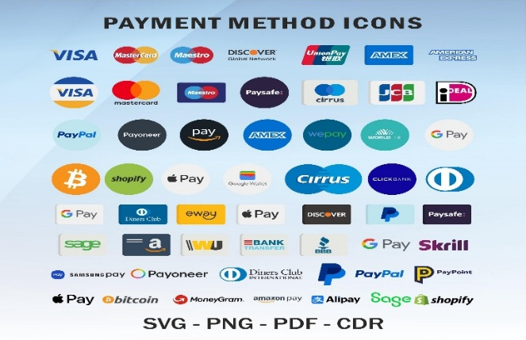
WHAT IS A:
WORD SPLASH: Brainstorming activity where students share words and ideas they associate or connect to the topic. The words are displayed for the whole class to see, helping build background knowledge, develop topic-specific vocabulary and prepare students for future discussions and learning activities.


WORD CLOUD: Visual image of words where the most frequently used words appear larger than the less common words.
Word Cloud Tool

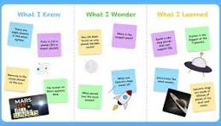
PADLET: Online collaborative or digital noticeboard where students can share ideas, pictures, links and comments in one place.
Padlet Tool

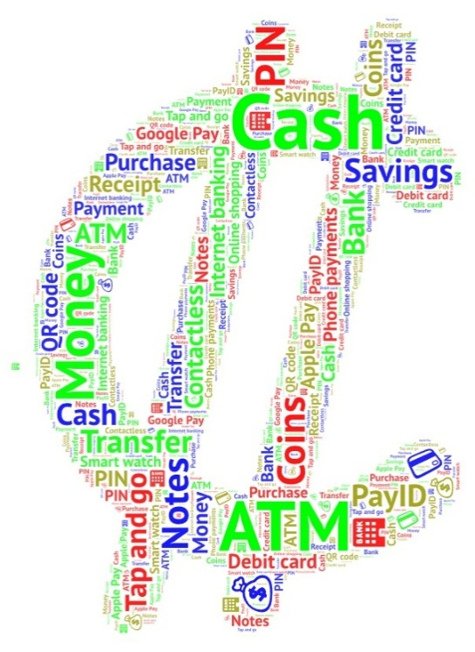
Instructions 3 and 4: Words students may already know:
Cash ATM Transfer Savings Money Tap and go Internet banking

Purchase Coins Phone payments PayID Contactless Notes

Apple Pay QR Code Credit Card Google Play Receipt Debit Card

Bank Online shopping PIN Smart Watch

Instruction 5: Sample made using the WordArt Tool

Use the ideas from your group’s Word Splash, Word Cloud or Padlet to participate in a class discussion. As a class, discuss the following questions:
- What payment methods require people to use physical cash or notes and coins?
- Charity donation tins.
- Street performers or buskers.
- Some community events or festivals.
- School fundraising stalls.
- Garage sales.
- Coin-operated laundromats (where you wash and dry your clothes).

- Which payment methods are cashless?
- Debit cards.
- Credit cards.
- Apple Pay.
- Google Pay.
- Samsung Wallet.
- Smartwatches.
- PayID.
- Online banking transfers.
- QR code payments.
- Digital wallets.
- Buy Now Pay later (e.g. Afterpay).

- Why do people choose different payment methods?
- It is faster and more convenient.
- Some people prefer using cash to help manage/limit their spending.
- Digital payments reduce the need to carry physical cash.
- Some businesses only accept electronic payments.
- Older people feel more comfortable using cash they can count.
- Online shopping requires electronic payment.
- Some people are worried about privacy and prefer cash.
- People choose the payment methods that best suit their needs.

- What would happen if all the shops stopped accepting cash?
- People without bank cards or smartphones will find it hard to buy everyday items.
- Older people and disadvantaged groups may find it hard to pay for goods and services.
- Tourists without electronic payment methods will have problems paying for things.
- If the internet or EFTPOS system fails, people might not be able to buy food or fuel.
- Businesses may process payments more quickly.
- Some people could feel excluded or left out if they only use cash.
- Less handling of physical cash and less cash theft.
As a class, write a definition of the term ‘cashless society’.
A cashless society is a society where people mainly pay for goods and services using electronic methods such as debit cards, credit cards, mobile phones or online banking instead of using notes and coins.

Activity 1c: Cash or Card? What are the Current Rules? Scenario Sorting Activity
Learning Intentions

We are learning about the current rules and practices relating to businesses accepting cash in Australia.

Success Criteria

I can identify when businesses are required to accept cash and explain one reason why some businesses choose to accept or refuse cash.

Task Instructions:
- Listen carefully as your teacher reads out some information about payment methods in Australia and the meaning of legal tender.
- Work with a partner to read each of the scenarios below. Decide whether each scenario belongs to one of the following three categories:
- Cash Accepted
- Cash not accepted
- Need more information
- Justify your decision by writing a brief reason next to each scenario.
- Think like a business owner. Choose two scenarios and, with your partner, answer the questions that follow:
- Why a business may choose to accept or refuse cash
- How this decision could affect different customers
- Is the decision fair? Why/Why not?
- Participate in a class discussion sharing your ideas about the questions being considered.

  - Information about payment methods in Australia (to be read out by the teacher)
In Australia, there are many ways to pay for goods and services, including cash, debit cards (using money in your bank account to pay for items), credit cards (money you borrow from a bank and repay with interest) and mobile payments using smartphones, smartwatches and other mobile devices. Most businesses can choose which payment methods they accept. However, they must tell customers before they make their purchases if they do not accept cash.

Australian notes and coins are legal tender, which means they are official forms of money. In some situations, cash can be used to pay a debt even if a business would prefer another payment method.

  - Scenario Challenge
Working in pairs, read each scenario and decide whether:
- Cash is accepted.
- Cash is not accepted.
- Need more information.

Justify your choice using evidence and reasons.
SAMPLE RESPONSES (Student answers will vary)
Scenario | Your decision | Justification/Why?
A café has a sign at the entrance saying ‘Card Only’. | Cash is not accepted. | Customers are told before they order that only card payments are accepted, so they can decide whether they want to buy something.
A customer finishes a meal at a restaurant and is told at the register that cash is not accepted. | Need more information. | We need to know whether the customer was told before ordering. If there is no clear sign or warning, the restaurant may still need to accept cash because the customer has received and eaten their meal.
An online clothing store only accepts online payments. | Cash is not accepted. | Online stores do not have a place where customers can pay with cash, so only electronic payments can be used to purchase clothing.
A school canteen accepts both cash and card. | Cash is accepted. | The school canteen allows customers the choice to pay using either payment method.
A sporting event advertises that all food stalls are cashless. | Cash is not accepted. | Customers are told before attending that only electronic payments will be accepted.
A market stall has no EFTPOS because the internet is down. | Cash is accepted (if the seller is still trading). | If the EFTPOS machine is not working, the seller may only be able to accept cash. However, if they choose not to accept cash, then they cannot make any sales if their electronic payments cannot go through.

3. Explain your thinking as a business owner
Working with a partner, choose two of the six business scenarios from Question 2. (Sample answers have been provided for all six businesses)
For each business, discuss and answer the following questions:
Business 1: Café with ‘Card Only’ Sign
- Why might this business prefer customers to pay with cash or card?
- Card payments are quicker.
- Staff do not need to handle cash or give change.
- There is less risk of cash being stolen.
- It can make the end-of-day banking easier.

- How could this decision affect its customers?
- Customers can pay quickly with a card or phone.
- People who only have cash cannot buy anything.
- Some customers may choose to go to another café.

- Do you think this payment method is fair? Why?
Yes, because customers are told before they order and can decide whether to buy something or leave and go to another café that does accept cash.

Business 2: Restaurant that tells customers at register that it does not accept cash
- Why might this business prefer customers to pay with cash or card?
- Card payments are faster.
- It reduces the need for staff to handle cash.
- It may lower the risk of theft.

- How could this decision affect its customers?
- Customers who only have cash may not be able to pay for their meals.
- Customers may feel angry or frustrated if they were not told of this policy/rule before ordering.

- Do you think this payment method is fair? Why?
No, it is not fair, as customers should be told before they order, so they know how they can pay for their meals.

Business 3: Online clothing store
- Why might this business prefer customers to pay with cash or card?
- This business sells products online, so electronic payments are the easiest option.
- Payments can be processed automatically/instantly.
- It is safer than sending cash.

- How could this decision affect its customers?
- Customers can shop anytime from home.
- People without a bank card or online banking cannot buy from this store.

- Do you think this payment is fair? Why?
Yes, because the online store needs electronic payment to complete customer purchases.
Business 4: School canteen that accepts both cash and card
- Why might this business prefer customers to pay with cash or card?
- It gives students and families more choice.
- It makes buying lunch easy for everyone.
- It allows students and families to choose the payment method that suits them.

- How could this decision affect its customers?
- More students can buy food.
- Customers can choose the method that suits them when paying for food.

- Do you think this payment is fair? Why?
Yes, it is very fair as everyone is given a choice.
Business 5: Sporting events where all food stalls are cashless
- Why might this business prefer customers to pay with cash or card?
- Payments are faster by card.
- Shorter queues at busy events as no change has to be given to customers.
- Less cash needs to be handled.
- Better security.
- How could this decision affect its customers?
- People who make purchases can pay quickly.
- Customers who only have cash are not able to buy food or drinks at the food stalls.

- Do you think this payment is fair? Why?
It can only be fair if customers are told before the event that it is cashless. However, it still disadvantages people who only have cash or want to pay with cash.
Business 6: Market stall with no EFTPOS because the internet is down
- Why might this business prefer customers to pay with cash or card?
- The EFTPOS machine is not working.
- Cash allows the business to continue selling goods.
- It avoids losing sales during the internet failure.

- How could this decision affect its customers?
- Customers with cash can still buy items.
- Customers with only a card or phone may miss out and cannot buy anything.

- Do you think this payment is fair? Why?
Yes, as the business cannot control the internet failure and accepting cash allows the market stall to continue trading.
4. Class Discussion Questions: (optional)
Should businesses be allowed to refuse cash?
No, all businesses should accept cash because it is still legal money and some people do not have bank cards or phones to make payments.
Who might be disadvantaged if businesses become cashless?
People who may be disadvantaged include:
- Older people who prefer using cash.
- Children who only have pocket money in cash.
- People without a bank account or debit card.
- People whose phones or cards stop working.
- People living in areas with poor internet or power failures.
What are the advantages and disadvantages of cashless payments for business and customers?
Advantages | Disadvantages
Payments are fast and easy. | Some people prefer or need to use cash.
Businesses do not have to handle cash. | Technology or internet problems can stop payments.
Less risk of money being stolen from the cash register. | Card payments may have extra fees for businesses and customers.
Customers can pay with a card, phone or smartwatch. | People may spend more because they cannot see their money.
Businesses do not need to keep change in notes and coins. | Personal information could be stolen through scams or hacking.
Digital records can make it easier for the business to keep track of spending and sales. | Some people may not have a bank card or phone to make payments.

Activity 2: Cash or Cashless? Sorting The Reasons Activity
Learning Intention

We are learning to identify and explain different viewpoints about cashless businesses.

Success Criteria

I can identify reasons that support cashless businesses and reasons that support allowing people to pay with cash for goods and services.

Task Instructions:
- Work with a partner.
- Read each statement carefully.
- Decide whether each statement is:
- a reason that supports cashless businesses.
- a reason that supports keeping cash as a payment option.
- Write each statement in the correct section of the mind map.
- Highlight three reasons you think are the strongest and be prepared to explain your choices.
- Share your answers and reasons with the class during the discussion.

SAMPLE RESPONSES (Student answers will vary for Instruction 5)
Statements:
- Card payments are quicker.
- Businesses are less likely to be robbed.
- Some people do not own a bank card.
- Older people may prefer using cash to buy their goods and services.
- Less cash means less counterfeit (forged or fake) money.
- Technology can stop working.
- Faster service.
- Paying with a phone is very convenient.
- Tourists can tap and pay instead of carrying cash.
- It costs businesses money to process card payments.
- Children often use cash to buy what they want or need.
- Everyone can still pay.
- Easier record keeping for businesses.
- Gives people more payment choice.

CASHLESS BUSINESSES
Reasons that Support Cashless Businesses  (reasons against a ban) | Reasons That Support Keeping Cash Available  (reasons to ban cashless businesses)
Card payments are quicker. | Some people do not own a bank card.
Businesses are less likely to be robbed. | Older people may prefer using cash to buy their goods and services.
Less cash means less forged or fake money. | Technology can stop working.
Faster service. | It costs businesses money to process card payments.
Paying with a phone is very convenient. | Children often use cash to buy what they want or need.
Tourists can simply tap and pay instead of carrying cash. | Everyone can still pay.
Easier record keeping for businesses. | Gives people more payment choices.

Sample of three strongest reasons for each side with an explanation of why
Reasons that Support Cashless Business
Reason 1: Card payments are quicker.
Explanation: Faster payments mean customers spend less time waiting, and businesses can serve more people to increase their sales.
Reason 2: Businesses are less likely to be robbed.
Explanation: There is less cash on the business premises, making the business a less attractive target for thieves who are only looking for money.
Reason 3: Easier record keeping for businesses.
Explanation: Every payment is automatically recorded, making it easier to track sales, prepare taxes and manage money.

Reasons that Support Keeping Cash Available
Reason 1: Everyone can still pay.
Explanation: Accepting both cash and cards is more inclusive because it gives people the option to pay in different ways.
Reason 2: Some people do not own a bank card.
Explanation: Everyone should still be able to buy essential goods and services, even if they do not have a card or bank account.
Reason 3: Technology can stop working.
Explanation: If the internet, power or payment system goes down, people may not be able to pay unless cash is accepted, so they will not be able to buy necessities like food and petrol.

Activity 3: Should We Go Cashless? BTN Video Investigation Activity
Learning Intention

We are learning to understand the benefits and problems of a cashless society.

Success Criteria

I can describe what a cashless society is, identify reasons for and against cashless payments and explain my opinion using evidence from the BTN video.

Task Instructions:
- Watch the BTN – High: Cashless Society video.
- Answer the comprehension questions as you watch.
- Complete the True or False activity.
- Complete the Cause-and-Effect table.
- Identify the advantages of cashless payments and the advantages of keeping cash.
- Complete the Who Said It? activity.
- Participate in the Opinion Line activity and justify your opinion using evidence from the video.

SAMPLE RESPONSES (Student answers will vary)
Behind the News (BTN) – Cashless Society
Answer the following questions as you watch the video:
- Describe what a cashless society is.
A cashless society is where people mostly pay for goods and services using cards, phones or other digital payments instead of cash.
- Explain why fewer Australians are using cash.
Many people find digital payments faster, easier and more convenient to use rather than notes and coins.
- Identify two ways people can make digital payments.
- Debit or credit cards.
- Mobile phones or smartwatches to tap and pay.

- Some businesses prefer cashless payments. Why?
Cashless payments are quicker, reduce the amount of cash they need to handle (e.g. count, ensure enough notes and coins for change) and lower the risk of robbery for cash.

- Explain what happened during the Optus power failure.
Many EFTPOS machines stopped working, so customers could not pay with cards, and some businesses lost customers and sales.
- List the groups of people who may still rely on cash.
- Older people.
- People who live in rural areas or the country rather than cities such as Melbourne.
- People who are less confident using technology.
- People who want cash as a backup in case the technology does not work.

- Why do some people believe cash should always be available?
Because technology can fail and cash lets people keep paying for goods and services when card systems or the internet are not working.
- Identify one advantage of paying with cash.
Cash can be used when technology or power fails.
- State one thing you learned from the video that you did not know before.
I learned that only about 13% of payments in Australia were made in cash in 2022.

Decide if the following statements are True or False
- Most Australians still pay with cash every day. False
- Businesses save time using digital payments. True
- Technology never fails. False
- Some people still rely on cash. True
- Power or internet outages or failures can affect digital payments. True
- Everyone agrees Australia should become cashless. False

Cause and effect table
Complete the table by thinking about what happens for each of the following scenarios:
Cause | Effect/Outcome
Many people use bank cards and phones. | Less cash is used, and more businesses will offer digital payments as the preferred method of paying for goods and services.
Businesses stop accepting cash. | Customers who only have cash or use cash may not be able to buy goods and services.
The Optus or Telstra network goes down. | Customers may not be able to pay with their cards or phones, and some businesses may lose sales.
Some people cannot use digital payments. | They may not be able to buy the goods or services they need if cash is not accepted.
Cash is no longer accepted. | People who rely on cash may be unable to buy the goods and services they need if cash is not accepted.

Advantages of both payment methods
Three advantages of cashless payments are:
- Payments are faster.
- Businesses are less likely to be robbed.
- Digital payments are convenient and easy to use.
Three advantages of keeping cash are:
- Cash works when technology fails.
- Everyone can pay, even without a bank card.
- Cash gives people another payment option/choice.

Who said it?
Decide whether each statement would most likely be said by:
- A business owner
- A customer
- Someone who supports cash
- Someone who supports cashless payments

Statements:
1. It’s much faster someone who supports cashless payments
2. I need cash when technology fails someone who supports cash
3. Handling cash takes too much time a business owner
4. Everyone should have a choice a customer

Opinion line
After watching the video, stand on an opinion line in the position that best represents/shows your view on the statement:
‘Australia should become a completely cashless society’.
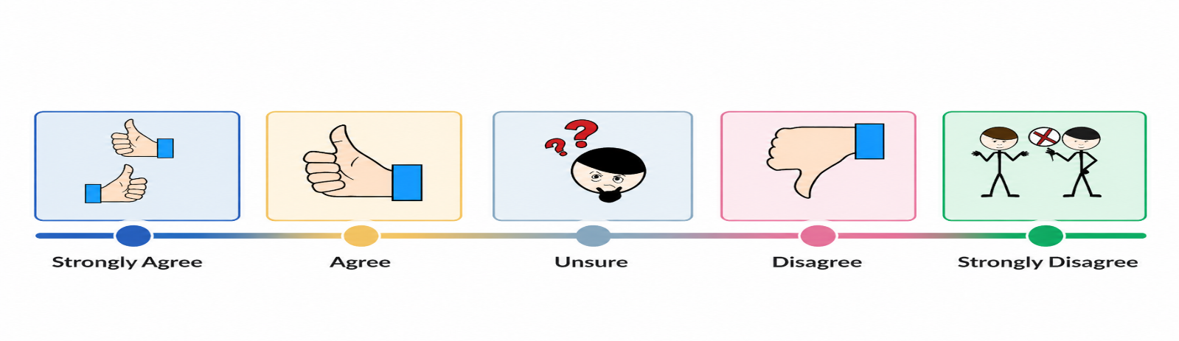

Activity 4: Cash or Card? The Great Money Debate Activity
Learning Intention

We are learning to compare the advantages and disadvantages of cash and cashless payment methods so we can explain our opinion about whether Australia should become a cashless society.

Success Criteria

I can describe the advantages and disadvantages of cash and card payments, listen to different opinions and explain my own opinion using reasons and evidence.

Task Instructions:
Step 1: Become an Expert
- Read the article your teacher has given you.
- Complete the Source Detective activity for your article, writing down the key ideas and important information relevant to this Convention topic.
- Form a group of three students. Each group member should have read a different article and completed the Source Detective activity before sharing their answers with the group.
Step 2: Teach your Team
- Take turns teaching the other members of your group about your article. Each expert has two minutes to explain the key information and the main ideas to the rest of the group.
- While each person is presenting, the other students record key advantages and disadvantages of cash and cashless payments in the table provided.
Step 3: Design Australia’s Payment System
- Imagine your team has been hired by the Australian Government to design Australia’s payment system for 2035.
- Using what you learned from the three articles, create an A3 poster explaining your payment system. Your poster can be completed by hand with each member contributing information or digitally using a computer program like Canva, Microsoft Word or Adobe Firefly.
- Use the guiding questions to help you make your decisions. You do not have to answer every question.
- Present your poster to the class and explain why your payment system is the best choice for Australia’s future.
Step 1: Source detective
Read your article and record the following information.
Article 1: ABC News – Teaching your kids about personal finance in the age of digital money
Three important facts:
- Children are using less cash and more digital payments than ever before.
- It can be harder for children to learn the value of money when they cannot see cash.
- Parents should teach children how to save, budget and spend wisely using both cash and digital money.
Who benefits most from this payment method?
Families and children who use digital banking because it is quick and convenient.
What is one concern or disadvantage?
Children may spend money more easily because digital money feels like it is less ‘real’.

Article 2: Kids News – Thousands of school canteens adopt cashless technology
Three important facts:
- Many Australian school canteens now use cashless payment systems.
- Students can pay using student ID cards, or parents can order lunches online.
- Cashless systems make lunch lines faster and can reduce bullying over lunch money between students.
Who benefits most from this payment method?
Schools, parents and students because buying lunch is quicker and easier.
What is one concern or disadvantage?
Students who have cash may not be able to buy their lunch.

Article 3: ABC News – Australia’s transition to a cashless society raises concerns about financial exclusion, privacy and safety
Three important facts:
- Only about 13 % of Australian payments were made in cash in 2022.
- Some people, including older Australians, people with disabilities and those in regional or country areas, still rely on cash.
- Cash is important during emergencies when the power or internet services stop working.

Who benefits most from this payment method?
People who enjoy fast and convenient digital payments.

What is one concern or disadvantage?
Some people may struggle if cash is no longer accepted.

Article 4: News.com.au – Why a truly cashless society will doom Australia
Three important facts:
- Some people worry that a cashless society could increase banking and card fees.
- Older Australians and people in regional/country areas may struggle without cash.
- Many people are concerned about privacy and that we are relying too much on technology.
Who benefits most from this payment method?
Businesses and customers who prefer fast digital payments.
What is one concern or disadvantage?
Technology failures or higher transaction fees could make it more difficult for people to pay for goods and services.

Article 5: Stripe – What is a cashless society and what does it mean for businesses?
Three important facts:
- A cashless society mainly uses digital payments for goods and services instead of notes and coins.
- Digital payments can make businesses faster and better.
- Cash is still important for some people and during emergencies.
Who benefits most from this payment method?
People who regularly use cards and mobile phones to pay.
What is one concern or disadvantage?
Not everyone can easily use digital payments.

Article 6: BBC Story Works – Why cash is no longer king
Three important facts:
- More Australians are choosing to pay with cards, phones and smartwatches instead of cash.
- Digital payments are becoming more common because they are fast and convenient.
- Cash is still important for some people and during emergencies when technology is unavailable.
Who benefits most from this payment method?
Customers and businesses who want a quick and easy way to pay.
What is one concern or disadvantage?
People who rely on cash may find it harder to buy goods or services if businesses stop accepting cash.

Article 7: ABC News – Cashless kids: Is tap-and-go technology promoting financial illiteracy?
Three important facts:
- Many children are growing up using tap-and-go instead of cash.
- Some children find it harder to understand the value of money because they do not see notes and coins being used.
- Schools and parents can help children learn important money skills such as budgeting, saving and avoiding debt or owing money.

Who benefits most from this payment method?
People who like fast and convenient payments, including families and schools.
What is one concern or disadvantage?
Children do not understand how money works or how to manage it responsibly/sensibly.

Article 8: Kids News – Invisible cash is making it harder for children to learn about money
Three important facts:
- Children see less cash because many adults use cards, phones and online banking.
- Using pocket money and real notes and coins can help children learn to save and budget.
- Many parents believe that tap-and-go payments make it easier for children to understand the value of money.

Who benefits most from this payment method?
Adults who prefer quick and easy digital payments.
What is one concern or disadvantage?
Children may find it harder to learn good money habits when they don’t use cash often.

Article 9: SBS News – Teaching kids money in a cashless society
Three important facts:
- Parents should teach children about saving, budgeting and spending wisely, even in a cashless world.
- Pocket money and budgeting apps can help children develop good money habits.
- Children need to understand the difference between spending their own money and borrowing money on credit.

Who benefits most from this payment method?
Children who are taught good money skills and learn to manage digital money responsibly or sensibly.
What is one concern or disadvantage?
Children may think money is unlimited because they do not see cash being exchanged.

Step 2: Teach Your Team
As each expert presents, record the key ideas in the table below
Article | Benefits (one example) | Negatives (one example)
Article 1 – ABC News: Teaching kids about money | Digital payments are quick and more convenient. | Children may find it harder to learn about the value of money.
Article 2 – Kids News: Cashless school canteens | Faster lunch orders, less lost cash and shorter queues. | Students who only have cash may not be able to buy their lunch.
Article 3 – ABC News: Cashless society concerns | Digital payments are fast and easy for most people. | Some people rely on cash especially during power or internet outages or failures.

Article | Benefits (one example) | Negatives (one example)
Article 4 – News.com.au: Why a cashless society could be a problem | Cash payments are fast and convenient. | Technology failures and few payment choices may disadvantage some people.
Article 5 – Stripe: Cashless society for businesses | Faster payments, easier record keeping and the business doing things well. | Businesses need reliable technology and may have to pay card fees.
Article 6 – BBC Storyworks: Cashless Australia | Quick, simple and a secure way to pay. | People who rely on cash may be left out if businesses stop accepting it.

Article | Benefits (one example) | Negatives (one example)
Article 7 - ABC News: Cashless kids | Digital payments are quick and easy to use. | Children may not understand the value of money well.
Article 8 -Kids News: Invisible cash | Digital payments are convenient for families to use. | Children have fewer opportunities or chances to learn about saving and budgets when cash is not used.
Article 9 – SBS News: teaching kids money | Parents can use digital tools to teach budgeting and saving. | Children still need to learn how to manage money responsibly in a cashless world.

Step 3: Design Australia’s Payment System for 2035
Create an A3 poster explaining your team’s payment system. (Students will need poster paper)

Teacher Note: Students may use poster paper, or this activity can be completed digitally using a program like Canva, Adobe Firefly or a Microsoft Word Poster Template. They can also create or find suitable images online and copy and paste these onto their poster paper.

Your poster should include:
- A title for your payment system.
- A labelled diagram or drawing.
- A short explanation of how it works.
- Reasons why it is the best system for Australia.
- Evidence or proof from the articles to support your decisions.

Guiding questions (students do not have to answer all of these questions on their poster)
- Should Australians still be able to use cash? Why/Why Not?
- How will children learn about money?
- What happens if the internet or electricity stops working?
- How will older Australians or people without smartphones pay?
- How will your system protect people from scams and fraud?
- How will your payment system be fair and accessible for everyone?
- List the main advantages of your payment system.

SAMPLE POSTER BELOW: (AI-generated only as an example)
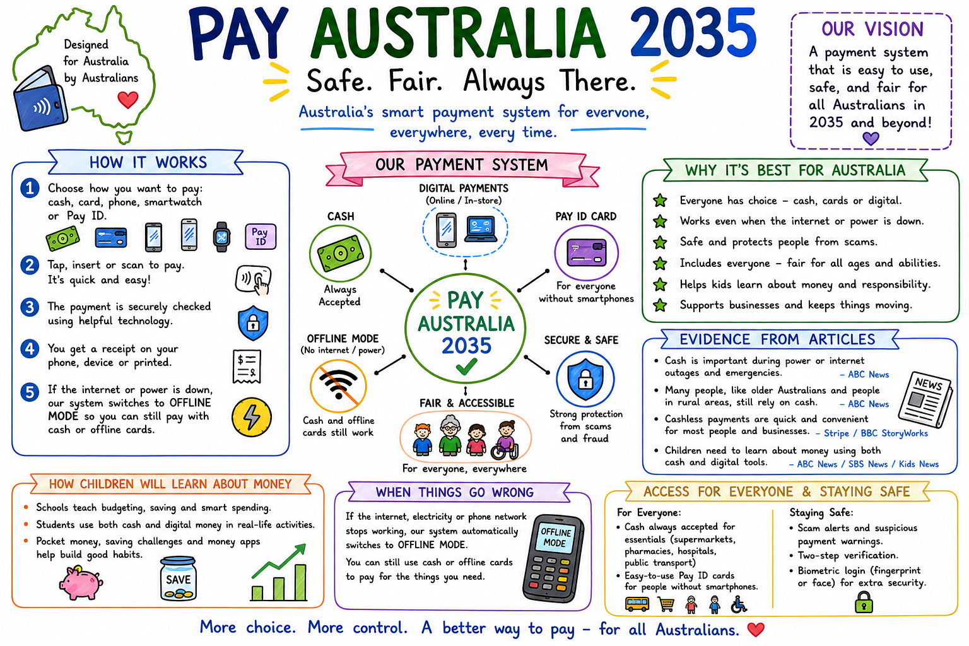

Activity 5: Exploring a Cashless World – Infographic Investigation
Learning Intention

We are learning to identify and organise the key information from the infographic about cashless societies.

Success Criteria
I can identify the main ideas in the infographic, organise them into categories, and explain the benefits and challenges of a cashless society.

Task Instructions:
- Get into groups of 3 to 4 students.
- Carefully read the ‘Cashless Society’ infographic (page 22).
- Use the information to complete the mind map that follows (page 23).
- Work together as a team to discuss your ideas and make sure everyone contributes.
- Share your completed mind map with the class and explain the most important thing your group learned about cashless societies from this activity.

Sources referred to in the Infographic on page 39:
- Reserve Bank of Australia.
- Bank of International Settlements (BIS).
- World Bank (Global Findex Database).
- European Central Bank.

On page 40, create a Mind Map.

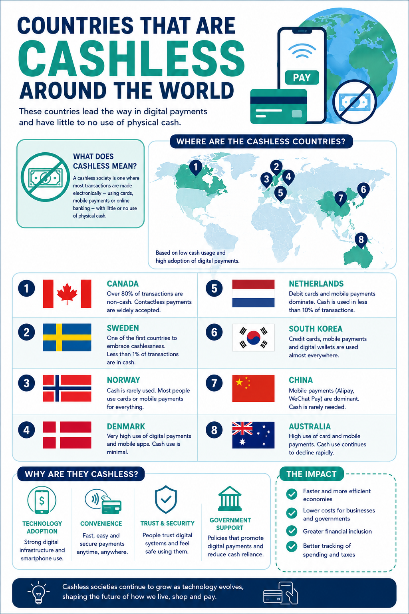1.
Note: The sample responses below match the mind map.
1. What is a cashless Society?
What does cashless mean?
A cashless society is one where most payments are made electronically instead of using cash.
How do people pay instead?
Using cards, mobile payments and online banking.
What technology is used?
Credit and debit cards, smartphones, mobile payment apps and digital wallets.

2. Countries Leading the Way
Write at least five countries from the infographic.
1. Canada – highest number of non-cash payments.
2. Sweden.
3. Norway.
4. Denmark.
5. Netherlands.
6. South Korea.
7. China.
8. Australia.

3. Why are Countries Becoming Cashless?
Technology adoption Example: Mobile Phone apps and Smartphones.

Convenience Example: Paying quickly with a phone or card.

Trust and Security Example: People feel safe using digital payments.

Government Support Example: Governments encourage people and businesses to use digital payments.

4. Benefits
List the positive impacts.
- Faster payments – People can pay in seconds.
- Lower business costs– Businesses spend less money on handling cash.
- Better tracking of spending – Customers can see what they have spent.
- Greater financial inclusion – More people can access banking using digital banking services.
- Other: Less cash to carry around.

5. Challenges
Possible ideas:
- Internet or power failures digital payments may stop working.
- Older people may struggle they find it harder to use digital payments as too confusing.
- Cybercrime or scams people could lose money online.
- Privacy Concerns people worry about their personal information being shared.
- Some people still prefer cash reluctant/ do not want to use digital payments.
- Other Children have fewer chances to learn about savings and budgeting using cash.

6. Australia
How do Australians mostly pay?
With cards and mobile payments.
Is cash use increasing or decreasing?
Decreasing.
Where have you seen cashless payments?
Supermarkets, cafes, restaurants, sporting events, public transport, school canteens.
My Opinion

A cashless society is a society where most people pay electronically for goods and services instead of using cash.

One benefit is that payments are faster and easier.

One concern is that some people may struggle if cash is no longer accepted.

I think Australia should/should not become completely cashless because some people still rely on cash to buy goods and services they need, and technology can still fail.

Activity 6: Cash vs Card – Which One Wins? - Be a Blog Detective Activity
Learning Intention

We are learning to identify the advantages and disadvantages of cash and cashless payments by finding evidence in a text.

Success Criteria

I can identify the advantages and disadvantages of cash and cashless payments, find evidence in a text to support my ideas and explain my opinion using reasons and evidence.

Task Instructions:
- Read the Kid Talk Blog: Would You Give Up Cash Forever?
- As you read, become a Blog Detective and look for clues about the advantages and disadvantages of becoming a cashless society.
- Highlight the evidence using three different colours:
🟢 Green = advantages or benefits of becoming a cashless society.
🔴 Red = disadvantages, challenges or concerns about becoming cashless.
🔴 Yellow = interesting points that surprised you or made you think.
- OPTIONAL STEP: Use the evidence you highlighted to complete the PMI (Plus, Minus, Interesting) Chart.
- Answer the two reflection questions and compare your ideas with another student.
- Share your findings with the class and explain which arguments you think are the strongest.

What is a blog?
A blog is an online article where a person shares their thoughts, opinions, ideas or experiences about a particular topic. Blogs are written in a friendly, conversational style as if the writer is talking to you.
In this activity:
The Kids Talk Blog has been set up by Priya, an 11-year-old who enjoys sharing her thoughts about different issues that affect her or her family. In this blog, Priya shares her thoughts about whether Australia should become a cashless society. She shares personal experiences, facts and different points of view to get readers thinking.

  PLUS (advantages) |   MINUS (disadvantages) |   INTERESTING (what surprised you or made you think)
- Paying with a card or phone is quick and easy.  - You don’t need to carry cash.  - Bank apps help people keep track of their spending and budget.  - Digital payments may help reduce crime because money is kept in a bank account.  - Digital payments make it harder for businesses to hide income and avoid paying tax.  - If a card is stolen, the bank may be able to cancel it before money is taken.  - Paying by phone or smartwatch is convenient if you forget your wallet. | - Some older people find digital payments confusing.  - Not everyone has a bank account, smartphone or internet.  - Children may find it hard to learn about money without using real notes and coins.  - If the power or the internet goes out, people may not be able to pay for goods and services.  - People worry about hackers, scams and online fraud.  - Digital payments are less private because every purchase is recorded.  - If cash disappears, some people may struggle to pay for goods and services if they cannot use digital payments. | - Priya’s family did not use cash all day at the football.  - More places like cinemas are becoming cash-only.  - A power outage stopped EFTPOS machines from working.  - Cash was useful during the storm because people could use it to buy food when digital payments could not be used.  - Every card or phone payment leaves a digital record.  - Cash can be lost or stolen, but digital payments also have risks.  - There are pros and cons for both payment systems.
Reflection:
What opinion do you think Priya has about this issue?
I think Priya believes Australia should keep both cash and digital payments. She says digital payments are fast and easy to use, but she also explains that cash is important during emergencies and for those people who find it hard or confusing to use digital payments. Instead of choosing one side, Priya thinks everyone should still have a choice of how they pay for their goods and services.
Do you agree with Priya? Why /Why not? Use evidence from the blog to support your answer.
Sample answer that agrees with Priya:
I agree with Priya because both cash and digital payments have benefits. Digital payments are quick, easy, and help people keep track of their spending. However, the blog explains that when a storm caused a power outage, some shops could not accept card payments, but people who had cash were still able to buy food and supplies. Keeping both payment methods gives everyone a choice and helps people pay, even when technology fails.
Sample answer that does not agree with Priya:
I do not agree with Priya because I think Australia should become completely cashless. The blog explains that digital payments are faster, more convenient and can reduce crime because money is kept safely in bank accounts. It also makes it harder for businesses to hide income and avoid paying tax.

POST CONVENTION ACTIVITIES

Activity 1: Looking Back, Looking Forward – Reflection Activity
Learning Intention

We are learning to reflect or think about the Convention topic of ‘Should the government ban businesses from being cashless?’ and express our opinion using what we have learnt about the advantages and disadvantages of requiring businesses to accept cash.

Success Criteria

I can explain how my thinking has changed after the Online Convention and identify the strongest arguments. I can also reflect on my participation and share my opinion using reasons and evidence.

Task Instructions:
Complete the following steps to reflect on your learning:
- Reflect on what you learned during the Online Convention.
- Consider whether your opinion changed after listening to different points of view and evidence.
- Think about how participating in the Online Convention helped you develop your communication, critical thinking and decision-making skills.
- Answer the questions listed below in complete sentences.
- Share your answers with the rest of the class.

SAMPLE RESPONSES (Student answers will vary)
Answer the following questions in complete sentences.
- What was your opinion on the topic before the online Convention?
Before the online Convention, I thought Australia should become completely cashless because paying with a card or phone is faster, easier and more convenient.
- What is your opinion on the topic after the online Convention?
After the online Convention, I think Australia should keep both cash and digital payments. Digital payments are useful, but cash is still important for emergencies and for people who find technology difficult to use.
- Choose the argument you found most convincing and explain your choice.
The most convincing argument was that cash is very useful during power or internet failures. If EFTPOS machines stop working, people can still use cash to buy food, medicine and other important items.
- Describe one new fact or idea you learned during the online Convention.
I learned that every digital payment leaves a record, which can help businesses and governments keep track of money and prevent people from not paying tax.
- List one thing you did well during the online Convention and one skill you would like to improve.
One thing I did well was listen carefully to other students’ ideas and share my own opinions. I would like to improve my public speaking skills, so I am more confident when speaking in front of a group.

- Suggest what the government should do about businesses operating without accepting cash and give two reasons to support your answer.

The government should require essential businesses like supermarkets, pharmacies and petrol stations to accept cash as well as digital payments.

My reasons are:
  - Cash can still be used when there is a power outage or internet failure.
  - Accepting cash ensures that everyone can pay for essential goods and services, including people who do not have a bank account, smartphones, or debit cards or who find digital payments difficult to use.
  - Giving people a choice of payment methods makes the system fairer and more inclusive of everyone.

Activity 2: Headline Challenge – Think- Pair-Share Activity
Learning Intention

We will be able to summarise the main ideas from the Online Convention and communicate our understanding by creating a newspaper headline, summary and recommendation.

Success Criteria

I will be able to create a catchy headline; summarise the main ideas from the Convention and explain what I think the government should do.

Task Instructions:
- Imagine you are a newspaper reporter covering the Victorian Students’ Parliamentary Program Convention.
- Create a front page that reports/tells readers about the debate on the topic: ‘Should the government ban businesses from being cashless?’ Your front page can be completed in the Student Resource Booklet or created digitally using a program such as Canva, ReadWriteThink Printing Press, Microsoft Word (newspaper template) or another suitable program.
- Make sure your front page covers all the features listed below.
- Share your completed front page with a partner and explain how your headline, image and recommendation help readers understand the issue.

SAMPLE RESPONSE (Student answers will vary)
Website links that can help students create the front page of a newspaper:
Canva – Newspaper Templates
Read Write Think – Writing and Printing Prose
Features to include on your front page include:
- A newspaper headline that captures the main issue in 6-10 words.
- One-to two sentence summary explaining what the debate was about.
- The strongest argument for banning businesses from being cashless.
- The strongest argument against banning businesses from being cashless.
- Recommend/Suggest what you think the government should do and explain your reasons in one or two sentences.
- Draw a front-page image or political cartoon that represents the debate.
- Write a caption (short sentence about your image) for your image.

Use the template/guide provided to help you with this activity.

Front Page Template/Guide
Headline:
Should Cash Still be Accepted in Every Shop and Business?
News Summary:
Strongest Argument For:
Students at the recent Victorian Students’ Parliamentary Program Convention debated whether the government should ban businesses from being cashless. Some students believed cash should always be accepted, while others argued that businesses should be free to choose how customers pay.
Strongest Argument Against:
Cashless payments are faster, safer and cheaper for businesses because they reduce the risk of theft, counting errors, and handling cash. Businesses should have the freedom to decide which payment methods to accept.
My Recommendation/Suggestion:
I think the government should require essential businesses, such as supermarkets, pharmacies and petrol stations, to accept cash, while allowing other businesses to choose. This ensures everyone can pay for important goods while still giving businesses choice.
Front Page Image or Political Cartoon
Source for sample: https://www.cartoonstock.co
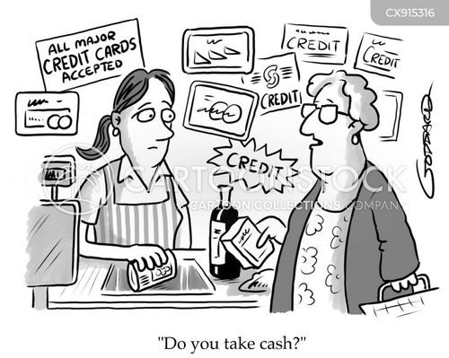

Caption: No cash, No choice!

Activity 3: Escape Room: Save the Community Activity
Learning Intention

We will be able to apply what we have learned during the Online Convention by working together to solve problems and make decisions about cashless businesses.

Success Criteria

I will be able to solve each challenge, explain my thinking, work together with my team and suggest a solution using evidence from the Online Convention.

Task Instructions:
A major systems failure has stopped electronic payment systems from working across Victoria. Your team has been asked to help the government decide what to do next.
Steps:
- Work together in teams of 3-4 students to complete each challenge.
- Read each clue carefully and solve the puzzles.
- Use what you learned during the Online Convention to answer the questions.
- Write down your team’s answers before moving to the next challenge.
- Complete all the challenges to gather evidence for your final recommendation.
- Present your team’s final recommendation and explain why it is the best solution for the community.

SAMPLE RESPONSE (Student answers will vary)
Challenge 1: Payment Detective
Sort the payment methods into the two category groups below. Payment Methods:
- Cash.
- Debit card.
- Credit card.
- Mobile phone payment.
- Smart watch payment.
- Gift card.
- Bank online transfer.
- Coins.
Works without electricity or the internet:
- Cash.
- Coins.
Needs electricity or the internet:
- Credit card.
- Debit cards.
- Mobile phone payment.
- Smart watch payment.
- Gift card (electronic).
- Bank online transfer.

Mission Notes - Complete this sentence:

We discovered that cash can be useful because it works even when electronic payments are unavailable and gives everyone a way to pay for essential goods and services.

Challenge 2: Who needs cash?
Mission - Read each scenario. Answer the questions for each person:
1. What problem do they face?
2. How could accepting cash help them?
Scenario 1: Mrs Patel
Mrs Patel is an 82-year-old pensioner. She prefers using cash because she finds bank cards and mobile phones confusing. She goes to her local bakery, but it no longer accepts cash.

Questions:
  - What problem does Mrs Patel face?
Mrs Patel cannot buy food from the bakery because it does not accept cash, and she finds digital payment methods difficult to use.

  - How could accepting cash help Mrs Patel?
Accepting cash would allow Mrs Patel to pay in a way that she is most comfortable with and continue to shop independently/on her own.

Scenario 2: Abdul
Abdul is 11 years old. His parents give him $10 cash to buy his lunch at the sports canteen after football practice. The canteen only accepts electronic payments.

Questions:
  - What problem does Abdul face?
Abdul cannot buy his lunch because he only has cash, but the sports canteen only accepts electronic payments.

  - How could accepting cash help Abdul?
Accepting cash would mean that Abdul can buy his lunch using the money his parents gave him.
Scenario 3: The Portelli Family
A severe storm causes a power failure across the country town. Internet and phone services stop working, and electronic payment systems cannot be used. The Portelli family has cash but no way to use their bank cards.

Questions:
  - What problem do the Portelli family face?
The power outage has stopped electronic payment systems from working, so they cannot use their bank cards or buy essential items.

  - How could accepting cash help the Portelli family during this emergency?
Accepting cash would allow them to buy food, fuel and other essential items even when electronic payments are unavailable.

Scenario 4: Mei
Mei is visiting Victoria from overseas. She has exchanged her money for Australian dollars in cash but has not yet set up an Australian Bank account. She wants to buy a MYKI card, but the train station only accepts electronic payments.

Questions:
  - What problem does Mei face?
Mei cannot buy a MYKI card or use a card to tap on, as she only has Australian cash, and the train station does not accept cash payments.
  - How could accepting cash help Mei?
Accepting cash would allow Mei to buy a MYKI card and use public transport before setting up an Australian bank account.

Scenario 5

Enrico works casually and is paid in cash each week. On his way home, he wants to buy groceries, but every supermarket nearby has become cashless.

Questions:
  - What problem does Enrico face?
Enrico cannot buy groceries because he has been paid in cash and the supermarkets nearby do not accept cash.

  - How could accepting cash help Enrico?
Accepting cash would allow Enrico to use his wages to buy the groceries and essential items he needs.

Mission Notes

Which groups of people benefit the most from businesses accepting cash? Why?
The groups that benefit the most from businesses accepting cash are older people, children, people without a bank account, tourists and people affected by power or internet failures because cash gives them a reliable way to pay for essential goods and services.

Challenge 3: Fact Check
Mission - Can you separate the facts from the opinions?
For each statement, decide whether it is Fact or Myth (False) (use ✔️)
Statement | Fact | Myth/False
Cash is legal tender in Australia. | ✔️
Every business in Australia must accept cash. |  | ✔️
Some businesses choose not to accept cash. | ✔️
Older Australians are the only people who use cash. |  | ✔️
Electronic payments rely on electricity or the internet. | ✔️
A cashless society affects different groups in different ways. | ✔️
Cashless payments are always faster than cash. |  | ✔️
Governments sometimes make laws to protect consumers. | ✔️

Mission notes:
Write down two facts that your team thinks are the most important when deciding whether businesses should continue accepting cash.

- Electronic payments rely on electricity and the internet, but cash can still be used during a power or internet failure.

- A cashless society affects different groups in different ways, so accepting cash means that everyone can still pay for essential goods and services.

Challenge 4: Social Media Detective
Mission - Three messages have been shared online.
Can you work out whether they are reliable or unreliable?
Statement | Reliable (supported by evidence) | Unreliable (not supported by evidence or is an opinion) | Why?
Cash should be banned because no one uses it anymore. |  | ✔️ | This is unreliable because it is not supported by evidence. Many Australians still use cash, so the statement is false.
Businesses should always be free to choose how customers pay. |  | ✔️ | This is unreliable because it is an opinion, not a fact. Different people have different views, and no evidence can prove this is definitely right or wrong.
Keeping cash available can help people during emergencies. | ✔️ |  | This is reliable because evidence shows that cash can be used during power and internet outages, and other emergencies when electronic payments are not available.

Mission Notes:
Why is it important to check whether information is reliable before making a decision?
It is important to check whether information is reliable because it helps us make good decisions based on facts and evidence rather than false information or opinions.
Challenge 5 – Make the Decision
Mission - Your team must decide what advice to give the Victorian Government.
Our decision: (highlight or circle one of the following options)
- Businesses should be required to accept cash.
- Businesses should choose whether they accept cash.
- Only essential businesses should be required to accept cash.
Reasons to support our decision:
- Everyone can still buy essential goods such as food, medicine and petrol during emergencies.
- People without bank accounts, smartphones or internet access are not excluded/left out.
Possible problems or disadvantages:
- Some businesses may have higher costs when it comes to handling cash.
- Businesses have less freedom to choose how customers pay.

Mission Notes:
Write one sentence explaining why your team chose this recommendation
Our team chose this recommendation because it helps everyone buy important things like food, petrol and medicine even if electronic payments are not working.
Final Mission – Save the Community
Congratulations – you have reached the final challenge.
Use your Mission Notes to prepare a one-minute emergency briefing for the Premier of Victoria.
Your briefing must:
- State your team’s recommendation.
- Include three reasons to support your recommendation.
- Explain how your recommendation will help people during emergencies.
- Suggest one action the Victorian government should take.
Sample Response (student answers will vary)
Good morning, Premier,

Our team recommends that essential businesses like supermarkets, pharmacies and petrol stations should be required to accept both cash and digital payments. We have three reasons for our recommendation.

Firstly, cash can still be used during a power or internet failure and other emergencies when electronic payments are not working. Secondly, accepting cash helps older people, children, tourists and people without a bank account or smartphone pay for the things they need. Thirdly, giving people a choice of payment methods makes the system fairer for everyone so they can buy essential goods and services.

This recommendation will keep our community safe during emergencies because people will still be able to buy food, medicine and petrol.

We therefore recommend that the Victorian government introduce a law requiring essential businesses to accept both cash and digital payments, so everyone has a reliable way to pay.

Thank you for your time.
Once your team presents its briefing, you will have completed the mission and helped save the community!
FINAL VOTE – The Decision is Yours!
You have heard the arguments, considered the evidence and listened to different viewpoints. Now it's time to make your final decision.
Should the government ban businesses from being cashless?
☐ Yes ☐ No ☐ Not Sure

Did the Convention change your opinion?
☐ Yes ☐ No
After the class has voted, the teacher, class captain or leader will count the votes and share the results for both questions with the rest of the class.

ADDITIONAL TEACHER REFERENCES:
You may find these resources helpful to unpack the topic as you prepare for the Convention with your students.
Suggested Resource | Overview
RMIT – Why mandating cash payments is a good thing for the community | Short Article by Dr Zhong that supports the Federal Government mandating Australian businesses accept cash for essential items like groceries and medicine.
The University of Melbourne – Retailers encouraged to embrace cashless revolution | Some interesting data provided indicating that consumers spend more when they go cashless compared to physical money. Indicates that retailers will benefit more by being cashless as sales are boosted.
RMIT – The move to a cashless society is well underway | Explores the move to a cashless society and how it can be traced back to the introduction of the bankcard 50 years ago. Convenience and technology are the driving forces for the shift for both businesses and consumers. The article also considers why government regulations are necessary.
ABC News – In an increasingly cashless society, some people without housing are being left behind | Article focuses on the plight of the homeless as society moves towards cashless transactions, with an estimate of only 13% of Australians now using cash. This is posing a serious problem to one of the most vulnerable groups in our community.
YouTube – ABC News – The risks of becoming a cashless society (4.33 minutes) | Good discussion about the role of banks in the push for individuals to go cashless and the costs they bear in transporting cash to regional areas. Reference also to the removal of cheques by 2028. 13% of transactions are done in cash, which is the same statistic coming through media articles.
ACCC – Payment Methods | Explanation of the rules that apply to different payment methods including cash, cards, buy now pay later and lay-by. Useful source to understand Australia’s consumer laws about payment.
Reserve Bank of Australia – Consumer Payment Behaviour in Australia | This article provides reliable Australian evidence about changing payment habits. It highlights the rapid growth of digital payments and the continued importance of cash for many Australians.
ACCC – About the cash acceptance mandate and codes | This Australian Government page explains the cash acceptance rules for supermarkets and fuel retailers. It outlines when businesses must accept cash, who the rules apply to and how the ACCC enforced the laws to make sure Australians can continue to use cash for essential purchases.
Have a go news – Are Aussie Consumers Returning to Cash? | Good article that explores why some Australians are using cash more often again.
Nine News – ‘Nobody’s voted for a cashless society’: Thousands withdraw cash in protest | This article explains the ‘Cash Out Day’ campaign, which encourages Australians to withdraw cash from ATMs to show support for keeping cash available.
SBS News – Cash was meant to be dying. But new RBA data tells a different story | The article explains that cash use in Australia has increased slightly for the first time since 2007 according to new Reserve Bank data.
YouTube - Nine News – Australia could soon be entirely cashless, say some experts (4.42mins) | Good news clip exploring the decline in cash across Australia and the growing shift towards digital payments.

