

Victorian Schools Parliamentary Program (VSPP)
2026 SECONDARY SCHOOL CONVENTION
Topic
Should governments regulate the use of facial recognition technology?


STUDENT ACTIVITIES

Contents
LEARNING INTENTIONS FOR THESE STUDENT ACTIVITIES: 3
SUCCESS CRITERIA FOR THESE STUDENT ACTIVITIES: 3
Activity 1: Introductory Tasks 4
1a: What is Government Regulation – Starter Activity 4
1b: Brainstorming Facial Recognition Technology – Think-Pair-Share Activity 6
Activity 2: Exploring Facial Recognition Technology through YouTube Clips – Group Investigation Activity 8
Activity 3: Australia’s Privacy Laws 17
Activity 3a: Did You Know? – Cloze Activity 17
Activity 3b: Application Scenarios – Group Work 19
Consider the following: 19
Scenario 3: Concert Entry 19
Scenario 4: Gym membership 20
Activity 4: Media Analysis – Mind Map Group Work Activity 21
Activity 5: The Bunning’s Breach Case Study and other articles – Reading Comprehension Activity 24
Activity 6: The Town Hall Meeting – Role Play Activity 29
POST CONVENTION ACTIVITIES 31
Activity 1a: Quickfire Question Round 31
Activity 1b: If I were the Government – Write a Law Activity 32
Activity 2: Media Response – Writing Activity 35
Activity 3: Where do I Stand? – Human Continuum Activity 37

LEARNING INTENTIONS FOR THESE STUDENT ACTIVITIES:
By the completion of these activities, students will be able to:
- Develop a comprehensive understanding of the legal, ethical and social implications of facial recognition technology.
- Examine the role of government in regulating emerging technologies.
- Apply critical thinking skills to evaluate arguments for and against government regulation.
- Analyse real-world case studies, media reports and stakeholder perspectives.
- Strengthen their ability to construct, express and justify viewpoints using evidence.
- Enhance public speaking and communication skills through discussion, role play and formal debate.

SUCCESS CRITERIA FOR THESE STUDENT ACTIVITIES:
Students will be able to:
- Clearly define facial recognition technology and explain how it is used.
- Identify and explain arguments that both support and oppose government regulation of facial recognition technology.
- Analyse key issues including privacy, consent, surveillance, data security, discrimination and public safety.
- Examine the perspectives of key stakeholders, including government, police, businesses and individuals.
- Refer to real-world examples and media reports as evidence.
- Present and justify their own informed opinion using supporting evidence.
- Demonstrate respectful and effective participation in class discussion and formal debate.

Activity 1: Introductory Tasks

1a: What is Government Regulation – Starter Activity
Learning Intentions
We will develop an understanding of government regulation, explain its purpose and accurately use key vocabulary related to facial recognition technology.

Success Criteria
I can explain what government regulation means and define key terms related to facial recognition technology.

Task Instructions:
1. Think about the key terms that you will use in this unit of work and answer the questions below.
2. Share your answers with the rest of the class.

- In your own words, define government regulation.
- What does government regulation aim to do? List as many purposes or reasons that you can think of and give an example of each.
Example: To raise money for public services, e.g., the federal government collects GST or a goods and services tax, to help pay for schools and hospitals.
- Australia has a system of shared law-making powers between three levels of government:
Local Government (L): Local Council
State Government (S): Victoria, New South Wales, etc.
Federal Government(F): National government of Australia
Which level of government is responsible for the following?
Example: Australia’s currency – F (Federal Government)
- Immigration Laws ______________________
- Road Laws ______________________
- Public schools ______________________
- National privacy laws ______________________
- Waste/rubbish collection ______________________
- Criminal law ______________________
- Parking permits ______________________
- Border protection ______________________
- Building permits ______________________

- Key Terms: Facial Recognition Technology
Match the word with the correct meaning in the third column.
Word | Meaning | Matching letter and number
- Facial Recognition Technology | - Computer systems that can perform tasks that normally need human intelligence
- Privacy | - Permission given by a person
- Surveillance | - Protection from danger or crime
- Consent | - Information collected and stored
- Data | - The right to keep personal information and parts of yourself secret
- Biometrics | - Close monitoring of people’s activities
- Security | - Permission given by a person for their information to be used
- Civil Liberties | - Technology that identifies people by analysing their facial features
- Data Protection | - Unique physical features used to identify someone
- Artificial Intelligence | - Basic rights and freedoms of citizens

- Highlight the words that you think apply to facial recognition technology.
Cloud storage | Algorithm | Database | Scan | Consent
Fingerprint | Biometrics | Privacy | Taxation | Identification
Camera | Surveillance | Public safety | GPS tracking | Algorithm
Medicare | Artificial Intelligence | Security | Electricity | Hacking
Parliament | Road rules | Voting | Facial scan | Cybersecurity

1b: Brainstorming Facial Recognition Technology – Think-Pair-Share Activity
Learning Intentions
We can identify what facial recognition technology is, how it works and where it is used.

Success Criteria
I can explain what facial recognition technology is and give examples of where it is used.

Task Instructions:
1. With a partner, decide on the answers for each question on this topic and write them in the space provided.
2. Share with the rest of the class to work towards developing a common understanding of what facial recognition technology is.

With a partner, think about the following questions and record your ideas in the space provided:
  - Where have you seen facial recognition used?
  - Would you feel comfortable if facial recognition technology were used at your school? Why/Why not?
  - Why would a business consider using facial recognition technology?

  - For each image, describe what you see
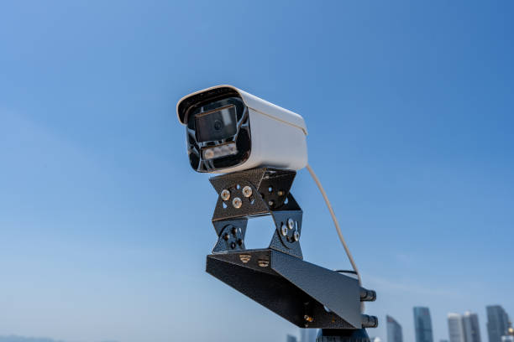
Image 1:


Image 2:

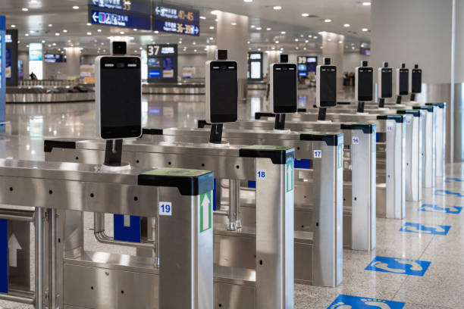
Image 3

Activity 2: Exploring Facial Recognition Technology through YouTube Clips – Group Investigation Activity

Learning Intentions
We will continue to develop our understanding of what facial recognition technology is as we prepare for the Convention.

Success Criteria
I will work collaboratively to identify and summarise the key points from my group’s YouTube clip and contribute to the class discussion on this topic.

Task Instructions:
1. Watch the ‘Behind the News’ Clip as a whole class, then discuss the ideas and points of view about facial recognition technology.
2. Your teacher will then assign you into a group (3-4 students) and allocate one YouTube clip to watch related to this topic.
3. As a group, write the key points your YouTube clip makes about facial recognition technology (sentence starters have been provided to help you)
4. Share your points with the rest of the class.

This activity starts over the page, on page 9.
  - Class discussion on Behind the News clip
Behind the News – Facial Recognition (3.41 minutes)
Questions to consider: (students can make notes as they watch the clip)
  - What is facial recognition technology?
  - How does facial recognition technology work?
  - Identify two ways facial recognition can be used in the real world.
  - Explain two problems or concerns linked to facial recognition technology.
  - What was the issue or problem with Bunning’s use of facial recognition technology?
  - Why is more government regulation needed for this technology?

Group 1: How facial recognition works.
Tech Round – What is Facial Recognition Technology? (4:51 minutes).
Sentence Starters to guide your notetaking as you watch the clip:
Facial recognition technology is
It works by
First, the system
Next, it
Then, it compares
This helps to

An example of this
One benefit
One concern
Overall, this video clip shows

Group 2: Strengths and weaknesses of facial recognition
Technologist – The Pros and Cons of Facial Recognition Technology (8.39 minutes)
Sentence Starters to guide your note-taking as you watch the clip:
One strength of facial recognition
Another strength
An example
One weakness of facial recognition
Another weakness
The video clip suggests that

Group 3: Ethical or moral issues and risks linked to facial recognition
Risk Bites – What are the risks and ethics of facial recognition tech? Public Interest Technology (4.29 minutes)
Sentence Starters to guide your note-taking as you watch the clip:
The clip states that:
However, there are important ethical issues that must be considered including:
Privacy:
Fairness and bias:
Government regulations:

Group 4: How facial recognition works
The Free 4U – How Face Recognition Works? (5.10 minutes)
What is facial recognition technology?
Five steps of facial recognition
1. Image Capture:
2. Face Detection:
3. Feature mapping:
4. Comparison:

5. Result:
Where is facial recognition technology used?
Facial recognition is not perfect because:

As the technology continues to develop:

In summary:

Group 5: Facial recognition: How it works
AFP News Agency – Facial recognition. How does it work? (1.17 minutes)
What is facial recognition?

How does facial recognition work?

Why is facial recognition used?

Some concerns about the use of facial recognition:

Activity 3: Australia’s Privacy Laws

Activity 3a: Did You Know? – Cloze Activity
Learning Intentions
We will learn more about how current privacy laws protect people when facial recognition technology is used.

Success Criteria
I can explain Australia’s current privacy laws and consider whether they are enough to protect individual rights.

Task Instructions:
1. As a class, read the ‘Did You Know’ facts and then complete the cloze activity independently.
2. Complete the extension question and share your thoughts with the class on whether the current regulations for facial recognition technology are strong and effective. (i.e. they work)


- In Australia, facial recognition is mainly regulated under the Privacy Act 1988 and applies to Government agencies (such as the Taxation Office and the Federal Police) and many private businesses.
- The Privacy Act includes the Australian Privacy Principles (APPs), which set out the rules that organisations must follow to protect people’s personal information.
- Facial recognition technology can be used to identify a person or prove their identity using a facial image.
- You cannot change your facial features, which is why facial images used for identification are considered sensitive information under the Privacy Act and have stronger legal protection.
- Businesses usually need clear and informed consent before collecting sensitive information. This means you should know when your data is being collected, why it is being collected, and how it will be used, and you should be given the choice about whether to agree to it.
- Walking into a store may not count as valid consent.
- The Privacy Act wants organisations to balance safety and security with privacy and individual rights.
- Organisations can only collect sensitive information if they genuinely need it to do their job.
- Organisations must take reasonable steps to keep personal information secure and prevent it from being misused, lost, accessed or shared without permission.
- Businesses usually need clear permission where people understand what they are agreeing to before they collect sensitive information.
- The law requires organisations to balance safety and security with privacy and individual rights.
- The Office of the Australian Information Commissioner (OAIC) can investigate privacy breaches to decide if the law has been broken.
- Because facial recognition technology collects biometric data, businesses and government agencies using it must comply or follow the Privacy Act and the Australian Privacy Principles.

Cloze Activity – Use the information above to fill in the missing words:
- In Australia, facial recognition is mainly regulated under the _____________________________________.

- The Privacy Act includes the ________________________________________________which set rules for protecting personal information.

- Facial recognition technology can be used to ___________who someone is or _________ their identity.

- A facial image used for identification is considered _________________ information under the law.

- Biometric data usually requires clear and ______________ consent before it can be collected.

- Consent must be ___________ which means that people understand why their data is being _____________and how it will be ____________.

- Simply walking into a store may not be considered valid _______________.

- Organisations can only collect sensitive information if it is _______________ for them to do their job.

- Organisations must take reasonable steps to keep personal information ____________ and prevent its _________ or unlawful_____________.

- If privacy laws are breached or broken the ______________________________________________can investigate this matter.

Extension question:

Do you think the Privacy Act 1988 is strong enough to regulate facial recognition technology? Give reasons for your answer.

Activity 3b: Application Scenarios – Group Work
Learning Intentions
We will apply our knowledge of Australia’s current privacy laws to real-life scenarios involving facial recognition technology.

Success Criteria
I can identify when facial recognition technology is being used in a scenario and whether privacy rights have been affected.

Task Instructions:
1. Your teacher will allocate a scenario to each group of 3-4 students.
2. As a group, read your allocated scenario and discuss the questions that follow.
3. Prepare a summary of your ideas and share with the rest of the class.

Scenario 1: Shopping Centre Security
A shopping centre has installed facial recognition cameras at all the entrances to help reduce shoplifting and other criminal activity. A small sign at each entrance says ‘CCTV in operation for security purposes’. Customers are not given any further details about how the technology works, what data is collected, how long it is stored for and if it is shared.
Consider the following:
- Is this informed consent?
- Is scanning everyone who comes into the shopping centre necessary?
- Does this balance safety and privacy?
Scenario 2: School Attendance System
A school introduces facial recognition technology to automatically record student attendance. Parents are told that it will save time, but they are not given any further details about how the data will be collected, stored or protected.

Consider the following:
- Is consent properly informed for both students and parents
- Is the use of biometric data necessary for school attendance?
- What are the privacy and security risks of collecting and storing students’ facial data?

Scenario 3: Concert Entry
A music venue uses facial recognition technology to verify or prove ticket holders and prevent ticket fraud. Customers must scan their faces to enter the venue. There is no alternative method of identity verification or proof allowed, and entry is refused if a person does not agree to the facial scan.
Consider the following:
- Can consent be considered as voluntary if there is no other way to enter the venue?
- Is requiring facial recognition fair to stop ticket fraud?
- Does this rule allow a balance between the interests of the business and the privacy rights of individuals?

Scenario 4: Gym membership
A gym replaces swipe cards with facial recognition technology to stop membership sharing. Members are told the system is more convenient and secure, but they are not offered another option to use the facilities.
Consider the following:
- Do members have a real choice here, or is their consent compulsory?
- Is the collection of sensitive information necessary to prevent membership sharing?
- Is this approach a balance between the needs of the business and individual privacy rights?
Scenario 5: Office Building Access
A corporate office building installs facial recognition technology to monitor employees as they enter and leave the workplace. Employees are told that this is to improve security and accurately track their attendance.
Consider the following:
- Can employees refuse to use this technology?
- Does the employer’s authority make it harder for employees to say no?
- How should the organisation protect this data?

Note-taking space

Activity 4: Media Analysis – Mind Map Group Work Activity
Learning Intentions
We will consider different viewpoints about facial recognition technology and decide whether it achieves a fair balance between public safety and individual privacy.

Success Criteria
I can identify and list the main arguments for and against the use of facial recognition technology from reading one or more of the articles provided.

Task Instructions:
Five articles outline the strengths and weaknesses of facial recognition technology. One article has been provided, and the remaining four are available through the attached links. Your teacher will assign each group of 3-4 students one article to read and complete the following tasks:
1. Carefully read your group’s allocated article and highlight the arguments both supporting and opposing the use of facial recognition technology.
2. Record these arguments in the mind map provided, placing each point into either the ‘For’ or ‘Against’ category.
3. For every argument identified, decide whether it mainly related to:
*Safety (S)
*Privacy Rights (P)
*Government Responsibility (G)
and place the appropriate letter (S, P or G) next to each point in the mind map.
4. Write a short paragraph (4-5 lines) explaining which category, i.e. Safety, Privacy or Government Responsibility, is the most strongly highlighted in your article.

This activity starts over the page, on page 22.

Article 1: Facial Recognition Technology: Fighting Tool or Privacy Threat?
NEWS TODAY
Tuesday, March 17, 2026


Facial Recognition Technology: Fighting Tool or Privacy Threat?
Imagine walking into Highpoint or Northland Shopping Centre and being identified before you even step inside your favourite shop. No ID card, no ticket, just your face.

Facial recognition technology is fast becoming part of our everyday lives. Many of us already use this technology to unlock our mobile phones. It is also being used in airports, at large events and sometimes by the police to identify suspects. Is this then technology that is a threat to our privacy, or is it a safety measure we cannot live without?

Police and security agencies tell us that facial recognition can help solve crimes faster. Instead of spending hours going through CCTV footage, the police can use the technology to quickly match a face to a database. Traveller’s identities can be checked at airports to reduce fraud, while at concerts or sporting events, this can help find people who are banned or considered dangerous.

Many supporters of this technology believe that governments have the responsibility to protect their citizens. If this type of technology can help prevent crime or act more quickly in emergencies, then they argue it should be used. Supporters of this technology also point out that many people are already choosing to use facial recognition on their devices. So, if we trust it on our phones, then why not in public spaces with proper rules?

However, not everyone feels comfortable with the idea of their face being scanned without their knowledge. Remember, with your mobile phone, you can choose to use facial recognition, whereas when it happens in public, people may not know when or where the data is being collected.

This raises the problem of consent or permission. Should your face be stored in a database without your knowledge or permission? There is also the question of accuracy, as studies have shown that facial recognition systems do not always get it right. What does this actually mean? Mistakes can lead to innocent people being questioned or treated unfairly. Critics of this technology are concerned that if there are no strong laws, then facial recognition could lead to constant monitoring or the feeling of being watched all the time.

The question is to find the right balance. Governments have a responsibility to keep people safe, but they also have a duty to protect individual rights related to privacy and freedom.

Some believe the solution is strong regulations. This means clear rules about when facial recognition can be used, how long data can be stored and who can have access to it.
The challenge is making sure we stay safe without taking away people’s personal freedom.

Article 2:
Click on the link below and carefully read the article
The Conversation – How safe is your face? The pros and cons of having facial recognition everywhere

Article 3:
Click on the link below and carefully read the article
Kaspersky – What is Facial Recognition – Definition and Explanation

Article 4:
Click on the link below and carefully read the article
The Knowledge Academy – Pros and Cons of Facial Recognition: An Overview

Article 5:
Click on the link below and carefully read the article
IT Pro – The pros and cons of facial recognition technology

Mind Map Template:
ARGUMENTS IN FOR FACIAL RECOGNITION TECHNOLOGY 👍 | ARGUMENTS AGAINST FACIAL RECOGNITION TECHNOLOGY👎

Summary:

Activity 5: The Bunning’s Breach Case Study and other articles – Reading Comprehension Activity
Learning Intentions
We are learning to analyse real-world examples of facial recognition technology and assess whether businesses and governments are balancing safety with individuals’ privacy rights.

Success Criteria
I can identify the legal and moral issues raised in the Bunnings case study and compare different media perspectives on the use of facial recognition technology.

Task Instructions:
1. Read the two articles about the Bunnings facial recognition case and answer the questions that follow.
2. Share your answers with the rest of the class in a group discussion.
3. In pairs, read one of the two additional articles provided and make some dot points under the headings given, and be prepared to share these points with the rest of the class. (optional)

1. Media Release
Bunnings and Facial Recognition: What happened?

Australia’s Privacy Commissioner Carly Kind found that Bunnings breached privacy laws by using facial recognition technology in some of its stores. Between 2018 and 2021, 63 Bunnings stores across Victoria and New South Wales used CCTV cameras with facial recognition software. This system scanned and recorded the faces of everyone who walked into the store.
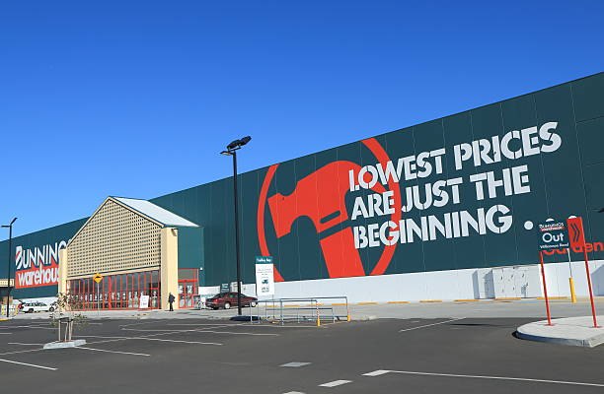
The Commissioner said that the facial recognition technology is one of the most ethically challenging technologies being used today. While it may help prevent crime or reduce violence, businesses must balance security methods with people’s right to privacy. The decision made it clear that just because a technology is useful or convenient does not mean it is legal or morally acceptable. In this case, Bunnings used an excessive approach by scanning all the customers, instead of focusing only on those suspected of wrongdoing.

The Commissioner found that Bunnings collected sensitive personal information (people’s facial images) without obtaining proper consent. Customers were not clearly informed that their faces were being scanned, and the company did not provide enough detail in its privacy policy about how the technology was being used. This means that most customers were not aware that their biometric information was being collected and stored.

Following the investigation, Bunnings stopped using the facial recognition system. The Commissioner ordered the company not to repeat these privacy breaches and reminded all businesses and organisations that when introducing new technologies, they must follow privacy laws and carefully consider the effect on individual rights.

Adapted from: https://www.oaic.gov.au/news/media-centre/bunnings-breached-australians-privacy-with-facial-recognition-tool

  - Do you think customers gave proper consent for the use of facial recognition technology by just walking into Bunnings, or was this not enough? Why/Why not?
- Is a small sign at the entrance of the Bunning store enough to clearly inform customers that their facial (biometric) data may be collected? Why or why not?
- If the aim or goal is to reduce shoplifting, could Bunnings have used other methods instead of facial recognition technology? Give some examples.
- Do you think the law should require businesses to seek clear permission before using technologies like facial recognition, even if they say it is for safety? Give reasons for your opinion.
- Do you agree with the findings of the Commissioner? Why/Why not?

Newspaper article 2:
ABC News – Bunnings wins fight to use AI facial recognition tech to combat store crime, opening door for other retailers.
  - What did the Administrative Review Tribunal decide about Bunning’s use of facial recognition technology in its stores?
- Why did the Tribunal say Bunnings was allowed to use facial recognition to help crime and staff safety?
- What did the Tribunal say Bunnings needed to improve, even though they could use the technology?
- How might this ruling effect other large stores or businesses in Australia?
- Do you think it is more important for Bunnings to protect privacy or prevent crime? Give reasons for your answer using the information in the article.

Additional newspaper articles to consider:
Newspaper Article 3:
Real Commercial – Face scans to become ‘commonplace’ in Australian shops
What the article says about legal changes:
• ____________________________________________________________________________________________
• ____________________________________________________________________________________________
• ____________________________________________________________________________________________
• ____________________________________________________________________________________________
Why retailers may use facial recognition
• ____________________________________________________________________________________________
• ____________________________________________________________________________________________
• ____________________________________________________________________________________________
• ____________________________________________________________________________________________
Possible benefits of the technology
• ____________________________________________________________________________________________
• ____________________________________________________________________________________________
• ____________________________________________________________________________________________
• ____________________________________________________________________________________________
Risks the article raises about this technology
• ____________________________________________________________________________________________
• ____________________________________________________________________________________________
• ____________________________________________________________________________________________
• ____________________________________________________________________________________________
What this could mean for shopping in the future
• ____________________________________________________________________________________________
• ____________________________________________________________________________________________
• ____________________________________________________________________________________________
• ____________________________________________________________________________________________

Newspaper Article 4:
The Conversation – Australians like facial recognition for ID but don’t want it used for surveillance, new survey shows
What the survey found
• ____________________________________________________________________________________________
• ____________________________________________________________________________________________
• ____________________________________________________________________________________________
• ____________________________________________________________________________________________
When Australians support facial recognition
• ____________________________________________________________________________________________
• ____________________________________________________________________________________________
• ____________________________________________________________________________________________
• ____________________________________________________________________________________________
When Australians do not support it
• ____________________________________________________________________________________________
• ___________________________________________________________________________________________
• ____________________________________________________________________________________________
• ____________________________________________________________________________________________
Concerns about the technology
• ____________________________________________________________________________________________
• ____________________________________________________________________________________________
• ____________________________________________________________________________________________
• ____________________________________________________________________________________________
Why consent and clear rules matter
• ___________________________________________________________________________________________
• ____________________________________________________________________________________________
• ____________________________________________________________________________________________
• ____________________________________________________________________________________________

Activity 6: The Town Hall Meeting – Role Play Activity
Learning Intentions
We are learning to explore different viewpoints about using facial recognition technology in the community and the need to develop fair and balanced rules that protect both safety and individual rights.

Success Criteria
I can clearly explain my assigned viewpoint using relevant arguments for this topic, listen to opposing perspectives and contribute in class, developing three clear and fair ‘Golden Rules’.

Task Instructions:
1. You will be assigned a role and must present and defend that perspective or point of view in relation to the proposed installation of facial recognition technology at all the public parks.
2. As a class, you will then work collaboratively to develop three “Golden Rules” that reflect and balance the key arguments raised during the role play.

Scenario:
A fictional suburb is considering installing facial recognition technology in all the public parks to reduce vandalism, theft and anti-social behaviour. A town hall meeting is called to discuss this proposal before a final decision is made.

The roles:

The mayor: Worried about the cost and how it will affect the budget but still wants to appear tough on crime.

The tech CEO: Selling the software and claiming that it is 99% accurate and highly effective.

The privacy spokesperson: Worried about the technology leading to constant monitoring, the misuse of personal information and the need for people’s privacy.

The student: Concerned about studies showing the technology may be less accurate for certain ethnic groups.

The local shop owner: Tired of their windows being smashed, continuous graffiti and theft, so wanting stronger security methods.

Goal:
After hearing all the points of view, the class must work together to develop three golden rules about how the government should regulate the use of facial recognition technology on this project.
The following headings are suggestions:
Rule 1: Limits on Use

Rule 2: Strong Privacy Protection

Rule 3: Fair and Accurate

POST CONVENTION ACTIVITIES

Activity 1a: Quickfire Question Round
Learning Intentions
We will understand and reflect on the key arguments for and against facial recognition technology and how government regulation balances safety and individual rights.

Success Criteria
I can state my position on whether the government should regulate the use of facial recognition technology with justification and listen respectfully to the opinions of other students.

Task Instructions:
1. This questioning activity is designed to be fast-paced, encouraging students to respond quickly, clearly and briefly to a series of short questions. It aims to check students’ understanding, promote quick thinking and build confidence in speaking.
2. The class is arranged in a circle to create an inclusive and focused discussion space. The teacher asks short, specific questions, allowing each student about 5-15 seconds to think before responding. Answers should be brief, limited to one sentence, with no detailed explanations or notes.

Questions:
- Should governments regulate facial recognition technology?
- Should police need a warrant (court order) to use facial recognition?
- Should businesses like Bunnings be allowed to use facial recognition technology in their stores?
- Should schools be allowed to use facial recognition for attendance?
- Should shopping centres like Northland, Highpoint and Westfield use facial recognition for security?
- Should facial recognition data be stored over a long period of time?
- Should people have the right to withdraw consent (permission) to facial recognition systems?
- Should children’s facial data receive extra legal protection?
- Should the government ban facial recognition in public protests or demonstrations?
- Should facial recognition be used to improve national security?

Activity 1b: If I were the Government – Write a Law Activity
Learning Intentions
We will learn how laws are created to balance people’s rights and responsibilities and examine (closely look at) the government’s role in managing new technologies.

Success Criteria
I can explain the purpose of the new law by showing how it balances the individual’s right to privacy with the need for security.

Task Instructions:
1. Students draft/plan a short law regulating facial recognition technology in pairs or groups using the dot points and the template provided to help them write the law.
2. Each pair or group then presents their law to the rest of the class

Steps to writing a law:
- Title or heading of the law
- Purpose or reason for the law
- Who the law applies to
- Three rules outlining how the law relating to facial recognition technology can or cannot be used
- The consequences of breaking this law

Complete the template on page 33 for your new law:

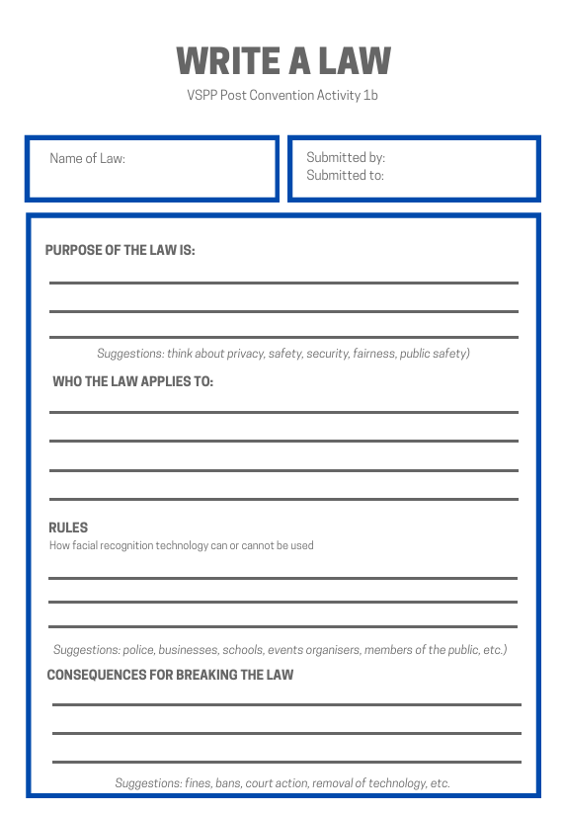

Sample Law for E-Bikes
Title: E-Bike Safety Regulation Act 2026

Purpose: The purpose of this law is to ensure the safe use of electric or e-bikes on roads and pathways to reduce accidents, protecting both the riders and pedestrians.

Who does the law apply to: This law applies to all e-bike riders, parents and guardians of riders who are under 18, businesses selling e-bikes and businesses that use e-bikes for their deliveries.

Rules about how e-bikes can or cannot be used:
1. Riders under 16 years of age must wear a helmet at all times
2. E-bikes must not go faster than 25 kilometres per hour on roads or footpaths
3. E-bikes cannot be used to ride on footpaths in busy shopping centres
4. Riders must not use their mobile phones while riding
5. All e-bikes sold must meet Australian safety standards
Consequences of breaking this law:
- Fines of up to $500 for speeding or riding without a helmet
- Confiscation or removal of the e-bike for those who reoffend or break the law more than once
- Business who sell illegal E-bikes will be fined

Activity 2: Media Response – Writing Activity
Learning Intentions
We are learning how governments regulate (make laws) new technologies, how laws balance rights and responsibilities and how to communicate these ideas through a suitable platform.

Success Criteria
I can explain what facial recognition technology is, provide arguments for and against its use and link these arguments to rights such as privacy and responsibilities such as security.

Task Instructions:
1. Students are to create a media response about the use of facial recognition technology, choosing one of the following options:
a. Newspaper article (approximately 300 - 400 words)
b. Social media post for either Instagram, Facebook, or Twitter/ (X (slides or detailed posts)
c. A short interview script that has 8-10 questions that they will use to interview another student. They will then summarise the key ideas to explain the position of the interview on this topic.
2. Students are required to reflect on the debate during the Convention and include at least two arguments in favour of the need for governments to regulate facial technology recognition and two arguments opposing regulation. They must also state their overall position on the issue, which would mean:
*A summary paragraph in the newspaper article
*A final slide or post in the social media task
*Concluding statement for the interview activity

Structure to Guide the Activity
- Newspaper article
Headline
Introduction – what is the issue and why it is important
Body paragraph 1: Argument for the need to regulate facial recognition technology
Body paragraph 2: Arguments against the need for regulating facial recognition technology
Conclusion (final opinion)

- Social Media Post
Slide/Post 1: What is facial recognition
Slide/Post 2: Why some people support it
Slide/Post 3: Why some people oppose it
Slide/Post 4: My opinion

- Interview Questions (sample):
What is facial recognition technology?
Why do some people support this technology?
Why are some people concerned about it?
Should there be regulations for facial recognition technology? Why/why not?
One major benefit is…
One major concern is…
Overall conclusion

Activity 3: Where do I Stand? – Human Continuum Activity
Learning Intentions
I will reflect on this Convention topic and decide whether I am in favour of or against it.

Success Criteria
I can clearly state my opinion and give one reason for my position after having participated in the Convention.

Task Instructions:
1. Place a sign on one side of the room that says:
Strongly Agree
(The government should regulate facial recognition technology)
On the opposite side, place a sign that says:
Strongly Disagree
(The government should not regulate facial recognition technology)
2. Students will first move to the side of the room that reflects their initial position on this topic before they attended the Convention.
3. Students are then asked to move again to show their final position on this topic, i.e. whether they agree or disagree with the statement.
4. Selected students will then be invited to explain why they changed their position or why they chose to remain with the same opinion.

Step 1:
Your teacher will read a statement (Governments should regulate the use of facial recognition technology), and you will be required to move to the side of the room that best reflects your opinion before this Convention.
Your teacher will select a student from each side (i.e. one who strongly agrees and one who strongly disagrees) to briefly state why this was their position.
Step 2
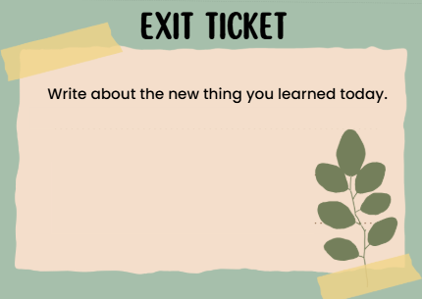
Your teacher will read the statement out again, and this time you will move to the side that best reflects your position after the Convention.
Your teacher will then select students from both sides to explain why they moved/did not move and which arguments influenced them the most.
Step 3
Complete the exit ticket to reflect on your experience in the convention, including the pre- and post- activities.

