

Victorian Schools Parliamentary Program (VSPP)
2026 ONLINE SECONDARY SCHOOL CONVENTION
Topic
Should Victoria require registration and licensing of e-bikes and e-scooters, or are there better ways to regulate them?

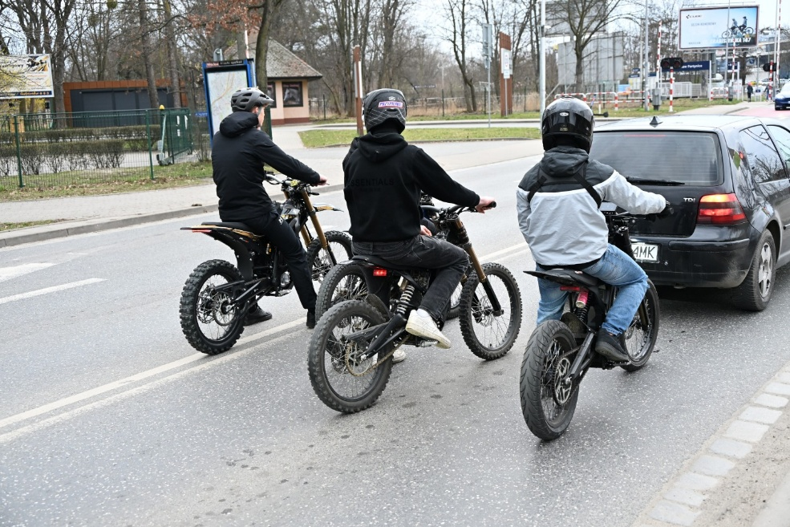

STUDENT ACTIVITIES

Contents
LEARNING INTENTION FOR THESE STUDENT ACTIVITIES: 3
SUCCESS CRITERIA FOR THESE STUDENT ACTIVITIES: 3
Activity 1: Introductory Activities 4
Activity 1a: Transport Regulation Challenge – How Much Do You Know Activity 4
Activity 1b: E-bikes and E-Scooters – Comparison and Comprehension 9
Activity 2: Understanding Victoria’s Laws 13
Activity 2a: Fact-Checking Victoria’s Current Road Laws – True/False Research Activity 13
Activity 2b: Road Rules in Action – E-Bike and E-Scooter Scenario Activity 15
Activity 3: Whose Lane is it Anyway? Stakeholder Mapping Activity 17
Activity 4: Media Messages: E-bikes and E-scooters in the Headlines – Group Activity 20
Activity 5: E-Bikes and E-Scooters: Safety or Freedom? Video Analysis: Group Work Activity 25
Activity 6: Unpacking the Problems with E-Bikes and E-Scooters in Victoria – Group Analysis Activity 30
Activity 7: What can Victoria Learn from E-Bike and E-Scooter Laws in Other Countries? - Global Investigation Activity 32
Activity 7a – Global Rules Comparison (Individual student activity) 34
Activity 7b – World Map investigation (Individual or Pair Activity) 35
Activity 7c – Traffic Light Ranking: Evaluating Policy Options (Small Group Activity) 36
Activity 7d – What should Victoria do? (Class Discussion) 37
Activity 8: Policy Spectrum Activity 38
Activity 9: Beyond Registration and Licensing: Finding the Best Approach to Regulating E-Bikes and E-Scooters in Victoria – Group Discussion Activity 41
POST CONVENTION ACTIVITIES 45
Activity 1: The Problem and the Solution – Infographic Activity 45
Activity 2: Should Victoria Introduce Licensing and Registration for E-Bikes and E-Scooters? – Argument Carousel Activity 48
Activity 3: Policy Recommendation Task – Reflection Activity 50

LEARNING INTENTION FOR THESE STUDENT ACTIVITIES:
By the completion of these activities, students will be able to:
- Understand the current laws and regulations relating to e-bikes and e-scooters in Victoria.
- Examine different arguments in favour of registration and licensing as well as arguments opposing registration and licensing of e-bikes and e-scooters.
- Consider alternative ways Victoria could regulate e-bikes and e-scooters, including education programs, speed limits, age restrictions and stronger enforcement measures.
- Improve communication and critical thinking skills through class discussions, participation at the Convention and completion of pre- and post-Convention activities.

SUCCESS CRITERIA FOR THESE STUDENT ACTIVITIES:
Students will be able to:
- Accurately explain the current rules and laws relating to e-bikes and e-scooters in Victoria.
- Present different viewpoints on whether registration and licensing of e-bikes and e-scooters should be required in Victoria.
- Identify and evaluate alternative regulatory approaches that could improve safety and responsible use of e-bikes and e-scooters.
- Actively and confidently contribute to discussions and Convention activities by responding to questions, sharing ideas and using evidence to justify their opinions on the issue of e-bike and e-scooter regulations in Victoria.

Activity 1: Introductory Activities

Activity 1a: Transport Regulation Challenge – How Much Do You Know Activity

Learning Intentions
We are learning to identify different forms of transport and understand laws, rules and safety requirements that apply to them in Victoria.
Success Criteria
I can identify different forms of transport, explain if a licence or registration is required and the laws and safety rules that apply to different types of transport used in Victoria.

Task Instructions:
1. As a class, carefully look at the six transport images shown by your teacher.
2. Identify the type of transport shown in each image, e.g., a car.
3. For each form of transport, brainstorm and record in the table on page 8:
*Any laws or rules that apply in Victoria.
*Whether a licence is required.
*Whether registration is required (registration means a vehicle is officially recorded with the government so it can legally be used on public roads).
*Any safety rules riders or drivers must follow.
4. As a class, discuss which forms of transport you think should have stricter regulations (i.e. speed, age of riders or drivers, danger to pedestrians and other road users, environmental impacts).

Image 1: ________________________
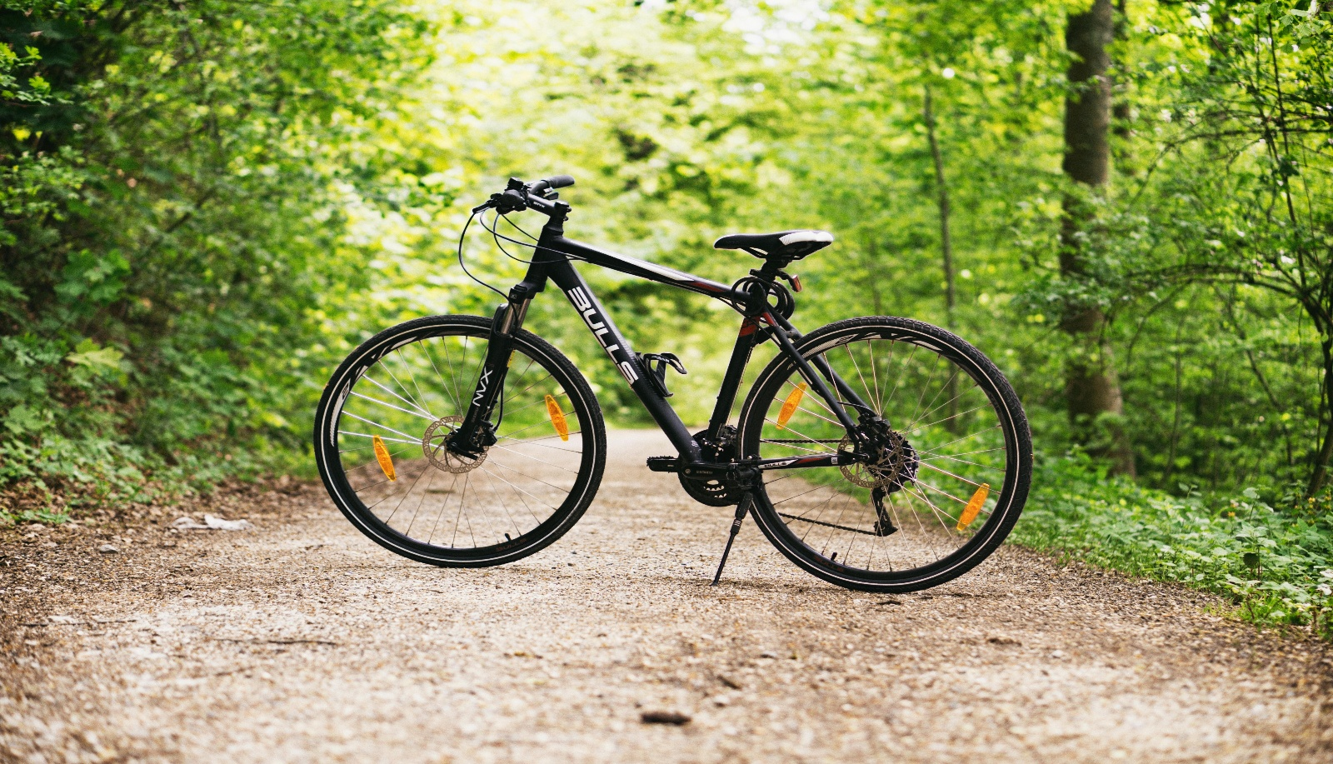

Image 2: _____________________________
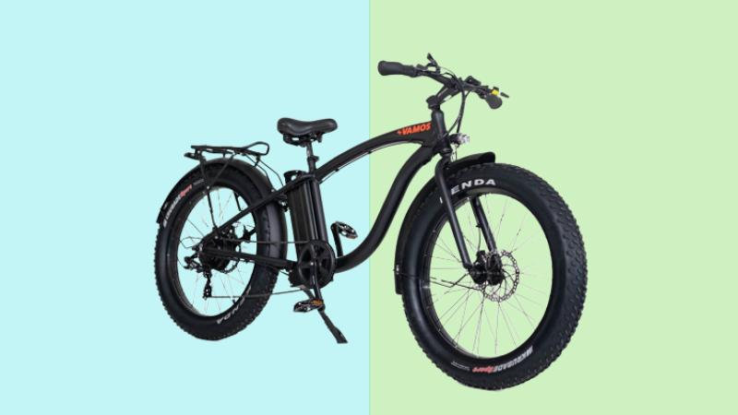

Image 3: __________________________
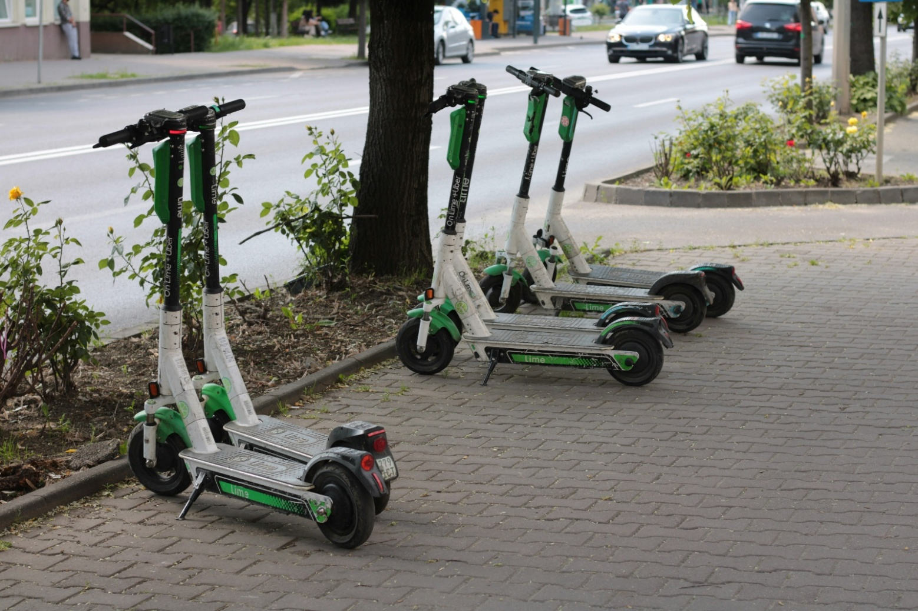

Image 4: ___________________________
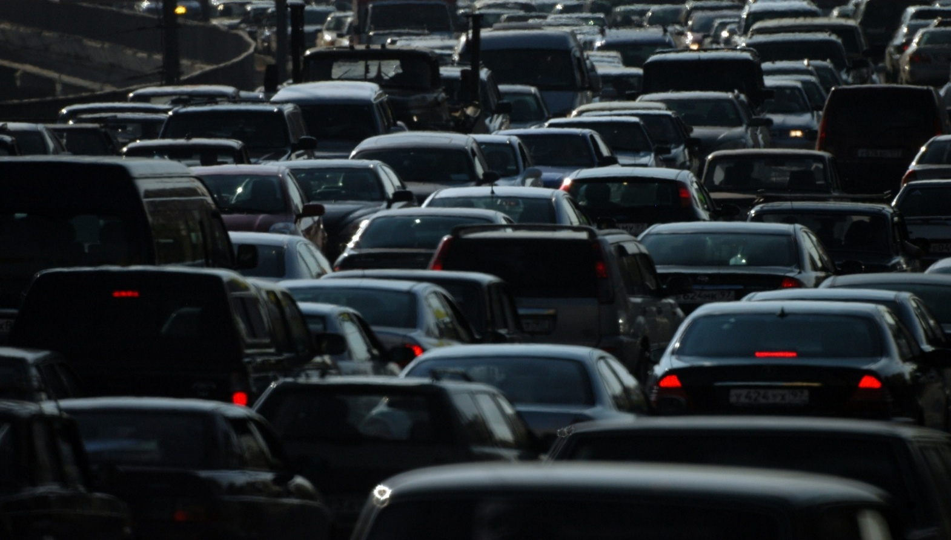
Image 5: ____________________
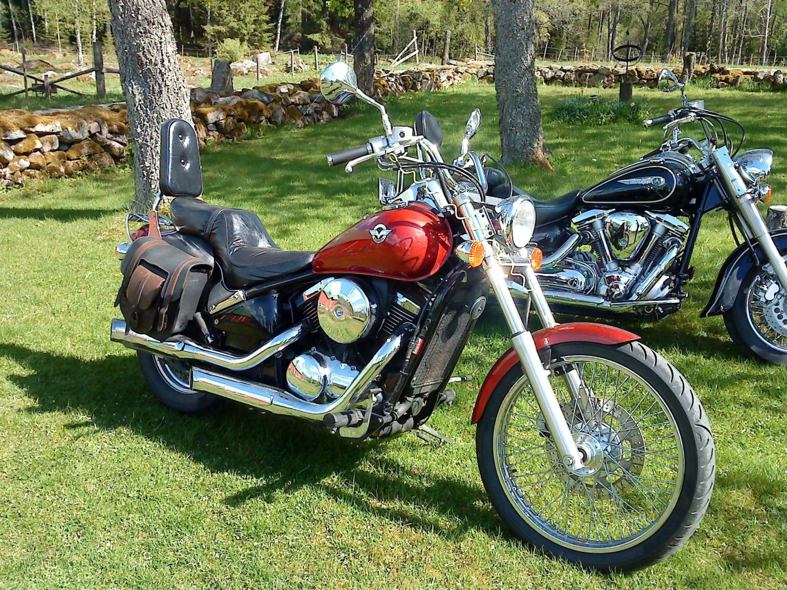

Image 6: _______________________
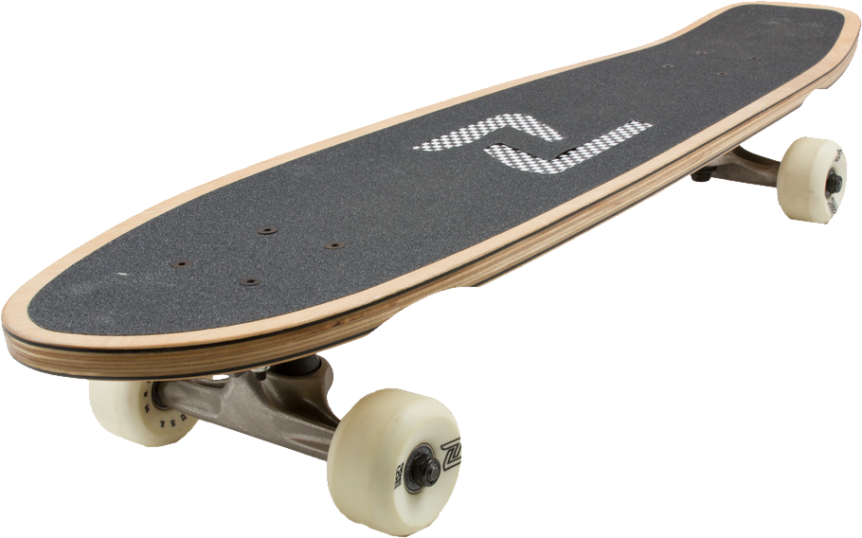

Type of Transport | List laws or rules that apply in Victoria. | Is a licence required? | Is registration required? | List safety rules that riders or drivers must follow.
Car
Bicycle
E-bike
E-scooter
Motorcycle
Skateboard

Activity 1b: E-bikes and E-Scooters – Comparison and Comprehension

Learning Intentions
We are learning to understand what e-bikes and e-scooters are, how they are used in Victoria and the laws and safety rules that apply to them.
Success Criteria
I can describe what e-bikes and e-scooters are. I can explain how they are powered and ridden and identify key Victorian laws and safety rules.

Task Instructions:
1. Read the information provided about e-bikes and e-scooters in Victoria.
2. Complete the comparison table on page 11 by identifying both similarities and differences between e-bikes and e-scooters.
3. Use the information provided as well as your own knowledge and experiences.
4. Think about how each form of transport works, the laws and rules that apply in Victoria, why people use them, and the benefits and concerns about each method of transport.
5. After completing the table, compare your answers with another student and then work together to answer the discussion questions.
6. Share your answers with the rest of the class.

Electric bikes (e-bikes) are bicycles fitted with an electric motor that helps the rider while they pedal. In Victoria, legal e-bikes are treated the same as ordinary bicycles, meaning that riders do not need a licence, registration or compulsory insurance.

To be legal, an e-bike must:
- have working pedals,
- only provide motor assistance while the rider is pedalling,
- has a motor generally limited to 250 watts,
- stop providing electric assistance once the bike reaches 25 km/h (riders can travel faster by pedalling on their own).

An e-bike becomes illegal if it has:
- a motor that is too powerful,
- an accelerator that works without pedalling at higher speeds,
- a modified speed control system,
- a petrol engine attached.

Illegal e-bikes may be treated as an unregistered motor vehicle, which can result in large fines and the police seizing the bikes.

Electric scooters (e-scooters) are small battery-powered vehicles that are usually ridden standing up. In Victoria, both private and shared e-scooters are legal, provided riders follow strict regulations.

These rules include:
- a maximum speed limit of 20 km/h,
- compulsory helmet use,
- a minimum riding age of 16,
- no riding on footpaths.

These restrictions are designed to improve safety for riders and pedestrians.

Both e-bikes and e-scooters provide convenient, affordable and environmentally friendly transport options. However, there are concerns about safety risks, accidents and how well the rules can be enforced or put into practice.

Complete this comparison table referring to the information above and your own knowledge of e-bikes and e-scooters:
Questions | E-Bikes | E-Scooters
What are they?

How are they powered?

How are they ridden?

Victorian rules that apply.

Why do people like them?

Safety concerns.

Commonly used for…

The big question is…

Discussion questions: (Complete the following questions with another student)
Why are e-bikes and e-scooters becoming more popular?
___________________________________________________________________________________________________________________________________________________________________________________________________________________________________________________________________________________________________________________________________________________________________________________________________________________________________________________________________________________________________________________________________

What benefits do they provide to individuals and society?
___________________________________________________________________________________________________________________________________________________________________________________________________________________________________________________________________________________________________________________________________________________________________________________________________________________________________________________________________________________________________________________________________

What problems or dangers do they cause?
___________________________________________________________________________________________________________________________________________________________________________________________________________________________________________________________________________________________________________________________________________________________________________________________________________________________________________________________________________________________________________________________________

Activity 2: Understanding Victoria’s Laws

Activity 2a: Fact-Checking Victoria’s Current Road Laws – True/False Research Activity
Learning Intentions
We are learning about the current road laws in Victoria relating to e-scooters and e-bikes, and how to find reliable legal information.
Success Criteria
I can identify whether statements about Victorian road laws are true or false using evidence from reliable sources. I can record and explain where I found this information.

Task Instructions:
1. Read each statement carefully.
2. Use the website links provided to investigate whether each statement is TRUE or FALSE under current Victorian road laws.
3. For each statement, write down the website or source you used to find your answer.
4. Be prepared to discuss with the class which laws surprised you and why, how the laws are designed to improve safety for riders and whether the current laws balance safety, convenience and environmental benefits (e.g. less pollution, fewer traffic jams, etc.).
Website links:
Transport Victoria – E-Scooter road rules
Victoria Police – Electric powered scooters (e-scooters)
RACV – RACV issues e-scooter and e-bike warning as Victorian kids head back to school
Transport Victoria – Electric Bikes (e-bikes)

Statement | True/False | Source
1. Riders must be at least 16 years old to legally ride an e-scooter in Victoria.

2. E-scooters are allowed to be ridden on footpaths in Victoria.

3. E-scooter riders must wear a helmet.

4. You need a driver’s licence to ride a legal e-bike in Victoria.

5. Legal e-bikes must follow the same road rules as bicycles.

6. E-bikes in Victoria must have working pedals to be legal on public roads and paths.

7. E-scooter riders can lose their driver’s licence for riding under the influence of alcohol or drugs.

8. E-bikes and e-scooters are both considered motor vehicles requiring registration in Victoria.

9. E-scooters can legally travel faster than 25km/h in Victoria.

10. It is legal to carry a passenger on a single-person e-scooter in Victoria.

Activity 2b: Road Rules in Action – E-Bike and E-Scooter Scenario Activity
Learning Intention

We are learning to investigate and apply Victorian road laws relating to e-bikes and e-scooters to real-life situations.

Success Criteria

I can identify whether Victorian e-bike or e-scooter laws have been followed or broken in different scenarios and justify my decisions using evidence from relevant road rules.

Task Instructions:
1. In pairs, read each scenario carefully and decide if a Victorian e-bike or e-scooter law has been broken.
2. Identify the road rule or law that applies and give a reason for your choice.
3. Share your answers with the rest of the class.
E-Bike Scenarios:
Scenario 1:
Jack has an e-bike with a motor, which helps him ride at 45 km/h while riding on a shared path in Carlton. He does not pedal and lets the motor do all the work.
Has Jack broken the law? Explain which e-bike rule applies.
_____________________________________________________________________________________________________________________________________________________________________________________________________________________________________________________________________________________________________________________

Scenario 2:
Priya rides her e-bike to school. Her bike meets all the Victorian requirements, but she does not wear a helmet because she is only riding for a short distance.
Has Priya broken the law? Why?
______________________________________________________________________________________________________________________________________________________________________________________________________________
_______________________________________________________________________________________________________

Scenario 3:
Bao rides his e-bike home from the train station while carrying his younger brother on the back rack of the bike, even though the bike was not designed to carry passengers.
Has Bao broken the law? Explain your answer using Victorian bicycle/e-bike rules.
_____________________________________________________________________________________________________________________________________________________________________________________________________________________________________________________________________________________________________________________

E-Scooter Scenarios:
Scenario 4:
Deng rides her e-scooter along a busy footpath outside shops because she feels safer there than riding on the road.
Has Deng broken the law? Where are e-scooters allowed to be ridden in Victoria?
_____________________________________________________________________________________________________________________________________________________________________________________________________________________________________________________________________________________________________________________

Scenario 5:
Mele is 14 years old and rides an e-scooter to basketball training using local bike paths.
Has Mele broken the law? Identify the relevant e-scooter rule.
_____________________________________________________________________________________________________________________________________________________________________________________________________________________________________________________________________________________________________________________

Scenario 6
After a party, Wei rides his e-scooter home while still affected by alcohol. Police stop him and conduct a breath test.
Has Wei broken the law? What penalty could apply to e-scooter riders who are under the influence of alcohol?
_____________________________________________________________________________________________________________________________________________________________________________________________________________________________________________________________________________________________________________________

Activity 3: Whose Lane is it Anyway? Stakeholder Mapping Activity
Learning Intention

We are learning how different groups in the community are affected by the use and regulations of e-bikes and e-scooters.

Success Criteria

I can identify different stakeholders connected to e-bikes and e-scooters and explain their point of view and concerns. I can work collaboratively to develop and present a position statement supported by relevant reasons and examples.

Task Instructions:
1. Working in pairs or groups of three students, you will be assigned one stakeholder from the list below. Each stakeholder has a particular interest in how e-bikes and e-scooters are regulated in Victoria.
2. Using the template/guide provided, write a short position statement that includes:
i. Your stakeholder’s two main priorities or key interests.
ii. The stakeholders' biggest fear or concern if laws relating to e-bikes and e-scooters were changed.
3. Be prepared to present your position statement to the class. Explain your stakeholders’ perspective and justify why they hold this view.
For this activity, you will need to know what the following terms mean:
- Position Statement: A short explanation of what a person or group think about an issue and why they think that way.
  - Example: A pedestrian group might believe stricter e-scooter speed limits are needed to improve safety on footpaths.
- Stakeholder: A person or group who is affected by an issue or has a strong interest in what happens.
  - Examples: riders, pedestrians, police, and delivery drivers are all stakeholders in e-bikes and e-scooters because the rules affect them in different ways.
Stakeholders to be allocated to each pair/group:
- Teenage riders: they rely on cheap, green transport to get to their part-time jobs, school and social events.
- Pedestrian representatives: they use the footpath or shared paths and are worried about safety, especially if they are elderly, young children or visually impaired.
- Emergency department doctors: they see lots of injuries caused by crashes from high-speed falls and a lack of helmets.
- Small business owners: they want customers to access shopping strips and local businesses easily.
- Victoria Police: they are responsible for enforcing the laws and rules relating to e-bikes and e-scooters.
- Parents: they want their children to travel safely and responsibly.
- Schools: they are responsible for student safety and manage issues like where students can ride and park their e-bikes or e-scooters.
- E-bike retailers: they are keen to sell e-bikes and e-scooters to the public.
- Delivery drivers: they often rely on e-bikes and e-scooters for fast and affordable transport to deliver food or parcels.

Option 1: Scaffolded Version – A Guide to completing this task
Stakeholder Group:
_____________________________________________________________________________________________________
Our Stakeholder’s Position
We believe that_______________________________________________________________________________________
Our Two Main Priorities or Issues are
1. One important issue for our stakeholders is __________________________________________________________
because______________________________________________________________________________________________
2. Another important issue for our stakeholders is _______________________________________________________
because ______________________________________________________________________________________________
Biggest fear or concern of the Laws Change
Our biggest concern is that ______________________________________________________________________________________________________________________________________________________________________________________________________________
This could lead to ______________________________________________________________________________________
Suggested Rule or Solution
We believe the government should ______________________________________________________________________
_______________________________________________________________________________________________________

Option 2: Graphic presentation – stakeholder profile
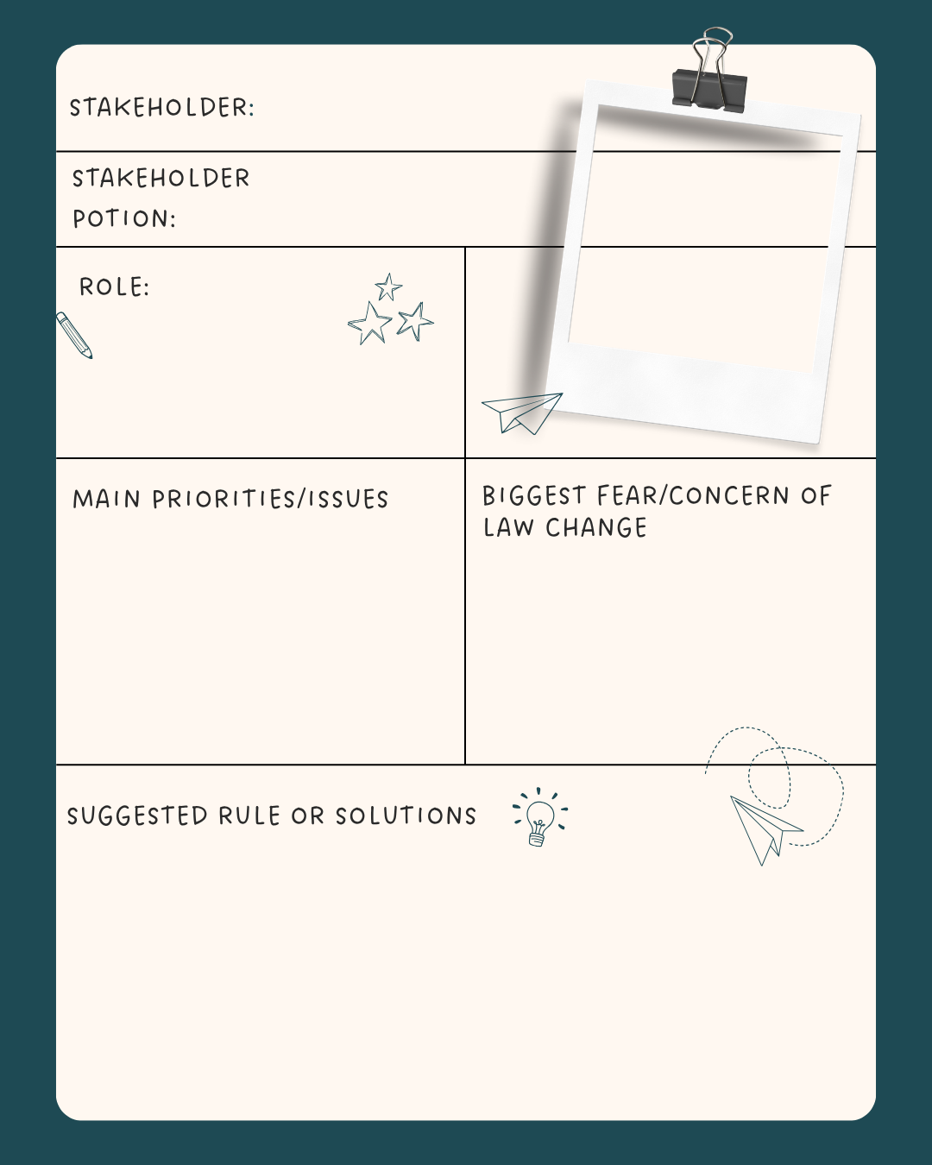

Activity 4: Media Messages: E-bikes and E-scooters in the Headlines – Group Activity
Learning Intention

We are learning to analyse how the media reports on issues related to e-bikes and e-scooters and evaluate or assess how media coverage can influence public opinion and government responses.

Success Criteria

I can identify the main issues discussed in a newspaper article and who is affected, consider the different points of view and explain how media coverage may influence public opinion and government decision-making.

Task Instructions:
1. Your teacher will place you in pairs or groups of 3-4 students and allocate ONE newspaper article or media report about e-bikes or e-scooters.
2. Read the article carefully and identify the main issues, viewpoints and concerns that are raised.
3. Complete each of the analysis questions using evidence and examples from the article to support your answers.
4. Share your findings with another pair/group and compare your responses.
5. As a class, discuss whether the media focuses more on the benefits or risks of e-bikes and e-scooters and write a brief summary in the space provided.
Article 1:
News.com.au – ‘E-bikes vs. Karens’: Unexpected response to teen bike swarms taking over Melbourne

Article 2:
Note: A summary of the article is provided below. The full article is available online if your school has a subscription to the Herald Sun.
Herald Sun – My e-bike beef and why Australia needs change
E-bike ‘scourge’ faces crackdown as states move to introduce new road rules

When a delivery rider brought peak-hour traffic to a crawl, chaos erupted — laying bare the dangers of a fast-growing, barely regulated e-bike free-for-all, writes Patrick Carlyon.

Patrick Carlyon, a senior journalist for the Herald Sun, examines the rapid growth of e-bikes and e-scooters in Australia and the growing concerns about their impact on road safety. He provides examples of riders speeding, ignoring road rules, riding without helmets and creating dangers for pedestrians, drivers and other road users. The article also highlights the growing number of injuries related to e-bikes and e-scooters, with hospitals reporting more emergency cases.

In response to these concerns or issues, governments are considering tougher regulations. Queensland has proposed new laws that would require riders to be at least 16 years old, hold a learner’s permit or current driver’s licence, obey speed limits and be required to take random breath tests. In New South Wales, police, legal experts and health officials have suggested introducing registration and compulsory third-party insurance to improve responsibility and safety.

The article presents different viewpoints on these proposals. Police, health professionals and legal experts believe that stronger laws are needed to reduce injuries and improve road safety. In contrast, cycling groups, disability organisations and delivery companies like Uber argue that stricter rules could make transport less accessible and negatively affect delivery workers who rely on e-bikes. Overall, the article presents e-bikes and e-scooters as a growing public issue that requires governments to balance convenience and innovation with community safety and regulation.

Article 3:
Note: A summary of the article is provided below. The full article can be accessed online if your school has a subscription to the Herald Sun
Herald Sun – ‘Happy to destroy them’: Police target illegal e-bikes
Officer offers to destroy illegal e-bikes as police tackle dangerous riding behaviour
A senior police officer says he will accept illegal e-bikes “for destruction” as dangerous youth riding behaviour escalates across the Bellarine Peninsula.

Geelong Advertiser

Oliver Condor of the Geelong Advertiser reports that there are growing concerns about dangerous e-bike riding on the Bellarine Peninsula (Geelong), particularly among young people using illegal or modified e-bikes. Police say some riders are travelling at speeds of more than 60 km/h without proper safety equipment, increasing the risk of serious injury or even death.

In response, police are encouraging parents to take responsibility by stopping their children from riding illegal e-bikes and, in some cases, handing the bikes over to be destroyed. Some young riders have already handed over their bikes as part of a police caution program instead of receiving large fines or going through the court system.

The articles also describes community concerns about unsafe riding behaviour, including reports of youths on e-bikes throwing objects at passing cars. Health professionals have reported an increase in injuries related to e-bikes and e-scooters and are participating in research to better understand the causes and effects of these accidents.

Overall, the article presents illegal and modified e-bikes as a growing community safety issue and emphasises the need for parental responsibility, safer riding behaviour and strong measures to reduce injuries and protect the community.

Article 4:
ABC News – Melbourne doctors call for greater regulation of e-scooters as injuries rise, clogging up hospitals
Article 5:
Bicycle Network – Coroner calls for e-scooter ban
Article 6:
RACV News – RACV issues e-scooter and e-bike warning as Victorian kids head back to school
Article 7:
National Seniors Australia – Crackdown on e-scooters and e-bikes
Article 8:
Nine.com.au – Kids’ e-scooter injuries balloon four-fold in just three years in Victoria, new research reveals

Headline Analysis Activity (each group completes one set of questions based on their article)
Question 1
State the headline of the article and describe what it suggests about e-bikes or e-scooters.
____________________________________________________________________________________________________________________________________________________________________________________________________________________________________________________________________________________________________________________________________________________________________________________________________________________________
Question 2
Outline the main issue/s or event/s discussed in the article.
____________________________________________________________________________________________________________________________________________________________________________________________________________________________________________________________________________________________________________________________________________________________________________________________________________________________
Question 3
Identify the individuals or groups affected by the issue/s and briefly explain how they have been affected. ____________________________________________________________________________________________________________________________________________________________________________________________________________________________________________________________________________________________________________________________________________________________________________________________________________________________
Question 4
List the concerns, problems or challenges highlighted in the article.
____________________________________________________________________________________________________________________________________________________________________________________________________________________________________________________________________________________________________________________________________________________________________________________________________________________________
_______________________________________________________________________________________________________
Question 5
Analyse the different viewpoints or opinions presented in the article.
____________________________________________________________________________________________________________________________________________________________________________________________________________________________________________________________________________________________________________________________________________________________________________________________________________________________
______________________________________________________________________________________________________________________________________________________________________________________________________________
Question 6
Decide whether the article presents e-bikes and e-scooters in a positive, negative or balanced way. Justify your answer using examples from the article.
____________________________________________________________________________________________________________________________________________________________________________________________________________________________________________________________________________________________________________________________________________________________________________________________________________________________
______________________________________________________________________________________________________________________________________________________________________________________________________________
Overall class discussion question
Does the media focus more on the benefits or the risks of e-bikes and e-scooters?
Your response: (to be completed individually)
________________________________________________________________________________________________________________________________________________________________________________________________________________________________________________________________________________________________________________________________________________________________________________________________________________________________________________________________________________________________________________________________________________________________________________________________________________________________________________________________________________________________________________________________________________________________________________________________________________________________________________________

Activity 5: E-Bikes and E-Scooters: Safety or Freedom? Video Analysis: Group Work Activity

Learning Intention

We understand the current laws and rules in relation to e-bikes and e-scooters in Victoria and discuss whether current laws are enough to balance safety, convenience and the benefits for the environment.

Success Criteria

I can identify and explain the current laws and rules for e-bikes and e-scooters in Victoria. I can use evidence and examples to discuss whether these laws are enough to keep people safe, while still allowing convenient and environmentally friendly transport.

Task Instructions:
1. Your teacher will place you into a group of 3-4 students. Each group will be allocated ONE video clip about e-bikes and e-scooters.
2. As you watch the clip, record important information, examples and opinions about e-bikes and e-scooters.
3. Work together to discuss and answer the questions provided after the clip.
4. Use evidence from the clips and your own knowledge of Victorian laws to support your answers.
5. Share your group’s ideas with the rest of the class.

Clip 1: BTN E-Scooter laws – Behind the News – E-Scooter laws (4 minutes 9 seconds)
a. Explain why e-scooters and e-bikes have become popular forms of transport.
_____________________________________________________________________________________________________________________________________________________________________________________________________________________________________________________________________________________________________________________

b. Describe the safety concerns about e-scooters mentioned in the clip.
_____________________________________________________________________________________________________________________________________________________________________________________________________________________________________________________________________________________________________________________
c. List some of the current laws or rules for e-scooters in Victoria.
____________________________________________________________________________________________________________________________________________________________________________________________________________________________________________________________________________________________________________________________________________________________________________________________________________________________

d. Discuss whether introducing registration or licences for e-bikes and e-scooters would improve safety in Victoria.
____________________________________________________________________________________________________________________________________________________________________________________________________________________________________________________________________________________________________________________________________________________________________________________________________________________________

e. Suggest other ways the government could improve safety without introducing registration or licences.
____________________________________________________________________________________________________________________________________________________________________________________________________________________________________________________________________________________________________________________________________________________________________________________________________________________________

f. Do you think the benefits of e-bikes and e-scooters outweigh the risks? Refer to examples from the clip to justify your choice.
____________________________________________________________________________________________________________________________________________________________________________________________________________________________________________________________________________________________________________________________________________________________________________________________________________________________

Clip 2: The debate over e-scooter safety – YouTube – Explained – How Electric Scooters Work: The Science of Urban Mobility (9 minutes 48 seconds)
a. Describe the advantages of using e-scooters or e-bikes in cities.
_____________________________________________________________________________________________________________________________________________________________________________________________________________________________________________________________________________________________________________________

b. Outline the safety risks can occur when people ride e- scooters or e-bikes.
_____________________________________________________________________________________________________________________________________________________________________________________________________________________________________________________________________________________________________________________

c. Explain why governments create laws and rules for e-scooters and e-bikes.
____________________________________________________________________________________________________________________________________________________________________________________________________________________________________________________________________________________________________________________________________________________________________________________________________________________________

d. Should riders need training or a licence before using e-scooters in public? Give reasons for your opinion.
____________________________________________________________________________________________________________________________________________________________________________________________________________________________________________________________________________________________________________________________________________________________________________________________________________________________

e. Recommend one law or rule you think Victoria should introduce to improve safety.
____________________________________________________________________________________________________________________________________________________________________________________________________________________________________________________________________________________________________________________________________________________________________________________________________________________________

f. Analyse whether e-bikes and e-scooters are a good long-term transport option for Melbourne.
____________________________________________________________________________________________________________________________________________________________________________________________________________________________________________________________________________________________________________________________________________________________________________________________________________________________

Clip 3: BTN - Should kids be allowed to ride e-bikes?
Behind the News – E-bikes, should kids be allowed to ride them? (3 minutes 46 seconds)
a. Explain why e-bikes are becoming increasingly popular with young people.
_____________________________________________________________________________________________________________________________________________________________________________________________________________________________________________________________________________________________________________________

b. Describe the safety concerns about e-bikes are discussed in the clip.
_____________________________________________________________________________________________________________________________________________________________________________________________________________________________________________________________________________________________________________________

c. Outline the current rules or restrictions that apply to e-bikes in Victoria.
____________________________________________________________________________________________________________________________________________________________________________________________________________________________________________________________________________________________________________________________________________________________________________________________________________________________

d. Explain why some people believe stricter laws or rules for e-bikes are needed.
____________________________________________________________________________________________________________________________________________________________________________________________________________________________________________________________________________________________________________________________________________________________________________________________________________________________

e. Discuss the advantages and disadvantages of young people using e-bikes.
____________________________________________________________________________________________________________________________________________________________________________________________________________________________________________________________________________________________________________________________________________________________________________________________________________________________

f. Do you think e-bikes should require registration, licensing or additional safety rules? Justify your answer.
____________________________________________________________________________________________________________________________________________________________________________________________________________________________________________________________________________________________________________________________________________________________________________________________________________________________
Clip 4: Regulating E-Bikes and E-Scooters in Victoria
Sunrise – Landmark parliamentary industry to investigate e-scooter safety reforms (2 minutes 38 seconds)
ABC News – E-scooter riders in Queensland could soon face stricter laws (6 minutes 30 seconds)
a. Describe the safety problems shown in the two video clips.
_____________________________________________________________________________________________________________________________________________________________________________________________________________________________________________________________________________________________________________________

b. Outline why some people want registration and licences for e-bikes and e-scooters.
_____________________________________________________________________________________________________________________________________________________________________________________________________________________________________________________________________________________________________________________

c. Outline why some people disagree with registration and licences.
____________________________________________________________________________________________________________________________________________________________________________________________________________________________________________________________________________________________________________________________________________________________________________________________________________________________

d. Suggest other ways Victoria could control e-bikes and e-scooters.
____________________________________________________________________________________________________________________________________________________________________________________________________________________________________________________________________________________________________________________________________________________________________________________________________________________________

e. Explain how stricter e-bike and e-scooter laws could affect teenagers, workers and families.
____________________________________________________________________________________________________________________________________________________________________________________________________________________________________________________________________________________________________________________________________________________________________________________________________________________________

Activity 6: Unpacking the Problems with E-Bikes and E-Scooters in Victoria – Group Analysis Activity

Learning Intention

We are learning to identify and analyse the issues associated with e-bikes and e-scooters in Victoria.
Success Criteria

I can identify and explain current issues related to e-bikes and e-scooters and how different groups are affected by these issues.

Task Instructions:
Working in groups of 3-4 students, investigate the current issues associated with e-bikes and e-scooters in Victoria.
1. Brainstorm the problems and issues that may arise from the use of e-bikes and e-scooters in Victoria. Then rank each issue in order of importance, with 1 being the most important issue, 2 being the next most important, and so on.
2. Categorise each issue under one of the following headings: Safety issues, Legal Issues, Road and Pathway Issues or Education and Awareness Issues.
3. Select the three most important issues and for each one:
*Explain why it’s an important issue
*Identify who is affected
*Recommend what action the Victorian government should take to address the problem
4. Share your answers with the other groups in a class discussion.

Task 1: Brainstorm & Rank the Issues
Task 2: Place each problem identified in Task 1 under the most appropriate heading in the table below:
Safety Issues | Legal issues | Road & Pathway Issues | Education & Awareness Issues

Task 3. Select the three most important problems from Task 1 and provide the following information:
Issue | Stakeholders | Recommendation
Example:  E-Bikes and e-scooters being ridden on footpaths can cause safety risks for other users. | - Riders, as they may be involved in collisions or face fines for breaking road rules.  - Local communities, as footpaths, may be less safe and accessible for residents.  - Pedestrians, especially the elderly or young children, who could collide with the e-bikes and e-scooters.  - Police, who must enforce rules and address safety concerns. | Victoria should improve education and increase law enforcement of existing rules that restrict riding on footpaths and have more dedicated bike lanes and shared-use paths.
Issue 1:

Issue 2:

Issue 3:

Activity 7: What can Victoria Learn from E-Bike and E-Scooter Laws in Other Countries? - Global Investigation Activity

Learning Intentions
We are learning to compare how Victoria and other countries regulate e-bikes and e-scooters and to evaluate which rules best promote safety and responsible use.
Success Criteria
I can identify e-bike and e-scooter rules in Victoria and other countries, comparing the similarities and differences. I can explain why different countries have different rules and assess whether regulations are the most effective way to improve safety.

Task Instructions:
In this activity, you will investigate how Victoria and other countries regulate e-bikes and e-scooters. Through a series of scaffolding activities, you will build your knowledge and understanding of different laws and regulations before assessing which approaches are most effective for promoting safety and responsible use.
1. Use the website links provided to research e-bike and e-scooter laws in Victoria and other countries.
2. Complete the Global Rules Comparison Table and identify similarities and differences between regulations.
3. Discuss your findings or results with a partner and think about which countries have the strictest rules, the most flexible rules and the most effective rules.
4. Use the interactive maps to investigate countries with strict, moderate and limited regulations.
5. Complete the Traffic Light Ranking Activity by deciding which regulations Victoria should keep, modify or not introduce.
6. Use evidence from your research to justify your ideas and recommendations during the class discussions.
**Remember, each activity is designed to build on the previous one, helping you develop the knowledge and evidence needed to evaluate different regulatory approaches and make informed recommendations for Victoria.
Website links:
Victoria Government E-Scooter Rules
Transport Victoria – E-scooter road rules

Victoria Government E-Bike Rules
Transport Victoria – Electric Bikes (e-bikes)
Victoria Police - Electric bike (e-bike) safety
Interactive E-Scooter World Map
Halfords – Planet e-scooter

International E-Bike Regulations
Reight Good Bikes – E-Bike Laws: How UK Rules Compare to US, EU and Other Countries

European E-Bike Laws Overview
Enguie – E-Bike Laws: Electric Bike Rules and Regulations Across Europe

Activity 7a – Global Rules Comparison (Individual student activity)
Use the websites provided to investigate e-bike and e-scooter laws in Victoria and at least three other countries, and complete the comparison table below:
Rule | Victoria | Country 1 | Country 2 | Country 3 | Country 4
Helmet required?
Minimum age

Licence required
Registration required
Speed limit

Where can they be ridden?

Pair and share your answers to the following questions:
1. Identify the country that has the strictest rules for e-bikes and e-scooters.
______________________________________________________________________________________________________________________________________________________________________________________________________________
2. Identify the country that has the most flexible rules for e-bikes and e-scooters.
______________________________________________________________________________________________________________________________________________________________________________________________________________
3. Explain which rules are most effective in improving safety for riders and the community.
_____________________________________________________________________________________________________________________________________________________________________________________________________________________________________________________________________________________________________________________
_______________________________________________________________________________________________________
4. Discuss whether these rules would work in Victoria.
_____________________________________________________________________________________________________________________________________________________________________________________________________________________________________________________________________________________________________________________
_______________________________________________________________________________________________________

Activity 7b – World Map investigation (Individual or Pair Activity)
Use the interactive maps to identify the following:
- One country with strict regulations
______________________________________________________________________________________________________________________________________________________________________________________________________________
- One country with moderate regulations
______________________________________________________________________________________________________________________________________________________________________________________________________________
- One country with limited or very few regulations
______________________________________________________________________________________________________________________________________________________________________________________________________________
Write a summary explaining what the rules are, why countries may have chosen those rules and whether Victoria should consider any of the approaches.
______________________________________________________________________________________________________________________________________________________________________________________________________________
______________________________________________________________________________________________________________________________________________________________________________________________________________
______________________________________________________________________________________________________________________________________________________________________________________________________________

Activity 7c – Traffic Light Ranking: Evaluating Policy Options (Small Group Activity)
Read each policy option listed below and decide whether Victoria should:
- Keep It 🟢
- Modify It 🟡
- Do Not Introduce It 🔴
Place the policy option in the correct category and be ready to explain your group’s choice to the class.
Regulations:
- Mandatory helmets.
- Registration for all e-bikes.
- Registration for all e-scooters.
- Minimum age of 16.
- Compulsory rider safety training.
- Speed limits for e-bikes and e-scooters.
- Stronger fines and penalties for unsafe riding.
- Licencing requirements for riders.
Keep it 🟢 | Modify It 🟡 | Do not introduce it 🔴

Activity 7d – What should Victoria do? (Class Discussion)
Based on what you have learnt, discuss what Victoria should do to improve the safe use of e-bikes and e-scooters. Give reasons to support your ideas.
Note to teachers:
This activity can be done as a whole (through class discussion) or as an individual (think-write-share) activity. Students may first record their ideas in the space below and then share and compare their opinions with the class.
______________________________________________________________________________________________________________________________________________________________________________________________________________
______________________________________________________________________________________________________________________________________________________________________________________________________________
______________________________________________________________________________________________________________________________________________________________________________________________________________
______________________________________________________________________________________________________________________________________________________________________________________________________________

Activity 8: Policy Spectrum Activity
Learning Intentions

We are learning to evaluate different viewpoints about e-bikes and e-scooter laws and consider how governments balance safety, freedom and community needs.

Success Criteria

I can place policy ideas along a spectrum and give reasons for my choice, explaining how different groups may be affected by the laws.

Task Instructions:
This activity needs sign s to be placed around the room showing a policy spectrum:
Strongly Agree/ Agree/Unsure/Disagree/ Strongly Disagree
1. Read each policy statement.
2. Move to the place on the spectrum that best matches your opinion.
3. Be prepared to justify or give a reason to support your position using safety, fairness, cost or environmental arguments
5. You can change your position if someone presents a strong argument.
Explanations:
Policy spectrum: classroom activity where students show how strongly they agree or disagree with an idea or law by standing or placing themselves along a line. It helps students explore different opinions and listen to other points of view.
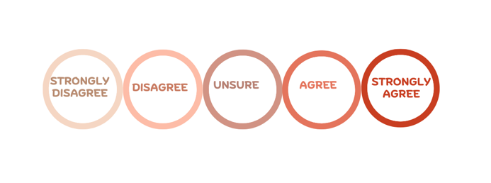
Policy statement: A clear explanation of what action should be taken about an issue and why.

Policy statements: (teachers can select how many statements they present to students)
1. Safety and Regulation
- E-scooters should be banned from all shared paths.
- Riders who break e-scooter laws should lose their driver’s licence or learner’s permit.
- Helmets should be compulsory for both e-bike and e-scooter riders.
- Police should have stronger powers to fine dangerous riders.
2. Age and Responsibility
- The minimum age for riding an e-scooter should be increased to 18.
- Students should be allowed to ride e-scooters to school.
- Parents should be fined for underage riders of e-scooters.
3. Speed and Access
- E-scooters should be allowed on footpaths if travelling slowly.
- The current 25km/h assisted speed limit for e-bikes should be increased.
- Rental e-scooters should be banned in busy city areas.
- More bike lanes should be built for e-bikes and e-scooters.
4. Environment and Transport
- Governments should encourage the use of e-bikes and e-scooters because they are environmentally friendly forms of transport.
- Public transport stations (e.g., train stations) should include parking and charging areas for e-scooters and e-bikes.
- The use of e-scooters should be expanded across Victoria because they can help reduce traffic jams.
5. E-Bike Age Minimums
- The Victorian government should introduce a minimum age of 16 for riding an e-bike.
- All e-bike riders should complete a basic road safety course before riding on their own.
- Parents should be responsible for making sure children use legal e-bikes safely.
- Victoria should keep the current e-bike laws and not introduce a minimum age.

Reflection Activity:
Complete the following questions individually:
1. Which policy statement did you feel most strongly about and why?
______________________________________________________________________________________________________________________________________________________________________________________________________________
______________________________________________________________________________________________________________________________________________________________________________________________________________
2. Did your opinion change during the activity? Explain why or why not.
______________________________________________________________________________________________________________________________________________________________________________________________________________
______________________________________________________________________________________________________________________________________________________________________________________________________________
3. Which argument presented by another student was the most convincing?
______________________________________________________________________________________________________________________________________________________________________________________________________________
______________________________________________________________________________________________________________________________________________________________________________________________________________
4. What do you think is the most important issue Victoria should address when regulating e-bikes and e-scooters?
______________________________________________________________________________________________________________________________________________________________________________________________________________
______________________________________________________________________________________________________________________________________________________________________________________________________________
5. In one sentence, explain what you think Victoria should do to improve e-bike and e-scooter safety.
______________________________________________________________________________________________________________________________________________________________________________________________________________
_______________________________________________________________________________________________________
_______________________________________________________________________________________________________

Activity 9: Beyond Registration and Licensing: Finding the Best Approach to Regulating E-Bikes and E-Scooters in Victoria – Group Discussion Activity

Learning Intentions
We understand the different policy options for regulating e-bikes and e-scooters in Victoria.
Success Criteria
I can identify different ways that governments can regulate e-bikes and e-scooters and explain the advantages and disadvantages of each through group work and collaboration.

Task Instructions:
1. Working in groups of 3 to 4 students, investigate and evaluate different ways the Victorian Government could regulate e-bikes and e-scooters.
2. Consider each policy option and list the advantages and disadvantages in the relevant columns below.
3. As a group, rank the policy options from the most effective to the least effective, providing reasons for your ranking.
4. Select and list the five policies that your group believes would be the most effective in improving the safe use of e-bikes and e-scooters in Victoria.
5. Write a recommendation to the Victorian Government identifying the policy your group believes would be the most effective and explain the reasons for your choice.
5. Present your recommendation to the rest of the class and explain the reasons for your decision.

Policy Options | Rank each policy option  (e.g. 1 = most effective 15 = least effective) | Advantages | Disadvantages
Introduce or strengthen helmet requirements.

Increase the minimum rider age.

Require rider safety education or training.

Lower or enforce speed limits.

Increased fines and penalties for unsafe riding.

Improve police enforcement of existing laws.

Creates more bike lanes and shared-use paths.

Require safety features such as lights and reflectors on both e-bikes and e-scooters.

Restrict where e-bikes and e-scooters can be ridden.

Run public awareness campaigns about road rules.

Introduce registrations only for high -powered devices.

Require retailers to provide safety information where the product is sold.

Increase funding and programs for road safety education in schools.

Introduce a licence or permit for high-powered e-bikes and e-scooters.

Develop separate road rules for private and shared e-scooters.

Others:

Select and list the 5 most effective policies (policies you think would work)
1. _____________________________________________________________________________________________________
2. _____________________________________________________________________________________________________
3. _____________________________________________________________________________________________________
4. _____________________________________________________________________________________________________
5. _____________________________________________________________________________________________________

Group recommendation: (which is the most effective policy option and reasons why)
Example:
We recommend that Victoria require all riders of *shared e-scooter riders to complete a short online road rules quiz before riding. This would help riders understand the rules, reduce unsafe behaviour and improve safety for riders and pedestrians. It would also be easy to include in existing e-scooter apps.
*shared e-scooters = e-scooters that people can rent using an app
__________________________________________________________________________________________________________________________________________________________________________________________________________________________________________________________________________________________________________________________________________________________________________________________________________________________________________

POST CONVENTION ACTIVITIES

Activity 1: The Problem and the Solution – Infographic Activity
Learning Intentions
We understand the different ways governments can regulate e-bikes and e-scooters in Victoria through investigating laws, safety concerns and possible solutions.
Success Criteria
I can explain the current laws and safety concerns about e-bikes and e-scooters in Victoria. I can use evidence and statistics in an infographic to justify the best way to regulate them.

Task Instructions:
Create an infographic that informs the public about the regulation of e-bikes and e-scooters in Victoria.
Your infographic should include:
1. The key issues surrounding the use of e-bikes and e-scooters in Victoria.
2. Different viewpoints and stakeholder perspectives were discussed during the Convention.
3. Recommendations about how Victoria could regulate them safely in the future.
4. Try to make your infographic visually interesting by including headings, subheadings, statistics, colours, images and short explanations to communicate your message.
What is an infographic:
A visual way of presenting information, facts and ideas so they are easy to understand quickly. Instead of writing long paragraphs, you can combine short pieces of text, headings, images, icons, graphs, statistics and colour.
For this task, your infographic should visually explain:
- The problem with e-bikes and e-scooters, e.g. accidents, injuries, reckless driving.
- Different viewpoints, e.g. environmentally friendly, cheaper transport option v’s riders ignoring road rules, difficult to police unsafe behaviour.
- Possible solutions, e.g. registration and licencing, compulsory helmets, speed limits, and age restrictions.
Example Layout:

1. Title: How Should Victoria regulate e-bikes and e-scooters?
2. The problem: Accidents, injuries, safety concerns.
3. Different opinions: Supporters v critics.
4. Statistics: Injury rates, popularity, environmental benefits.
5. Best solution: Your recommendation.
6. Conclusion: Why your solution is best.

Digital tools you can use:
Canva: Canva: Visual Suite for Everyone
PowerPoint: Microsoft PowerPoint
Piktochart: Piktochart Infographics
Adobe: Adobe

Statistics and Data Sources:
Transport Accident Commission (TAC): e-scooter safety

Rules:
Transport Victoria: e-scooter road rules
Transport Victoria: Electric Bikes (e-bikes)
Monash University – Monash Lens: E-micromobility is booming, but so are injuries
Victoria Police: Electric bike (e-bike) safety

Other Countries:
EVZ: E-scooter rules in Europe: What is allowed and what is not?

**Note: Sample provided on the next page
Sample made using https://piktochart.com/infographic-maker

Sources used to create the sample:
- Transport Victoria: Electric Bikes https://transport.vic.gov.au/road-and-active-transport/active-transport/bicycles/electric-bikes
- Transport Victoria: E-scooter road rules E-scooter road rules in Victoria - Transport Victoria
- Victoria Police: E-bike safety: https://www.police.vic.gov.au/e-bike-safety
- E-Rideables in Victoria: https://www.roadsafetyeducation.vic.gov.au/educational-resources/additional-resources/e-rideables-in-victoria
- Transport Victoria: https://transport.vic.gov.au/road-and-active-transport/active-transport/bicycles

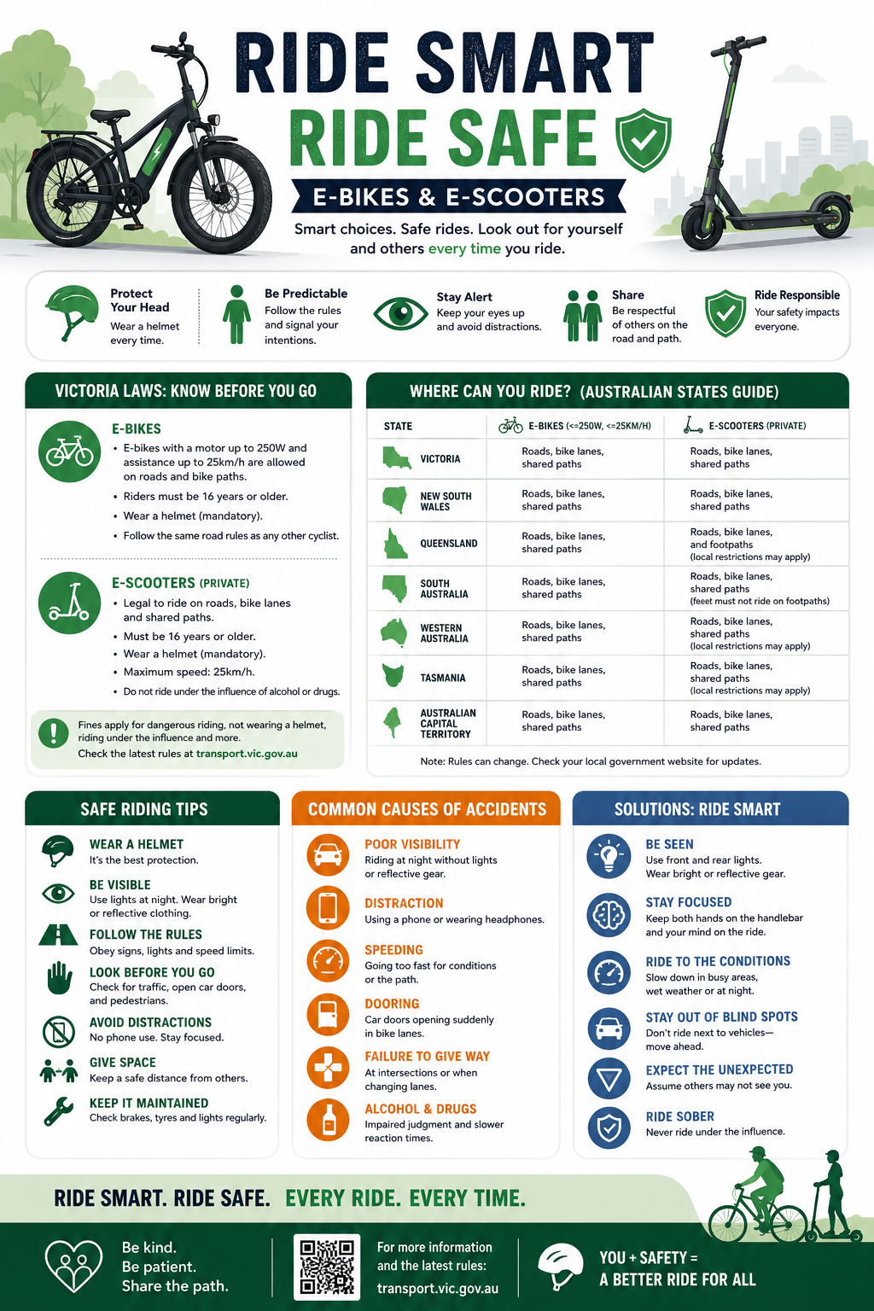

Activity 2: Should Victoria Introduce Licensing and Registration for E-Bikes and E-Scooters? – Argument Carousel Activity
Learning Intentions
We are learning to consider different viewpoints about licensing and registration for e-bikes and e-scooters in Victoria and can use evidence to support our opinions.
Success Criteria
I can explain different viewpoints about licensing and registration for e-bikes and e-scooters, use evidence to support my arguments, and justify which solution I believe would be the most effective for improving public safety.

Task Instructions:
Activity Overview:
You will work in groups to investigate different arguments about whether Victoria should introduce licensing and registration for e-bikes and e-scooters. As you move around the room, add arguments, evidence and ideas to a range of discussion stations.
At the end of this activity, you will review the class responses and decide which solution would be the most effective for Victoria.
1. Your teacher will divide the class into groups of 3-4 students. Each group will start at a different discussion station.
2. Large sheets of paper will be placed around the room with the following headings: Safety, Cost, Environment, Freedom, Enforcement, and Young People. Each station focuses on or looks at a different issue related to licensing and registration of e-bikes and e-scooters.
3. At each station:
i. Read the heading and any ideas already written
ii. Discuss arguments for and against licensing and registration
iii. Add your group’s ideas, statistics or questions on the sheet
iv. You may use dot points, diagrams, examples from other countries, or ideas discussed at the Convention
4. Every 3-5 minutes, your group will move to the next station. Continue adding ideas and responding to or addressing points raised by previous groups.
5. After visiting all the stations, participate in a class discussion about:
i. Which arguments were the most convincing or strongest
ii. Whether Victoria should introduce licensing and registration for e-bikes and e-scooters
iii. If there are alternative solutions that may be more effective
6. Independently write a short response explaining your own opinion on whether Victoria should introduce licensing and registration of e-bikes and scooters. Remember to give reasons for your decision.
7. Share your written response with the rest of the class.

Teacher Notes:
Suggested timeframe:
- Introduction: 5 minutes
- Rotations between groups: 20-25 minutes
- Review discussion: 10 minutes
- Reflection writing: 10 minutes
Materials needed:
Large butchers paper, markers, timer or bell for rotations.
Helpful argument prompts:
Arguments for licensing and registration:
- Improves rider accountability.
- Encourages riders to know road rules.
- Reduces reckless behaviour.
- Helps police identify dangerous riders.
- Improves public safety.
- Creates rules similar to those for cars and motorcycles.
- Could reduce accidents and injuries.
- Encourages safer riding habits.
Arguments against licensing and registration:
- It’s expensive and unfair.
- Discourages environmentally friendly transport.
- May reduce e-scooter and e-bike use.
- Difficult for police to enforce.
- Gives governments too much control.
- Is unnecessary for casual riders.
- May not stop unsafe behaviour.
- Education programs may work better.
Final Reflection:
Based on today’s activity, I believe Victoria should/should not introduce licensing and registration for e-bikes and e-scooters because:
__________________________________________________________________________________________________________________________________________________________________________________________________________________________________________________________________________________________________________________________________________________________________________________________________________________________________________

Activity 3: Policy Recommendation Task – Reflection Activity
Learning Intentions
We understand the arguments for and against licensing and registration of e-bikes and e-scooters in Victoria. We also understand how different policy options may impact safety, cost, freedom and regulation within the community.
Success Criteria
I can develop and justify a policy recommendation using evidence and arguments discussed during the class activities and the Convention.

Task Instructions:
1. Think about the pre-convention activities, the convention and the post-convention activities completed in class.
2. Imagine you are an advisor to the Victorian government. Your task is to recommend the best way to manage e-bikes and/or e-scooters in Victoria.
3. Write a short policy recommendation that includes the following: your recommendation, reasons to support your recommendation, evidence or examples from the activities or the Convention, possible advantages and disadvantages of your solution.
4. Your policy recommendation could include one or more of the following: licencing and registration, age restrictions, safety education or training programs, speed limits, stricter rules or penalties, or another alternative solution. (Your recommendation can focus on both e-bikes and e-scooters, or you may choose to focus on one of the two means of transport)
5. Be prepared to share and explain your recommendation with the class.
What is a policy?
A plan or action used to achieve a goal or address an issue.
Examples of policies:
School mobile phone policy: All students must keep their mobile phones in lockers during class time and throughout the school day to reduce distractions and improve learning and student interest in the classroom.
Government road safety policy: All passengers in a car are required to wear a seatbelt at all times to reduce injuries and save lives. Fines and penalties are imposed on people who fail to follow the law.
What is a policy recommendation?
Suggested solution or action to help solve a problem or improve an issue. It explains what you think should happen and why.

Template/Guide to write a policy recommendation:
Policy Recommendation Template or Guide (with examples)
Issue/Problem
Briefly explain this problem or issue.
Example: There has been an increase in unsafe e-scooter use in Victoria.

Recommendation
State what action should be taken to address this.
Example: Victoria should introduce compulsory or mandatory helmet laws for all e-scooter riders.

Reasons for the Recommendation
Explain why this policy would help:
- It would improve rider safety.
- It could reduce serious injuries and accidents.
- It encourages responsible use of e-scooters.
Evidence or Examples:
Include evidence or an example from the activities you have completed in relation to this topic.
Example: Road safety campaigns show helmets reduce the risk of head injuries.

Conclusion:

Summarise why this is the best solution.
Example: Overall, mandatory or compulsory helmet laws would improve safety while still allowing people to use e-scooters conveniently.

Sample Policy Recommendation:
There has been an increase in concerns about unsafe e-scooter use in Victoria, including accidents, injuries and unsafe riding behaviours. Some riders do not wear helmets, travel at unsafe speeds or fail to follow road rules, creating risks for both riders and pedestrians.
Victoria should introduce compulsory helmet laws and stronger safety regulations for all e-scooter riders. This would improve safety for riders and the wider community. Wearing a helmet can help reduce the risk of serious head injuries if an accident occurs. Stronger safety regulations, such as speed limits and increased penalties for dangerous riding, would encourage better behaviour with riders following the road rules. This would help reduce accidents and make shared spaces safer for everyone.
Evidence from road safety campaigns shows that helmets do reduce the risk of serious head injuries significantly. So compulsory helmet laws and stronger safety regulations are the best solution because they improve safety while still allowing people to enjoy the convenience and environmental benefits of e-scooters.
Exit Activity – Sticky Note Final Vote
Sticky Note Final Vote Instructions:
Question:
Should Victoria require registration and licensing for e-bikes and e-scooters?
Instructions:
- Think about all the arguments, evidence and ideas discussed during the classroom activities and the Convention.
- Decide on your final position on this topic:
YES = Victoria should require registration and licensing for e-bikes and e-scooters
NO = Victoria should not require registration and licensing for e-bikes and e-scooters
- Write YES or NO on a sticky note.
- Place your sticky note under the matching heading displayed on the board.
- Once everyone has voted, the class will count the results and discuss the outcome.
- Students can share final comments, reasons or reflections about the issue.

