

Victorian Schools Parliamentary Program (VSPP)
2026 ONLINE SECONDARY SCHOOL CONVENTION
Topic
Should Victoria require registration and licensing of e-bikes and e-scooters, or are there better ways to regulate them?
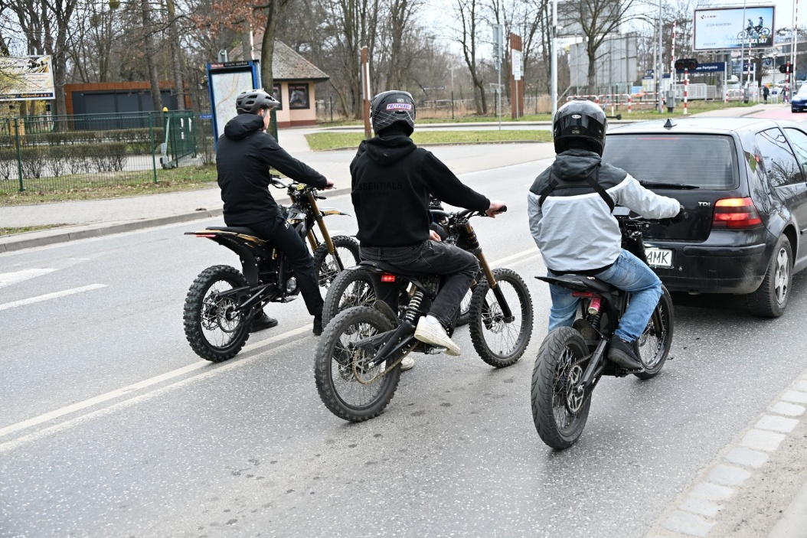

TEACHER RESOURCE

Contents
IMPORTANT INFORMATION 3
CONTEXT OF THE TOPIC 3
LINKS TO THE CURRICULUM v2.0 4
Achievement Standard – Levels 9 and 10 (Civics and Citizenship 2.0) 5
Level 9 and 10 Content Descriptions 6
LEARNING INTENTION FOR THESE STUDENT ACTIVITIES: 14
SUCCESS CRITERIA FOR THESE STUDENT ACTIVITIES: 14
Activity 1: Introductory Activities 16
Activity 1a: Transport Regulation Challenge - How Much Do You Know 16
Activity 1b: E-Bikes and E-Scooters – Comparison and Comprehension Activity 21
Activity 2: Understanding Victoria’s Laws 24
Activity 2a: Fact-Checking Victoria’s Current Road Laws – True/False Research Activity 24
Activity 2b: Road Rules in Action: E-Bike and E-Scooter Scenario Activity 26
Activity 3: Whose Lane is it Anyway? – Stakeholder Mapping: Pair-Share Activity 28
Activity 4: Media Messages: E-Bikes and E-Scooters in the Headlines – Pair and Share or Group Activity 34
Activity 5: E-Bikes and E-Scooters: Safety or Freedom? – Video Analysis: Group Work Activity 45
Activity 6: Unpacking the Problems with E-Bikes and E-Scooters in Victoria – Group Analysis Activity 49
Activity 7: What can Victoria Learn from E-Bike and E-Scooter Laws in Other Countries? Global Investigation Activity 52
Activity 7a - Global Rules Comparison (individual student activity) 54
Activity 7b – World Map investigation (Individual or Pair Activity) 56
Activity 7c Traffic Light Ranking: Evaluating Policy Options (Small Group Activity) 57
Activity 7d – What should Victoria do? (Class Discussion) 57
Activity 8: Policy Spectrum Activity 58
Activity 9: Beyond Registration and Licensing: Finding the Best Approach to Regulating E-Bikes and E-Scooters in Victoria – Group Discussion Activity 61
POST CONVENTION ACTIVITIES 71
Activity 1: The Problem and the Solution – Infographic Activity 71
Activity 2: Should Victoria Introduce Licensing and Registration for E-Bikes and E-Scooters? - Argument Carousel Activity 74
Activity 3: Policy Recommendation Task – Reflection Activity 77

IMPORTANT INFORMATION
The pre-convention activities and resources provided to support the VSPP Program are suggestions only.
They have been developed to help students prepare for the Secondary Schools’ Convention to debate this topic in more detail.
The pre-convention activities and resources provided can be completed independently of each other at the teacher’s discretion and choice. This means the teacher may choose to do one, some, or all the activities to help build students’ knowledge and help them prepare to be active participants in the Convention.
In using these suggested pre-convention activities and resources, teachers should make themselves aware of the content contained and the complexity of it to ensure it is appropriate for their student cohort and school context.
Teachers should plan for appropriate support to prepare their students for the Secondary Schools’ Convention by adapting, updating, extending, or removing activities (including task instructions) and any resources contained in this pack.
Students are not expected to complete all activities before participating in the Convention, nor are they expected to complete all post-convention activities.

CONTEXT OF THE TOPIC
The use of e-bikes and e-scooters has increased rapidly across Victoria, particularly among young people. These forms of transport provide a convenient, affordable and environmentally friendly way to travel, helping to reduce traffic congestion and carbon emissions. However, their growing popularity has also raised concerns about public safety. There has been an increase in accidents, injuries, speeding, dangerous riding behaviour and conflicts with pedestrians and other road users.
Governments across Australia and around the world are debating how best to regulate e-bikes and e-scooters. Some people believe riders should be required to obtain a licence and register their e-bike or e-scooter, similar to drivers of cars and motorcycles. They argue this would improve accountability, compliance with road rules and public safety. Others believe registration and licensing would be costly, difficult to enforce and discourage people from using e-bikes and e-scooters as affordable and environmentally friendly forms of transport. Instead, they support alternative measures such as compulsory helmet laws, rider education and training programs, minimum age requirements, speed limits, stronger penalties for unsafe behaviour and improved bike lanes and shared paths.
As e-bikes and e-scooters become more common in Victoria, governments must decide how to balance safety, personal freedom, accessibility and environmental benefits. The challenge is finding the best way to keep riders and the community safe while encouraging people to use sustainable transport.

LINKS TO THE CURRICULUM v2.0
This topic has strong links to Levels 9 and 10 of the Civics and Citizenship strand (Version 2.0) of the Victorian Curriculum F-10. Civics and Citizenship aims to develop students’ understanding of democracy, laws, rights and responsibilities and how citizens can participate in shaping public policy. By investigating whether Victoria should require registration and licensing of e-bikes and e-scooters, students apply these concepts to a contemporary issue involving transport policy, public safety, individual freedoms, environmental sustainability and government regulation.
The pre-Convention resources support the curriculum’s focus on inquiry, critical thinking, discussion, and active citizenship. Through activities such as media analysis, class discussions, scenario-based activities, stakeholder mapping and global investigations, students explore a range of viewpoints on the regulation of e-bikes and e-scooters. They consider the perspectives of the riders, pedestrians, police, local communities, governments and environmental groups while examining the advantages and disadvantages of various policy options, including registration, licensing, age restrictions, safety education programs, speed limits, stronger penalties for unsafe behaviour and improved cycling infrastructure.
These learning experiences encourage students to analyse evidence, evaluate competing viewpoints and develop informed policy recommendations. They align with Curriculum v2.0’s focus on critical and creative thinking, ethical understanding and respectful discussion as students prepare to participate in the Convention and engage in a real-world public policy issue.

The Links to the Convention Topic:
Students gain a deeper understanding of how governments balance individual rights, public safety and community responsibility when regulating new forms of transport. The debate about whether Victoria should require the registration and licensing of e-bikes and e-scooters raises important questions about accountability, road safety, accessibility, environmental sustainability and the role of government in responding to emerging technologies.
Students explore how laws, regulations, and policy decisions can affect people in everyday lives. They examine how different approaches to regulate e-bikes and e-scooters may impact riders, pedestrians, local communities, police, businesses and the wider public. Students consider the benefits and challenges of policy options such as registration and licensing, age restrictions, rider education programs, speed limits, stronger penalties for unsafe behaviour and improved bike pathways.
This contemporary issue encourages students to think critically about how governments make decisions in response to changing social and technological trends. By investigating different perspectives and evaluating evidence, students consider how Victoria can best balance safety, personal freedom, accessibility, and environmental benefits while supporting sustainable transport options for the future.

Achievement Standard – Levels 9 and 10 (Civics and Citizenship 2.0)
By the end of Level 10, students can:
- Explain the role of Victorian government in developing, implementing and enforcing laws and policies relating to transport, road safety and emerging technologies such as e-bikes and e-scooters.
- Analyse how laws and regulations balance competing interests, including public safety, personal freedom, environmental sustainability, accessibility and economic considerations.
- Investigate the social, legal and economic impacts of e-bikes and e-scooters on individuals, communities and government.
- Evaluate information from a range of sources to assess the effectiveness of different policy options, including registration, licensing, safety education, infrastructure improvements, speed restrictions and enforcement measures.
- Analyse diverse perspectives and stakeholder viewpoints, including those of government agencies, pedestrians, businesses, road safety organisations and local communities.
- Explain how democratic processes enable individuals and groups to influence government decision-making and public policy.
- Use evidence to construct and justify reasoned arguments about how e-bikes and e-scooters should be regulated in Victoria.
- Participate in informed discussions, debates and decision-making activities, demonstrating respect for differing viewpoints and applying critical thinking skills.
- Propose and evaluate policy recommendations that address community needs while promoting fairness, safety, sustainability and responsible transport use.
- Reflect on the challenges governments face when addressing emerging technologies and changing community expectations.
- Explain how people can help change laws and government policies in a democratic society by taking actions, sharing their opinions and speaking up about issues that matter to them.

Level 9 and 10 Content Descriptions
CIVICS AND CITIZENSHIP
Government and democracy
Students learn about the processes through which government policy is shaped, developed and implemented, including the role of political parties, interest groups, the media and legislative processes.

Code: VC2HC10K02

Elaborations:

- charting the process of the development of a policy from the initial idea to enacted legislation,
- investigating political parties’, interest groups’ and media organisations’ public viewpoint on one contemporary issue,
- evaluating whether policy can effectively resolve a contemporary issue.

The link to the topic:
The topic of whether Victoria should require registration and licensing of e-bikes and e-scooters or adopt alternative forms of regulation encourages students to explore how governments respond to contemporary public policy issues. Different viewpoints about safety, personal freedom, accessibility, environmental benefits and government regulation can influence political parties, interest groups, media and decision-makers. Students investigate whether current regulations provide an effective balance between promoting the safe use of e-bikes and e-scooters while maintaining affordable, sustainable and convenient transport options. This makes the topic a valuable example of how public policy is shaped, debated and implemented in a democratic society.

The learning connects directly to VC2HC10K02 as students examine how government policy is developed and influenced by a range of stakeholders. Students explore different stakeholder perspectives through activities such as media analysis, comprehension tasks, group discussions and global investigations. Students can then develop a deeper understanding of the issue and evaluate whether registration and licensing or alternative regulatory approaches are the most effective way to address safety concerns in Victoria. Students use evidence to justify their conclusions and recommendations about future government policy.

Citizenship, diversity and identity

Students learn about individual and group participation and contribution to civil life and global citizenship.

Code: VC2HC10K09

Elaboration:
- investigating individuals and communities, including religious and cultural groups, that actively participate in local and global civic life, and identifying gaps in civic contributions where new groups may need to form, including areas not yet supported online or in person.

The link to the topic:
The topic of whether Victoria should require registration and licensing of e-bikes and e-scooters or adopt alternative forms of regulation provides opportunities for students to explore how individuals and groups participate in civic life and contribute to public debate. Students investigate how community members, advocacy groups, road safety organisations and transport groups can influence government decisions about e-bike and e-scooter regulation. They examine how citizens can contribute to safer and more sustainable communities by expressing their views, participating in consultations, and advocating for policy change. This helps students understand the importance of active citizenship and community participation in addressing contemporary issues.

Citizenship, diversity and identity

Students learn about the challenges to and ways of sustaining a resilient democracy and a cohesive society in Australia and/or in our region or globally.

Code: VC2HC10K10

Elaboration:
- identifying the key characteristics of cohesive, democratic societies, such as cooperation, inclusion, respect and peaceful resolution of conflicts, and the importance of an active and informed citizenry.

The link to the topic:
The topic of whether Victoria should require registration and licensing of e-bikes and e-scooters or adopt alternative forms of regulation encourages students to consider how governments can balance the interests of different groups within society. Students explore competing viewpoints about safety, personal freedom, accessibility and public responsibility and examine how democratic societies resolve disagreements through informed debate and evidence-based decision-making. The topic highlights the importance of cooperation, respect for differing opinions and active citizenship participation in addressing contemporary public policy issues. This helps students understand how democratic processes contribute to a cohesive and well- functioning society.

Citizenship, diversity and identity

Students learn about the influence of a range of media, including social media, in shaping identity and attitudes in diversity.

Code: VC2HC10K11

Elaboration:
- examining media and social media ownership and how this influences public opinion and policy, nationally and internationally.

The link to the topic:
The topic of whether Victoria should require registration and licensing of e-bikes and e-scooters or adopt alternative forms of regulation allows students to examine how media and social media influence public attitudes towards road safety and transport policy. Media reports of accidents, injuries and unsafe riding behaviours may shape public perceptions of e-bike and e-scooter users and influence support for stricter regulations. Students can investigate how different forms of media present the issue and consider the impact of media coverage on public opinion and government decision-making.

Skills: Investigating contemporary issues, civics, and citizenship

Students learn to develop and evaluate questions to investigate contemporary political, legal and civic issues.

Code: VC2HC10S01

Elaboration:
- brainstorming questions about a contemporary local or global issue and then evaluating which question will result in the most useful answer.

The link to the topic:
The topic of whether Victoria should require registration and licensing of e-bikes and e-scooters or adopt alternative forms of regulation requires students to develop and evaluate questions about a contemporary civil and public policy issue. Students investigate the effectiveness of current regulations, explore alternative policy options and examine different stakeholder perspectives. Through this process, they learn how to formulate inquiry questions and guide research, analysis and decision-making about a real-world issue affecting Victorian communities.

Skills: Investigating contemporary civics and citizenship issues

Students learn to evaluate information, data, perspectives and ideas from a range of sources on contemporary issues.

Code: VC2HC10S02

Elaboration:
- explaining multiple perspectives in responding to a contemporary issue,
- examining possible changes to laws and the multiple perspectives on these changes.

The link to the topic:
The topic of whether Victoria should require registration and licensing of e-bikes and e-scooters, or adopt alternative forms of regulation, requires students to gather, evaluate and interpret information from a range of sources. Students analyse evidence, statistics, media reports, government policies, stakeholder opinions and international examples to assess the effectiveness of different regulatory approaches. They also examine multiple perspectives before reaching an evidence-based conclusion and recommendation.

Skills: Evaluating democratic institutions and systems
Students learn to recommend changes to political, legal and/or civic institutions and justify these recommendations.
Code: VC2HC10S03
Elaboration:
- explaining how a political, legal and/or civic institution could better uphold human rights and/or democracy.
- showing how Australia could improve a political, legal or civic institution by adopting the processes of an Asia-Pacific country, or vice versa.

The link to the topic:
The topic of whether Victoria should require registration and licensing of e-bikes and e-scooters or adopt alternative forms of regulation requires students to evaluate existing laws and government policies and recommend improvements. Students investigate the effectiveness of current regulations, consider alternative approaches and justify their recommendations using evidence. This directly aligns with the skill of recommending changes to legal and civic systems and explaining why those changes would better address a contemporary issue.

Skills: Participating in civic processes

Students learn to evaluate the effectiveness of democratic decision-making.

Code: VC2HC10S06

Elaboration:
- analysing the scope of consensus-building and what democratic decision-making may be needed at a bigger scale,
- evaluating the potential for democratic decision-making about global issues.

The link to the topic:
The topic of whether Victoria should require registration and licensing of e-bikes and e-scooters or adopt alternative forms of regulation requires students to evaluate how effectively democratic decision-making can address a contemporary public policy issue. Students examine how governments consult with stakeholders, consider evidence, balance competing interests and make decisions about road safety and transport regulation. They evaluate whether current and proposed regulatory approaches effectively respond to community concerns while meeting the needs of different groups.

Skills: Participating in civic processes

Students learn to participate and evaluate the methods and strategies of civic participation with regard to contemporary issues from local to global.

Code: VC2HC10S07

Elaboration:
- examining ways in which people under the age of 18 can participate in responding to a contemporary political, legal or civic issue
- determining effective ways to participate in various issues, from school and local issues to global crises
- engaging with democratic institutions about a contemporary issue through at least one method of participation, such as letter-writing, a petition and/or contributing to a campaign

The link to the topic:
The topic of whether Victoria should require registration and licensing of e-bikes and e-scooters or adopt alternative forms of regulation provides opportunities for students to investigate how citizens can participate in civic processes to influence government policy. Students explore different methods of civic participation and evaluate their effectiveness in addressing road safety and transport issues. They consider how individuals and groups can contribute to public debate, advocate for change and engage with decision-makers to improve community outcomes.

Skills: Communicating

Students learn to construct evidence-based arguments using civics and citizenship knowledge, concepts and different perspectives, and determine the most effective method of communication.

Code: VC2HC10S08

Elaboration:
- using reflective tools to evaluate how they came to their perspective on a contemporary issue and what evidence they used to come to that perspective, including acknowledging evidence that does not support their perspective,
- analysing the most effective methods of communication when responding to contemporary issues,
- determining whether some methods of communication are more effective in particular campaigns.

The link to the topic:
The topic of whether Victoria should require registration and licensing of e-bikes and e-scooters or adopt alternative forms of regulation requires students to construct evidence-based arguments about a contemporary public policy issue. Students analyse information from a range of sources, consider different stakeholder perspectives and develop a justified position on the most effective approach to regulating e-bikes and e-scooters. They communicate their conclusions using appropriate civics and citizenship concepts and select different methods to present their recommendations to different audiences.

Ethical Capabilities
Understanding Ethical Concepts and Perspectives

Students learn about how and why ethical perspectives can be challenged and changed, such as increasing cultural diversity, challenging a conception of shared expectations, and factors that support negotiating a shared ethical perspective, such as respect for human rights.

Code: VC2CE10U02

Elaborations:
- considering how an influence on an ethical perspective can develop over time and lead to changing ethical perspectives,
- exploring a scenario where an ethical perspective is collective and requires negotiation.

The link to the topic:
The topic of whether Victoria should require registration and licensing of e-bikes and e-scooters, or adopt alternative forms of regulation, encourages students to explore how ethical perspectives can change over time in response to new information, experiences and community concerns. As the use of e-bikes and e-scooters has increased, concerns about rider and pedestrian safety, accessibility and public responsibility have led to debate about whether existing regulations remain appropriate. Students investigate how different stakeholders may hold different ethical perspectives and how these perspectives can be negotiated to develop policies that balance safety, freedom, fairness and community well-being.

Understanding Ethical Concepts and Perspectives

Students learn about interconnections between dispositions, experiences, emotions and/or context and how these influence and can challenge and change ethical perspectives.

Code: VC2CE10U03

Elaborations:
- exploring how engaging with the experiences of others, can challenge ethical perspectives and lead to change,
- analysing how people with different dispositions might interpret the ethical significance of an experience differently, and how they could influence each other’s perspectives through discussion.

The link to the topic:
The topic of whether Victoria should require registration and licensing of e-bikes and e-scooters, or adopt alternative forms of regulation, encourages students to explore how personal experiences, emotions, values and contexts can influence ethical perspectives. Students examine why different stakeholders may hold different views about regulation and how exposure to new evidence, experiences and perspectives can challenge or change these views. This helps students understand that ethical positions are often shaped by individual experiences and circumstances rather than simply by facts alone.

Decision-making and Actions

Students learn about how connections, distinctions and tensions between ethical concepts and between ethical perspectives are used to identify and analyse ethical issues, including their ethical significance, and how they are used to analyse responses to ethical issues, including their ethical significance.

Code: VC2CE10D01

Elaborations:
- investigating an issue, identifying relevant ethical concepts, and analysing tensions between them,
- investigating similarities and differences in stakeholder perspectives on a response to an ethical issue, including their views on the ethical significance of economic, environmental and social impacts, and considering connections between these impacts.

The link to the topic:
The topic of whether Victoria should require registration and licensing of e-bikes and e-scooters, or adopt alternative forms of regulation, requires students to identify and analyse ethical issues arising from competing values and perspectives. Students examine tensions between ethical concepts such as safety and freedom, individual rights and community well-being, and accessibility and responsibility. They investigate how different stakeholders view the ethical significance of these issues and evaluate the strengths and limitations of different policy responses.

Critical and Creative Thinking
Questions and Possibilities
Students learn about when and how to critically reflect on suspension of judgement when generating and evaluating alternative ideas and possibilities from different perspectives.
Code: VC2CC10Q02
Elaboration:
- discussing the concept of unconscious bias and how this might affect suspension of judgement when engaging with alternative perspectives,
- discussing how challenging assumptions and being open-minded can assist in evaluating ideas to generate possibilities when engaging with different perspectives on a social issue,
- exploring when it is appropriate to suspend judgement and when it is not, for the purpose of generating alternative ideas and possibilities.

The link to the topic:
The topic of whether Victoria should require registration and licensing of e-bikes and e-scooters or adopt alternative forms of regulation requires students to consider a range of viewpoints before concluding. Students are encouraged to suspend judgement, challenge assumptions and remain open-minded while investigating evidence and stakeholder perspectives. By exploring alternative regulatory approaches and evaluating their strengths and weaknesses, students develop a deeper understanding of the issue and make informed recommendations based on evidence rather than preconceived opinions.

Questions and Possibilities

Students learn about strategies for generating new ideas and possibilities including identifying links and patterns across multiple information sources and perspectives.

Code: VC2CC10Q03

Elaboration:
- undertaking research to gather a range of data from multiple information sources and stakeholders, and analysing it for a link or pattern to support generating new ideas and possibilities.

The link to the topic:
The topic of whether Victoria should require registration and licensing of e-bikes and e-scooters or adopt alternative forms of regulation requires students to investigate information from multiple sources and stakeholder perspectives. Students analyse data, research findings, media reports and viewpoints from road safety organisations, government agencies, riders and community groups to identify patterns, trends and shared concerns. They use these insights to generate and evaluate possible solutions and recommendations for improving safety and regulation in Victoria.

Reasoning
Students learn about ways to analyse and evaluate claims and grounds for claims for the qualities of accuracy, precision, depth or breadth when reasoning and ways to identify what qualities are required in different contexts.

Code: VC2CC10R02

Elaboration:
- developing a checklist of questions associated with particular qualities, such as ‘Is supporting evidence accurately presented? ’
- using knowledge to critically analyse the validity of information obtained from primary and secondary sources, suggesting possible alternative explanations and describing specific ways to improve the quality of data,
- planning an investigation and response and analysing whether depth or breadth is required, or both, using a particular aim or purpose to help guide their thinking.

The link to the topic:
The topic of whether Victoria should require registration and licensing of e-bikes and e-scooters, or adopt alternative forms of regulation, requires students to critically analyse and evaluate claims made by governments, road safety organisations, advocacy groups, media outlets and community members. Students assess the accuracy, reliability and quality of evidence used to support different viewpoints and policy proposals. They examine data, research findings and stakeholder arguments to determine whether claims about safety, accessibility, costs and effectiveness are well supported. This enables students to make informed judgements and develop evidence-based recommendations about the most appropriate approach to regulating e-bikes and e-scooters in Victoria.

LEARNING INTENTION FOR THESE STUDENT ACTIVITIES:
By the completion of these activities, students will be able to:
- Understand the issue of increasing e-bike and e-scooter use in Victoria and the challenges associated with its regulation.
- Explain the purpose of registration, licensing and other regulatory measures used to promote safety and responsible use.
- Explore different viewpoints about whether Victoria should require registration and licensing of e-bikes and e-scooters.
- Identify alternative ways governments can regulate e-bikes and e-scooters, such as helmet laws, speed limits, education campaigns, enforcement and designated riding areas.
- Develop and express an informed opinion about the most effective way to regulate e-bikes and e-scooters in Victoria.
- Participate in respectful discussion and debate, listening to different perspectives and responding appropriately.
- Use persuasive speaking skills to present arguments clearly and confidently.
- Develop and strengthen their communication, critical thinking and decision- making skills through discussions, comprehension tasks, research investigations, analytical activities and debates.

SUCCESS CRITERIA FOR THESE STUDENT ACTIVITIES:
Students will be able to:
- Clearly identify and describe the issue of regulating e-bikes and e-scooters in Victoria.
- Explain the advantages and disadvantages of registration and licensing requirements.
- Describe alternative regulatory approaches and explain how they may improve safety and compliance.
- Compare different policy options and evaluate their effectiveness in addressing safety concerns.
- Form and justify an opinion about the best way to regulate e-bikes and e-scooters in Victoria.
- Use examples or evidence to support their arguments and ideas.
- Communicate their views in a clear, confident and respectful manner.
- Participate actively in class discussions, group activities and decision-making processes.
- Demonstrate an understanding of how governments make decisions and develop policies to address community issues.

Teacher Notes:

Before commencing the pre-Convention activities, teachers may want to introduce students to the Parliament of Victoria’s ‘So You Think You Can Make a Law’ program. This engaging activity provides real-world context for the Convention topic and encourages students to think critically about how laws and policies are developed in Victoria.

The activity allows students to guide a bill through the Victorian Parliament and make decisions that influence whether the proposed law succeeds or fails. It provides an accessible introduction to parliamentary process, active citizenship and law reform.

Teachers may use the activity as a whole-class demonstration or allow students to complete it individually or in pairs. The interactive game takes between 10 and 20 minutes to complete, depending on the level of discussion and exploration of different pathways.

After the game is completed, teachers may facilitate a short discussion about challenges involved in passing laws, the role of elected representatives and how community concerns can lead to law reform. This provides a useful foundation before students begin investigating the Convention topic and developing their own opinion on the issue.

Link:
So, you think you can make a law - Parliament of Victoria.

Additional Teacher Notes:
Review key vocabulary before beginning the activities. Some students may not be familiar with the following terms:

Term | Meaning
Accessibility | How easy something is to use.
Accountability | Taking responsibility for what you do; being answerable for your actions.
Crackdowns | When police and governments take action to stop rule breaking.
Compliance | Following the rules, laws and requirements that have been set.
Congestion | Too many vehicles or people in one place cause delays.
Devices | Equipment or technology that is invented for a particular purpose, so in this context, refers to e-bikes and e-scooters.
Discourage | Less likely to do something.
Effective | Something works well and achieves what it is intended to do.
Enforcement | Making sure people follow the rules.
Infrastructure | The roads, paths, buildings and other facilities that support people and services.
Mandatory | Something that must be done; it is not optional.
Penalty | Punishment or consequence for breaking the law.
Sustainable | Something that can continue without harming the environment.

Activity 1: Introductory Activities

Activity 1a: Transport Regulation Challenge - How Much Do You Know

Learning Intentions
We are learning to identify different forms of transport and understand laws, rules and safety requirements that apply to them in Victoria.
Success Criteria
I can identify different forms of transport, explain if a licence or registration is required and the laws and safety rules that apply to different types of transport used in Victoria.

Task Instructions:
1. As a class, carefully look at the six transport images shown by your teacher.
2. Identify the type of transport shown in each image, e.g. car.
3. For each form of transport, brainstorm and record the following:
*Any laws or rules that apply in Victoria.
*Whether a licence is required.
*Whether registration is required (Registration means a vehicle is officially recorded with the government so it can legally be used on public roads).
*Any safety rules riders or drivers must follow.
4. As a class, discuss which forms of transport you think should have stricter regulations (i.e. speed, age of riders or drivers, danger to pedestrians and other road users, environmental impacts).

SAMPLE RESPONSES
Image 1: Standard bicycle (non-electric).
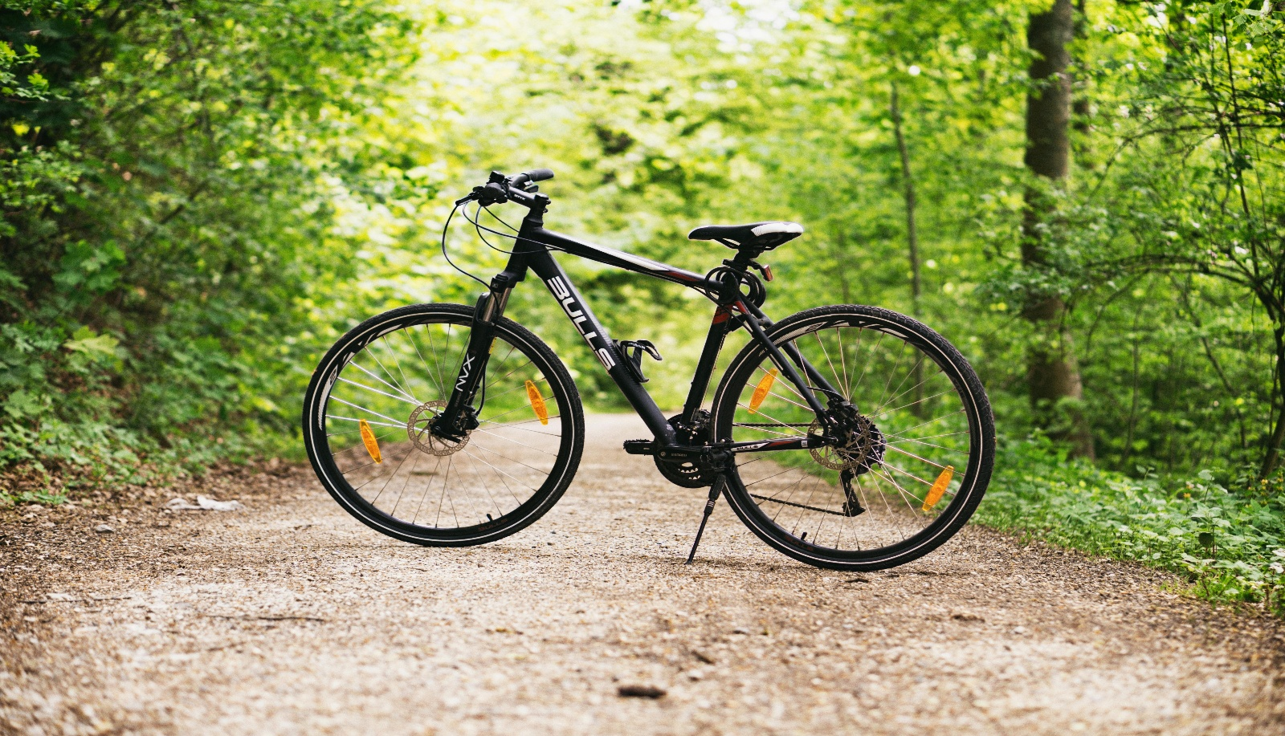
Image 2: Electric bicycle (has a rechargeable battery in a black box under the seat).
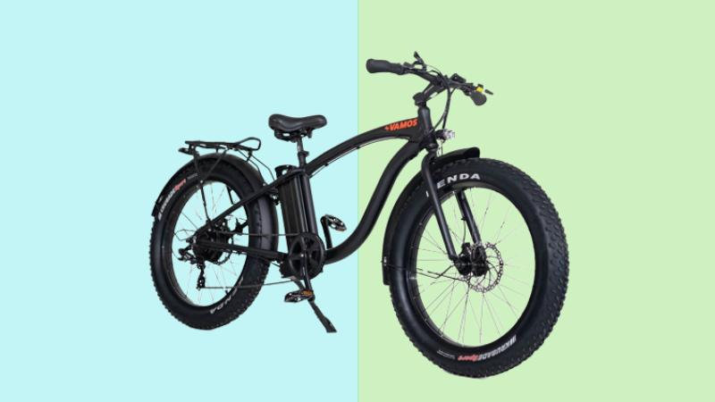

Image 3: Electric scooters (e-scooters), specifically shared rental-e-scooters.
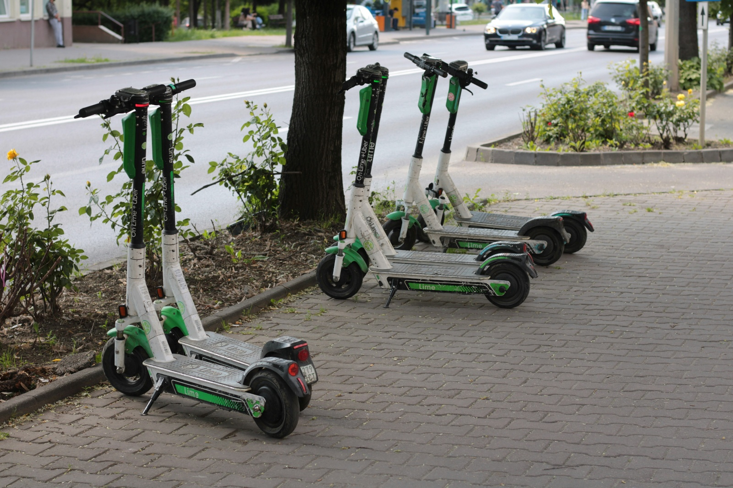
Image 4: Motor vehicles or cars – includes sedans, hatchbacks, vans and SUVs.
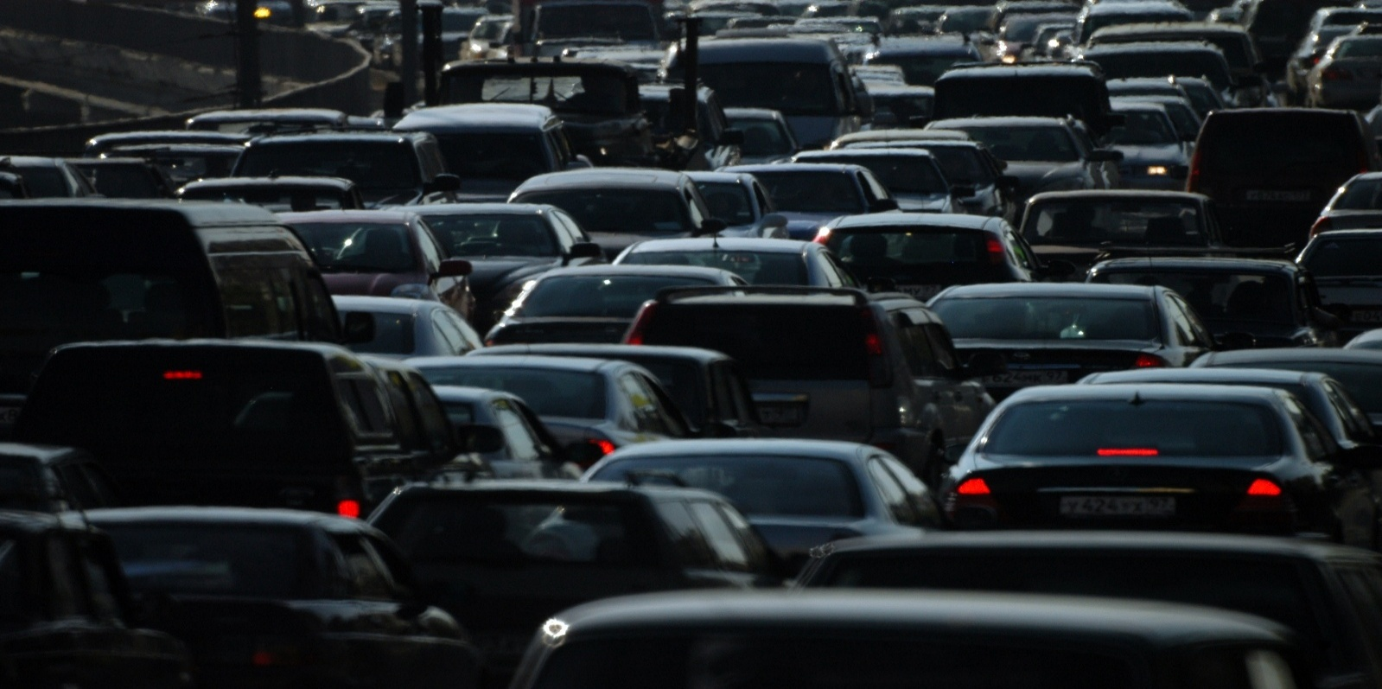

Image 5: Motorcycle or Motorbike.
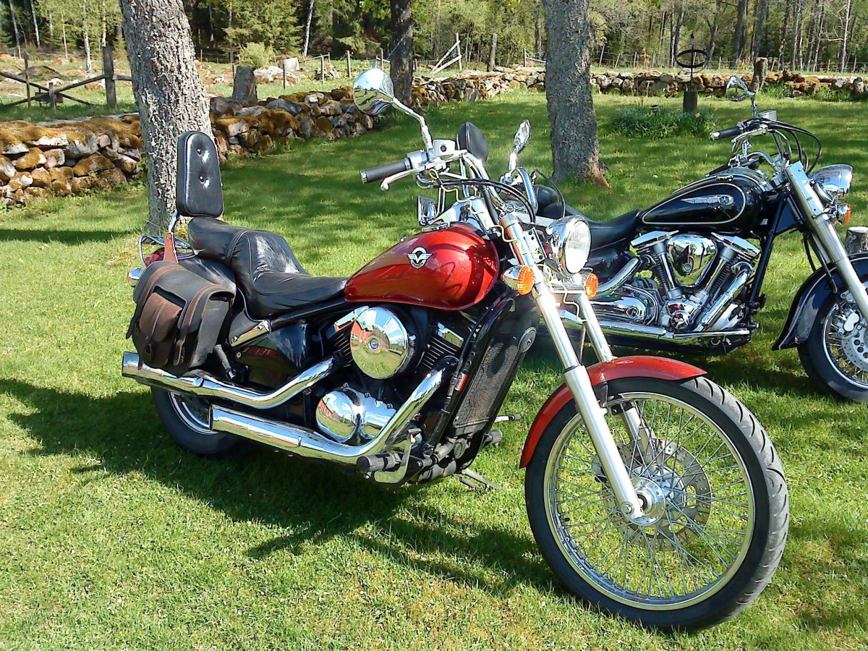

Image 6: Skateboard.
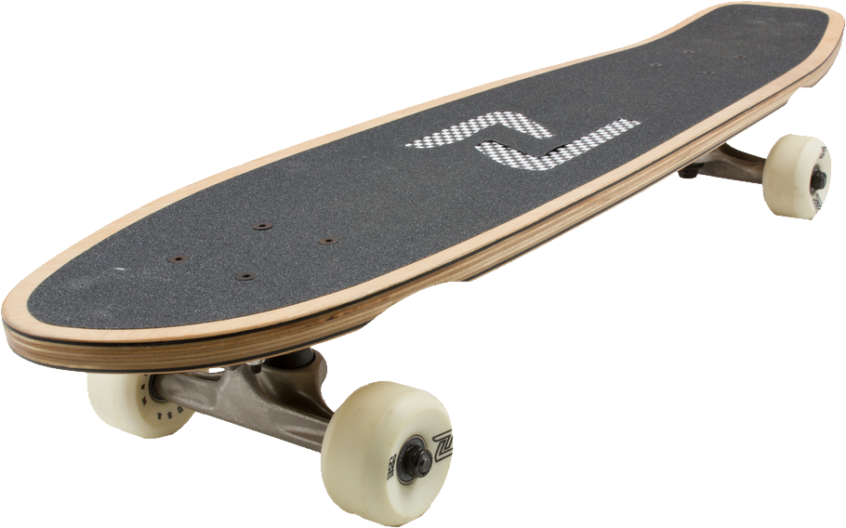

SAMPLE RESPONSES (student answers will vary)
Type of Transport | Any laws or rules that apply in Victoria. | Is a licence required? | Is registration required? | Safety rules that riders or drivers must follow.
Car – vehicle with four wheels that can run on petrol, electricity or both as a hybrid | Must follow all road rules, traffic lights and speed limits. | Yes | Yes – legal permission given by governments to allow a car to be driven on public roads. | Wear a seatbelt, obey speed limits, no illegal phone use, no drink or drug driving, car must be registered, must have a current driver’s licence, etc.
Bicycle – pedal-powered, no motor | Must follow the bicycle road rules and traffic signals. | No | No | Wear an approved helmet, follow bicycle rules, ride safely, and be visible to other road users.
E-bike – pedal plus electric motor and battery | Must have pedals and motor only assists while pedalling. | No | No | Wear an approved helmet, follow bicycle rules, ride safely, and ensure the e-bike meets legal requirements.
E-scooter – electric motor, no pedals | The rider must be at least 16 years of age and follow  e-scooter rules. | No | No | Wear an approved helmet, maximum speed 20km/h, only one rider, follow e-scooter rules.
Motorcycle – power comes from a petrol engine | Must have a motorcycle licence and follow road rules. | Yes | Yes | Wear an approved helmet and protective clothing, obey speed limits and have an appropriate motorcycle licence.
Skateboard – a board with four wheels that people ride by standing on it and pushing with one foot. | Cannot be towed by vehicles and cannot be used on some roads. | No | No | Wearing a helmet and protective gear is strongly recommended. Ride carefully around others and follow local rules about where the skateboards can be used.

Activity 1b: E-Bikes and E-Scooters – Comparison and Comprehension Activity

Learning Intentions
We are learning to understand what e-bikes and e-scooters are, how they are used in Victoria and the laws and safety rules that apply to them.
Success Criteria
I can describe what e-bikes and e-scooters are, explain how they are powered and ridden and identify key Victorian laws and safety rules.

Task Instructions:
1. Read the information provided about e-bikes and e-scooters in Victoria.
2. Complete the comparison table by identifying both similarities and differences between e-bikes and e-scooters.
3. Use the information provided as well as your own knowledge and experiences.
4. Think about how each form of transport works, the laws and rules that apply in Victoria, why people use them, the benefits and concerns about each method of transport.
5. After completing the table, compare your answers with another student and then work together to answer the discussion questions.
6. Share your answers with the rest of the class.
E-bikes are bicycles fitted with an electric motor that helps the rider while they pedal. In Victoria, legal e-bikes are treated the same as ordinary bicycles, meaning that riders do not need a licence, registration or compulsory insurance.

To be legal, an e-bike must:
- have working pedals,
- only provide motor assistance while the rider is pedalling,
- has a motor generally limited to 250 watts,
- stop providing electric assistance once the bike reaches 25 km/h (riders can travel faster by pedalling on their own).

An e-bike becomes illegal if it has:
- a motor that is too powerful,
- an accelerator that works without pedalling at higher speeds,
- a modified speed control system,
- a petrol engine attached.

Illegal e-bikes may be treated as an unregistered motor vehicle, which can result in large fines and the police seizing the bikes.

Electric scooters (e-scooters) are small battery-powered vehicles that are usually ridden standing up. In Victoria, both private and shared e-scooters are legal, as long as riders follow strict regulations.

These rules include:
- a maximum speed limit of 20 km/h,
- compulsory helmet use,
- a minimum riding age of 16,
- no riding on footpaths.

These restrictions are designed to improve safety for riders and pedestrians.

**Both e-bikes and e-scooters provide convenient, affordable and environmentally friendly transport options. However, there are concerns about safety risks, accidents and how well the rules can be enforced or put into practice.

Complete this comparison table referring to the information above and your own knowledge of e-bikes and e-scooters:
SAMPLE RESPONSES (Student answers will vary)
Questions | E-Bikes | E-Scooters
What are they? | Bicycles fitted with an electric motor to help the rider while pedalling. | Small battery-powered vehicles that are ridden standing up.
How are they powered? | Electric motor and rechargeable battery combined with physical pedalling. | Electric motor and rechargeable battery.
How are they ridden? | Seated and pedalled just like a standard bicycle. | Standing on a board and steering with handlebars.
Victorian rules that apply | Must have pedals, motor assistance only while pedalling, generally limited to 250 watts, assistance cuts out at 25 km/h, helmet required. | Riders must be at least 16 years old, wear a helmet, not ride on footpaths and not exceed 20km/hr.
Why do people like them? | Easy to ride, reduces effort, environmentally friendly, affordable transport, useful for long trips. | Convenient, affordable, environmentally friendly, easy for short trips and commuting/travelling.
Safety concerns | Accidents, speeding, collisions with pedestrians or other vehicles, illegal modifications to increase speed or power. | Accidents, falls, collisions with pedestrians, unsafe riding behaviour, difficulty enforcing rules.
Commonly used for | Travelling to work or school, recreation, exercise and longer journeys. | Short distance travel, commuting, connecting to public transport and recreational use.
Big question? | Should Victoria introduce registration and licensing for e-bikes? | Should Victoria introduce registration and licensing for e-scooters?

Discussion questions: (Complete the following questions with another student)
Why are e-bikes and e-scooters becoming more popular?
E-bikes and e-scooters are becoming more popular because they are convenient, affordable and environmentally friendly. They can help people avoid traffic jams and congestion, reduce travel costs and make it easier to travel short distances without using a car.
What benefits do they provide to individuals and society?
E-bikes and e-scooters provide people with a quick and flexible way to travel. They reduce traffic congestion, lower carbon emissions and air pollution, improve access to transport and encourage people to use alternatives to cars.
What problems or dangers do they cause?
They can contribute to accidents and injuries, especially when riders travel at unsafe speeds or do not follow the rules. There are also concerns about collisions with pedestrians, dangerous riding behaviour and the difficulties police face in enforcing the laws and regulations. People using e-bikes or e-scooters irresponsibly have killed or seriously injured pedestrians.

Activity 2: Understanding Victoria’s Laws

Activity 2a: Fact-Checking Victoria’s Current Road Laws – True/False Research Activity

Learning Intentions
We are learning about the current road laws in Victoria relating to e-scooters and e-bikes and how to find reliable legal information.
Success Criteria
I can identify whether statements about Victorian road laws are true or false using evidence from reliable sources. I can record and explain where I found this information.

Task Instructions:
1. Read each statement carefully.
2. Use the website links provided to investigate whether each statement is TRUE or FALSE under current Victorian road laws.
3. For each statement, write down the website or source you used to find your answer.
4. Be prepared to discuss with the class which laws surprised you and why, how the laws are designed to improve safety for riders and whether the current laws balance safety, convenience and environmental benefits (e.g. less pollution, fewer traffic jams, etc.)

SAMPLE RESPONSES
Website links:
Transport Victoria – E-Scooter road rules
Victoria Police – Electric powered scooters (e-scooters)
RACV – RACV issues e-scooter and e-bike warning as Victorian kids head back to school
Transport Victoria – Electric Bikes (e-bikes)

Statement | True/False | Source
1. Riders must be at least 16 years old to legally ride an e-scooter in Victoria. | True | Transport Victoria – E-Scooter road rules
2. E- scooters are allowed to be ridden on footpaths in Victoria. | False | Transport Victoria – E-Scooter road rules
3. E-scooter riders must wear a helmet. | True | Transport Victoria – E-Scooter road rules
4. You need a driver’s licence to ride a legal e-bike in Victoria. | False | Victoria Police – Electric powered scooters (e-scooters)
5. Legal e-bikes must follow the same road rules as bicycles. | True | Victoria Police – Electric powered scooters (e-scooters)
6. E-bikes in Victoria must have working pedals to be legal on public roads and paths. | True | Victoria Police – Electric powered scooters (e-scooters)
7. E-scooter riders can lose their driver’s licence for riding under the influence of alcohol or drugs. | True | Transport Victoria – E-Scooter road rules
8. E-bikes and e-scooters are both considered motor vehicles requiring registration in Victoria. | False | Transport Victoria – Electric Bikes (e-bikes)
9. E-scooters can legally travel faster than 25km/h in Victoria. | False | Transport Victoria – Electric Bikes (e-bikes)
10. It is legal to carry a passenger on a single-person e-scooter in Victoria. | False | Transport Victoria – Electric Bikes (e-bikes)

Activity 2b: Road Rules in Action: E-Bike and E-Scooter Scenario Activity

Learning Intention

We are learning to investigate and apply Victorian road laws relating to e-bikes and e-scooters to real-life situations.

Success Criteria

I can identify whether Victorian e-bike or e-scooter laws have been followed or broken in different scenarios and justify my decisions using evidence from relevant road rules.

Task Instructions:
1. In pairs, read each scenario carefully and decide if a Victorian e-bike or e-scooter law has been broken.
2. Identify the road rule or law that applies and give a reason for your choice.
3. Share your answers with the rest of the class.
SAMPLE RESPONSES (Student answers will vary)
E-Bike Scenarios:
Scenario 1:
Jack has an e-bike with a motor, and that helps him ride at 45 km/h while riding on a shared path in Carlton. He does not pedal and lets the motor do all the work.

Has Jack broken the law? Explain which e-bike rule applies.
Yes, Jack has broken the law. His e-bike is travelling at 45 km/h using motor power alone, which does not meet Victorian e-bike requirements. Legal e-bikes can only provide motor assistance up to 25 km/h, and generally most require the rider to be pedalling. Because Jack is not pedalling and is travelling well above the legal limit, his e-bike could be classified as an unregistered motor vehicle.

Scenario 2:
Priya rides her e-bike to school. Her bike meets all the Victorian requirements, but she does not wear a helmet because she is only riding for a short distance.
Has Priya broken the law? Why?
All e-bike riders in Victoria must wear an approved bicycle helmet, regardless of how far they are travelling. The distance of the trip does not matter. By riding without a helmet, Priya is breaking the law and could receive a fine.

Scenario 3:
Bao rides his e-bike home from the train station while carrying his younger brother on the back rack of the bike, even though the bike was not designed to carry passengers.

Has Bao broken the law? Explain your answer using Victorian bicycle/e-bike rules.
Although e-bikes follow the same road rules as bicycles, passengers can only be carried if the bicycle is designed to carry them. Because Bao’s younger brother is riding on a back rack that was not designed as a passenger seat, Bao is riding unsafely and breaking Victorian bicycle and e-bike rules.

E-Scooter Scenarios:
Scenario 4:
Deng rides her e-scooter along a busy footpath outside shops because she feels safer there than riding on the road.
Has Deng broken the law? Where are e-scooters allowed to be ridden in Victoria?
E-scooters cannot be ridden on footpaths in Victoria, even if the rider feels safer there. E-scooters are only allowed on roads with a speed limit of 60km/h or less, bike paths or shared-use paths. By riding on the footpath outside the shops, Deng is breaking the law and could receive a fine.

Scenario 5:
Mele is 14 years old and rides an e-scooter to basketball training using local bike paths.
Has Mele broken the law? Identify the relevant e-scooter rule.
Victorian law states that e-scooter riders must be at least 16 years of age. Mele is only 14, so she is not legally allowed to ride an e-scooter, even though she is using the local bike path.

Scenario 6
After a party, Wei rides his e-scooter home while still affected by alcohol. Police stop him and conduct a breath test.

Has Wei broken the law? What penalty could apply to e-scooter riders who are under the influence of alcohol?
Wei has broken the law by riding his e-scooter while under the influence of alcohol.
E-scooter riders must not ride while affected by alcohol or drugs, and similar drink-driving rules apply.
If Wei is over 18 and above the legal alcohol limit, then he could face penalties such as fines, loss of his driver’s licence, an alcohol interlock (ignition lock) requirement and participation in a behaviour change program.

If Wei is under 18, he could still face penalties such as a fine, and if he has a learner permit, it could be suspended or cancelled.

Activity 3: Whose Lane is it Anyway? – Stakeholder Mapping: Pair-Share Activity

Learning Intention

We are learning how different groups in the community are affected by the use and regulations of e-bikes and e-scooters.

Success Criteria

I can identify different stakeholders connected to e-bikes and e-scooters and explain their point of view and concerns. I can work collaboratively to develop and present a position statement supported by relevant reasons and examples.

Task Instructions:
1. Working in pairs or groups of three students, you will be assigned one stakeholder from the list below. Each stakeholder has a particular interest in how e-bikes and e-scooters are regulated in Victoria.
2. Using the template/guide provided, write a short position statement that includes:
i. Your stakeholder’s two main priorities or key interests.
ii. Their biggest fear or concern if laws relating to e-bikes and e-scooters will be changed.
3. Be prepared to present your position statement to the class. Explain your stakeholder’s perspective and justify why they hold this view.
Note: Students may choose to complete the scaffolded or graphic version of this activity. Teachers may choose to present students with both options, or choose which option would work for their cohort.
Option 1: Scaffolded presentation (page 18).
Option 2: Graphic presentation – stakeholder profile (page 19).

What is a:
Position Statement: A short explanation of what a person or group think about an issue and why they think that way.
Example: A pedestrian group might believe stricter e-scooter speed limits are needed to improve safety on footpaths
Stakeholder: A person or group who is affected by an issue or has a strong interest in what happens.
Examples: Riders, pedestrians, police and delivery drivers are all stakeholders in e-bikes and e-scooters because the rules affect them in different ways
Stakeholders to be allocated to each pair/group:
- Teenage riders: they rely on cheap, green transport to get to their part-time jobs, school and social events.
- Pedestrian representatives: they use the footpath or shared paths and are worried about safety, especially if they are elderly, young children or visually impaired.
- Emergency department doctors: they see lots of injuries caused by crashes from high-speed falls and a lack of helmets.
- Small business owners: they want customers to access shopping strips and local businesses easily.
- Victoria Police: they are responsible for enforcing the laws and rules relating to e-bikes and e-scooters.
- Parents: they want their children to travel safely and responsibly.
- Schools: they are responsible for student safety and manage issues like where students can ride and park their e-bikes or e-scooters.
- E-bike retailers: they are keen to sell e-bikes and e-scooters to the public.
- Delivery drivers: they often rely on e-bikes and e-scooters for fast and affordable transport to deliver food or parcels.
Option 1: Scaffolded Version – A Guide to completing this task
Option 2: Graphic presentation – stakeholder profile
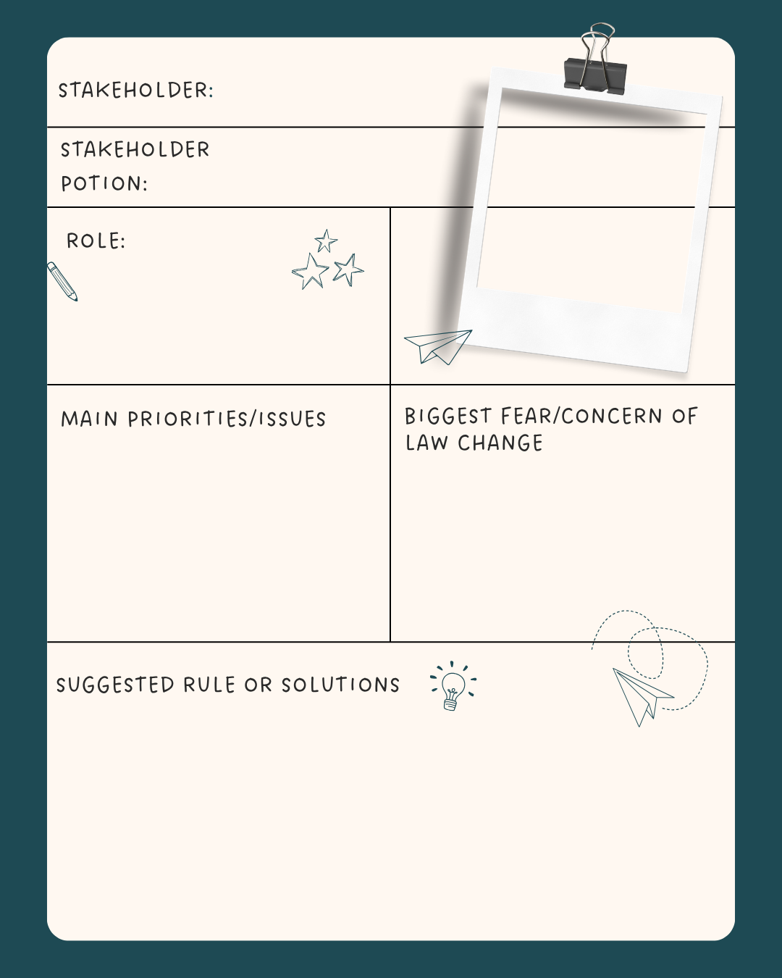

SAMPLE ANSWERS (Student answers will vary)
1. Stakeholder Group: Teenage Riders
Stakeholder Position | E-bikes and e-scooters should remain affordable and accessible for young people because they provide a convenient way to travel.
Two Main Priorities or Issues | 1. Affordable transport because teenagers rely on e-bikes and e-scooters to be able to get to school, part- or full -time jobs and social activities, giving them some independence from their parents.  2. Having safe places to ride because dedicated bike lanes reduce the risks of accidents and injuries.
Biggest Fear or Concern if Laws Change | Stricter laws could make e-bikes and e-scooters too expensive or difficult to use. This could lead to fewer transport options for young people and greater reliance on parents or public transport.
Suggest Rule/ Solution | We believe the government should improve the bike lane network while continuing to allow responsible riders to use e-bikes and e-scooters.

2. Stakeholder Group: Pedestrian Representatives
Stakeholder Position | Strong safety laws are needed to protect pedestrians from dangerous riding behaviour.
Two Main Priorities or Issues | 1. Pedestrian safety because high-speed riding on both e-bikes and e-scooters can increase the risk of accidents and injury.  2. Enforcement of laws because some riders ignore speed limits and road rules.
Biggest Fear or Concern if Laws Change | Weaker laws could lead to more accidents that involve pedestrians, particularly elderly people, young children and people with disabilities.
Suggest Rule/ Solution | We believe the government should enforce speed limits and increase penalties for unsafe riding.

3. Stakeholder Group: Emergency Department Doctors
Stakeholder Position | Stronger safety measures are needed to reduce injuries caused by e-bike and e-scooter crashes.
Two Main Priorities or Issues | 1. Improved helmet use because helmets reduce the risk of serious head injuries in the event of an accident.  2. Greater rider safety education because many injuries occur due to excessive speed, unsafe riding and a lack of understanding of road laws.
Biggest Fear or Concern if Laws Change | Relaxed safety laws could increase the number of serious injuries. This will place greater pressure on emergency departments and healthcare services.
Suggest Rule/ Solution | We believe the government should strengthen safety education and enforce helmet laws.

4. Stakeholder Group: Small Business Owners
Stakeholder Position | We believe that e-bikes and e-scooters can help customers access local businesses more easily.
Two Main Priorities or Issues | 1. Customer access is important because easier transport can increase foot traffic to shopping areas.  2. Safety is also important because unsafe riding can discourage people from visiting local shopping strips, leading to fewer sales and profits.
Biggest Fear or Concern if Laws Change | Very strict laws could reduce the number of people using e-bikes and e-scooters to visit local businesses to shop.
Suggest Rule/ Solution | We believe the government should support safe riding while providing adequate parking facilities near shopping areas for e-bike and e-scooter users.

5. Stakeholder Group: Victoria Police
Stakeholder Position | Clear and enforceable laws are necessary to ensure the safe use of e-bikes and e-scooters.
Two Main Priorities or Issues | 1. Public safety because Victoria police are responsible for reducing road accidents and ensuring the safety of all road users.  2. Compliance or following all the road rules because e-bike and e-scooter riders must follow the law to help reduce accidents and ensure everyone can use roads and shared paths safely.
Biggest Fear or Concern if Laws Change | Unclear or inconsistent laws can make enforcement difficult, leading to increased unsafe rider behaviour and more accidents.
Suggest Rule/ Solution | We believe the government should provide clear laws and resources to support the effective enforcement of road laws.

6. Stakeholder Group: Parents
Stakeholder Position | Children should be able to use e-bikes and e-scooters safely and responsibly.
Two Main Priorities or Issues | 1. Child safety because parents want to ensure their children are protected from injury and can ride safely in public areas.  2. Responsible riding because children need to understand and follow road rules to reduce risks and promote safe behaviour when using e-bikes and e-scooters.
Biggest Fear or Concern if Laws Change | Unsafe riding behaviour because it could place children at greater risk of serious injury affecting families and communities.
Suggest Rule/ Solution | We believe ethe government should introduce rider education programs in all schools and maintain strong safety standards.

7. Stakeholder Group: Schools
Stakeholder Position | Students should be able to travel to school safely while following school and road rules.
Two Main Priorities or Issues | 1. Student safety because schools have a duty of care to protect students and promote safe travel to and from school.  2. Managing parking and storage because an increasing number of students use e-bikes and e-scooters for their daily journey to and from school, creating the need for secure and organised parking facilities.
Biggest Fear or Concern if Laws Change | Unsafe riding behaviour could lead to injuries for students travelling to and from school, placing them and other road users at risk.
Suggest Rule/ Solution | We believe the government should provide safety education and training programs while also supporting schools in installing secure e-bike and e-scooter parking facilities to improve safety and encourage responsible use.

8. Stakeholder Group: E-Bike and E-Scooter Retailers
Stakeholder Position | E-bikes and E-scooters provide an environmentally friendly transport option and should remain available to consumers.
Two Main Priorities or Issues | 1. Consumer access because demand for e-bikes and e-scooters supports businesses through increased sales and profit.  2. Product safety because safe products help build consumer confidence and trust.
Biggest Fear or Concern if Laws Change | More strict regulations could reduce sales and discourage customers from buying e-bikes and e-scooters.
Suggest Rule/ Solution | We believe the government should ensure e-bikes and e-scooters meet safety standards while continuing to support environmentally friendly transport options in the community.

9. Stakeholder Group: Delivery Drivers
Stakeholder Position | E-bikes and e-scooters are important transport options that help delivery drivers to do their jobs quickly.
Two Main Priorities or Issues | 1. Affordable transport because e-bikes and e-scooters cost less to operate than many other vehicles.  2. Safe riding infrastructure because delivery drivers spend many hours on the road and paths each day.
Biggest Fear or Concern if Laws Change | Stricter restrictions could make it harder for drivers to complete deliveries quickly and may reduce their income.
Suggest Rule/ Solution | We believe the government should improve bike paths while ensuring all riders follow safety rules.

Activity 4: Media Messages: E-Bikes and E-Scooters in the Headlines – Pair and Share or Group Activity

Learning Intention

We are learning to analyse how the media reports on issues related to e-bikes and e-scooters and evaluate or assess how media coverage can influence public opinion and government responses.

Success Criteria

I can identify the main issues discussed in a newspaper article and who is affected, consider the different points of view and explain how media coverage may influence public opinion and government decision-making.

Task Instructions:
1. Your teacher will place you in pairs or groups of 3-4 students and allocate ONE newspaper article or media report about e-bikes or e-scooters.
2. Read the article carefully and identify the main issues, viewpoints and concerns that are raised.
3. Complete each of the analysis questions using evidence and examples from the article to support your answers.
4. Share your findings with another pair/group and compare your responses.
5. As a class, discuss whether the media focuses more on the benefits or risks of e-bikes and e-scooters.
SAMPLE RESPONSES (Student answers will vary)
Article 1:
News.com.au – ‘E-bikes vs. Karens’: Unexpected response to teen bike swarms taking over Melbourne
Headline Analysis Activity (each group completes one set of questions based on their article)
Question 1
State the headline of the article and describe what it suggests about e-bikes or e-scooters.
The headline is ‘E-bikes v’s Karens: Unexpected response to teen bike swarms taking over Melbourne’. The headline suggests that there is conflict between groups of teenage e-bike riders and adults in the community who are concerned about their behaviour. The use of the word ‘Karens’ may encourage readers to view the complaints as exaggerated, while ‘bike swarms’ suggests that large groups of riders are causing problems in public spaces.

Question 2
Outline the main issue/s or event/s discussed in the article.
The article focuses on groups of teenagers riding e-bikes around Melbourne and the reactions/feedback from local residents and businesses. It raises issues about safety, noise and behaviour while also looking at why young people enjoy riding e-bikes and gathering with their friends.
Question 3
Identify the individuals or groups affected by the issue/s and briefly explain how they have been impacted.
Teenage riders are affected because they face criticism, stricter rules or increased police attention. Residents, pedestrians and business owners are also affected as they feel unsafe or disrupted by large groups of riders. Parents may also be concerned about the safety of their children.

Question 4
List the concerns, problems or challenges highlighted in the article.
The article highlights concerns about:
- reckless or dangerous riding,
- large gatherings of riders that may disrupt public spaces,
- potential intimidation or threats to pedestrians,
- difficult for police to enforce road rules,
- irresponsible riding could lead to accidents and injuries,
- public safety for the community when riders do not follow the rules.

Question 5
Analyse the different viewpoints or opinions presented in the article.
The article presents different viewpoints about teenage e-bike ride-outs in Melbourne. One viewpoint is that e-bikes give young people independence, social connection and an affordable way to travel. Supporters believe the group rides encourage teenagers to spend time with friends and stay away from negative influences. Another viewpoint is that some riders behave dangerously by performing stunts, breaking road rules and disrupting traffic, creating safety risks for others. As a result, residents and police may support stricter rules, while many riders argue they are being unfairly blamed for the actions of a small group. Responsible cyclists are also concerned that this behaviour could damage the reputation of all e-bike riders and lead to tougher laws.
Question 6
Decide whether the article presents e-bikes and e-scooters in a positive, negative or balanced. Justify your answer using examples from the article.
The article presents a balanced view, but slightly negative view of e-bikes and e-scooters. It recognises that they can be fun, affordable and help young people become more independent and social. However, it tends to focus more on the safety concerns, dangerous driving and complaints from the community. While both sides are included, the overall message is more negative because greater attention is given to the risks and problems.

Article 2:
Note: A summary of the article is provided below. The full article is available online if your school has a subscription to the Herald Sun.
Herald Sun – My e-bike beef and why Australia needs change
E-bike ‘scourge’ faces crackdown as states move to introduce new road rules

When a delivery rider brought peak-hour traffic to a crawl, chaos erupted — laying bare the dangers of a fast-growing, barely regulated e-bike free-for-all, writes Patrick Carlyon.

Patrick Carlyon, a senior journalist for the Herald Sun, examines the rapid growth of e-bikes and e-scooters in Australia and the growing concerns about their impact on road safety. He provides examples of riders speeding, ignoring road rules, riding without helmets and creating dangers for pedestrians, drivers and other road users. The article also highlights the growing number of injuries related to e-bikes and e-scooters, with hospitals reporting more emergency cases.

In response to these concerns or issues, governments are considering tougher regulations. Queensland has proposed new laws that would require riders to be at least 16 years old, hold a learner’s permit or current driver’s licence, obey speed limits and be required to take random breath tests. In New South Wales, police, legal experts and health officials have suggested introducing registration and compulsory third-party insurance to improve responsibility and safety.

The article presents different viewpoints on these proposals. Police, health professionals and legal experts believe that stronger laws are needed to reduce injuries and improve road safety. In contrast, cycling groups, disability organisations and delivery companies like Uber argue that stricter rules could make transport less accessible and negatively affect delivery workers who rely on e-bikes. Overall, the article presents e-bikes and e-scooters as a growing public issue that requires governments to balance convenience and innovation with community safety and regulation.

Headline Analysis Activity (each group completes one set of questions based on their article)
Question 1
State the headline of the article and describe what it suggests about e-bikes or e-scooters.
The headline is ‘E-bike ‘scourge’ faces crackdown as states move to introduce new road rules.’ The word ‘scourge’ suggests that e-bikes are a serious problem and that government actions is needed. The headline encourages readers to focus on the risks and dangers of e-bikes.
Question 2
Outline the main issue/s or event/s discussed in the article.
The article discusses the growing number of e-bike injuries, unsafe riding and calls for stricter rules. It highlights dangerous rider behaviour, pressure on hospitals and police concerns about riders following the road rules. The article also refers to possible changes such as licence requirements and registration.

Question 3
Identify the individuals or groups affected by the issue/s and briefly explain how they have been impacted.
Many groups are affected, including e-bike riders, pedestrians, car drivers, delivery workers, hospitals and governments. Riders may face new, stricter rules, which could improve safety for pedestrians and drivers. Hospitals must deal with a growing number of injuries and governments are under pressure to address community concerns about improving road safety.
Question 4
List the concerns, problems or challenges highlighted in the article.
The article highlights several concerns, including:
- riders travelling at unsafe speeds,
- riders not wearing helmets,
- inexperienced riders who do not understand road rules,
- increasing numbers of injuries in the hospital,
- limited regulation compared to cars and motorcycles,
- concerns that riders may not have insurance if they cause an accidently.

Question 5
Analyse the different viewpoints or opinions are presented in the article.
The article presents different viewpoints about e-bikes. Police argue that illegal e-bikes create serious safety risks and believe parents need to make sure their children ride safely and follow the rules. Health professionals are concerned about the rising number of injuries linked to e-bike use and support stronger regulations. In contrast, some young people may see e-bikes as a convenient, affordable and enjoyable way to travel. However, the article mainly focuses on safety concerns and the need for greater responsibility and enforcement.

Question 6
Decide whether the article present e-bikes and e-scooters in a positive, negative or balanced way. Justify your answer using examples from the article.
The article presents e-bikes in a mostly negative way. It uses words such as ‘scourge’ and focuses on accidents, injuries and unsafe riding. The article discusses riders not wearing helmets, breaking road rules and creating risks for other road uses. It also highlights increasing injury numbers and calls for stricter regulations. While some benefits are mentioned, the article focuses much more on safety concerns and the dangers of e-bikes.

Article 3:
Note: A summary of the article is provided below. The full article can be accessed online if your school has a subscription to the Herald Sun
Herald Sun – ‘Happy to destroy them’: Police target illegal e-bikes
Officer offers to destroy illegal e-bikes as police tackle dangerous riding behaviour
A senior police officer says he will accept illegal e-bikes “for destruction” as dangerous youth riding behaviour escalates across the Bellarine Peninsula.

Geelong Advertiser

Oliver Condor of the Geelong Advertiser reports that there are growing concerns about dangerous e-bike riding on the Bellarine Peninsula (Geelong), particularly among young people using illegal or modified e-bikes. Police say some riders are travelling at speeds of more than 60 km/h without proper safety equipment, increasing the risk of serious injury or even death.

In response, police are encouraging parents to take responsibility by stopping their children from riding illegal e-bikes and, in some cases, handing the bikes over to be destroyed. Some young riders have already handed over their bikes as part of a police caution program instead of receiving large fines or going through the court system.

The articles also describes community concerns about unsafe riding behaviour, including reports of youths on e-bikes throwing objects at passing cars. Health professionals have reported an increase in injuries related to e-bikes and e-scooters and are participating in research to better understand the causes and effects of these accidents.

Overall, the article presents illegal and modified e-bikes as a growing community safety issue and emphasises the need for parental responsibility, safer riding behaviour and strong measures to reduce injuries and protect the community.

Headline Analysis Activity (each group completes one set of questions based on their article)
Question 1
State the headline of the article and describe what it suggests about e-bikes or e-scooters.
The headline is ‘Officer offers to destroy illegal bikes as police tackle dangerous riding behaviour.’ It suggests that illegal e-bikes have become a serious safety issue and the police are taking strong action to address or fix this problem.

Question 2
Outline the main issue/s or event/s discussed in the article.
The article discusses police concerns about dangerous riding by young people using modified or illegal e-bikes. It explains how police are encouraging parents to take responsibility and remove unsafe bikes. The article also refers to police operations that are targeting unsafe riders.

Question 3
Identify the individuals or groups affected by the issue/s and briefly explain how they have been impacted.

Young riders are affected because they may be fined, face police action and the risk of injury. Parents are affected because they are expected to supervise their children’s use of e-bikes. The wider community, including pedestrians and drivers, may also be affected by unsafe riding behaviour.

Question 4
List the concerns, problems or challenges are highlighted in the article.
The article highlights:
- illegal modifications to e-bikes,
- excessive speeds above legal limits,
- riders not wearing helmets,
- serious injury and death risks,
- dangerous behaviour in public areas,
- growing concerns from police and residents.
Question 5
Analyse the different viewpoints or opinions are presented in the article.
The article presents several viewpoints about e-bikes. Police believe stronger action is needed to improve safety and reduce serious injuries caused by illegal and dangerous driving. Community groups also support safer riding behaviour and want riders to follow the rules. The article highlights the importance of parental responsibility to make sure young people ride safely and legally. While some riders may believe the rules are too strict, this viewpoint is not the major focus of the article.
Question 6
Decide if the article presents e-bikes and e-scooters in a positive, negative or balanced way. Justify your answer using examples from the article.
The article presents e-bikes in a mostly negative way. It focusses is on illegal bikes, dangerous riding and police action. Examples include riders travelling at high speeds, not wearing t helmets and using modified e-bikes. The article also discusses accidents, injuries and police crackdowns. There is very little reference to the benefits of e-bikes, so readers are encouraged to focus on the risks and safety concerns.

Article 4:
ABC News – Melbourne doctors call for greater regulation of e-scooters as injuries rise, clogging up hospitals
Headline Analysis Activity (each group completes one set of questions based on their article)
Question 1
State the headline of the article and describe what it suggests about e-bikes or e-scooters.
The headline of the article is ‘Melbourne doctors call for greater regulation of e-scooters as injuries rise, clogging up hospitals’. It suggests that more people are being injured while riding e-scooters and that hospitals are under pressure. It also suggests that stricter rules may be needed to improve safety.
Question 2
Outline the main issue/s or event/s discussed in the article.
The article discusses the growing number of e-scooter injuries and the effect this is having on the emergency departments of hospitals. It looks at the types of injuries being treated and raises concerns about rider safety.
Question 3
Identify the individuals or groups affected by the issue/s and briefly explain how they have been impacted.
E-scooter riders are the most affected because they may suffer serious injuries. Hospitals, doctors and nurses are also affected because they must treat an increasing number of injured riders. Taxpayers may also be affected through increased healthcare costs.

Question 4
List the concerns, problems or challenges are highlighted in the article.
The article highlights:
- rising injury rates,
- pressure on hospital emergency departments,
- head injuries and broken bones,
- lack of helmet use,
- concerns about inexperienced riders.
Question 5
Analyse the different viewpoints or opinions are presented in the article.
Health professionals argue that stronger safety measures are needed to reduce the growing number of e-scooter injuries and reduce pressure on hospitals. Supporters of e-scooters may argue that they are a convenient and environmentally friendly form of transport, and that education and safety awareness are better solutions than banning or heavily restricting them.
Question 6
Decide whether the article presents e-bikes and e-scooters in a positive, negative or balanced way. Justify your answer using examples from the article.
The article presents e-scooters in a negative way because it focuses on injuries, pressure on hospitals and safety concerns. It highlights the growing number of accidents and the effects these injuries have on hospitals and healthcare workers. The article says very little about the benefits of e-scooters and instead focuses on the risks and problems they can cause.

Article 5:
Bicycle Network – Coroner calls for e-scooter ban
Headline Analysis Activity (each group completes one set of questions based on their article)
Question 1
State the headline of the article and describe what it suggests about e-bikes or e-scooters.
The headline of the article is ‘*Coroner calls for e-scooter ban’. It suggests that a coroner believes e-scooters present serious risks and that a ban should be considered to improve public safety.
*A coroner investigates or looks at how and why a person dies and makes recommendations to help prevent similar deaths in the future.
Question 2
Outline the main issue/s or event/s discussed in the article.
The article discusses deaths or serious injuries linked to e-scooters and looks at whether existing regulations or rules are enough to protect the public.
Question 3
Identify the individuals or groups affected by the issue/s and briefly explain how they have been impacted.
Riders, pedestrians, families of accident victims and the government are affected by this issue. Serious accidents can cause injuries, emotional stress and financial difficulties for individuals and families. The government is also affected because it may need to introduce new laws and spend more on resources on safety and healthcare services.
Question 4
List the concerns, problems or challenges highlighted in the article.
The article highlights:
- fatal accidents (causing death),
- serious injuries,
- concerns about current regulations,
- public safety risks,
- whether e-scooters should continue to operate.
Question 5
Analyse the different viewpoints or opinions are presented in the article.
Some people support a ban on e-scooters because they believe e-scooters are too dangerous and have caused serious injuries or deaths. Others believe better regulations, rider education and enforcement of the rules by the police would be a better solution than banning scooters completely.

Question 6
Decide whether the article present e-bikes and e-scooters in a positive, negative or balanced way. Justify your answer using examples from the article.
The article presents e-scooters in a very negative way as it focuses on death, injuries and calls for a ban. It highlights safety concerns and questions whether current rules are strong enough. The article gives little attention to the benefits of e-scooters and mainly focuses on the risks, encouraging readers to see them as dangerous.

Article 6:
RACV News – RACV issues e-scooter and e-bike warning as Victorian kids head back to school
Headline Analysis Activity (each group completes one set of questions based on their article)
Question 1
State the headline of the article and describe what it suggests about e-bikes or e-scooters.
The headline of the article is ‘RACV issues e-scooter & e-bike warning as Victorian kids head back to school.’ It suggests that there are safety concerns about students using e-scooters and warns of the potential safety risks and the need for young riders to follow the rules.

Question 2
Outline the main issue/s or event/s discussed in the article.
The article discusses the increasing use of e-scooters and e-bikes by students travelling to and from school. It highlights concerns about safe riding practices, following road rules and reducing the risk of accidents around schools and on shared paths.
Question 3
Identify the individuals or groups affected by the issue/s and briefly explain how they have been impacted.
Students, parents, schools and local communities are affected by this issue. Students may face a greater risk of accidents if they do not ride safely. Parents need to supervise their children and ensure they understand the rules. Schools may need to provide safety education, while local communities are concerned about the safety of shared paths and areas around schools.
Question 4
List the concerns, problems or challenges are highlighted in the article.
The article highlights:
- young riders lacking experience and road awareness,
- not wearing helmets correctly,
- limited understanding of road rules,
- increased risks around schools and on shared paths,
- the possibility of accidents and injuries.
Question 5
Analyse the different viewpoints or opinions are presented in the article.
Safety experts believe more education and awareness programs are needed to help young people ride safely and reduce the risk of injuries. Others argue that e-scooters and e-bikes are convenient and affordable ways for students to travel and should continue to be available, provided riders follow the rules and use them responsibly.

Question 6
Decide if the article presents e-bikes and e-scooters in a positive, negative or balanced way. Justify your answer using examples from the article.
The article presents e-bikes and e-scooters in a mostly negative way because it focuses on warnings and safety concerns. It highlights risks such as accidents, not wearing helmets and not following road rules. Although the article mentions that e-scooters and e-bikes can be useful forms of transport, most of the attention is on rider safety and preventing injuries.

Article 7:
National Seniors Australia – Crackdown on e-scooters and e-bikes
Headline Analysis Activity (each group completes one set of questions based on their article)
Question 1
State the headline of the article and describe what it suggests about e-bikes or e-scooters.
The headline of this article is ‘Crackdown on e-scooters and e-bikes’. It suggests that governments and police are taking stronger action to deal with safety concerns and dangerous riding behaviour involving e-bikes and e-scooters.

Question 2
Outline the main issue/s or event/s discussed in the article.
The article discusses new laws; police operations and increased enforcement aimed at reducing unsafe riding behaviour and improving public safety.

Question 3
Identify the individuals or groups affected by the issue/s and briefly explain how they have been impacted.
Riders are affected because they may face fines, penalties or stricter rules if they break the law. Police, pedestrians and the wider community are also affected because they are involved in efforts to improve safety and reduce the risk of accidents.

Question 4
List the concerns, problems or challenges are highlighted in the article.
The article highlights:
- speeding,
- dangerous riding,
- rule-breaking behaviour,
- growing accident numbers,
- the need for stronger enforcement of the rules.
Question 5
Analyse the different viewpoints or opinions presented in the article.
Supporters of stronger enforcement of rules believe it is necessary to improve safety and encourage responsible riding. Others argue that too many regulations could discourage people from using e-bikes and e-scooters, which are convenient and environmentally friendly forms of transport.

Question 6
Decide if the article present e-bikes and e-scooters in a positive, negative or balanced way. Justify your answer using examples from the article.
The article presents e-bikes and e-scooters in a mostly negative way because it focuses on unsafe riding and police action. It discusses riders breaking the rules, speeding and causing safety concerns. The article also highlights fines and police crackdowns, while giving little attention to the benefits of e-bikes and e-scooters. This means that readers are more encouraged to focus on or think about the risks and problems associated with their use.

Article 8:
Nine.com.au – Kids’ e-scooter injuries balloon four-fold in just three years, new research has revealed
Headline Analysis Activity (each group completes one set of questions based on their article)
Question 1
State the headline of the article and describe what it suggests about e-bikes or e-scooters.
The headline of the article is ‘Children’s e-scooter injuries balloon fourfold in just three years.’ It suggests that injuries involving children using e-scooters are increasing rapidly, and there are serious safety concerns.
Question 2
Outline the main issue/s or event/s discussed in the article.
The article discusses the significant increase in injuries among children using e-scooters and raises concerns about the effect this is having on hospitals and emergency departments.
Question 3
Identify the individuals or groups affected by the issue/s and briefly explain how they have been impacted.
Children, parents, healthcare workers and hospitals are affected by this issue. Children are being injured in e-scooter accidents; parents are worried about their children’s safety, and hospitals and healthcare workers are facing increased pressure from treating these injuries.
Question 4
List the concerns, problems or challenges highlighted in the article.
The article highlights:
- The growing number of e-scooter injuries among children,
- Serious injuries requiring hospital treatment,
- Pressure on hospitals and emergency departments,
- Children not following safety rules,
- Concerns about how to improve rider safety.
Question 5
Analyse the different viewpoints or opinions presented in the article.
Safety experts believe stronger rules and safety measures are needed to reduce injuries and protect children. Others argue that e-scooters are a convenient and environmentally friendly form of transport and that better education is a more suitable solution than introducing more restrictions.
Question 6
Decide whether the article present e-bikes and e-scooters in a positive, negative or balanced way. Justify your answer using examples from the article to explain.
The article presents e-scooters in a negative way because it focuses more on the large increase in injuries and the pressure this puts on hospitals. It highlights concerns from doctors and health experts and gives little attention to the benefits of e-scooters. This means that readers will mainly think about the safety risks and problems associated with their use.

Overall class discussion question

Does the media focus more on the benefits or the risks of e-bikes and e-scooters?
Your response: (to be completed individually)
Most of the articles we have looked at, focus more on the risks rather than the benefits of e-bikes and e-scooters. Common concerns include injuries, speeding, illegal modifications, hospital admissions and calls for stronger rules. While some articles refer to benefits such a convenience, independence and environmentally friendly transport, these receive less attention. Overall, the media tends to focus on safety concerns and the need for stronger government action.

Activity 5: E-Bikes and E-Scooters: Safety or Freedom? – Video Analysis: Group Work Activity

Learning Intention

We understand the current laws and rules in relation to e-bikes and e-scooters in Victoria and discuss whether current laws are enough to balance safety, convenience and the benefits for the environment.

Success Criteria

I can identify and explain the current laws and rules for e-bikes and e-scooters in Victoria. I can use evidence and examples to discuss whether these laws are enough to keep people safe, while still allowing convenient and environmentally friendly transport.

Task Instructions:
1. Your teacher will place you into a group of 3-4 students and allocate your group ONE video clip about e-bikes and e-scooters.
2. As you watch the clip, record important information, examples and opinions about e-bikes and e-scooters.
3. Work together to discuss and answer the questions provided after the clip.
4. Use evidence from the clips and your own knowledge of Victorian laws to support your answers.
5. Share your group’s ideas with the rest of the class.
SAMPLE RESPONSES (Student answers will vary)
Clip 1: BTN E-Scooter laws
Behind the News – E-Scooter laws (4 minutes 9 seconds)
a. Explain why e-scooters and e-bikes have become popular forms of transport.
E-scooters and e-bikes have become popular because they are a quick, affordable and an environmentally friendly way to travel. They help people avoid traffic jams, reduce travel times for short trips and are often cheaper than owning a car. Many young people also enjoy the convenience and independence they provide.
b. Describe the safety concerns about e-scooters mentioned in the clip.
The clip highlights concerns about riders travelling too fast, riding without helmets and not following the road rules. There are also concerns about accidents involving pedestrians, cars and other road users. Injuries from accidents, particularly head injuries are a major safety issue.
c. List some of the current laws or rules for e-scooters in Victoria.
E-scooter riders must be at least 16 years old, wear an approved helmet and ride only on roads with speed limit of 60 km/h or less, as well as on bike paths or shared -use paths. Riders are not permitted to ride on footpaths, carry passengers, or operate an e-scooter while under the influence of alcohol or drugs.
d. Discuss whether introducing registration or licences for e-bikes and e-scooters would improve safety in Victoria.
We think a licence or registration system could improve safety because it would ensure riders understand the rules before using public roads. It could also help police identify riders who break the law. However, it may increase costs and discourage people from using a sustainable form of transport.
e. Suggest other ways the government could improve safety without introducing registration or licences.
The government could increase education campaigns, improve cycling and scooter facilities, provide safety training programs and increase police enforcement of existing rules. More separated bike lanes and safer shared paths could also reduce accidents.
f. Do you think the benefits of e-bikes and e-scooters outweigh the risks? Refer to examples from the clip to justify your choice.
We believe the benefits outweigh the risks when riders follow the rules. E-bikes and e-scooters provide a convenient and affordable way to travel, help reduce traffic congestion (traffic jams) and produce less air pollution than cars. With more safety education programs and safer shared paths many accidents could be prevented, and these benefits can be enjoyed with fewer risks.

OR
We believe the risks outweigh the benefits. E-bikes and e-scooters can cause serious accidents, especially when riders speed, ignore the road rules or ride in crowded areas. They may also increase the risk of injuries to pedestrians. The government should introduce stricter regulations, stronger enforcement of the rules and higher penalties to improve public safety.

Clip 2: The debate over e-scooter safety
YouTube – Explained – How Electric Scooters Work: The Science of Urban Mobility (9 minutes 48 seconds)
a. Describe the advantages of using e-scooters or e-bikes in cities.
E-scooters and e-bikes help reduce traffic congestion or bottlenecks, lower transport costs, and provide convenient ways to travel short distances. They can also reduce carbon emissions and make it easier for people to connect with public transport services.

b. Outline the safety risks that can occur when people ride e- scooters or e-bikes.
Safety risks include collision with pedestrians, cyclists or cars. Riders may also be injured if they travel at high speeds, ride without helmets or used modified e-bikes or e-scooters. Poor rider behaviour and lack of awareness of road rules can increase the chances of accidents.

c. Explain why governments create laws and rules for e-scooters and e-bikes.
Governments create or make laws to protect riders and the wider community. Rules help ensure that road users behave safely, reduce the number of accidents and make it clear how and where e-bikes and e-scooters can be used.

d. Should riders need training or a licence before using e-scooters in public? Give reasons for your opinion.
We think that some training would help riders learn the road rules and safe riding practices. A full licence may not be needed, but an online safety course or education program could improve safety while keeping e-scooters easy to access.

e. Recommend one law or rule you think Victoria should introduce to improve safety.
Victoria could introduce compulsory safety education for first time riders. This would ensure people understand speed limits, helmet requirements and where e-scooters can legally be ridden before using them in public.

f. Analyse whether e-bikes and e-scooters are a good long-term transport option for Melbourne.
E-bikes and e-scooters could be a good long-term transport option for Melbourne because the city’s growing population is increasing traffic jams. They provide an efficient and environmentally friendly way to travel short distances and can reduce reliance on cars. Their long-term success very much depends on greater investment in bike paths and shared pathways, as well as stronger enforcement of road rules to improve safety.

Clip 3: BTN - Should kids be allowed to ride e-bikes?
Behind the News – E-bikes, should kids be allowed to ride them? (3 minutes 46 seconds)
a. Explain why e-bikes are becoming increasingly popular with young people.
E-bikes allow young people to travel further and faster than regular bicycles. They provide independence, make it easier to get to school, sports and social activities and need less effort than traditional bikes.

b. Describe the safety concerns about e-bikes discussed in the clip.
The clip raised concerns about high speeds, inexperienced young riders and modified bikes that do not meet legal regulations. There were also concerns about riders not wearing helmets and the growing number of e-bikes accidents.

c. Outline the current rules and restrictions that apply to e-bikes in Victoria.
Legal e-bikes must have working pedals and comply with or meet power and speed restrictions. Riders must wear helmets and follow the same road rules as bicycles. E-bikes that exceed legal limits may be classified as cars.

d. Explain why some people believe stricter laws or rules for e-bikes are needed.
Some people believe stricter laws a needed because accidents and injuries are increasing. They argue that some riders travel too fast, use modified bikes or do not understand the road rules, placing themselves and others at risk.

e. Discuss the advantages and disadvantages of young people using e-bikes.
Advantages include greater independence, easier travel and reduced reliance on parents for transport.
Disadvantages include safety risks, higher speeds, potential injuries and the possibility that some riders may not have enough experience to ride safely.

f. Do you think e-bikes should require registration, licensing or additional safety rules? Justify your answer.

We do not think all e-bikes should require registration because it would be more costly, difficult to manage and may discourage people from using them. Instead, strong enforcement of speed limits and compulsory safety education would improve safety without making e-bikes harder to access.

Clip 4: Regulating E-Bikes and E-Scooters in Victoria
Sunrise – Landmark parliamentary industry to investigate e-scooter safety reforms (2 minutes 38 seconds)
ABC News – E-scooter riders in Queensland could soon face stricter laws (6 minutes 30 seconds)
a. Describe the safety problems shown in the two video clips.
The clips show riders travelling at excessive speeds, using modified e-bikes and e-scooters, riding dangerously around pedestrians and not following road rules. Some riders are shown without helmets while others use roads or paths in unsafe ways.

b. Outline why some people support registration and licences for e-bikes and e-scooters.
Supporters believe that registration and licensing would, make riders of e-bikes and e-scooters more responsible and help police identify people who break the law. They also think it would improve riders’ understanding of the road rules and encourage safer riding.

c. Outline why some people disagree with registration and licences.
Some people believe that registration for e-bikes and e-scooters would increase costs and make them harder to access. They argue that e-bikes and e-scooters are more like bicycles than cars and that education and enforcement would work better than licensing.

d. Suggest other ways Victoria could control e-bikes and e-scooters.
Victoria could improve rider education, increase police enforcement, increase the number of bike lanes, run safety campaigns and impose tougher penalties for dangerous riding and illegal modifications to e-bikes and e-scooters.

e. Explain how stricter e-bike and e-scooter laws could affect teenagers, workers and families.
Teenagers may have less transport options if regulations become too strict. Workers, particularly delivery riders may face additional costs or requirements. Families may benefit from improved safety but could also face higher costs if registration or licensing systems are introduced. Overall stricter laws could improve safety but my reduce convenience and accessibility for some users.

Activity 6: Unpacking the Problems with E-Bikes and E-Scooters in Victoria – Group Analysis Activity

Learning Intention

We are learning to identify and analyse the issues associated with e-bikes and e-scooters in Victoria.
Success Criteria

I can identify and explain current issues related to e-bikes and e-scooters and how different groups are affected by these issues.

Task Instructions:
Working in groups of 3-4 students, investigate the current issues associated with e-bikes and e-scooters in Victoria.
1. Brainstorm the problems and issues that may arise from the use of e-bikes and e-scooters in Victoria. Then rank each issue in order of importance, with 1 being the most important issue, 2 being the next most important and so on.
2. Categorise each issue under one of the following headings: Safety issues, Legal Issues, Road and Pathway Issues or Education and Awareness Issues.
3. Select the three most important issues and for each one:
i. Explain why it’s an important issue.
ii. Identify who is affected.
iii. Recommend what action the Victorian government should take to address the problem.
4. Share your answers with the other groups in a class discussion.

SAMPLE RESPONSE (Student answers will vary)
Task 1: Brainstorm & Ranking of these Issues
- Lack of dedicated bike lanes and shared-use paths.
- Speeding and reckless driving.
- Lack of rider education and awareness.
- Riders do not follow road rules.
- Riding on footpaths and creating risks for pedestrians.
- Underage riders using e-scooters.
- Riding without helmets.
- Riding while distracted, e.g. on a mobile phone.
- Riding under the influence of alcohol or drugs.
- Illegal or modified e-bikes exceeding speed limits.

Task 2: Place each problem identified in Task 1 under the most appropriate heading in the table below:
Safety Issues | Legal issues | Road & Pathway Issues | Education & Awareness Issues
- Speeding and reckless driving.  - Riding without helmets.  - Riding while distracted.  - Collisions with pedestrians. | - Underage riders using e-scooters.  - Riders not following the road rules.  - Riding under the influence of alcohol or drugs.  - Illegal or modified e-bikes. | - Lack of dedicated bike lanes and shared-use paths.  - Riding on footpaths.  - Congestion/crowding or shared pathways.  - Poor pathway designs. | - Lack of rider education and awareness.  - Limited understanding of road rules.  - Lack of safety training.  - Lack of awareness of legal responsibilities.

Task 3. Select the three most important problems from Task 1 and provide the following information:
Issue | Stakeholders | Recommendation
Example:  E-Bikes and e-scooters being ridden on footpaths can cause safety risks for other users. | - Riders as they may be involved in collisions or face fines for breaking road rules.  - Local communities, such as footpaths, may be less safe and accessible for residents.  - Pedestrians, especially the elderly or young children, who could collide with the e-bikes and e-scooters.  - Police who have to enforce rules and address safety concerns. | Victoria should improve education and more law enforcement of existing rules that restrict riding on footpaths and have more dedicated bike lanes and shared use paths.
Issue 1:  Lack of dedicated bike lanes and shared-use paths.  Important because riders often share the road with cars, increasing the risk of accidents and injuries | - E-bike and e-scooter riders.  - Pedestrians.  - Motorists.  - Local councils.  - Victorian Government. | Victoria should invest in more bike lanes and shared-use paths to separate riders from cars and improve overall safety for all road users.
Issue 2:  Speeding and reckless riding.  Riding at excessive speeds increases the risk of crashes and can result in more serious injuries to riders and pedestrians. | - Riders.  - Pedestrians.  - Cyclists.  - Police.  - Local Communities. | Victoria should improve police enforcement of existing laws and introduce more education programs to encourage safe riding behaviour.
Issue 3:  Lack of rider education and awareness.  Many riders may not understand relevant laws, road rules and safe riding practices, leading to unsafe behaviour on the roads and shared pathways | - Riders.  - Schools.  - Parents.  - Police.  - Victorian Government. | Victoria should require rider safety education and public awareness campaigns to improve knowledge of road rules and rider responsibilities.

Activity 7: What can Victoria Learn from E-Bike and E-Scooter Laws in Other Countries? Global Investigation Activity

Learning Intentions
We are learning to compare how Victoria and other countries regulate e-bikes and e-scooters and to evaluate which rules best promote safety and responsible use.
Success Criteria
I can identify e-bike and e-scooter rules in Victoria and other countries, comparing the similarities and differences. I can explain why different countries have different rules and assess whether regulations are the most effective way to improve safety.

Task Instructions:
In this activity, you will investigate how Victoria and other countries regulate e-bikes and e-scooters. Through a series of scaffolding activities, you will build your knowledge and understanding of different laws and regulations before assessing which approaches are most effective for promoting safety and responsible use.
1. Use the website links provided to research e-bike and e-scooter laws in Victoria and other countries.
2. Complete the Global Rules Comparison Table and identify similarities and differences between regulations.
3. Discuss your findings or results with a partner and think about which countries have the strictest rules, the most flexible rules and most effective rules.
4. Use the interactive maps to investigate countries with strict, moderate and limited regulations.
5. Complete the Traffic Light Ranking Activity by deciding which regulations Victoria should keep, modify or not introduce.
6. Use evidence from your research to justify your ideas and recommendations during the class discussions.
**Remember each activity builds on the previous one helping you develop the knowledge and evidence needed to evaluate different regulatory approaches and make informed recommendations for Victoria.
Website links:
Victoria Government E-Scooter Rules
Transport Victoria – E-scooter road rules
Victoria Government E-Bike Rules
Transport Victoria – Electric Bikes (e-bikes)
Victoria Police - Electric bike (e-bike) safety

Interactive E-Scooter World Map
Halfords – Planet e-scooter
International E-Bike Regulations
Reight Good Bikes – E-Bike Laws: How UK Rules Compare to US, EU and Other Countries
European E-Bike Laws Overview
Enguie – E-Bike Laws: Electric Bike Rules and Regulations Across Europe

Activity 7a - Global Rules Comparison (individual student activity)
SAMPLE ANSWERS (Student answers will vary)
Use the websites provided to investigate e-bike and e-scooter laws in Victoria and at least three other countries and complete the comparison table below:
Rule | Victoria | Country 1 Germany | Country 2  United Kingdom | Country 3  France | Country 4  Netherlands
Helmet required? | Yes, for e-bikes and e-scooters. | No for standard e-bikes but yes for some high-powered models. | Yes, for e-bikes under bicycle rules; recommended but not legally required for e-scooters. | Not compulsory for adults; required for children under 12 on e-scooters. | Not compulsory but strongly recommended.
Minimum age. | E-scooters must be 16 + | E-scooters 14 + | E-scooters 16 + (trial scheme) | E-scooters 14+ | E-scooters 16 +
Licence required. | No | No for standard e-bikes and e-scooters. | No for e-bikes; e-scooter in trails require a valid driver’s licence. | No | No
Registration required. | No | Required for some high-powered e-bikes and e-scooters. | No for standard e-bikes; private e-scooters generally not legal on public roads. | No | No
Speed limit. | E-scooters 20km/h | E-scooters  20km/h. | E-scooters  25 km/h (trial scheme). | E-scooters 25 km/h. | E-bikes 25 km/h.
Where can they be ridden? | Roads, bike lanes and shared paths  (not footpaths). | Bike lanes, roads and approved paths. | Rental scooters are only allowed in specific trial areas; e-bikes on roads and bike paths. | Bike lanes, roads and shared paths; not on footpaths. | Well -developed bike path network and roads where allowed.

Pair and share your answers to the following questions:
1. Identify the country that has the strictest rules for e-bikes and e-scooters.
Germany has some of the strictest rules. Higher-powered e-bikes require registration, insurance and a licence, and there are clear rules about power, speed and where riders can travel.
2. Identify the country that has the most flexible rules for e-bikes and e-scooters.
The United Kingdom is more flexible in some areas, with e-scooters being allowed on certain roads and bike paths and fewer restrictions than in some other countries.
3. Explain which rules are most effective in improving safety for riders and the community.
Rules such as mandatory or compulsory helmets, speed limits and minimum age requirements would be the most effective because they help reduce the risk of serious injuries and crashes. Rider education programs may also improve safety as they increase rider awareness of road rules.
4. Discuss whether these rules would work in Victoria.
Some of the rules could work in Victoria. For example, tougher penalties for dangerous riding and compulsory safety training could improve rider behaviour. However, requiring registration for every e-bike may be expensive and difficult to put into practice and could discourage people from using environmentally friendly transport options.

Activity 7b – World Map investigation (Individual or Pair Activity)
Use the interactive maps to identify the following:
- One country with strict regulations
Germany.
- One country with moderate regulations
Australia.
- One country with limited or very few regulations
Mexico.
Write a summary explaining what the rules are, why countries may have chosen those rules and whether Victoria should consider any of the approaches.
Germany has strict rules e-bikes and e-scooters, including speeding limits and registration for some high-powered vehicles. These rules are designed to improve safety and reduce accidents. Victoria has moderate rules, such as helmet requirements, speed limits and restrictions on where e-scooters can be ridden. Countries with fewer rules, such as the Netherlands, may make e-bikes and e-scooters easier to use, but this can increase safety risks. Victoria could consider stronger education and enforcement while avoiding rules that are too strict.

Activity 7c Traffic Light Ranking: Evaluating Policy Options (Small Group Activity)
Ready each policy option listed below and decide whether Victoria should:
- Keep It 🟢
- Modify It 🟡
- Do Not Introduce It 🔴
Place the policy option in the correct category and be ready to explain your group’s choice to the class.
Regulations:
- Mandatory helmets.
- Registration for all e-bikes.
- Registration for all e-scooters.
- Minimum age of 16.
- Compulsory rider safety training.
- Speed limits for e-bikes and e-scooters.
- Stronger fines and penalties for unsafe riding.
- Licencing requirements for riders.
Keep it 🟢 | Modify It 🟡 | Do not introduce it 🔴
- Mandatory helmets.  - Minimum age of 16.  - Speed limits for e-bikes and e-scooters. | - Compulsory rider safety training (consider online courses instead of formal training).  - Stronger fines and penalties for repeat offenders.  - Licensing requirement only for high powered e-bikes or e-scooters. | - Registration for all e-bikes.  - Registration for all e-scooters.  - Licensing requirements for all riders.

Activity 7d – What should Victoria do? (Class Discussion)
Based on what you have learnt, discuss what Victoria should do to improve the safe use of e-bikes and e-scooters. Give reasons to support your ideas.
Victoria should continue with compulsory helmets, speed limits and minimum age requirements because these rules help keep riders and pedestrians safe. The government could also introduce compulsory online safety education and stronger fines for dangerous riding. However, requiring all e-bike and e-scooter riders to have registration or licences would be expensive and difficult to enforce. A more balanced approach that includes education, enforcement and fair rules is more likely to encourage safe and responsible riding.

Activity 8: Policy Spectrum Activity

Learning Intentions
We are learning to evaluate different viewpoints about e-bikes and e-scooter laws and consider how government balance safety, freedom and community needs.
Success Criteria
I can place policy ideas along a spectrum and give reasons for my choice explaining how different groups may be affected by the laws.

Task Instructions:
This activity needs signs to be placed around the room showing a policy spectrum:
Strongly Agree/ Agree/Unsure/Disagree/ Strongly Disagree
1. Read each policy statement.
2. Move to the place on the spectrum that best matches your opinion.
3. Be prepared to justify or give reason to support your position using safety, fairness, cost or environmental arguments.
5. You can change your position if someone presents a strong argument.
Explanations:
Policy spectrum: classroom activity where students show how strongly they agree or disagree with an idea or law by standing or placing themselves along a line. It helps students explore different opinions and listen to other points of view.
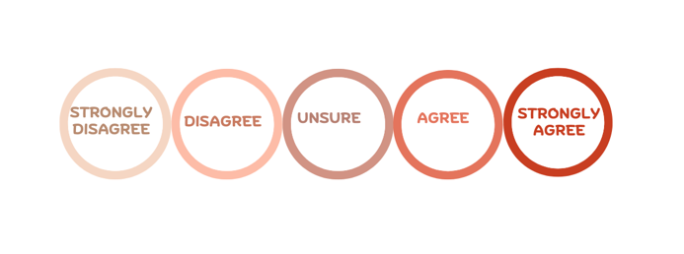
Policy statement: A clear explanation of what action should be taken about an issue and why.

Policy statements: (teachers can select how many statements they present to students)
1. Safety and Regulation
- E-scooters should be banned from all shared paths.
- Riders who break e-scooter laws should lose their driver’s licence or learner’s permit.
- Helmets should be compulsory for both e-bike and e-scooter riders.
- Police should have stronger powers to fine dangerous riders.
2. Age and Responsibility
- The miminun age for riding an e-scooter should be increased to 18.
- Students should be allowed to ride e-scooters to school.
- Parents should be fined for underage riders of e-scooters.
3. Speed and Access
- E-scooters should be allowed on footpaths if travelling slowly.
- The current 25km/h assissted speed limit for e-bikes should be increased.
- Rental e-scooters shoud be banned in busy city areas.
- More bike lanes should be built for e-bikes and e-scooters.
4. Environment and Transport
- Governments should encourage the use of e-bikes and e-scooters because they environmentally friendly forms of transport.
- Public transport stations (e.g train stations) should include parking and charging areas for e-scooters and e-bikes.
- The use of e-scooters should be expanded across Victoria because they can help reduce traffic jams.
5. E-Bike Age Minimums
- The Victorian government should introduce a minimum age of 16 for riding an e-bike.
- All e-bike riders should complete a basic road safety course before riding on their own.
- Parents should be responsible for making sure children use legal e-bikes safely.
- Victoria should keep the current e-bike laws and not introduce a minimum age.

SAMPLE RESPONSES ( Student answers will vary)
Reflection Activity:
Complete the following questions individually:
1. Which policy statement did you feel most strongly about and why?
I felt most strongly about building more bike lanes and shared-use paths because this action will improve safety for riders and pedestrians, separating them from cars.
2. Did your opinion change during the activity? Explain why or why not.
Yes, after listening to other students, I gained a better understanding that there were benefits and weaknesses to some policies that I had not considered before.

3. Which argument presented by another student was the most convincing?
The argument that all riders should complete a basic safety course was the most convincing because it could help reduce accidents and improve rider knowledge. It would ensure riders understand current laws, road rules and their responsibilities when using e-bikes and e-scooters.
4. What do you think is the most important issue Victoria should address when regulating e-bikes and e-scooters?
I think safety is the most important issue because e-bikes and e-scooters can cause accidents and injuries to riders, pedestrians and other road users if they are used irresponsibly.
5. In one sentence, explain what you think Victoria should do to improve e-bike and e-scooter safety.
Victoria should build more bike lanes and require road safety education to help reduce accidents caused by e-bikes and e-scooters.

Activity 9: Beyond Registration and Licensing: Finding the Best Approach to Regulating E-Bikes and E-Scooters in Victoria – Group Discussion Activity

Learning Intentions
We understand the different policy options for regulating e-bikes and e-scooters in Victoria.
Success Criteria
I can identify different ways that governments can regulate e-bikes and e-scooters and explain the advantages and disadvantages of each through group work and collaboration.

Task Instructions:
1. Working in groups of 3 to 4 students, investigate and evaluate different ways the Victorian Government could regulate e-bikes and e-scooters.
2. Consider each policy option and list the advantages and disadvantages in the relevant columns below.
3. As a group, rank the policy options from the most effective to the least effective, providing reasons for your ranking.
4. Select and list the five policies that your group believes would be the most effective in improving the safe use of e-bikes and e-scooters in Victoria
5. Write a recommendation to the Victorian Government identifying the policy your group believes would be the most effective and explain the reasons for your choice.
6. Present your recommendation to the rest of the class and explain the reasons for your decision.
OPTIONAL TASK INSTRUCTIONS
1. Working in groups of 3 to 4 students, read through the completed table of advantages and disadvantages of 15 policy options. [This will need to be supplied to students from the teacher resource booklet (see below). Teachers may wish to print this table in A3 landscape format to place on each group's table].
2. As a group, evaluate each policy option from 1 – 15 (from the most effective to the least effective)
3. Provide 2 to 3 reasons for your ranking of the top 5 policy options.
4. Write a recommendation to the Victorian Government identifying the policy your group believes would be the most effective and explain the reasons for your choice.
5. Present to the rest of the class the policy deemed most effective by your group, providing the reasons for your choice.
SAMPLE RESPONSE (Student answers may vary)
Policy Options | Rank each policy option  (e.g. 1 = most effective 15 = least effective) | Advantages | Disadvantages
Introduce or strengthen helmet requirements. | 5 | - Reduces the risk of serious head injuries.  - Improves rider safety especially if the rider crashes or falls.  - Encourages safe riding habits.  - Can reduce pressure on hospitals and emergency services by lowering the severity of injuries.  - Can provide greater confidence for parents and other road users. | - Does not prevent accidents from occurring.  - Can be difficult for the police to enforce consistently.  - Riders can still suffer other injuries such as broken bones or leg injuries even when wearing helmets.  - Increases costs for riders who need to buy a suitable helmet.
Increase the minimum rider age. | 10 | - May reduce risks associated with younger, less experienced riders.  - Older riders may have better judgement, maturity and decision-making skills.  - Can reduce the number of accidents involving children.  - Encourages riders to gain a better understanding of road rules before riding independently.  - May improve safety for pedestrians and others.  - Makes it easier to ensure riders are physically capable of safely controlling an e-bike or e-scooter. | - Restricts access for responsible young riders who can ride safely.  - May reduce independence and transport options for younger people.  - Can be difficult for police to enforce if riders do not carry identification.  - Does not address unsafe behaviour for older riders.  - May discourage the use of environmentally friendly transport among young people.  - Could increase reliance on parents for transport.
Require rider safety education or training. | 4 | - Improves rider knowledge of road rules and safety and decision-making.  - Helps riders make safer decisions in different traffic situations.  - May reduce accidents caused by rider error or lack of awareness.  - Encourages responsible riding behaviour and greater compliance with laws.  - Increases awareness of risks to pedestrians, cyclist and other road users.  - Can improve confidence and competence when operating an e-bike or e-scooter.  - Provides consistent safety information to all riders.  - May reduce pressure on police enforcement by preventing unsafe behaviour before it occurs. | - Requires additional time and cost for riders to complete training.  - May discourage some people from using e-bikes or e-scooters.  - Can be difficult and expensive for governments to administer and monitor.  - Training does not guarantee that riders will follow the rules.  - Existing riders may need to complete training, creating inconvenience.  - Could reduce access for people who need e-bikes or e-scooters for affordable transport.  - Enforcement may be challenging if there is no practical way to check training completion.  - Benefits may diminish over time if riders forget what they have learned.
Reduce and enforce speed limits. | 2 | - Reduces severity of crashes and injuries when accidents occur.  - Gives riders more time to react to hazards and unexpected obstacles.  - Improves safety for pedestrians, cyclists and other road users.  - May reduce the likelihood of losing control of an e-bike or e-scooter.  - Encourages more responsible riding behaviour.  - Easy for governments to introduce through legislation.  - May reduce pressure on hospitals and emergency service by lowering injury rates. | - Requires additional police resources and monitoring of riders.  - Some riders may ignore the speed limits if their enforcement is inconsistent.  - Can increase travel times for riders.  - May reduce the attractiveness and convenience of e-bikes and e-scooters as transport options.  - Speed limiting technology can increase costs for manufacturers and riders.  - Difficult to monitor speeds in all locations.  - May frustrate riders who already use their devices safely and responsibility.  - Lower speed limits alone may not address other causes of accidents such as distractions.
Increased fines and penalties for unsafe riding. | 14 | - Acts as a deterrent for some riders.  - Encourages greater compliance with road rules and safety laws.  - Sends a clear message that unsafe riding is not acceptable.  - May reduce dangerous behaviours such as speeding or riding under the influence of alcohol or drugs.  - Can improve safety for pedestrians, cyclists and other road users.  - Provides consequences for riders who put others at risk.  - Can be implemented relatively quickly through changes in legislation.  - May support police efforts to improve road safety. | - Less effective if enforcement is low.  - Some riders may continue to break the rules despite higher penalties.  - Does not address the underlying causes of unsafe riding, such as lack of education or poor bike paths.  - Can affect low-income riders more who will struggle to pay fines.  - May be viewed more as a punishment rather than being a preventative measure.  - Requires police resources to monitor and enforce compliance or riders following the laws.  - Does not physically prevent accidents from occurring.  - May create negative public attitudes towards e-bike and e-scooter regulations.
Improve police enforcement of existing laws. | 3 | - Targets dangerous behaviour and encourages riders to follow the current laws.  - Increases compliance with speed limits, wearing of helmets and other safety rules.  - Acts as a preventative measure by increasing the chances of riders being caught.  - Can reduce unsafe behaviours such as speeding, reckless riding and riding under the influence of drugs or alcohol.  - Helps protect pedestrians, cyclists and other road users.  - Makes use of laws that are already in place, rather than requiring major legislative changes.  - Can improve public confidence that road safety laws are being enforced.  - Allows police to focus on high-risk locations and repeat offenders. | - Requires additional police resources time and funding.  - May distract police from other police priorities.  - Enforcement can be difficult across large areas and shared use paths.  - Some riders may return to unsafe behaviours when police are not present.  - Can be expensive to maintain over the long-term.  - May lead to complaints if riders feel they are unfairly targeted.  - Does not address underlying causes of unsafe riding, such as lack of education or poor bike paths.  - Depends on consistent and ongoing enforcement to work.
Create more bike lanes and shared-use paths. | 1 | - Separates riders from cars, reducing the risk of accidents.  - Improves safety for e-bike riders from cars, reducing the risk of collisions.  - Improves safety for e-bike riders, e-scooter riders, cyclists and pedestrians.  - Encourages more people to use active and sustainable transport.  - Provides dedicated spaces for riders, reducing conflicts with other road users.  - Can reduce traffic jams by encouraging alternatives to car travel.  - Creates a more connected and accessible transport network.  - May improve rider confidence, particularly for less experienced riders.  - Provides long-term safety benefits for the community. | - Expensive and time-consuming to plan and build.  - Requires ongoing maintenance and funding.  - May reduce road or parking spaces available for cars.  - Construction can cause short-term disruptions to traffic and local businesses.  - Benefits may be limited if the network is incomplete or poorly connected.  - Not all areas have enough space for additional bike lanes to be created.  - Shared-use paths can still lead to conflicts between riders and pedestrians.  - Infrastructure improvements by themselves may not address unsafe rider behaviour.
Require safety features such as lights and reflectors on both e-bikes and e-scooters. | 6 | - Improves visibility especially at night and in poor weather conditions.  - Helps reduce the risk of accidents with motorists, cyclists and pedestrians.  - Makes it easier for other road users to see and predict the riders’ movements.  - Provides a consistent safety standard for all e-bikes and e-scooters.  - Can improve rider confidence when travelling in low-light conditions.  - Relatively simple and practical requirements compared with more restrictive laws.  - Supports safer use of shared paths and roads. | - Increased costs for riders who need to purchase and maintain equipment.  - Some riders may ignore or remove safety features.  - Requires police resources to ensure laws are followed.  - Safety features alone do not prevent unsafe riding behaviour.  - Lights and reflectors can become damaged or stop working if not maintained.  - May have limited effect on accidents that occur during the day.
Restrict where e-bikes and e-scooters can be ridden. | 9 | - Reduces conflict between riders, pedestrians and motorists.  - Improves safety in crowded areas like shopping centres and busy footpaths.  - Helps create clearer rules about where riding is permitted.  - May reduce the number of accidents and near misses involving pedestrians.  - Encourages riders to use safer designated paths and roads.  - Can improve public confidence in the safe use of e-bikes and e- scooters.  - Helps protect road users that are at greater risk such as children and older pedestrians. | - May limit convenience and accessibility for riders.  - Riders may have less direct routes to their destinations.  - Can be difficult for riders to understand and follow the different restrictions.  - Requires additional signage and public education.  - Police may find it difficult to enforce these restrictions consistently.  - May discourage people from using e-bikes and e-scooters as a transport option.
Run public awareness campaigns about road rules. | 8 | - Educates riders and road users about their rights and responsibilities.  - Can reach a large number of riders and road users.  - May improve knowledge of road rules and safe riding practices.  - Can encourage safer behaviour and reduced risky riding.  - Helps promote a culture of road safety and shared responsibility.  - Can target specific groups such as young riders or new users.  - Less restricting than brining in new laws or penalties. | - Changes in behaviour may be limited if people ignore the messages.  - Campaigns can be expensive to develop and deliver.  - Hard to measure if these campaigns have been successful.  - Behaviour change may on be short-term.  - Information alone may not be enough to prevent accidents.  - Some riders may never see or connect with the campaign.  - Campaigns work better when combined with enforcement and education programs.
Introduce registrations only for high -powered devices/ vehicles. | 11 | - Helps identify riders using more powerful and potentially riskier devices/ vehicles.  - Makes it easier for police to enforce laws and investigate incidents.  - Targets high risk devices rather than all e-bikes and e-scooters.  - May encourage safer and more responsible use.  - Provides better information about the number and type of high- powered devices/ vehicles being used.  - Creates greater accountability for riders of powerful devices/ vehicles.  - Allows low-powered devices/ vehicles to remain easily accessible. | - Creates administration costs and compliance issues.  - Riders may view registration as inconvenient.  - Some riders may avoid registering their devices/ vehicles.  - Can be difficult to define which devices/ vehicles need registration.  - May discourage people from using e-bikes and e-scooters.  - Requires ongoing monitoring and enforcement.  - Registration alone may not reduce unsafe riding behaviour.
Require retailers to provide safety information where the product is sold. | 13 | - Inform riders about road rules and safe riding practices before use.  - Help new riders understand their legal responsibilities.  - Relatively low-cost policy compared to more bike paths or enforcement measures.  - Ensures riders receive consistent safety information at when buying the e-bike or e-scooter.  - Can increases awareness of helmet, speed and age requirements.  - Encourages a culture of safety from the time of purchase.  - Easy to implement without restricting access to e-bikes and e-scooters. | - Information may be ignored or forgotten by riders.  - Does not guarantee safer riding behaviours.  - Retailers may face additional costs and responsibilities.  - Information may become outdated if laws change.  - Difficult to ensure all retailers provide the information properly.  - Has little effect on people who buy second hand e-bikes or e-scooters.  - Hard to measure how well this policy works.
Increase funding and program for road safety education in schools. | 7 | - Builds long term safe riding habits among young people.  - Improves knowledge of road rules and safe riding practices.  - May reduce risky behaviours before students begin riding independently.  - Can reach large numbers of future riders.  - Encourages a culture of road safety from a young age.  - May reduce accidents and injuries over the long term.  - Supports other safety measures such as enforcement and awareness campaigns. | - Benefits may take time to appear.  - Requires ongoing government funding.  - Not all students will apply what they learn.  - Difficult to measure the direct effect or impact on accident rates.  - School time may be taken away from other subjects.  - Does not address unsafe behaviour by current adult riders.  - Results depend on the quality of the education program.
Introduce a licence or permit for high-powered e-bikes and e-scooters. | 12 | - Helps identify riders of higher-risk vehicles.  - Ensures riders understand road rules before operating powerful vehicles.  - May improve rider responsibility.  - Makes it easier for police to enforce laws and investigate incidents.  - Targets higher-powered e-bikes and e-scooters that may have greater safety risks.  - May reduce accidents caused by inexperienced riders.  - Encourages riders to develop safe riding skills. | - May discourage people from using e-bikes and e-scooters.  - Creates costs for licensing and administration.  - Can be inconvenient and time consuming for riders.  - Some rider may choose to ride without a licence or permit.  - Requires ongoing monitoring and enforcement.  - Can be difficult to determine which vehicles require a licence.  - Licensing alone may not prevent unsafe riding behaviour.
Develop separate road rules for private and shared e-scooters. | 15 | - Shared e-scooters can be programmed to automatically limit speeds.  - Allows regulations to be specific to the risks of each type of e-scooter.  - Provides flexibility for governments to regulate each type differently.  - Can improve safety if shared e-scooters have stricter requirements.  - May encourage operates to include extra safety features like speed limiters.  - Recognises that private and shared e-scooters are used in different ways.  - Could help address safety concerns specific to shared e-scooters.  - Allows governments to trial new safety measures on shared fleet before applying them to all e-scooters. | - Creates costs for manufacturers and operators.  - May be difficult for riders to understand different sets of rules.  - Can cause confusion about which rules apply in different situations.  - Requires additional education and public awareness campaigns.  - Makes enforcement more difficult for police.  - Riders may unintentionally break rules due to confusion.  - Different rules may be seen as unfair by some riders.  - Separate rules alone may not significantly reduce accidents or unsafe behaviour.
Others:
(Students complete)

Select and list the 5 most effective policies (policies you think would work)
1. Create more bike lanes and shared-use paths.
2. Lower or enforce speed limits.
3. Improve police enforcement of existing laws.
4. Require rider safety education or training.
5. Introduce or strengthen helmet requirements.

Group recommendation: (which is the most effective policy option and reasons why)
SAMPLE RESPONSE (Student answers may vary)
Creating more bike lanes and shared-use paths is likely to be the most effective policy because it gives e-bike and e-scooter riders a safe space away from cars and other traffic. This can reduce the risk of accidents and injuries, while also encouraging riders to stay off the footpaths. Unlike policies that rely on people following rules, improved paths and bike lanes help prevent problems before they occur and provide long term benefits for all road users.

POST CONVENTION ACTIVITIES

Activity 1: The Problem and the Solution – Infographic Activity
Learning Intentions
We understand the different ways governments can regulate e-bikes and e-scooters in Victoria through investigating laws, safety concerns and possible solutions.
Success Criteria
I can explain the current laws and safety concerns about e-bikes and e-scooters in Victoria. I can use evidence and statistics in an infographic to justify the best way to regulate them.

Task Instructions:
Create an infographic that informs the public about the regulation of e-bikes and e-scooters in Victoria.
Your infographic should include:
1. The key issues surrounding the use of e-bikes and e-scooters in Victoria.
2. Different viewpoints and stakeholder perspectives discussed during the Convention.
3. Recommendations about how Victoria could regulate them safely in the future.
4. Try to make your infographic visually interesting by including headings, subheadings, statistics colours, images and short explanations to communicate your message.
What is an infographic:
A visual way of presenting information, facts and ideas so they are easy to understand quickly. Instead of writing long paragraphs you can combine short pieces of text, headings, images, icons, graphs, statistics and colour.
For this task your infographic should visually explain:
- The problem with e-bikes and e-scooters e.g. accidents, injuries, reckless driving.
- Different viewpoints e.g. environmentally friendly, cheaper transport option v’s riders ignoring road rules, difficult to police unsafe behaviour.
- Possible solutions e.g. registration and licencing, compulsory helmets, speed limits, age restrictions.
Example Layout:

  - Title: How Should Victoria regulate e-bikes and e-scooters?
  - The problem: Accidents, injuries, safety concerns.
  - Different opinions: Supporters v critics.
  - Statistics: Injury rates, popularity, environmental benefits.
  - Best solution: Your recommendation.
  - Conclusion: Why your solution is best.

Digital tools you can use:
Canva: Canva: Visual Suite for Everyone
PowerPoint: Microsoft PowerPoint
Piktochart: Piktochart Infographics
Adobe: Adobe

Statistics and Data Sources:
Transport Accident Commission (TAC): e-scooter safety

Rules:
Transport Victoria: e-scooter road rules
Transport Victoria: Electric Bikes (e-bikes)
Monash University – Monash Lens: E-micromobility is booming, but so are injuries
Victoria Police: Electric bike (e-bike) safety

Other Countries:
EVZ: E-scooter rules in Europe: What is allowed and what is not?

SAMPLE RESPONSE (Student answers will vary)
**Note: Sample provided on the next page
Sample made using https://piktochart.com/infographic-maker

Sources used to create the sample:
- Transport Victoria: Electric Bikes https://transport.vic.gov.au/road-and-active-transport/active-transport/bicycles/electric-bikes
- Transport Victoria: E-scooter road rules E-scooter road rules in Victoria - Transport Victoria
- Victoria Police: E-bike safety: https://www.police.vic.gov.au/e-bike-safety
- E-Rideables in Victoria: https://www.roadsafetyeducation.vic.gov.au/educational-resources/additional-resources/e-rideables-in-victoria
- Transport Victoria: https://transport.vic.gov.au/road-and-active-transport/active-transport/bicycles

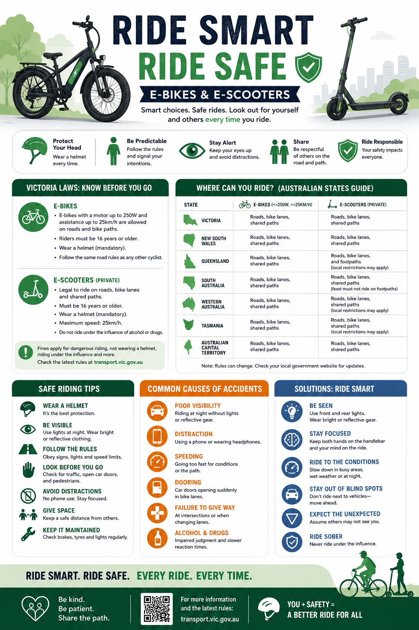

Activity 2: Should Victoria Introduce Licensing and Registration for E-Bikes and E-Scooters? - Argument Carousel Activity
Learning Intentions
We are learning to consider different viewpoints about licensing and registration for e-bikes and e-scooters in Victoria and can use evidence to support our opinions.
Success Criteria
I can explain different viewpoints about licensing and registration for e-bikes and e-scooters, use evidence to support my arguments, and justify which solution I believe would be the most effective for improving public safety.
Task Instructions:
Activity Overview:
You will work in groups to investigate different arguments about whether Victoria should introduce licensing and registration for e-bikes and e-scooters. As you move around the room, add arguments, evidence and ideas to a range of discussion stations.
At the end of this activity, you will review the class responses and decide which solution would be the most effective for Victoria.
1. Your teacher will divide the class into groups of 3-4 students. Each group will start at a different discussion station.
2. Large sheets of paper will be placed around the room with the following headings: Safety, Cost, Environment, Freedom, Enforcement, Young People. Each station focuses on or looks at a different issue related to licensing and registration of e-bikes and e-scooters.
3. At each station:
i. Read the heading and any ideas already written
ii. Discuss arguments for and against licensing and registration
iii. Add your group’s ideas, statistics or questions on the sheet
iv. You may use dot points, diagrams, examples from other countries, or ideas discussed at the Convention
4. Every 3-5 minutes, your group will move to the next station. Continue adding ideas and responding or addressing points raised by previous groups.
5. After visiting all the stations, participate in a class discussion about:
i. Which arguments were the most convincing or strongest
ii. Whether Victoria should introduce licensing and registration for e-bikes and e-scooters
iii. If there are alternative solutions that may be more effective

6. Independently write a short response explaining you own opinion on whether Victoria should introduce licensing and registration of e-bikes and scooters. Remember to give reasons for your decision.
7. Share your written response with the rest of the class.
Teacher Notes:
Suggested timeframe:
- Introduction: 5 minutes.
- Rotations between groups: 20-25 minutes.
- Review discussion: 10 minutes.
- Reflection writing: 10 minutes.
Materials needed:
Large butchers paper, markers, timer or bell for rotations.
Helpful argument prompts:
Arguments for licensing and registration:
- Improves rider accountability.
- Encourages riders to know road rules.
- Reduces reckless behaviour.
- Helps police identify dangerous riders.
- Improves public safety.
- Creates rules similar to those for cars and motorcycles.
- Could reduce accidents and injuries.
- Encourages safer riding habits.
Arguments against licensing and registration:
- It’s expensive and unfair.
- Discourages environmentally friendly transport.
- May reduce e-scooter and e-bike use.
- Difficult for police to enforce.
- Gives governments too much control.
- Is unnecessary for casual riders.
- May not stop unsafe behaviour.
- Education programs may work better.

SAMPLE RESPONSES (Student answers will vary)
Final Reflection:
Based on today’s activity, I believe Victoria should/should not introduce licensing and registration for e-bikes and e-scooters because:
Sample Reflection 1: Supporting the introduction of Licensing and Registration
Based on today’s activity, I believe Victoria should introduce some form of licensing and registration for e-bikes and e-scooters. Licensing could help riders learn the road rules and encourage safer riding behaviour. Registration may also help police identify riders who break the law and increase responsibility. With the number of accidents involving e-bikes and e-scooters increasing, stronger regulations could help improve safety for riders, pedestrians and other road users. However, the system should be simple and affordable, so it does not discourage/stop people from using environmentally friendly transport.
Sample Reflection 2: Against Licensing and Registration
Based on today’s activity, I do not believe Victoria should introduce licensing and registration for e-bikes and e-scooters. Registrations would increase costs and make these forms of transport more difficult to access, especially for young people. E-bikes and e-scooters are more similar to bicycles than cars and are often used for short trips. I think improving education, building more bike paths and shared paths and increasing the enforcement of existing rules by the police would be more effective than introducing licensing and registration. These methods could improve safety without making it harder for people to ride.

Activity 3: Policy Recommendation Task – Reflection Activity
Learning Intentions
We understand the arguments for and against licensing and registration of e-bikes and e-scooters in Victoria. We also understand how different policy options may impact safety, cost, freedom and regulation within the community.
Success Criteria
I can develop and justify a policy recommendation using evidence and arguments discussed during the class activities and the Convention.

Task Instructions:
1. Think about the pre-convention activities, the convention and the post-convention activities completed in class.
2. Imagine you are an advisor to the Victorian government. Your task is to recommend the best way to manage e-bikes and/or e-scooters in Victoria.
3. Write a short policy recommendation that includes the following: your recommendation, reasons to support your recommendation, evidence or examples from the activities or the Convention, possible advantages and disadvantages of your solution.
4. Your policy recommendation could include one or more of the following: licencing and registration, age restrictions, safety education or training programs, speed limits, stronger rules or penalties, or another alternative solution. (Your recommendation can focus on both e-bikes and e-scooters, or you may choose to focus on one of the two means of transport)
5. Be prepared to share and explain your recommendation with the class.
What is a policy?
A plan or action used to achieve a goal or address an issue.
School mobile phone policy: All students must keep their mobile phones in lockers during class time and throughout the school day to reduce distractions and improve learning and student interest in the classroom.
Government road safety policy: All passengers in a car are required to wear a seatbelt at all times to reduce injuries and save lives. Fines and penalties are imposed on people who fail to follow the law.
What is a policy recommendation?
Suggested solution or action to help solve a problem or improve an issue. It explains what you think should happen and why.
Template/Guide to write a policy recommendation:
Policy Recommendation Template or Guide (with examples)
Issue/Problem
Briefly explain this problem or issue

Example: There has been an increase in unsafe e-scooter use in Victoria

Recommendation
State what action should be taken to address this

Example: Victoria should introduce compulsory or mandatory helmet laws for all e-scooter riders

Reasons for the Recommendation
Explain why this policy would help:
- It would improve rider safety
- It could reduce serious injuries and accidents
- It encourages responsible use of e-scooters
Evidence or Examples:
Include evidence or an example from the activities you have completed in relation to this topic

Example: Road safety campaigns show helmets reduce the risk of head injuries

Conclusion:
Summarise why this is the best solution

Example: Overall, mandatory or compulsory helmet laws would improve safety while still allowing people to use e-scooters conveniently.

Sample Policy Recommendation: (Student answers will vary)
There has been an increase in concerns about unsafe e-scooter use in Victoria, including accidents, injuries and unsafe riding behaviours. Some riders do not wear helmets, travel at unsafe speeds or fail to follow road rules, creating risks for both riders and pedestrians.
Victoria should introduce compulsory helmet laws and stronger safety regulations for all e-scooter riders. This would improve safety for riders and the wider community. Wearing a helmet can help reduce the risk of serious head injuries in the event of an accident. Stronger safety regulations, such as speed limits and increased penalties for dangerous riding, would encourage better behaviour with riders following the road rules. This would help reduce accidents and make shared spaces safer for everyone.
Evidence from road safety campaigns shows that helmets significantly reduce the risk of serious head injuries. So compulsory helmet laws and stronger safety regulations are the best solution because they improve safety while still allowing people to enjoy the convenience and environmental benefits of e-scooters.

Exit Activity – Sticky Note Final Vote
Sticky Note Final Vote Instructions:
Question:
Should Victoria require registration and licensing for e-bikes and e-scooters?
Instructions:
  - Think about all the arguments, evidence and ideas discussed during the classroom activities and the Convention.
  - Decide on your final position on this topic:
YES = Victoria should require registration and licensing for e-bikes and e-scooters
NO= Victoria should not require registration and licensing for e-bikes and e-scooters
  - Write YES or NO on a sticky note
  - Place your sticky note under the matching heading displayed on the board.
  - Once everyone has voted, the class will count the results and discuss the outcome.
  - Students can share final comments, reasons or reflections about the issue.

