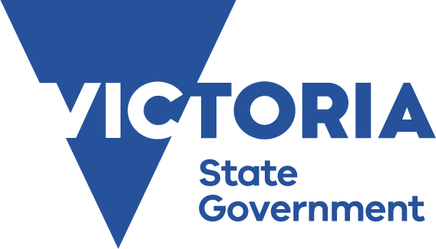

Program

Victorian Students’ Parliamentary Program
Teachers’ Capacity Building Convention
Tuesday 13 October 2026

Parliament of Victoria

Should the state of Victoria advocate
for lowering the voting age to 16 years?

The Victorian Students’ Parliamentary Program
is supported by the Victorian Government
Program (as of 27/04/2026)
8:45am – 9:15am  (30 minutes) | Attendees Registration
Opening
9:15am – 9:25am  (10 minutes)  Queen’s Hall | Welcome by Facilitator – Russell Ives
PART 1 – WHAT ARE WE DOING & WHY?
9:25am – 9:40am  (15 minutes)  Queen’s Hall | What are we doing and why?  By Facilitator  - What are the key components of a Parliamentary Convention?  - What is the purpose of each component?  - What does a good classroom/school convention model look like?  - What are the real-life links to modern Australian politics, parliamentary and political processes?
9:40am – 10:10am  (30 minutes)  Queen’s Hall | Links to curriculum and curriculum updates  Representative from Victorian Curriculum and Assessment Authority (VCAA)  - Briefing on F-10 and relevant VCE and Australian curriculum and where the links exist to Conventions and how to draw these out and strengthen them  - Curriculum updates
10:10am – 10:35am  (25 minutes)  Queen’s Hall | Morning Tea and Networking
PART 2 – MOCK CONVENTION
Topic: Should the state of Victoria advocate for lowering the voting age to 16 years?
Led by President: Sandra Venneri
10:35am – 10:40am  (5 minutes)  Legislative Council Chamber | Introduction of the Mock Convention  - Key elements, what happens in Parliament
10:40am – 10:50am  (10 minutes)  Legislative Council Chamber | Opening statements  - Selected Opening Statements 2 mins each from 5 representatives
10:50am – 11:25am  (35 minutes)  Legislative Council Chamber | Keynote 1 with Q&A
11:25am – 12:00pm  (35 minutes)  Legislative Council Chamber | Keynote 2 with Q&A
12:00pm – 12:05pm  (5 minutes)  Legislative Council Chamber | Next Steps in a Student Parliament Convention:  - Discussion Groups  - Group Reporting Back  - Soap Box  - The Vote
12:05pm – 12:20pm  (15 minutes)  Legislative Council Chamber | Mock Soapbox
12:20pm – 12:30pm  (10 minutes)  Legislative Council Chamber | Running Your Own Convention in a School Setting (sharing)
12:30pm – 1:00pm  (30 minutes)  Queen’s Hall | Lunch and Networking
PART 3 – CIVICS AND CITIZENSHIP - Pedagogy, classroom strategies and high-quality teaching and learning resources
1:00pm – 1:30pm  (30 minutes)  Queen’s Hall | Tips & Resources – Session 1
1:30pm – 2:00pm  (30 minutes)  Queen’s Hall | Tips & Resources – Session 2
2:00pm – 2:50pm  (50 minutes)  Queen’s Hall | Tips & Resources – Session 3
2:50pm – 3:10pm  (20 minutes)  Queen’s Hall | Disciplinary knowledge and pedagogies that work  - Open floor discussion  - Successes and Shortcomings at your school  - Challenges arising in practice  - Strategies to address these
3:10pm – 3:20pm  (10 minutes)  Queen’s Hall | Official Closing
3:20pm – 3:30pm  (10 minutes)  Queen’s Hall | By Facilitator  - Recap of the day  - List of resources  - Evaluation  - Thank you and closing
3:30pm | Close
If you have any questions or comments please contact Candy Chan, National Curriculum Services on (03) 9415 1299 or candy.chan@ncsonline.com.au.

