

Victorian Schools Parliamentary Program (VSPP)
2026 PRIMARY SCHOOL CONVENTION
Topic
Should children who work at major Australian sporting events, such as the Australian Open, be paid for their work?

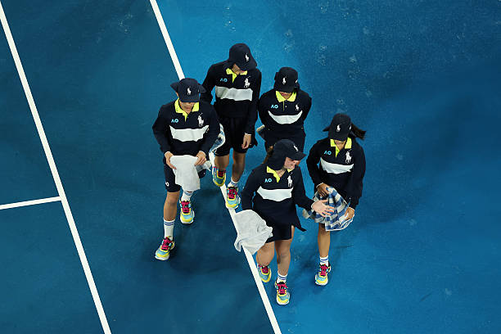

STUDENT ACTIVITIES

Contents
LEARNING INTENTIONS FOR THESE STUDENT ACTIVITIES: 3
SUCCESS CRITERIA FOR THESE STUDENT ACTIVITIES: 3
Activity 1: Introductory Tasks 4
1a: Volunteer or Paid – Sorting Activity 4
1b: Values Line – Warm-Up Activity 6
1c: Who is Responsible? Classification, Brainstorming and Rule-Making Activity 8
Activity 2: Unpacking the Vocabulary – Think-Pair-Share Activity 12
Activity 3: Investigating Roles at Major Australian Sporting Events – Analysis Activity 13
Activity 4: Ball Kids at the Australian Open: Behind the Scenes of a Grand Slam Activities – Case Study Activities 20
4a: Australian Open Ball Kids – Comprehension Activity 20
4b: Netflix Feature on Ball Kids – Documentary Review Activity (Optional) 23
4c: The Grand Slam Comparison – Global Research Activity 24
Activity 5: Media Analysis – Mind Map Activity 31
Activity 6: Exploring the Pros and Cons of Volunteering in Sport: Interview Role Play Activity 35
POST CONVENTION ACTIVITIES 39
Activity 1: Reflection Journal Activity 39
Activity 2: Should children be paid? Make your case -Policy Proposal Writing Activity 42
Activity 3: Stakeholder Voices – Role Play Activity 44
Activity 4: Corners of the Room – Take a Stand Activity 47

LEARNING INTENTIONS FOR THESE STUDENT ACTIVITIES:
By the completion of these activities, students will be able to:
- Understand the roles and responsibilities of children who participate in major sporting events, such as the Australian Open.
- Explore the real-life issues around whether young people should be paid or volunteer for this kind of work.
- Think critically about whether decisions in these situations are fair and reasonable.
- Build confidence in sharing their ideas through discussion, teamwork and exchanging viewpoints.

SUCCESS CRITERIA FOR THESE STUDENT ACTIVITIES:
Students will be able to:
- Explain the different roles children perform at major sporting events (e.g. ball kids, volunteers).
- Discuss the advantages and disadvantages of paying children for working at major sporting events.
- Consider different perspectives on this topic, including children, families, event organisers, and the community.
- Present and justify their own opinion using reasoning and examples.

Activity 1: Introductory Tasks

1a: Volunteer or Paid – Sorting Activity
Learning Intention
We are able to understand the difference between volunteering and paid work.
Success Criteria
I can describe what volunteering is. I can also describe what paid work is. I can identify two differences between volunteering and paid work and give an example of each.

Task Instructions:
1. Students are to work independently to complete the table below.
2. For each activity, students must decide whether it is an example of volunteering or paid work and provide a reason to justify their decision.
3. In pairs, students complete the extension activity to deepen their understanding of the similarities and differences between volunteering and paid work.
4. Students then share their answers with the rest of the class.

Activity | Is this activity an example of volunteering or paid work? | Reason
Assisting at a sausage sizzle to help raise money for a charity.
Helping a neighbour carry groceries to their house.
Selling homemade bracelets at a market.
Mowing lawns for neighbours in exchange for $15.
Doing chores at home for pocket money.
Reading to younger students during lunchtime in the school library.
Helping clean up rubbish at a local park on the weekend.
Answering a babysitting ad which pays $15 an hour.
Coach a junior sports team for free.
Working at a local café for a casual wage.
Helping a friend clean their room.
Walking your dog every day.
Helping a charity fun run by handing out water.
Working at McDonald's once a week.
Helping move furniture for your uncle and receiving a gift card as a thank you.

Extension Activity (Complete in pairs)
1. Discuss with your partner and write down a definition for each term:
Volunteering:

______________________________________________________________________________________________________________________________________________________________________________________________________________
Paid Work:

______________________________________________________________________________________________________________________________________________________________________________________________________________

2. Spot the difference
Work together to compare the two (volunteering and paid work) and provide:
One similarity:

______________________________________________________________________________________________________________________________________________________________________________________________________________
One difference:

______________________________________________________________________________________________________________________________________________________________________________________________________________
A second difference:

______________________________________________________________________________________________________________________________________________________________________________________________________________

3. Real-life examples
Think about your own experiences or people you know and provide an:

Example of volunteering:

______________________________________________________________________________________________________________________________________________________________________________________________________________
Example of paid work:

______________________________________________________________________________________________________________________________________________________________________________________________________________

1b: Values Line – Warm-Up Activity
Learning Intention
We are learning to consider different points of view about whether children working at major sporting events should be paid.
Success Criteria
I can explain at least two different points of view on this issue. I can listen respectively to the opinions of other students.

Task Instructions:
1. Your teacher will place a series of statements around the classroom.
2. Read each statement carefully.
3. Move to the statement that best represents your opinion.
3. Give reasons for your choice with other students at your station.
4. Share your ideas with the rest of the class.

Statements:

- Children should always be paid for any work they do.
- Children should only be paid if the organisation is making a profit.
- Volunteering at major events is a valuable experience for children.
- Major sporting events can afford to pay everyone, including children.
- It is acceptable for children to volunteer if they choose to.
- Children should not work at major sporting events at all.
- Payment is less important than gaining skills and experiences.
- Not paying children is unfair and takes advantage of them.

Concluding Activity: Take a Stand (to revisit some of the key statements)

- As a class, return to one key statement, e.g. Children should always be paid for any work they do; or Volunteering is a valuable experience for children.

- Move a position along the line below that shows your opinion from strongly agree to strongly disagree
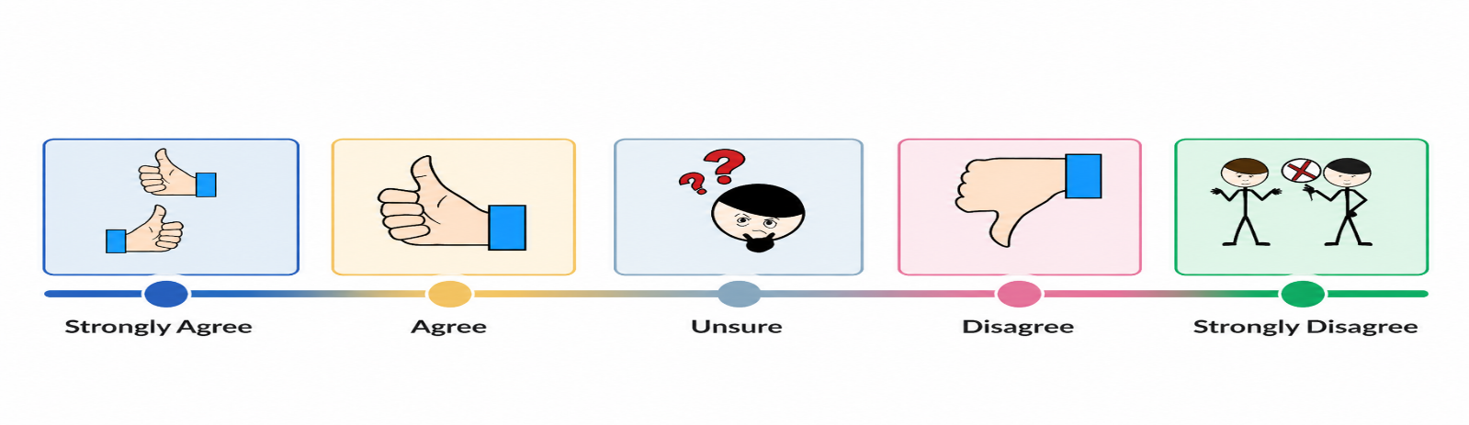

- Be ready to explain your choice with the rest of the class, using reasons or examples.

1c: Who is Responsible? Classification, Brainstorming and Rule-Making Activity
Learning Intention
We are learning to classify the responsibilities of governments, sporting organisations and parents in protecting children at major sporting events. We are also learning about the importance of rules and laws to help keep children safe when they volunteer or work at sporting events.
Success Criteria
I can correctly classify different responsibilities and rules into the correct group or organisation. I can explain how governments and sporting organisations help protect children at sporting events and share my ideas during class discussions.

Task Instructions:
1. Students work in groups to complete each of the three classification activities.
2. Each group discusses and brainstorms ideas for the six discussion questions.
3. In the same groups, students create a new rule about children participating in major sporting events.
4. The groups share and explain their responses, ideas and new rules during a class discussion.

Activity 1: Who makes the rules?
Work with your group to match each scenario with the correct heading:
- Local government (LG) - responsible for the needs of the local community, e.g. Yarra City Council
- State government (SG) – responsible for the services and laws of the state, e.g. Victoria
- Federal government (FG) – responsible for making national laws and looking after the country (Australia)
- Sporting organisation (SO) – responsible for organising and managing sporting activities, rules and competition, e.g. AFL

- Rules about children working ____________________________
- Safety rules at sporting events ___________________________
- Public transport at an event _____________________________
- Working with Children Checks ___________________________
- Rules for volunteers at the Australian Open _______________
- Rules about advertising and sponsors ____________________
- Health and safety rules at events ________________________
- School attendance during sporting events ________________

Activity 2: Who is responsible?
Read each scenario carefully and decide whether the responsibility belongs mainly to;
- Government (G)
- Sporting organisation (SO)
- Parents (P)
- School (S)

- Ball kids must attend training after school for several weeks. ___________________________________
- Ball kids receive free uniforms and tickets to matches, but no payment. _________________________
- Children can volunteer if parents give permission. _____________________________________________
- Sporting events set age limits for junior volunteers. ____________________________________________
- Children working late at sporting events must have adult supervision. ___________________________
- A sporting organisation decides volunteers should receive gift vouchers instead of the wages for the work they complete. _________________________________________________________________________
Activity 3: True (T) or False (F)?
Read each statement with your group and decide whether it is true or false. Be prepared to explain your answer.
- Children can volunteer at sporting events without adult supervision. ____________________________
- Parents or guardians usually need to give permission for children to volunteer. ___________________
- Sporting organisations must help keep children safe at events. __________________________________
- Children can work unlimited hours during school days. _________________________________________
- Adults working closely with children may need a Working with Children Check. ___________________
- Child Safe Standards help protect children from harm. _________________________________________
- Children under 15 are protected by child employment laws in Victoria. __________________________
- Sporting organisations do not need to think about children’s safety. _____________________________
- Children volunteering at events should have rest breaks. _______________________________________
- Both governments and sporting organisations help protect children at sporting events. ___________
Activity 4: Discussion Questions
Working in your groups, brainstorm and record your ideas on a sheet of paper for each of the following questions:
1. Who has the biggest responsibility for protecting children at sporting events?
______________________________________________________________________________________________________________________________________________________________________________________________________________
______________________________________________________________________________________________________________________________________________________________________________________________________________
2. Why might parents and sporting organisations have different opinions?
______________________________________________________________________________________________________________________________________________________________________________________________________________
______________________________________________________________________________________________________________________________________________________________________________________________________________

3. What could happen if there were no rules protecting children?
______________________________________________________________________________________________________________________________________________________________________________________________________________
______________________________________________________________________________________________________________________________________________________________________________________________________________

4. Should children be allowed to volunteer late at night at tournaments?
______________________________________________________________________________________________________________________________________________________________________________________________________________
______________________________________________________________________________________________________________________________________________________________________________________________________________

5. What makes a sporting event safe for children?
______________________________________________________________________________________________________________________________________________________________________________________________________________
______________________________________________________________________________________________________________________________________________________________________________________________________________

Activity 5: Create a new rule
In a group, create or write a new rule for children involved in major sporting events (e.g. Australian Open, AFL Grand Final, Melbourne Cup):
Your rule could include the following:
- Minimum age
- Payment rules
- Maximum working hours
- Adult supervision requirements
- Rest breaks
- Safety requirements
Rule for ____________________________________________________ (fill in the event)
_________________________________________________________________________________________________________________________________________________________________________________________________________________________________________________________________________________________________________________________________________________________________________________________________________________________________________________________________________________________________________________________________________________________________________________________________________________________________________________________________________________________________________________________________________________
As a group, be ready to explain:
- Your new rule
- Who would enforce the rule
- Why the rule is important
- Who would be affected by the rule

Activity 2: Unpacking the Vocabulary – Think-Pair-Share Activity
Learning Intention
We are learning to understand and explain key terms related to work, employment and payment.
Success Criteria
I can explain key terms related to this topic and use them to explain my opinion.

Task Instructions:
1. Students independently read each statement and match it to the correct term. (Think)
2. Students then compare answers with a partner and discuss how each term relates to real- life situations. (Pair)
3. Students share their responses and ideas with the class. (Share)
Terms:
Volunteer | Wages/Pay | Opportunity
Employment | Ethical | Event Organiser
Compensation | Reward | Perks
Rule | Fairness | Reason
Labour | Profit | Training

Definitions
1. Work that you get paid to do (having a job) ____________________________________________________
2. Learning new skills through practice or instructions ___________________________________________
3. Someone who chooses to work without being paid_____________________________________________
4. Money you earn from working _______________________________________________________________
5. A person or group who plans and runs events ________________________________________________
6. Money or benefits you receive for doing work ________________________________________________
7. Extra benefits instead of money, e.g. uniforms, food ___________________________________________
8. A chance to do something helps you learn or improve _________________________________________
9. Physical or mental effort to complete a task __________________________________________________
10. Money left over after all costs are paid______________________________________________________
11. Doing what is right, fair and responsible ____________________________________________________
12. Something you receive for your effort or work ______________________________________________
13. A rule or requirement that must be followed ________________________________________________
14. Treating people in a way that is reasonable and fair _________________________________________
15. Why you think something ________________________________________________________________

Activity 3: Investigating Roles at Major Australian Sporting Events – Analysis Activity
Learning Intention
We are learning to analyse different roles children play at Australian sporting events and assess whether these roles should be paid.
Success Criteria
I can identify the type of work in my assigned case study and explain whether it’s fair using reasons to support my opinion. I can contribute to group discussions and share my ideas with the class.

Task Instructions:
1. Your teacher will place you into groups of 3–4 students. Each group will be given one of five case studies about children in sporting events. Read your group’s case study carefully.
2. As a group, discuss and answer the questions provided. One student should write down the group’s main ideas and answers for your case study.
3. Choose another student to share your group’s ideas with the class. Be ready to share your answers with the rest of the class.
4. As a group, discuss the common issues and similarities across all the case studies.
Please note: The discussion questions below are the same for all five case studies that follow.
Discuss and answer the following questions in your assigned group:
Note: The case studies follow the questions below.
a. What type of work is being done? (labour, volunteering, participation)
___________________________________________________________________________________________________________________________________________________________________________________________________________________________________________________________________________________________________________________________________________________________________________________________________________________________________________________________________________________________________________________________________

b. What is the compensation? (wages, perks, rewards, experience)
___________________________________________________________________________________________________________________________________________________________________________________________________________________________________________________________________________________________________________________________________________________________________________________________________________________________________________________________________________________________________________________________________

c. Is this fair in the group’s opinion? Why or why not?
___________________________________________________________________________________________________________________________________________________________________________________________________________________________________________________________________________________________________________________________________________________________________________________________________________________________________________________________________________________________________________________________________

d. Who benefits more? Is it the child or the organisation? Why?
___________________________________________________________________________________________________________________________________________________________________________________________________________________________________________________________________________________________________________________________________________________________________________________________________________________________________________________________________________________________________________________________________

Case Study 1. Australian Open
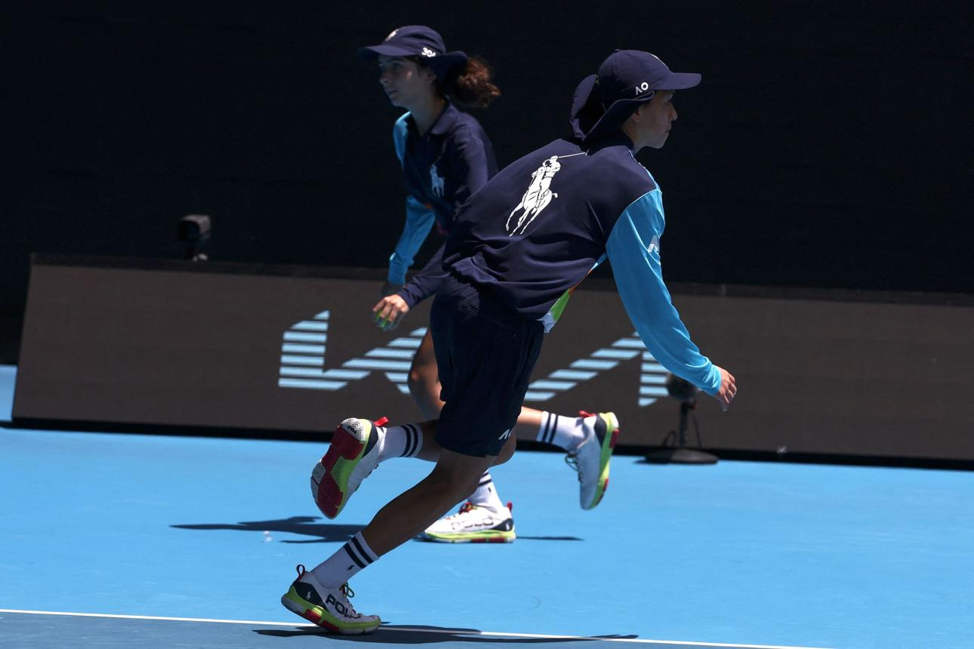
What is their role: Ball Kids (volunteer)
What they do:
- Collect and roll balls during matches in the tournament.
- Provide towels and assist players in between points.
- Stay alert and follow strict timing and specific rules.
- Work in high-pressure televised environments.
Requirements:
- Must attend training sessions and trials.
- Selection process from hundreds of applications.
- Need to show discipline, fitness and teamwork.
Benefits/Rewards:
- Receive official uniform and meals.
- Certificate of participation.
- Unique experience at a global event.
- Skill development in teamwork, responsibility, problem-solving and confidence.
Points to consider:
- This Grand Slam event makes a significant profit.
- Roles involve lots of responsibility and pressure.
- Is the experience enough as compensation or reward?

Case Study 2. AFL Auskick / AFL Grand Final
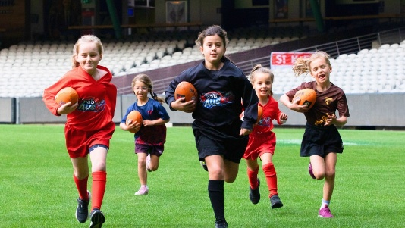

What is their role: participants/helpers (participation-based)
What they do:
- Play halftime games during major matches.
- Can help with simple equipment jobs.
- Represent junior programs in front of large crowds.
Requirements:
- Participation in Auskick programs.
- Selection through clubs or schools.
Benefits/Rewards:
- Opportunity to play on a professional field, e.g. the Melbourne Cricket Ground (MCG).
- Enjoyment and memorable experience.
- Getting to experience professional sport.
Points to consider:
- Mostly focused on participation rather than labour.
- Entertainment value for the crowd.
- Should fun experiences be paid for?

Case Study 3. Cricket Australia

What is their role: Junior volunteers.
What they do:
- Help with drink runs for players.
- Manage boundary flags or simple game tasks.
- Help run junior clinics and activities.
- Support event organisation behind the scenes.
Requirements:
- Often linked to a local cricket club or to development programs.
- Basic training or supervision provided.
Benefit/Rewards:
- Skill building (communication, teamwork, etc.).
- Confidence building.
- Pathways to sport involvement.
- Sense of contribution.
Points to consider:
- Mix of learning and labour.
- Help large organisations run smoothly.
- Should development roles be unpaid?

Case Study 4. National Rugby League (NRL) and Australian Soccer League (A-League)
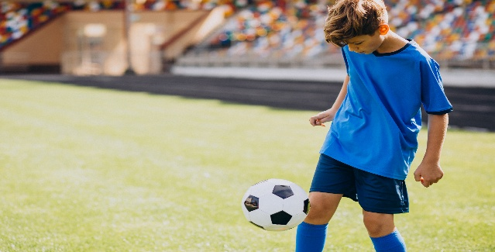

What is their role: Volunteers/Match Day Participants.
What they do:
- Walk on the field with professional players.
- Participate in pre-game ceremonies.
- Represent clubs and engage with the event atmosphere.
Requirements:
- Selected through competitions, clubs or promotions.
- Expected to follow instructions and event rules.
Benefits/Rewards:
- Unique once–in–a–lifetime experience.
- Close interaction with professional athletes.
- Lasting memories and excitement.
Points to consider:
- Minimal labour but part of a major commercial event.
- The experience itself is seen as a perk or a reward.
- Should all roles at profit-making events be paid?

Case Study 5. Community Events (e.g. fun runs, local festivals)

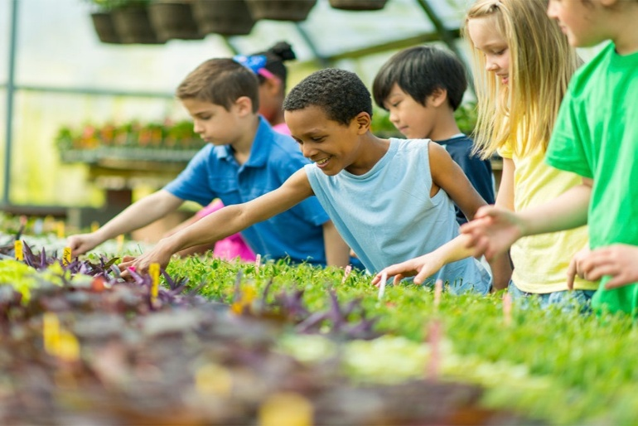

What is their role: Event helpers (volunteer).
What they do:
- Hand out water or snacks.
- Help guide those participating.
- Assist with set up or pack-up.
- Support event organisers.
Requirements:
Usually minimal training.
Often organised through schools or community groups.
Benefits/Rewards:
- Helping others and contributing to the community.
- Building responsibility and teamwork.
- May receive a certificate of recognition.
Points to consider:
- Often non-profit or charity-based events.
- Focus is on community and service.
- Should payment depend on whether the event makes a profit?

Activity 4: Ball Kids at the Australian Open: Behind the Scenes of a Grand Slam Activities – Case Study Activities

4a: Australian Open Ball Kids – Comprehension Activity
Learning Intention
We are learning to understand the role, responsibilities and experiences of ball kids at the Australian Open.
Success Criteria
I can describe what balls kids do during matches, identify the skills and requirements needed for the role, explain the benefits and challenges of being a ball kid and answer comprehension questions using information from the BTN video.

Task Instructions:
1. Watch the BTN clip on the Australian Open ball kids carefully
2. Answer the comprehension questions below using the information from the video (from both what is said and what you can see).
3. Check your answers with another student in the class and add any missing details.
4. Contribute to a class discussion and be prepared to share your answers.
Link: Behind the News - ABC – Ball Kids
Answer each of the questions in the space provided as you are watching the video:
1. What is the role of a ball kid at the Australian Open?
______________________________________________________________________________________________________________________________________________________________________________________________________________

2. List two tasks that ball kids are responsible for during matches.
______________________________________________________________________________________________________________________________________________________________________________________________________________
______________________________________________________________________________________________________________________________________________________________________________________________________________

3. What skills or qualities do ball kids need to do their job well?
______________________________________________________________________________________________________________________________________________________________________________________________________________
_______________________________________________________________________________________________________

4. Describe the process or what is involved to become a ball kid.
______________________________________________________________________________________________________________________________________________________________________________________________________________
______________________________________________________________________________________________________________________________________________________________________________________________________________

5. What do ball kids enjoy most about the experience?
______________________________________________________________________________________________________________________________________________________________________________________________________________
______________________________________________________________________________________________________________________________________________________________________________________________________________

6. Give one example of a challenge or difficult situation ball kids may face.
______________________________________________________________________________________________________________________________________________________________________________________________________________

7. Is being a ball kid an example of labour, volunteering or participation? Explain your choice.
______________________________________________________________________________________________________________________________________________________________________________________________________________
______________________________________________________________________________________________________________________________________________________________________________________________________________

8. What type of compensation do ball kids receive?
______________________________________________________________________________________________________________________________________________________________________________________________________________
______________________________________________________________________________________________________________________________________________________________________________________________________________

9. Who benefits more from ball kids? Is it the children or the event organisers? Give a reason for your answer.
______________________________________________________________________________________________________________________________________________________________________________________________________________
______________________________________________________________________________________________________________________________________________________________________________________________________________

10. Do you think ball kids should be paid. Give reasons for your opinion.
______________________________________________________________________________________________________________________________________________________________________________________________________________
______________________________________________________________________________________________________________________________________________________________________________________________________________

4b: Netflix Feature on Ball Kids – Documentary Review Activity (Optional)
Please note: You will need access to a Netflix account to show the documentary to students.
Learning Intention
We are learning to analyse how the media represents the experiences of ball kids and evaluate different points of view.
Success Criteria
I can identify how ball kids are portrayed in the documentary, explaining both the positives and challenges that are shown.

Task Instructions:
1. Watch the Netflix documentary on ball kids
2. As you watch, make some notes under the headings listed below.
3. In small groups, discuss whether the documentary presents the role of ball kids positively or negatively.
4. Write a short review of the documentary (at least 1 paragraph) explaining your opinion using examples.
Explanation of what a documentary review is:
A review is your opinion about a film/documentary.
It should include:
- What the documentary is about
- Your opinion (can be positive, negative or a mixture of both)
- Examples from the documentary to support your opinion
Sentence starters for your review could include:
The documentary is about………………………….
Ball kids at the Australian Open are responsible for……………………………
I think it is fair that ball kids are not paid because………………………………
OR
I think it is unfair that ball kids are not paid because…………………………

4c: The Grand Slam Comparison – Global Research Activity
Learning Intention
We will compare how ball kids are used and treated at major international sporting events, specifically the Australian Open, Wimbledon Championships, US Open and French Open Grand Slam tennis tournaments and evaluate whether they are treated fairly and should be paid.
Success Criteria
I can identify similarities and differences between how ball kids are treated in different countries. I can describe the type of work and compensation provided at each event. I can evaluate whether these approaches are fair and give reasons for my opinion. I can use evidence from research to support my ideas in a class discussion.

Task Instructions:
1. Your teacher will assign you one of the four major Grand Slam tournaments to research: the Australian Open, Wimbledon Championships, the US Open or the French Open.
2. In groups of 3-4 students, read the information provided and use the websites to complete all sections of the worksheet.
3. Share your group’s findings with the class, then individually complete the comparison table using information gathered from the other groups.
4. Rejoin your group to answer the discussion questions using evidence from your research and be prepared to contribute to a class discussion.
RESEARCH WORKSHEET (to be completed in groups)
ARE ALL THE BALL KIDS ACROSS THE FOUR GRAND SLAM TENNIS TOURNAMENTS PAID FAIRLY?
Grand Slam Tournament: (circle one only)
Australian Open Wimbledon US Open French Open
1. Basic information
- Location of tournament: ___________________________________________
- When is it held: ___________________________________________________
2. Payment
- Are ball kids paid? Yes / No (circle one)
If YES:
- How much are they paid? _________________________________________
- Type of payment (hourly/allowance/other): _________________________
If NO:
- What do they receive instead? _____________________________________
________________________________________________________________________________________________
________________________________________________________________________________________________
3. Working Conditions
- Typical hours per day: _____________________________________________
- Length of shifts: __________________________________________________
- What do ball kids do (list 3 tasks)
1. _______________________________________________________________
2. _______________________________________________________________
3. _______________________________________________________________

4. Who Can Apply?
- Age requirements: ________________________________________________
- Selection process (how are the ball kids picked):
______________________________________________________________________________________________
______________________________________________________________________________________________

5. Interesting Facts:
Write ONE or TWO interesting or surprising facts that you learned:
____________________________________________________________________________________________________________________________________________________________________________________________________________________________________________________________________________________________________________________________________________________________________________________________________________________________

Complete the table using the information from other groups: (to be completed individually and shared)
Tournament | Paid/Not Paid | Benefits | One Interesting Fact
Australian Open

Wimbledon

US Open

French Open

Discussion points: (to complete with your group and then share with the class)
Which tournament treats ball kids the most fairly? Why?
____________________________________________________________________________________________________________________________________________________________________________________________________________________________________________________________________________________________________________________________________________________________________________________________________________________________

Which tournament is the least fair? Why?
____________________________________________________________________________________________________________________________________________________________________________________________________________________________________________________________________________________________________________________________________________________________________________________________________________________________

Should ball kids be paid? Why?
____________________________________________________________________________________________________________________________________________________________________________________________________________________________________________________________________________________________________________________________________________________________________________________________________________________________

SUMMARY OF EACH TOURNAMENT TO SHARE WITH STUDENTS:
1. AUSTRALIAN OPEN
Behind the Scenes of Melbourne's Largest Tennis Tournament!
Melbourne hosts the Australian Open every January, which features high-quality tennis and scorching summer weather. Although the players are the stars, ball kids assist in maintaining the game's smooth flow.
Although they don't get paid, the ball children at the Australian Open get free meals, beverages, uniforms and life-changing moments. The greatest benefit, according to many of the past ball kids, is being so close to professional athletes.

Ball kids often work extended hours (up to 8–10 hours) with rotating shifts. Their responsibilities include:
- Gathering balls at a fast pace
- Rolling balls to players
- Helping with equipment and towels
Usually between the ages of 12 and 15, students must complete trials, training, and fitness testing in order to be accepted.
Fun Facts:
- Melbourne’s extreme heat sometimes stops matches, but ball kids must stay focused even in tough conditions. In fact, it is the hottest grand slam as it is played in the middle of summer. Special extreme heat rules help keep players safe.
- The Australian Open is the first Grand Slam each year and sets the standard for the entire season.
- Major stadiums like Rod Laver Arena have a retractable (opens and closes) roof so games can continue even when it rains or is extremely hot.
- Ball kids are not paid but receive free uniforms, meals and drinks and a chance to be close to the world’s top players.

Website links for further information:
- Tennis Australia – Ballkids: Your courtside adventure awaits
- Australian Open – Australian Open 2026 – ballkid trails underway
- YouTube Guardian Australia – What it takes to be an Australian Open ballkid

2. Wimbledon Championships
Tradition Takes Centre Stage at Wimbledon Championships
The oldest tennis event in the world is Wimbledon, which was first played in 1877 in London, England. It takes place during the months of June and July and is famous for its distinct atmosphere and rich history.
The game is played on grass courts, which adds to the excitement and pace of the match, and players are required to follow a rigid all-white dress code. Wimbledon has a distinct vibe from other tournaments; it is more subdued, more official, and steeped in history. The Royal Box is frequently used by members of the Royal Family to watch the games, and spectators can enjoy strawberries and cream.
The ball boys and girls at Wimbledon are well-trained and must demonstrate great concentration and discipline. They often must complete their duties during a 6–8-hour shift. These duties include:
- Collecting and delivering balls quickly.
- Moving in a controlled way and working well together.
- Supporting players during matches.

The ball kids at Wimbledon are paid, unlike those at many other Grand Slams. In addition to a daily allowance (approximately £200 throughout the tournament), they also get the following:
- Official uniforms.
- Food and refreshments.
- A certificate of participation.
To be a ball kid, students between the ages of 13 and 15 must go through school nominations, trials, and several weeks of training.
Wimbledon is the third Grand Slam of the year and is often seen as the most prestigious because of its long history and traditions.
Fun Facts:
- Wimbledon was the last Grand Slam to introduce night play.
- A trained hawk is used to keep the pigeons off the courts.
- Over 190,000 strawberry and cream are eaten during the tournament each year by spectators.
- The grass is cut to an exact height of 8mm.

Websites for further information:
- Wimbledon – Ball Boys and Ball Girls
- BBC – Bitesize – The journeys of Wimbledon ball boys and ball girls
- YouTube – Tennis Channel – How Wimbledon selects their ball kids | The Break

3. US Open
Where Tennis Meets Entertainment: Inside the US Open
The US Open takes place in New York, USA, during August and September at the huge Billie Jean King National Tennis Centre. It is the last of the four Grand Slam events, and the atmosphere is very different from the other three tournaments as it is louder, faster and more energetic.
Fans cheer between points, music plays during breaks and matches are often held late at night under the bright lights, especially in the massive Arthur Ashe Stadium, which is the largest tennis stadium in the world.
Ball kids at the US Open are paid, which makes it different from some of the other Grand Slams. The ball kids usually earn an hourly rate of pay ($16-$17 per hour) and must also receive:
- Official uniforms.
- Meals or food vouchers.
- Transport help in some cases.

Ball kids usually work 5-to-8-hour shifts depending on the schedule. Because matches can go late, some ball kids may finish very late into the night.

They are responsible for:
- Collecting and distributing balls quickly.
- Keeping up with the fast pace of hard-court matches.
- Communicating clearly with other ball kids and officials.
- Staying focused in loud, high-pressure environments.

To apply, students must be between the ages of 14 and 17 and must complete tryouts, fitness and agility tests and training sessions before the tournament.

Fun Facts:
- The US Open is famous for night matches that can finish after midnight.
- Athur Ashe Stadium holds over 23,000 seats compared to Rod Laver Arena, which holds 14,800 seats
- It was the first Grand Slam to use a roof over its main stadium in the US.
- The hard courts make the ball move faster, leading to quick and powerful rallies.

Websites for further information
- US Open – US Open Ball Crew
- New York Post – Meet the ballkids breaking a sweat on the court during the US Open – and they don’t even have rackets • YouTube – Today – What does it take to be a Tennis ball person at the US Open
- YouTube – Today – What does it take to be a Tennis ball person at the US open

4. French Open
Clay Court Battles Begin at the French Open
The French Open (Roland Garros) takes place in Paris, France, during May and June and is the only Grand Slam tournament to be played on clay courts, which gives it a different feel from the other three events.
The red clay surface slows the ball down and makes it bounce higher, leading to longer rallies between players and tougher matches. Players often slide across the court to reach the ball, showing great skill and balance. This tournament tests players’ fitness, patience and mental strength.

Ball kids at the French Open are highly trained and must be quick, alert and able to move well on the clay surface. They usually work 6 to 8-hour shifts to help matches run smoothly. Their duties include:
- Collecting balls during long rallies.
- Rolling balls accurately to players.
- Helping maintain the court, including checking marks on the clay.

Like the Australian Open, ball kids are not paid, but they receive:
- Official uniforms.
- Meals and refreshments.
- A unique once-in-a-lifetime experience at a world-famous event.

The selection process targets 12-16-year-olds who go through a competitive process, including trials and training camps.

The French Open is the second Grand Slam event of the year, and many players find it the most physically demanding tournament because of the red clay surface.

Fun Facts:
- The clay is made from crushed brick, not dirt.
- Players slide on purpose as it helps them move better on the clay.
- Matches can last for 4 to 5 hours because of the long rallies.
- All announcements are made in French and then English.
- The clay absorbs water, allowing matches to continue after light rain.

Websites for further information:
- Roland-Garros – Ball-Kids
- Roland-Garros – Day in a Life: Ball Kids
- YouTube – Roland-Garros – Ball Kids, Roland-Garros, here we come! Episode 9 (In French with subtitles)

Activity 5: Media Analysis – Mind Map Activity

Learning Intention
We are learning to analyse different media articles/blogs about whether children working at major sporting events (e.g. Australian Open ball kids) should be paid, so we understand how the media presents different viewpoints and influences public opinion.
Success Criteria
I can identify the main issues and compare different viewpoints on this topic using evidence from the articles. I can explain how media language and tone can influence the reader.
Task Instructions:
1. Your teacher will place you into pairs or small groups. You will be given a newspaper article/blog on this topic ‘Should children who work at major Australian sporting events be paid?’
2. Read the article/blog carefully and highlight the key ideas.
3. Identify the main issues and the different viewpoints presented, whether for or against payment and record these in your hamburger mind map.
4. As a group, decide your position on this topic and include your final judgement in the conclusion.
5. Share your group’s ideas with the rest of the class.

Article 1: Blog
Kylie Orr – [Un]reasonable outraged by unpaid Ballkids (Australian Open)
Article 2:
Lawyers Weekly – Ballkids are in the news, and it has nothing to do with the tennis
Article 3:
News.com.au – Emphatic response to ballkids controversy at Australian Open.

Article 4:
The Herald Sun – Push for remuneration for Australian Open ball kids rejected by Craig Tiley who says the children get ‘paid in lieu of cash’
Should Australian Open ballkids be paid?

A recent Herald Sun article has raised debate about whether Australian Open ballkids should receive payment for their role at Melbourne Park.

The article reports that Tennis Australia has defended its decision not to pay Australian Open ballkids in cash, even though ballkids at some other major tennis tournaments overseas receive payment or a stipend. According to the article, ballkids at the US Open are paid about $24 an hour, while Wimbledon ballkids receive a stipend of about $395 for two weeks’ work.

The article states that 435 ballkids aged 12 to 15 participated in the 2026 Australian Open. It reports that ballkids work about eight hours a day, in 45-minute to one-hour sessions on court, including late nights and days of extreme heat. Their role includes retrieving balls, returning them to players, assisting with court presentation and supporting the smooth running of matches.

Tennis Australia Chief Executive Craig Tiley argued that ballkids receive other benefits instead of cash payment, including uniforms, food, transport support, tickets, gifts and the experience of being involved in one of the world’s major sporting events. Tiley said the children are “paid in lieu of cash” through these non-cash benefits. He also described the Australian Open ballkid program as highly regarded internationally, saying participants are selected through trials and training and become part of a strong program culture.

Supporters of the current model argue that the role provides young people with a unique opportunity, valuable experience and a strong addition to their CV. Former Australian tennis player Alicia Molik expressed this view, saying she saw the role as a great opportunity for young people, regardless of whether it was paid. She also noted that having worked at the Australian Open would be valuable experience to include on a CV.

However, the article also presents the opposing view. Former Australian tennis player Mark Philippoussis argued that ballkids should receive some payment, saying they deserve “some pocket money”. This view highlights the time commitment involved, the importance of the role to the tournament and the fact that ballkids contribute to a major commercial sporting event.

The issue raises broader questions about volunteering, youth work, non-cash benefits, event management and the responsibilities of major sporting organisations.

Source: Peter Rolfe, “Push for remuneration for Australian Open ball kids rejected by Craig Tiley who says the children get ‘paid in lieu of cash’”, Herald Sun, 27 January 2026. Available at: Australian Open ballkids unpaid, Tennis Australia defend stance | Herald Sun

Article 5:
Herald Sun – Australian Open 2026: Leaders reveal what life is like as a ball kid at Melbourne Park (article provided below)
What is it like to be an Australian Open ballkid?

A recent Herald Sun article explores what life is like for ballkids at the Australian Open, highlighting the skill, teamwork and physical demands involved in the role.

The article reports that the 2026 Australian Open had a record 435 ballkids, the largest squad in the tournament’s history. Ballkids work approximately eight hours per day, including late nights. Their shifts usually involve one hour on court followed by one hour off court, although rotations are reduced to 45 minutes during extreme heat.

The article explains that ballkids are often required to respond quickly and safely in high-pressure situations. Ballkid leaders Maddy Sekias and Jack James described some of the challenges involved, including having to deal with fast serves travelling at around 200km/h. Jack explained that the ball can hurt a ballkid’s hands if it is not caught cleanly.

The article also highlights that communication and teamwork are central to the role. Because ballkids cannot speak during play, they rely on signals, eye contact and awareness of each other’s movements. Jack said it is important to communicate clearly with other ballkids at the net, while Maddy explained that each person needs to perform their role well so the whole team can function effectively.

Although Australian Open ballkids are not paid and are considered volunteers, the article notes that they receive benefits such as free tickets, food, uniforms and an end-of-tournament gift pack. In previous years, gift packs have reportedly included items such as GoPro cameras and Beats speakers.

The article also notes the diversity of the 2026 ballkid group, which included First Nations ballkids, Interstate Leadership Program representatives, All Abilities ballkids, Kia Korea representatives, China Open ballkids and two ballkids from France.

Overall, the article presents the ballkid role as demanding but rewarding. It shows that ballkids contribute significantly to the smooth running of the Australian Open and that the role requires focus, resilience, teamwork and the ability to perform under pressure.

Source: Brendan Casey, “Australian Open 2026: Leaders reveal what life is like as a ball kid at Melbourne Park”, Herald Sun, 26 January 2026. Available at: Unsung Aus Open heroes: Life as a ballkid revealed | Herald Sun

Article 6:
7news – Aus Open anger grows over ‘disgusting’ ballkids treatment: ‘Are we in a Dickens novel?’

Mind Map Activity

Conclusion:
Fact 3:
Fact 2:
Fact 1:
Should children who work at major Australian sporting events, such as the Australian Open, be paid for their work?

Activity 6: Exploring the Pros and Cons of Volunteering in Sport: Interview Role Play Activity
Learning Intention
We will listen to an interview about children volunteering in sport without being paid and identify the positive, negative and interesting aspects using a PMI chart.
Success Criteria
I can listen carefully to the interview and identify key ideas about children volunteering in sport without being paid. I can record relevant points under Plus, Minus and Interesting, using examples to show my understanding.

Task Instructions:
1. Your teacher will select two students to role-play the interview (Commentator and Official).
2. Listen carefully to the interview and complete a PMI chart identifying Plus, Minus and Interesting points.
3. Share your ideas and contribute to a class discussion.
Characters
- Commentator – asks questions, curious and engaging.
- Official – represents a sporting organisation, balanced and informative.
Scene:
A commentator stands with a microphone. The official is beside them, holding a clipboard or wearing event staff gear.
Script:
Commentator:
Today, we’re talking about children volunteering at major sporting events like the ball kids at the Australian Open. Some people think it’s a great opportunity, while others think it’s unfair. So, what is really going on?

Official:
It’s a really interesting issue.
Volunteering in sport can be a positive experience, but it also comes with challenges.
PROS
Commentator:
Let’s start with the positives, shall we and look at why children want to do this?
Official:
One of the biggest benefits is skill development.
Children are given the opportunity to learn teamwork, communication, and responsibility, not just in the classroom but in real-life situations.
Commentator:
So, are you saying that it’s more than just picking up balls?
Official:
Exactly.
They work under pressure, follow instructions, and learn to stay focused in big moments. Imagine being out on Rod Laver Arena with thousands of people watching. That is a really huge experience and one they will never forget.
Commentator:
I imagine events like the Australian Open would be exciting?
Official:
Absolutely.
There’s a strong sense of community, of belonging and children are made to feel like they’re part of something important. It can even inspire future careers in sport. Pat Rafter began his tennis career as a ball kid, and so did Nick Kyrgios.
Commentator:
So, it’s better than just sitting at home and watching the tennis or another sport on television?
Official:
Absolutely.
It gets kids involved, active, and learning skills that they can use later in life, not just on a screen.
CONS
Commentator:
But let’s be real here, if it looks like work, is it actually work?
Official:
That’s where it becomes more complicated.
There can be time pressures, especially when trying to balance school, family, and long hours at events.
Commentator:
So, it can be tiring and stressful for children?
Official:
Very. Standing for long periods of time, staying focused, and dealing with noise and crowds can be really exhausting, especially for the younger kids.
Commentator:
What about fairness? These events make a lot of money, so should children be paid?
Official:
That’s a big debate.
Some people argue it can feel like unpaid labour.
But others point out that many sporting events, especially community ones, depend on volunteers and simply could not run without them.
Commentator:
Are there safety concerns as well?
Official:
Yes, which is why training and supervision are important. There needs to be clear rules to make sure that children are safe and supported at all times.
Commentator:
And is it fair for everyone to get involved?
Official:
Not always.
There can be issues with transport, time, and costs, which makes it harder for some children to participate, which means that not everyone gets the same opportunity.
CONCLUSION
Commentator:
So, it’s not just good or bad?
Official:
Exactly as it really does depend on the situation and how the program is run.
Commentator:
What should we be asking instead?
Official:
We should be asking:
Is it fair, safe, and worthwhile for young people to volunteer and be part of these sports and community events?
Commentator:
And if the answer is, yes?
Official:
Then volunteering in sport can be a really valuable experience. Something that children will remember for the rest of their lives.

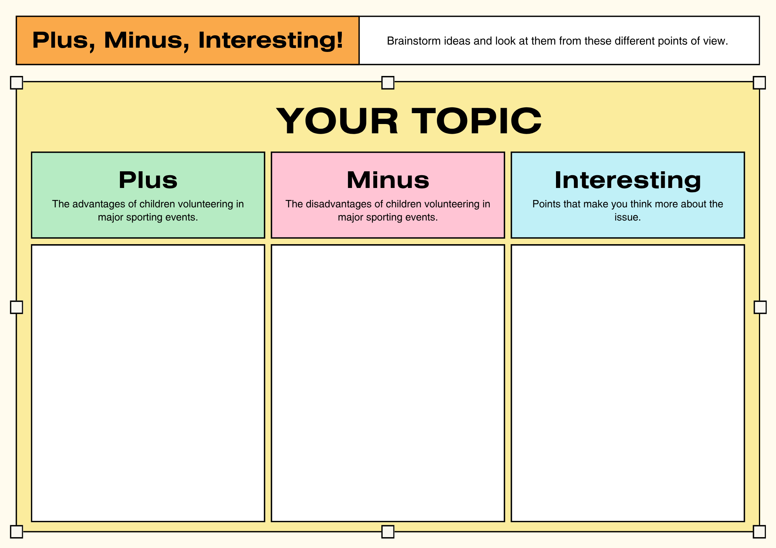

POST CONVENTION ACTIVITIES

Activity 1: Reflection Journal Activity
Learning Intentions
We are learning to consider different points of view and reflect on our own opinion about whether children should be paid for their work at major sporting events.
Success Criteria
I can clearly describe my opinion and explain at least one reason in favour of children being paid at major sporting events and one reason against it. I can also reflect on what I have learned from others, explaining if and how my thinking has changed.

Task Instructions:
1. Complete your reflection journal individually by reading each prompt carefully and writing your answers in full sentences.
2. Remember to give reasons for your opinions where required.
3. Be thoughtful in your reflection so describe your opinions clearly.
2. In a circle, share your thoughts and opinions with the rest of the class.
What is a reflection journal?
A reflection journal is where you write about your thoughts, what you have learned and how your ideas may have changed. It helps you to:
- Think back on what you learned during the convention.
- Consider the different opinions students shared.
- Explain if your thinking has changed and why.
**There are no right or wrong answers. The most important thing is that you explain your ideas clearly and give reasons for what you think.
Reflection Journal Prompts (writing ideas):
Before the Convention
Did you think children who work at major Australian sporting events should be paid for their work? Why?
___________________________________________________________________________________________________________________________________________________________________________________________________________________________________________________________________________________________________________________________________________________________________________________________________________________________________________________________________________________________________________________________________

Primary School Parliamentary Convention
What were some of the different opinions that you heard about this topic?
___________________________________________________________________________________________________________________________________________________________________________________________________________________________________________________________________________________________________________________________________________________________________________________________________________________________________________________________________________________________________________________________________
What is one idea or opinion that made you think differently?
___________________________________________________________________________________________________________________________________________________________________________________________________________________________________________________________________________________________________________________________________________________________________________________________________________________________________________________________________________________________________________________________________
Both sides of the debate
One reason children should be paid is:
_____________________________________________________________________________________________________________________________________________________________________________________________________________________________________________________________________________________________________________________
One reason children should not be paid is:
_____________________________________________________________________________________________________________________________________________________________________________________________________________________________________________________________________________________________________________________
After the Convention
Has your opinion changed? Explain why or why not.
_____________________________________________________________________________________________________________________________________________________________________________________________________________________________________________________________________________________________________________________
______________________________________________________________________________________________________________________________________________________________________________________________________________

My Final Opinion
Do you think children working at events like the Australian Open should be paid? Explain your reasons.
_____________________________________________________________________________________________________________________________________________________________________________________________________________________________________________________________________________________________________________________
_______________________________________________________________________________________________________
_______________________________________________________________________________________________________
Reflection on Learning
What did you learn from this activity?
_____________________________________________________________________________________________________________________________________________________________________________________________________________________________________________________________________________________________________________________
How did listening to others help your thinking?
_____________________________________________________________________________________________________________________________________________________________________________________________________________________________________________________________________________________________________________________

Activity 2: Should children be paid? Make your case – Policy Proposal Writing Activity
Learning Intentions

We are able to use ideas from the Convention to create a policy proposal that shares what we think and why on the topic of should children who work at major Australian sporting events be paid for their work.

Success Criteria

I can share what I think about this topic, explain my reasons and suggest a fair rule for the policy proposal.

Task Instructions:
1. Work in pairs or small groups to design or create a policy about children working at sporting events. You can focus on a specific event, like the Australian Open or create a general policy for all sporting events.
2. Use the sentence starters to help you share your ideas and your opinions. Think about what you believe, why you think that, who is affected and what would be fair.
3. Write your policy proposal and include clear rules, reasons and how your policy will work in real life.
4. Share your policy with the class, explaining your group’s ideas and listen to the ideas of other groups.
What is a policy proposal?
A plan or a set of rules designed to solve a problem or improve a situation. It explains what should happen, why it's fair and who it affects.
Sample Policy Proposal for Bicycles at School

Title: Bicycle Safety and Use Policy

Group (or Pairs) Opinion
We believe that students should be allowed to ride bicycles to school.

Why:
Riding bicycles keeps us active, helps the environment by reducing car use and allows students to become more independent.

Who is affected:
This policy affects the students at the school, parents, teachers and the wider school community.

Our Rules:
- Students must always wear a helmet when riding their bicycle.
- Bicycles must be ridden safely, and the rider must follow all road rules.
- Bicycles must be parked in an allocated bike area and secured with a proper lock.
- Younger students should be supervised when riding near the school.
- Bicycles should have working lights, and riders should wear a high- visibility vest so that they can be easily seen on the road.

Why this policy is fair:
These rules keep students safe while still allowing them to enjoy riding their bicycles to school.
Sentence Starters for a Policy Proposal about Children Working at Sporting Events
Group/Pair Opinion:
We believe/ think that children should/should not be paid for working at sporting events because
_____________________________________________________________________________________________________________________________________________________________________________________________________________________________________________________________________________________________________________________
Reasons:
One reason for this is
_____________________________________________________________________________________________________
This is important because
______________________________________________________________________________________________________
Another reason is
______________________________________________________________________________________________________
This is important because
_______________________________________________________________________________________________________

Who is affected:
______________________________________________________________________________________________________________________________________________________________________________________________________________
Our Rules:

This policy is fair because:
______________________________________________________________________________________________________________________________________________________________________________________________________________

Activity 3: Stakeholder Voices – Role Play Activity
Learning Intentions

We can express our opinions about whether children who work at major sporting events should be paid through role play.

Success Criteria

Through role play, I can clearly share a stakeholder’s point of view, explain whether they think children should or should not be paid and why, and listen to others to understand different perspectives on this topic.

Task Instructions:
1. You will be assigned a role by your teacher.
2. Think about your role and decide what your stakeholder would feel about children working at sporting events.
3. Write down 2-3 reasons that support your stakeholder’s opinion.
4. Take part in a class discussion, speak in your role and share your stakeholder’s point of view.
5. Listen carefully to other students’ ideas. Be ready to agree, disagree or add new ideas to the discussion.
6. Write a short summary of your view of this topic, thinking about the discussion and the different stakeholder opinions.
Role cards to be assigned to students:
ROLE CARD 1: Child worker

Role: You are a child working at a major Australian sporting event
Present your point of view on whether children should be paid, thinking about fairness, effort, and rewards

Sentence starters you could use to present your point of view: (choose one option only to argue)
- I think children should be/ should not be paid because…………………………………………………….
- I believe I deserve/don’t need payment because………………………………………………………………
- It feels fair/unfair when………………………………………………………………………………………………..

ROLE CARD 2: Parent

Role: You are the parent of a child working at a major Australian sporting event
Present your point of view on whether children should be paid, thinking about safety, fairness, and learning.

Sentence starters you could use to present your point of view: (*choose one option only to argue)
- As a parent, I think ………………………………………………………………………………………………………
- *I believe this is a good/not good opportunity because……………………………………………………..
- *Children should/should not be paid because ………………………………………………………………..
ROLE CARD 3: Event Organiser

Role: You organise the major Australian sporting event
Present your point of view on whether children should be paid, thinking about cost, the success of the event, and the sporting organisation

Sentence starters you could use to present your point of view:
- As the organiser, I need to …………………………………………………………………………………………….
- Paying children would …………………………………………………………………………………………………
- Volunteers are important because…………………………………………………………………………………

ROLE CARD 4: Volunteer Coordinator

Role: You organise volunteers at the major Australian sporting event
Present your point of view on whether children should be paid, thinking about volunteering, helping, and community.

Sentence starters you could use to present your point of view:
- Volunteering is important because……………………………………………………………………………………………
- If children were paid, it would ……………………………………………………………………………………………
- I think children should/should not be paid (choose one) …………………………………………………………

ROLE CARD 5: Spectator and fan of the Sporting Event

Role: You are attending and watching the major Australian sporting event
Present your point of view on whether children should be paid, thinking about fairness, the experience, and the different roles of volunteers and paid workers at the event

Sentence starters you could use to present your point of view:
- As a fan or spectator, I notice………………………………………………………………………………………………
- Watching the children makes me think……………………………………………………………………………………
- I believe children should/should not be paid because (choose one) ……………………………………………

ROLE CARD 6: Government Representative

Role: You make the rules and the laws that people follow
Present your point of view on whether children should be paid, thinking about safety, fairness, and rules

Sentence starters you could use to present your point of view:
- My job is to make sure that ..…………………………………………………………………………………………………..
- It is important that children …………………………………………………………………………………………………..
- I believe children should/should not be paid because (choose one) …………………………………………….

ROLE CARD 7: Commentator/Announcer at the Sporting Event

Role: You talk about the major Australian sporting event to the audience
Present your point of view on whether children should be paid, thinking about recognition, fairness, and public opinion

Sentence starters you could use to present your point of view:
- As a commentator, I can see that……………………………………………………………………………………………
- It is important to recognise……………………………………………………………………………………………………
- I believe children should/should not be paid because (choose one) ……………………………………………

My point of view after the role play activity on this topic:
__________________________________________________________________________________________________________________________________________________________________________________________________________________________________________________________________________________________________________________________________________________________________________________________________________________________________________________________________________________________________________________________________________________________________________________________________________________________________________

Activity 4: Corners of the Room – Take a Stand Activity
Learning Intentions

We are learning to decide and take a stand on whether children who volunteer at Australian sporting events should be paid, and support our view with reasons, ideas and points from the Convention.

Success Criteria

I can choose a clear position (yes, no, sometimes) on this topic and explain my thinking using what I learned before and during the Convention.

Task Instructions:
1. Each corner of the room has a label:
*Strongly Agree (Children should be paid)
*Agree
*Disagree
*Strongly Disagree (Children should not be paid)
2. Your teacher will read the statement out: Children who volunteer at major Australian sporting events like the Australian Open should be paid.
3. Move to a corner that best represents your opinion on this topic.
4. In your group, discuss your ideas and come up with 2- 3 reasons to support your position. Write these down on butcher's paper.
5. Share your group’s thinking with the class.
6. You may change corners if your opinion changes after hearing other students’ ideas.
7. Final Reflection: Explain why you chose your final position and state whether your opinion changed, including why or why not.



